September 1950

GUS AND THE

GAS HUNGRY MILK TRUCKS
by Martin Bunn
When a friend in the milk business
brings his headaches to the Model Garage,
Gus takes on the job of trouble-shooter - and scores a bull's-eye.
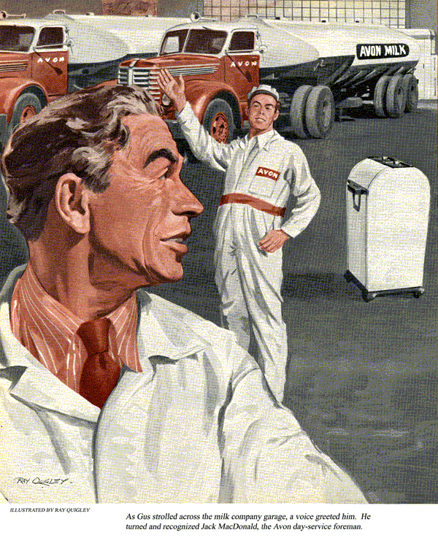
Gus Wilson perched himself up on his repair bench, thumbed some shreds of tobacco into the bowl of his pipe, and looked at a completely empty shop floor. It was the first time since June that there hadn't been at least three cars stacked up in the Model Garage for some kind of repair. It had been a particularly busy summer, but at the moment Gus was enjoying the pleasant feeling of having nothing pressing to do.
His dream of leisure, however, was short-lived. Through the puffs of smoke that billowed up as he fired his pipe he noticed that Ed Nealy's car had rolled to a stop in front of the shop doors. Ed, one of Gus's really old friends, owns the milk company down in the city. He started out in a small way about 20 years ago, but now he services our town as well as a dozen other communities. He hasn't been getting to town much during recent years, but whenever he does, his trip includes a stop at the Model Garage.
"Ed Nealy, how come you're out touring the country on a work day?" Gus greeted him as the two shook hands.
"Playing hookey from those milk routes of yours?"
"No such luck, Gus," Nearly replied. "Believe it or not, this is strictly a business call."
"Something wrong with the car?" Gus asked as the two strolled back into the shop.
"No, car's okay. It's something more important than that. Can we go into the office and talk?"
"Sure thing." Said Gus, leading the way.
"Gus, I've got a favor to ask," Nealy began when they had settled themselves at Joe Clark's battered oak desk. "How would you like to take on a consulting job down at my plant? I'm sure it wouldn't take you more than a couple of days, and you can charge me whatever you think your time is worth. I've got a problem and I think you can lick it for me."
"Now hold on, Ed," Gus put in, "I'm just a small-town garageman. I may be able to tell when a gasoline engine has gone sour, but when it comes to milk it's been a good many years since I was a farm boy."
"That's just why I want you to help me," Nealy explained. "I do know the milk business but I don't know the first thing about engines. And there's lots of gasoline mixed up in the milk business. To pick up my milk and distribute it every day I have a fleet of 42 trucks. About half of them roll during the day, the other half at night so to keep them in shape I run the service department on two shifts.'
Night Trucks versus Day Trucks
I've got a good foreman heading up each service crew," Nealy went on. John MacDonald on the day side and Ned Pocheck at night. You know them both. Good, reliable men."
Gus nodded. He remembered them as local boys who'd taken jobs in the city, and wondered if Jack MacDonald was still as cocky as he used to be.
"Well, for about two years now," Nealy continued, "the night trucks serviced by MacDonald's crew have cost me more to operate, mile for mile, than Pocheck's day trucks. Last year, thinking that a little friendly competition might help. I even offered a semi-annual cash bonus to the crew that kept their maintenance costs the lower for each six-month period. It didn't help. So far, Pocheck's crew has won both bonuses."
"You sure of your cost figures?" asked Gus.
"Absolutely. The whole operation is cost-accounted every month, and invariably the day trucks get much better gasoline and tire mileage than the night trucks."
Gus thoughtfully scratched his chin with his thumb. "And you want me to play private eye and snoop out the leak?"
"That's it," said Nealy, "but don't get me wrong. I'm not asking you to do a sneak snooping job. No one's going to get fired. All I'd like you to do is spend some time with the service boys down at the plant, check over our maintenance procedures, and tell me what, if anything, we're doing wrong.
How about it?"
Gus Takes On the Job
Gus didn't answer immediately. Then he said, "Well, Ed, I'm not so sure I can help you, but I'm willing to take a try. I guess Stan Hicks and Joe Clark can keep the garage from falling apart for a few days."
"It's a deal," said Nealy, beaming.
"I hoped you wouldn't let me down. I'll have everything ready - and you don't know how much I appreciate this, Gus."
Two days later Gus found himself in a new role. Instead of tinkering with ailing carburetors, ignition systems, and fuel pumps, he was sitting uncomfortably at an office desk, going over volumes of records. Gus never has liked offices, records, or desks, but he knew that his first job was to check the facts and figures. What he found was just as Ed had outlined it. For some unknown reason, the day trucks were getting better gasoline mileage than the night trucks and the tires on the night trucks were wearing out about 20 percent faster than those on the day trucks.
With the pencil work out of the way by the end of his first day, Gus put on a pair of coveralls the next morning. Unfortunately he hadn't remembered to bring a pair of his own, so he had to wear a pair Ed Nealy gave him - a white pair with the words, "Avon Milk Co.," embroidered in red across the back. He felt more like a milkman than a mechanic as he strolled toward the service shop.
"Well, if it isn't Gus Wilson!" came a loud greeting. "The boss said you'd be over to solve all my problems."
Gus turned his head and recognized, Jack MacDonald, the day service foreman. "Jack hasn't changed much - cocky as ever," he thought as he acknowledged the greeting with a handshake.
"Sure hope you can straighten things out, Gus, and get my boys in on that bonus money."
"I'll try, Jack. Now, if...
"Try?" broke in Jack, "I've tried just about everything. Even sort of spied around a little to see if Pocheck's crew had thought up any new service angles."
"And had they?" asked Gus.
"Nope, I just don't get it. Both our shifts use exactly the same maintenance schedules.
Come on over to the office and I'll show you what I mean."
As they walked across the shop floor, Gus noticed that the equipment was all of the best. The place was a garageman's dream. As modern as 1950."
Service Schedule Meets Gus's Approval
Once inside the office, MacDonald pulled out a desk drawer, picked up a mimeographed booklet, and handed it to Gus.
"There's our service schedule, Pocheck's crew and mine follow it right to the letter."
Gus fingered through the pages. He had to admit it was a complete schedule and he said so.
"Thanks," Jack grinned. "We modeled it after the preventive maintenance plan used for government cars and trucks. It doesn't leave a thing to the imagination. Tells you not only when to make the various checks, but just how to make them. Any grease monkey can follow it if he can read."
"How often do you check wheel alignment?" asked Gus.
Jack licked his thumb and flopped the book open to page 10.
"There it is, item 24 under the 4,000-mile check. Now, on page six of Appendix B you'll find a list of the exact steps to be followed in making the check and how adjustments should be made. There's no guesswork and no need for thinking; it's all right there."
Maybe that's the trouble, Gus thought as Jack rambled on. Gus had learned that working strictly by the book wasn't always the best way. He knew by long experience that sometimes a little independent thinking, plus a little imagination, were mighty important when it came to smoking out what ailed a car.
"Mind if I mosey around by myself?" he asked.
"Go right ahead. Help yourself. Do any checking you want. And if you want anything, just holler."
For the next hour or so, Gus watched the three mechanics work on the parked trucks and did a little spot checking on his own.
He tested the wheel alignment on one truck, checked the timing and carburetor adjustment on another, and looked for possible brake drag on a third. He even pitched in and helped one of the men change a tire. By two o'clock in the afternoon, Gus decided he was a long way from uncovering a solution to Ed Nealy's problem. The men in the shop seemed to know their jobs and the trucks he'd personally checked seemed to be in good shape. But he wasn't satisfied.
He knew he had missed something some place that made a vital difference.
A Study Period Brings a Question
When Jack MacDonald returned to the service office just before four o'clock - quitting time for the day crew - he found Gus seated at the desk busily poring over the maintenance manual.
"I've been going over your service book," he said, looking up. "Seems to cover the ground, except one point."
"What's that?" Jack asked indignantly.
"There's no mention of daily servicing. You know, gas, oil, water, and air. Do you have any set time for those?"
"Oh, that's routine. All the trucks get their daily servicing every morning. We've overlapped the day and night shifts to take care of that. As each night truck comes in, it's gassed, and oil, water, and tire pressures checked. The same goes for each day truck as it goes out. Simpler that way. Less chance for a slip-up."
"Could be," Gus replied as he pulled himself up out of the chair and headed for the office door. "Can you hang around for a few minutes? I won't be long."
When Gus returned 10 minutes later, he had a tire gauge in his hand and a broad smile on his face. "It may be simpler your way, " he grinned, "but it sure ain't efficient."
"What do you mean?" Jack asked.
"Just this," Gus waggled the tire gauge as he spoke. "Not a single one of your trucks on that whole floor out there has a tire that's up to the recommended pressure."
"That's impossible," blustered Jack. "We, checked the tires on every one of those trucks this morning when they came in."
"That's just it," said Gus. "You did check them this morning, just as you do every morning. And I've a hunch that's the cause of your troubles."
"I don't get it." Jack was puzzled "What's the catch?" he asked.
Explanation Is Hot Air
"It all boils down to the fact that air expands when it's heated," Gus explained.
"You've been checking the tires of your trucks every morning when they're hot after a night's run. Even if they are up to pressure when you check them, or after you've put air in them, they probably are four or five pounds under pressure by the time they cool off.
"Pocheck's crew, on the other hand, have been checking their tires when they are cool after a night in the garage. On the average, Pocheck's tires have probably been slightly over inflated while yours have been under-inflated."
"Say, that does add up," admitted Jack.
"Sure, son, it adds up to more tire wear and less gasoline mileage on your trucks.
A lot of motorists don't take into account that recommended tire pressures are for cool tires, not for tires that have been pounding the roads and heated up."
A couple of weeks later, back in the Model Garage, Gus had just about forgotten about his trip to the city and his two-day job at the milk company when a short letter arrived in the mail. It read;
"Dear Gus,
Gas mileage up already. The Whole day crew is looking forward to sharing the January 1 bonus with you. And that's not hot air.
Thanks a million."
It was signed "Jack MacDonald."
END

