June 1950

GUS COOLS A HOT ENGINE
by Martin Bunn
A nasty customer gets slow service at Dan's Grille –
but unexpectedly quick service
and a pair of handcuff's at Gus's garage.

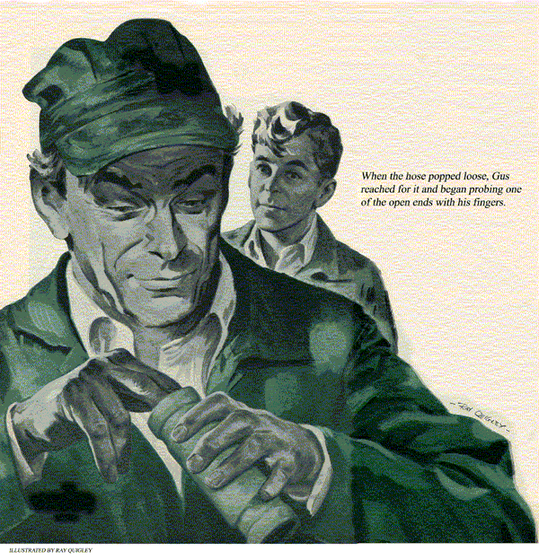
Tuesdays, during June and most of July, are usually shorter than most days at the Model Garage. Gus Wilson generally goes bass fishing on Wednesdays, so on Tuesdays he likes to close shop fairly early so he can go home, get an early start in the morning.
At about 6:30 on this particular Tuesday, Stan Hicks was finishing up his last job for the day. This, thought Stan, really would be an early evening.
That, as I say, was about 6:30. At 6:31 Stan wasn't quite so sure. For at that moment, a blue sedan with out-of-state license plates rolled through the open doors, came to a stop in front of the greasing rack, and a tall, heavy-set man unlimbered himself from behind the wheel.
"The boss here?" The tone of the man's voice made it sound more like a command than a question.
Before Stan could answer, Gus appeared from the rear of the shop. "Something we can do for you?" he inquired. "We were just about to close up for the night."
"Yeah, I've got troubles," the stranger grumbled jerking his thumb in the general direction of the car. "Just a few miles outside town, the engine started to get hot and sputter. Seemed to lose its power. Just when I'm in a hurry, too. Got no time to waste. Think you can fix it for me right away?"
"We can try," Gus answered, patting his hands with a wad of waste as he looked over both the car and the driver. "Might take time, through to locate your trouble."
"But I said I was in a hurry!" the stranger snapped. Then, as if a sudden evening breeze had cooled him down a bit, he added.
"Okay, but step on it. I'll get some chow. Is there a diner or lunchroom close by?"
After Gus had pointed the way to Dan's Grille - that's one of Gus' favorite eating places - down on the Square, and the man had left, Stan said. "Unpleasant jerk. Why didn't you tell him to peddle his car, his troubles, and his ugly puss some place else 'cause you want to go fishin?"
"A job's a job, Stan. Besides, those fish will wait for me, they always do. You finish up your job, while I'll see what I can do about tracking down the trouble here."
Gus slid into the driver's seat and started the engine. Stan could see him checking the gauges on the dash. Then he walked around to the front of the car and lifted the hood. The V-8 engine looked particularly clean. Next, he unscrewed the radiator cap.
"Water seems to be circulating," Gus muttered to himself. "Might know it wouldn't be something simple to put your finger on." He touched one of the cylinder heads. It was considerably hotter than it should be.
Slowly and methodically, the veteran garageman proceeded to check the normal things that are apt to cause an engine to overheat and lose power - a shipping fan belt, wrong ignition timing or mixture, poor spark plugs, even low oil level. Everything seemed to be in fair shape. The timing was a little out, but not enough to cause much trouble.
When Stan finished with the car he'd been working on, he walked over to the blue sedan. Gus' head was deep inside the hood. He had a trouble light and was going over the engine carefully.
"What's the matter, boss, this car got you stumped?"
Gus straightened up and flicked off the light. "There's more than one thing about this car that's got me stumped," he answered.
What else is Wrong?
For a moment neither man spoke. They both, just stood there thoughtfully looking down at the engine. Gus was leaning over, his right hand resting on the nearest of the two hoses that led from the tops of the cylinder heads to the top of the radiator.
Suddenly a big grin began to spread across his face. He squeezed the hose with his fingers.
"If it had been a snake it would have bitten me," Gus chuckled. "Stan, I think if you'll drain the radiator and take off that right-hand hose you'll find our trouble.
While you're doing that," he added, after a look at his watch. "I've got to make a phone call. If you need me, just sing out."

Service with a Smile
That guy is just too good natured, Stan thought as Gus disappeared into the garage office and closed the door. Probably phoning Ed up at the lake to tell him he'll be late tomorrow, and all on account of some out-of-towner who barges in here at the last moment and wants on-the-spot service.
Stan took his time moving another car from the drain hole and setting to the job. By the time Gus came back, the last of the water was just dribbling out of the bottom of the radiator and Stan was attacking the hose clamps with a screw driver.
"I'll have it off in a jiffy," Stan reported.
When the hose popped loose, Gus reached for it and began probing one of the open ends with his fingers. In no time he had succeeded in pulling out what looked like a cylinder of metal.
"Thermostat," Gus announced, holding it up for Stan to see. "Or at least part of one.
There are two thermostats in these V-8's, one mounted in each of the two water outlet fittings that extend up from the cylinder heads. From the looks of things, this one got badly rusted and came loose. Water pressure forced it up into the radiator hose where it jammed and shut off most of the water circulation to that bank of cylinders.
"See if we've got a replacement in stock, Stan," Gus added. "I'll remove the water outlet fitting and cut a new length of hose."
Working together, it didn't take them more than about twenty minutes to install a new thermostat and the new length of hose. When they had finished, Gus looked at his watch.

All This and Timing Too
"Our man won't have reached dessert yet," Gus said. "Might as well do the job right and adjust the timing while we're at it."
Stan, was just about to make some comment about doing so much for a peevish stranger they'd probably never see again when the office phone rang.
"I'll get it," Gus called as he hurried toward the office door.
"Probably for me anyway."
Stan was fussing with the timing when Gus came back out of the office. What he saw next was hard to be believe. Gus picked up a cloth and began wiping the car down.
"Pretty dirty," Gus offered in way of explanation. "Might just as well give it a good dusting while we're waiting. Nothing like a little extra service for a friend."
"Friend?" Stan grunted. "Why that guy wasn't even civil."
"Did seem that way," Gus answered with a grin, as he went right on with his cleaning job, even to spraying the windows and the windshield and wiping off the hub caps.
Best Is None Too Good
Stan couldn't figure out Gus's desire to give so much extra service to someone who obviously was just a one-time customer and a not-too-pleasant one at that. However, he'd worked for the gray-haired mechanic long enough to know that he usually had a good reason for just about everything he did.
Stan had just closed the car's hood and was rolling the engine analyzer back to the bench when the bulky stranger strode through the open doors.
"My car ready?" he barked as he came in.
"Just finished with it," Gus replied. "We had to put in one new thermostat and adjusted the timing. That'll be $8.75 for labor and parts."
"What?" the man bellowed belligerently, "$8.75? I didn't expect to have to pay for an engine overhaul."
"Take it or leave it," Gus shot back.
"I'd sure like to leave it if I could," the man continued to grumble. Then, reluctantly, he dug down into his pocket pulled out a wad of bills, and peeled off a crisp, new ten. "I haven't the time to argue. Give me my change and I'll get out of here."
"Did you just buy this car secondhand?" Gus asked as he slowly counted out $1.25.
"What business is that of yours?" the fellow snapped.
"None, but it's plenty of mine," put in a new voice.
As the man spun around, he bumped smack into Sergeant Jerry Corcoran who had come quietly out of the office.
Quickly, the stranger made a dart for the door only to tangle with Gus's out-thrust foot and go sprawling on the floor, Jerry was on him almost before he hit.
"Nice work, Gus," Jerry said as he snapped a handcuff on the man's wrist. "Wouldn't be surprised if we find more than car snatching on this guy when we begin checking up. In any case, he won't be around for awhile."
Stan just stood there bewildered as Jerry led the stranger out the back door to a white squad car where another trooper was waiting. Finally, he said, "Will you please tell me what the devil this is all about? If you knew the car was hot and the fellow was a crook, why did we do all that work?"
Gus laughed. "I just didn't want Jim Fleming to have to pay for those repairs," he grinned.
"I still don't get it. Who is Jim Fleming?" asked Stan.
"He's an old friend of mine, and the owner of this car," Gus explained. "When Jim lived here in town I used to see quite a lot of him. About a year ago, Jim and his family had to move over to Brighten and I hadn't seen either Jim or his car again until tonight.
Something Familiar Here
"It's funny, but the minute I started working on that engine," Gus continued, "I had a feeling I'd worked on it before. Then I happened to notice something - a welded brace on the generator support. I remembered I'd done a job just like that on Jim's car just before he'd left. So, I played a hunch. I made a note of the motor number and put in a long-distance call to Jim. I had no idea of his address, or whether he was still in Brighten, but the operator located him for me.
"He didn't know whether his car had been stolen or not. His wife had both the car and the license. He hadn't the slightest idea of what the motor number was, that was on the license. He said he'd try to locate his wife and call me back. When he did call back, everything checked, including the motor number. Seems his wife had parked the car in downtown Brighten and left the keys in the ignition. When she discovered the car was gone, she went right to the Brighten police without letting Jim know. They put a description of the car and the license number on the police teletype, but our pal had switched license plates.
"After I'd talked to Jim the second time, I called the State Police Barracks and tipped off Jerry Corcoran."
Waiting at the Plate
"But," put in Stan, "how did you know our friend wouldn't get back here ahead of time and mess up your little plan?"
"Elementary, Dr. Watson," Gus explained with a grin. "I just called Dan and told him to give our customer the slowest service that Dan's Grille ever served up."
"Okay, Boss," Stan grinned. "Tomorrow we'll have a new sign made. "Model Garage - Sherlock Wilson Prop. - Auto Repairs and Crimes Solved."
END

