January 1950

GUS LEARNS THE RULE OF THREE
by Martin Bunn
Was the Professor right?
Does everything in the universe always go by threes?
Well, let's consider the case of those wheel jobs.
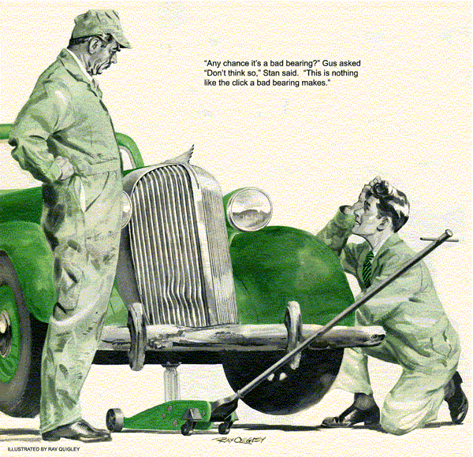
Pulling into the Model Garage after an errand downtown, Gus Wilson grinned with recognition when he saw a battered '35 sedan on the shop floor. "Gabriella, the car that thinks for herself," he mused. He well remembered the day a year ago when the car, through a temporary and still unexplained refusal to start, had kept him from jerking loose the air hose that Greg Jones had draped around the rear bumper.
As Gus got out, the curious figure of Dr. Jason Evants stepped from behind the hard-used vehicle.
Gus shook hands heartily with the town's most eccentric citizen. "Glad to see you again, Professor. How's the Philosophy of Universal Sentiency coming along?"
Dr. Evants gestured with a skinny hand.
"I have progressed beyond that," he said gravely. "Presently I am engaged in a study of the Phenomenon of the Sequence of Three in human affairs."
Stan Hicks, who had just come up, looked startled. "Gee, Professor," he asked in an awestruck tone, "what's this?"
Dr. Evants' keen eyes glittered. "It is an all-important natural phenomenon which you undoubtedly have experienced, young man, but have failed to evaluate. Haven't you ever read an unfamiliar word or heard an unfamiliar name, and then had that new word or name brought forcibly to your attention twice more within a very brief period of time? Everything!"
Stan's eyes goggled, "Gee, Professor! That's right! Why, the other night I met a babe named -"
Dr. Evants' decisive gesture cut him short.
"Obviously, young man," he said, "you have experienced one of the less complex of the manifold manifestations of the Sequence of Three. Ponder on it, and learn to turn it to your advantage."
"I'll do that, Professor - I certainly will!" Stan said earnestly. "This babe - "
"That carburetor job is promised for ten o'clock, Stan," Gus reminded him diplomatically. "Now, about Gabriella, Professor - has she been warning you again by refusing to start?"
Dr. Evants shook his shaggy head. "No.
But she may be attempting to warn me against driving slowly - "
"You mean against driving fast, don't you?" Gus interrupted.
"I invariably mean precisely what I say!" Evants snapped tartly. "I repeat that Gabriella may be trying to warn me against driving slowly by emitting an as yet unidentified rattling sound which ceases when she attains a speed of exactly 18 miles per hour. On the other hand, the rattle may be merely the result of some obscure mechanical maladjustment or imbalance. I am confident your expert investigation will determine which is the fact."
"Okay, Professor," Gus said, smothering a grin. "I'll be glad to look the old gal over, but I can't do it right now."
"At your convenience, Mr. Wilson. I shall return at five," Dr. Evants replied.
"Boss," Stan remarked early that afternoon, "I promised Wiggins I'd deliver that battery to his shop soon as it was charged. Maybe I better do it now."
"Maybe so," Gus agreed. "Wait a minute, though. No need of getting the wrecker out. I want to test the Professor's bus. I'll take you and the battery up to Wiggins' place."
They got into Gabriella, and Gus drove out of the shop. The rattle started as soon as the wheels begin to turn and continued while they worked slowly through the sticky traffic. When they got out on the highway and Gus speeded up, the noise suddenly stopped.
Stan was watching the speedometer. "Just like the old guy said," he commented. "It quit when she hit 18. Why, boss?"
"That's for you to find out," Gus said.
"That'll be easy," Stan predicted cock-surely. "Something to do with th' wheels."
When they got back to the Model Garage Stan pried off Gabriella's hub caps one after another. As he removed the fourth one, a wheel nut clattered to the floor.
Was it a Carelesss Mechanic?
"Somebody besides the professor must have been absent-minded, "Stan mused." Sure didn't tighten that nut - or it wouldn't have worked loose and rattled around inside the hub cap. "After tightening it securely on the stud, he reported his success.
"Good for you," Gus applauded. "But what made the rattle disappear?"
Stan looked blank. "I forgot about that," he confessed. "I'll take another look."
"You needn't," Gus said. "Ever hear of centrifugal force? That's the answer. When the car got up to 18, the wheels were turning fast enough so centrifugal force held the nut at the edge of the cap."
Stan thought it over. "I get it," he said at last. Then, after more thought: "Say, boss - do you think we'll get two more wheel jobs today, like the old guy said?"
"Well," said Gus. "the Professor's smart, but that Phenomenon of the Sequence of Three sounds like so much hooey to me. But whatever comes in, you'll have to take care of it. I'm going to pull this transmission."
He still was busy some time later when Jim Jelliff drove his business coupe into the shop - but not too busy to cock an ear and hear Jim tell Stan there was a mysterious rattle that seemed to come from one of the wheels. Stan sidled over to Gus, a delighted look on his face. "Another wheel job!" he whispered.
Sold on Dr. Evants' theory of the Sequence of Three, and confidently expecting to find another loose wheel nut, Stan removed each hub cap and checked every nut individually.
But all were tight. A half hour of trouble-shooting got him nowhere. Finally, he walked over to Gus. "I'm stumped, boss," he said.
Leaving his transmission job, Gus took a look at all the wheels. Then he drove the car around the block. He was grinning when he returned. "You've found the trouble," he told Stan. "Take the bus for a ride, kid."
The Second Case is Solved
From the corner of his eye Gus watched Stan replace the hub caps and drive out. Ten minutes later the young mechanic was back, looking dejected. "The rattle's as bad as ever," he said.
"Use your head, "Gus told him. "I tested the car without the hub caps. You put them on before you took it out."
"Why, sure!" Stan said, brightening. "One of the hub caps must be loose."
Quickly prying off all except one of the caps, he again road-tested the car. No rattle. The same with two caps. But as soon as he started out the door after installing the third cap, the rattle popped up again. Looking closely, Stan could see the retaining clips closely, Stan could see the retaining clips weren't doing their job. He bent them so they would hold tighter - and the rattle was gone.
As he finished his transmission job, Gus glanced at the shop clock. Half-past four. He grinned at Stan. "Looks as if the Professor's Sequence of Three is going to bog down."
"Still have an hour to quitting time," Stan said stubbornly.
A horn sounded outside. When Stan opened the shop door old Silas Barnstable, the town's leading penny pincher, drove in and hopped out of his veteran sedan. "Hey!" he yelped.
"There's a funny noise!"
"There always are funny noises in your car," Gus kidded him. "What's this one?"
"It's a mean noise," Silas told him. "Thump, Bump. Not loud - a dull, sneaky sort of noise.
Irregular like. Only hear it when I'm drivin' slow - under 20. Funny part of it is I don't never hear it except when I'm on a dead-smooth road. If I cut the motor and coast, I can hear it real well. Sounds like it's somewhere in the wheels."
Stan jumped. Gus laughed. "Stan's specializing in wheels today," he chuckled.
Still going on Dr. Evants' theory of the Sequency of Three Stan pried the hub caps off Barnstable's car and drove it up the street.
But, to his disappointment, the noise was still there - a faint, elusive thump that seemed to come from one of the front wheels. He drove back to the shop.
"Well," said Gus, "so long as you've got wheels on your mind, why not jack up those front ones and see if you can find anything?"
Stan followed instructions. After considerable wheel spinning, he came up with the information that the noise was coming from the left front wheel.
"Any chance it's a bad bearing?" Gus asked.
"Don't think so, "Stan said. "This noise is a dull thump - nothing like the click a bad bearing makes."
Just then a customer tooted at the gas pump and Stan hurried out. Gus stood looking at the wheel for a moment, thinking.
Then he grabbed a lug wrench and quickly pulled off the wheel. Keeping pace with it, he rolled the wheel the length of the shop, like a boy rolling a hoop, leaning over to listen closely as he did so. When Stan returned, Gus was standing at his workbench writing out a time slip.
"What'll I do next, boss?" Stan asked.
Gus didn't look up. "Take off the tire and bring me the tube," he said.
Stan shrugged his shoulders, but was back with the tube in a couple of minutes. Gus shook the tube - an amply patched one - and grinned when he heard a slight noise in it.
"There's a stone in it," he said. "That's what's making the noise."
How Did It Get Inside?
Deflating the tube completely, Stan could easily feel the stone. "But how could a stone - "
"Hey, Silas," Gus interrupted. "How long since you had a blowout?"
"Last week," Silas said. "Out in the country on a gravel road, it was."
"Who patched the tube?" Gus demanded.
"Feller in th' Four Corners garage," Silas told him. "Do a job cheaper than you fellers in town."
Gus let him feel the stone in the tube.
"That's the cause of your noise," he said. "The stone must have been driven in through the hole in your tire casing, and the fellow who patched your tire sealed it in... Better have a new tube. This one isn't worth another patch."
"Well, I dunno," Silas said. "Tubes are right high these days. Guess you'd better fix this one. Th' two patches have held all right, so why shouldn't another one? I've noticed things go by threes."
Dr. Evants had come quietly into the shop.
“Sir," he said to Silas, "you have discovered through experience one of the deepest of nature's secrets. Should you desire to pursue your investigation of it on the philosophical level. I am at your service. My forthcoming book - "
"Your car's ready, Professor," Gus interrupted. "That noise came from a slight mechanical misadjustment. Gabriella wasn't trying to warn you."
When Doctor Evants and Silas had finally driven their separate ways, Stan turned to his employer. "Now boss," he asked seriously, "do you believe in the old guy's dope about threes?"
Gus laughed. "You bet I do!" he said.
"Matter of fact there's one part of it I've always believed in. So far today, I've had two meals. And now, if you'll close up the shop, I'm going straight down to the Park House - and have the third one. I always eat by threes!"
END

