April 1950

GUS REMEMBERS

THE HOMELESS WASP
by Martin Bunn
When a husband wants to save fenders,
he's apt to put the car in the garage for his wife.
Gus proves that this has its perils, too.
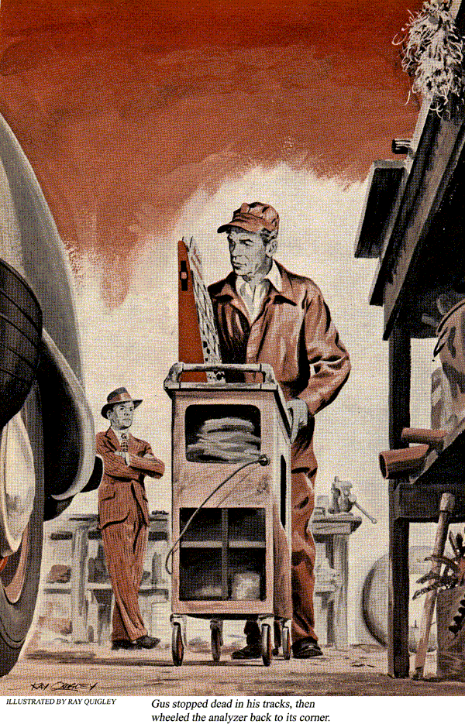
On Joe's day off, Gus Wilson generally helps man the Model Garage's gas pumps. Although Gus always gripes jokingly that it cuts into his master-minding at the repair bench, he really likes the chance to gossip with such old customers as have nothing wrong but a thirsty tank.
It was mid-morning on one such day when a honking horn brought Gus to the shop doorway. A glistening new 1950 sedan was parked beside the first pump. Gus didn't recognize the car, but he did recognize the driver. It was Paul Tarlin, who had shucked his O.D. uniform for the quiet gray worsted of a rising young assistant cashier at the bank.
"Hi, Paul," Gus greeted him. "Where'd you get that fancy jalopy?"
"Gus you're the first man in town to gaze on the Tarlin's first brand-new car," Paul boasted proudly as he slid out of the driver's seat. "Just picked it up at the dealer's - a beauty, what?"

New Filly a Dilly
As the two men walked around the shiny gray sedan, they looked for all the world, like a couple of horse fanciers judging a prize mare. The illusion was completed when Paul lovingly patted the car's gleaming flank.
"So you finally broke down and parted with that paint-less '39 convertible," Gus said as he reached for the gas nozzle.
"Had to," replied Paul, "if only to keep peace in the family. Agatha got so she practically wouldn't ride in the old bus. And when she drove it herself something always happened. Besides," he added with a smile, "Agatha's mother is coming over from England for a visit and I'm afraid the old heap wouldn't have given her a good impression of modern industrial America."
As Paul talked, Gus noted that the dealer in the city certainly had done a "Grade A" job of selling Paul the works. The car had everything: fog lights backing lights, heater, radio, exhaust pipe deflector, seat covers bumper guards. Gus figured it probably had cost Paul at least $200 more than the naked price.
"She rides and drives like a dream, Gus," Paul continued enthusiastically. "Lots of power, and I never realized before how smooth bumpy roads can be. There's just one thing that's worrying me. Is she or isn't she going to fit in that old-size garage we've got? I measured the other day, and I figure I should just about be able to squeeze her in."
"Well, you can always leave the doors open," Gus said. "How much gas, Paul? Shall I christen her with a full tank?"
Paul nodded. "And while you're at it. Gus, I wish you'd check the oil, water, and the battery, just in case those guys down in the city slipped up on something."
When Gus had completed his rounds and slapped down the hood, Paul climbed back into the driver's seat. "Well, off to Agatha," he said as he pressed the starter. "You know, this is all a surprise for her. She hasn't the foggiest! When I left this morning in the old car her parting shot was, 'Well, I hope you'll at least have that car washed and polished before Mother arrives."

Petrol in the Tank
As Paul swung his new pride and joy onto the road, Gus watched him go. Perhaps the fact that Paul also was an ardent fisherman had something to do with it, but Gus liked him. He liked Agatha, too, in spite of her unfamiliar way of speaking. Paul had brought back a wife, complete with accent, from Britain. They had settled in a remodeled farm cottage about eight miles from town and since had become a popular couple. Paul was doing a fine job at the town bank, and Agatha had adjusted herself to American ways, even if she did slip up now and then with "petrol" or "spanner" or "wind-screen."
Gus didn't see Paul, Agatha, or the new car again until the following Friday. Then it was a worried-looking Paul, a bristling Agatha, and an ailing automobile. It was about 8:30 in the morning when the Tarlin's new sedan sputtered to a stop in front of the Model Garage.

Talk About Trouble
As Gus approached both Tarlins started talking at once, with Agatha getting the best of it. All Gus could filter out of the babble was that something was wrong with their car - he'd already guessed that - and that this was the day they were to meet Agatha's mother in the city.
"Whoa," shouted Gus. "Let's take one thing at a time."
"But that's just it, Mr. Wilson," cut in Agatha, "we haven't got the time. Mother is due on the noon train and it takes fully an hour to get to the city. You've simply got to do something about it in a hurry, Mr. Wilson, really."
Gus long ago had got used to people demanding repair miracles in a matter of minutes, so he paid only smiling attention to Agatha's last comment. Instead he turned to Paul. "Well, what's the trouble, Paul?" he asked.
"It's all rather odd, Gus. We got into the car this morning so Agatha could drive me over to the bank so I could do a little work before we left for the city. First off, Agatha had trouble getting the engine started. Then, when we'd driven about a quarter of a mile toward town, the engine began to miss badly and Agatha complained that it had no power. To make sure, I slid over into the driver's seat."

Agatha Gets the Brush
At this point, Gus, who had been watching Agatha's strained efforts to keep from butting in, made a suggestion. "Mrs. Tarlin," he said, "you've probably got all sorts of last-minute chores to do at home to get ready for your mother's visit. How about your driving on home in my car?"
As he spoke, Gus literally pushed Agatha toward where his car was parked. Agatha had no time to protest.
"Now, then, Paul," Gus said, "let's you and me take your Gray Beauty for a short spin while you tell me the rest of it."

She runs a temperature
Gus too had difficulty getting the engine started but eventually it ticked over and he swung the new sedan onto the highway. As he stepped on the accelerator, however, the engine spat and coughed.
"Well," Paul continued, "it was just like this. The engine missed and wouldn't take the gas and had no power. Then I happened to glance down at the temperature gauge. It was almost up to 200."
"Did you check the radiator?" Gus queried.
"That's the very next thing I did. But the water level was up and the water seemed to be circulating."
Coaxing Is Needed
By this time they were back at the Model Garage. Gus drove or rather coaxed the car into the shop. Leaving the engine running, he got out, opened the hood, and unscrewed the radiator cap. Evidently satisfied with what he saw, he shut off the ignition and checked the wires leading to the spark plugs.
"Could be the timing," he muttered as he walked toward the far corner of the shop and started to wheel his ignition analyzer toward the car from the rear. About halfway to the car he stopped dead in his tracks, stood there motionless for a moment and then wheeled the analyzer back.
"Let's get this car up on the greasing rack," Gus said. As the car reached its top position Gus walked under and began probing around the right side of the rear axle with his extension light.
"How do you park this car in your garage, Paul?" he called out, without taking his eyes off the underside of the car.
"What do you mean, how do I park the car in my garage?"
"I mean do you drive it in head first, or do you back it in?"
Agatha's Reverse English
"Oh, I back it in," Paul replied. "Backup a car in tight spots isn't one of Agatha's best accomplishments. So to make it easier for her, I always do it. Then there's less chance of her picking up wrinkled fenders. All she has to do is drive straight out and she's in the clear. But what's that got to do with it?"
Gus had a wry smile on his face as he ducked from under the greasing rack. "Paul, about all that's ailing your car is a tight garage."
"A tight garage?" Paul repeated.
"Yup," Plus one of the fancy gimmicks the dealer sold you. I'll bet you a dry fly against a bare hook that when you put the car away at night you have to back it in until the rear bumper hits the rear wall of the garage. Right?"
"Right," Paul agreed. "I have to get the car all the way back. Otherwise, I can't close the garage doors."
Lip Is the Villain
"And right there is your trouble," said Gus, pointing to the end of the exhaust pipe. "See how the lip of that pretty chrome exhaust deflector is bent down? Originally, it extended beyond your bumper. Well, each time you've backed into your garage you've bent it a little more when you hit the back well. That helped to close off the end of your tailpipe.
"But that's not all. Each time you bumped the rear wall, the force of the bump was transmitted through the deflector and along your exhaust pipe until the pipe began to buckle at its weakest point - the point where it loops up to clear your rear axle. Evidently, the bump you gave it last night was just hard enough to finish the job and start the trouble. Come here, I'll show you."
Gus led Paul under the car and pointed up at the exhaust pipe.
With an Assist from a Kink
"Why, that pipe's practically kinked closed," Paul exclaimed.
"That's right," said Gus. "And because it's almost kinked closed, it's been acting as a stopper to build up enough back pressure to cut down your engine's power, making it miss and buck when you gave it the gas."
"I guess I'm a little dumb on the mechanical sides," put in Paul, "but why?
"Ever try to blow your nose when you're pinching it closed? Ever try to push down on the handle of a tire pump when you're holding a finger over the end of the connecting tube?" Gus asked. Then, without waiting for an answer he went on. "Well, it's the same way with an engine that tries to compete with some obstruction in the exhaust line that keeps the engine gases from escaping. The back pressure builds up a cushion against the motion of the pistons.
What's more, the proper air and gasoline mixture isn't drawn into the cylinders. The two combine to make the engine miss and lose power."
"But what caused the overheating?"
"The same thing - back pressure," Gus continued. "Since the hot gases weren't being exhausted as fast as they should be, they produced more engine heat than the cooling system was designed to carry away."
"Well, what do I do now?" Gus replied, "I'll take the kink out of that tailpipe so you can pick up Agatha and meet your English mother-in-law. When you have time, better get the dealer to install a new one. If you still want one of those fancy gadgets on the end of your exhaust pipe, fasten a four by four to the floor of that right-fitting garage of yours to act as a block for the hind wheels. That'll stop you from smacking the deflector against the wall when you back in. Or, you could teach Agatha to back out."
Off to Meet Mater
It didn't take Gus long to open out the tailpipe again, so it wasn't much past 9:45 when Paul pulled out of the shop and headed for home. He and Agatha still had plenty of time to meet the 12 o'clock train.
"What was the tip-off, Gus?" Stan asked. "I'll tell you a secret, Stan," Gus confessed. "That car had me more than a little worried until I just happened to spot that bent-over deflector."
Case of the Homeless Wasp
"Cases like that aren't too common," Gus added as he began to thumb tobacco into his pipe. "Happens once in a while when a rear-end bump bends an exhaust, or when a country driver backs into a dirt bank along side a road and plugs his exhaust with a slug of clay. About the strangest case of back pressure I've ever run into was old Jim Hadden's car. He'd put it up for a year during the war, and when he finally took it off the blocks it had all the symptoms of Paul's car, only worse. I stopped by his place one day and he asked me to look at it. It was parked in the barn. That time it was a wasp that led me to the trouble."
"A wasp?" Stan repeated.
"That's right. I saw a wasp buzzing around the end of the exhaust pipe. When we poked in the tailpipe, there, just a few inches from the end, was a wasp's nest that all but closed up the opening. While Jim had had the car up on blocks, a family of mud wasps had built their nest inside the pipe. The little critter I saw evidently was out visiting when Jim tried to start the car and was going back home."
END

