June 1949

GUS PULLS A PLANE OUT OF A HOLE
by Martin Bunn

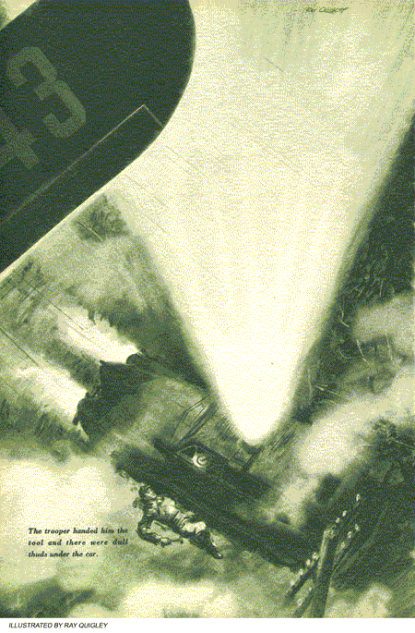
FOR the third time that morning, Gus poked his head into the office and scowled at Joe Clark's empty chair.
"I ain't heard nothing yet, Mr. Wilson," Greg Jones told him. Greg, the grease monkey, had been delegated by Gus to answer the phone while the other partner of the Model Garage was away. Reading the sport page of the morning paper, Greg was enjoying his new, but temporary duty .
"Well, let me know the minute you hear anything," Gus said. He glanced at the clock and walked back to the shop, muttering. Coming up that afternoon was a bit of business Gus didn't like-paper work involving renewal of the garage lease. Gus had little patience with any kind of paper work. Joe handled all that for the garage.
"Why the dickens did he have to pick yesterday to visit his sister?" Gus mumbled,
"What'd you say, boss?" Stan Hicks asked.
"Just wondering what's keeping Joe," Gus said. "It's not more than a few hours' drive from his sister's place, If he left there early this morning, as he said he would, he'd be here by now." "Maybe the weather gummed him up," Stan suggested.
The day had begun fair enough, but a low-lying bank of clouds had rolled in, bringing with it a steady drizzle. "Even so," Gus insisted, "he ought to be here by now unless something's gone wrong,"
Greg came out of the office at a run. "Mr. Wilson!"
"That must be him now," Gus said, starting for the office.
"It's Mr. Corcoran, the state cop," Greg spluttered excitedly. "He wants you. He says it's an emergency and you gotta talk to him." Trooper Jerry Corcoran's voice crackled over the wire. Greg could dimly hear the squawking noises from the phone, but he couldn't make out what was said. "Yes," Gus said, "we could but it would take too long." More crackling noises came from the phone. Greg strained his ears to hear.
"Of course I understand he's in a spot," Gus snapped. "Hold on now. Let me dope this out." Gus scowled at the far wall for a moment. The phone was silent. "I think I've got it," he went on. "Come over here as fast as you can. By the time you get here, we'll have an emergency rig ready to install. I've got everything I need-no I haven't either. Stop at a radio shop and pick up a dozen small alligator clips..."
Plane on a Spot
The phone squawked again. "What?" Gus yelled. More squawking. " Alligator clips-alligator," Gus repeated. "A-l-l-i-g-a-t-o-r," he spelled. Another crackle from the phone, "That's right," Gus said, "and step on it." He dropped the phone in the cradle and hurried back into the shop.
Stan knew there was something unusual in the wind the minute he saw Gus. "What's cooking?" he asked. "There's a plane lost in that muck up top, and probably low on gas," Gus explained. "Jerry Corcoran was going to try to guide him into the airport with his spotlight, but the light's control linkage won't swing the beam up far enough. We've got to have an emergency lamp ready to put on his car when he gets here." "Holy cow. How're we going to do that?"
"Get me three sealed headlight units, out of the stockroom," Gus said. "Bring them in their cartons. And get some heavy cord, too." While Stan hurried to the stockroom, Gus cut several eight-foot lengths off a reel of insulated wire and stripped the ends. Then he pulled a board about five feet long from under his workbench. Stan returned with the headlight units and cord.
"Get me that stapler off Joe's desk," Gus told him. Stan left at a run while Gus tore the covers off the stiff cardboard cartons that held the lamp units. He was waiting for the stapler when Stan returned. Gus swiftly stapled the cartons together and then tacked them to the board. "Here he comes," Stan said.
Light Up the Overcast
A siren shrieked and then died away to a moan as the police car shot past the gas pumps and into the garage. "Make it fast," Corcoran called as he stepped out of the car. "That guy up there could run out of gas."
"Gimme those clips and keep out of our way," Gus told him. The trooper handed over the alligator clips, and Gus quickly went to work. He attached clips to both ends of each length of wire. Then he clipped the leads to the prongs of the lamp units so both filaments would be energized. Next he ran a ground to the car's frame. "That'll make each lamp equal in power to two headlights," he told Stan. He replaced the last unit, lens up, in its corrugated-card- board nest in its carton on the board. "Here, give me a hand."
Stan helped him place the board across the car's top and lash it in place with cord passed through the rear windows. While Stan finished tying down the board, Gus clipped the free ends of the leads to the wire running to the cigarette-lighter connection behind the dash.
"Those lights will cause a heavy overload, especially with the radio going," Gus explained to Corcoran. "We can't risk blowing a fuse and this way their draw won't run through the fuse...let's check."
A vivid splash of light glared on the garage ceiling
"Okay, Jerry, get going," Gus said. "You better come along," Corcoran said. "Something might go haywire with that rig."
Headlights gleamed mistily through the drizzle as the trooper swung the car out of the drive and into the highway. The ceiling was even lower. Ragged streamers of scudding clouds hid the hilltops from time to time.
"The guy who's lost is in a light plane over Daggettsville, eight miles from here," Corcoran shouted to Gus above the siren's scream. "They phoned in to say he's circling low over the crossroads."
"Step on it," Gus told him.
Corcoran stepped on it. He drove hard but expertly, and they covered the eight miles in nine minutes.
Daggettsville is a general store and a dozen or so houses at a crossroad. Most of its population was in front of the store, staring up at the gray sky. Gus and Corcoran jumped out of the car. Somewhere overhead was the plane. They could hear the sound of its engine. Gus connected the emergency lamps and a shaft of light stabbed skyward.
"Here he comes again," someone shouted. The plane, so low it just seemed to clear the house tops, skimmed over the crossroads and through the beam of light. The pilot waggled his wings and the plane disappeared into the overcast.
"He saw us all right," Corcoran said. They climbed back into the car and the trooper drove south several hundred yards. "I hope he understands he's to follow the light. It's only ten miles to the airport by this road. What's the slowest one of those things can fly, Gus?"
"I guess he can throttle back to about 50 or 55," Gus answered.
"He's apt to get ahead of us then," Corcoran said. "We can't count on averaging 50 in this weather, especially when we run into heavier traffic down the road."
"If you can do 45, it'll be all right," Gus told him. "He can stay behind us by flying S-turns...here he comes again."
Waggling its wings, the plane once more flew through the light beam.
"He's going to follow us," the trooper said. He put the patrol car in gear and started along the highway. Luckily traffic was thin. They hit 60 most of the time with the plane hanging close to the light beam.
Trouble with a Rock
"I think he'll make it," Gus said. "If he's got enough gas." "There's a short cut along here that'll save a couple of miles," Corcoran said. "I'm going to take it." A moment later he swerved off the highway and into a farm lane. After a few hundred yards, the lane degenerated into a pair of rock-strewn, water-filled ruts. Corcoran slowed the car only a little. They dipped into a brook, scattering gravel and plowing through it in a shower of water. "Another hundred yards and we'll be back .on the highway," the trooper said. Then they approached the main road. A steep grade led up to it. Corcoran put the car in low. Wheels spinning on the loose, rocky surface, the patrol car pulled out on the highway.
"Step on it," Gus urged. "I can't," the trooper yelled. "Something's wrong with the gearshift lever. I can't get it out of low." They crawled along at 20 miles an hour, the plane circling around the light beam. "I shouldn't have taken that short cut."
Gus had been doing some hard thinking. "Stop the car," he told Corcoran. "If it's what I think it is, I might fix it in a hurry." Corcoran jammed on the brakes and Gus dove under the car with a flashlight. Then he yelled for a hammer. The trooper pulled it from the toolbox and handed it to him. There were several dull thuds under the car. Then Gus pulled himself out, shaking water from his coveralls. Overhead the plane still circled the vertical beam.
"It's okay now," he said. "There was a stone jammed between the shift levers running back from the steering column."
Corcoran pushed the car along at almost 50 and in a couple of minutes the plane shot ahead of them.
End Of the Race
"He sees the airfield lights," Corcoran said. "Good thing you were along, Gus. Let's go see who the guy is." They drove into the field in time to meet the pilot as he walked toward the administration building. He was a gangling youngster. When he saw the improvised lights on the patrol car, he stared for a moment and then broke into a broad grin.
"I never thought I'd want to kiss a cop," he grinned, shaking Corcoran's hand hard. The trooper laughed. "What are you flying around in this weather for?" he asked.
"I live over in Middleburg;" the pilot explained. "I only got my private ticket last month, and when my uncle dropped in to see us, I took him up for a ride. He'd never been in a plane before."
"He sure has now," Gus put in.
The pilot laughed. "The ceiling was high at Middleburg and I guess I flew farther than I intended. Then before I knew it, the ceiling dropped in on me and it began to rain. I was just plain lost. I guess I should have put it down in the first pasture I saw instead of looking around for an airport."
"That probably would have been your best bet," Corcoran said.
"I'll learn...I hope," the pilot grinned. " Anyway," he went on, "I finally found that little town where you picked me up. I was circling it, trying to get a bearing...here comes my uncle. He's really wrung out."
Wrung out was a perfect description of Joe Clark as he came slowly toward them. When Gus saw his partner, his jaw dropped and then he laughed.
"Well," Gus said, "you finally made it...after I went out and dragged you half way in. If I'd known you were in that plane, I'd have sweated a lot more." "Why, that's darn nice of you, Gus. After all, we've been together twenty years...I mean, it's good of you to worry about me," Joe floundered.
"You, nuts!" howled Gus. "It was me I'd have worried about. I sure wouldn't have wanted to sweat over that new lease by myself!"
END

