August 1949

GUS CLEARS AN F.B.I. SUSPECT
by Martin Bunn

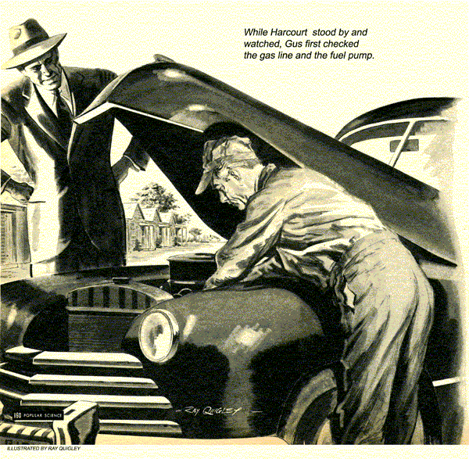
Gus Wilson slipped the socket wrench into a pocket of his coveralls, wiped his hands on a wad of waste, and took the identification card the young man offered him.
"F.B.I." Gus said.
"That's right," the man answered, pocketing the card.
"Okay, Mr. Harcourt," Gus said. "What can I do for you?"
"I'd appreciate your help in a matter I'm looking into. Know the Acme plant?"
Gus nodded.
"Know what they're doing there?"
"Heard it was something hush-hush."
"That's putting it mildly," Harcourt grinned. "Anyway, here's my problem. A little after midnight last night someone tried to break into the department of the plant where top-secret work is done. If he'd succeeded.. well, it wouldn't have been so good."
"But where do I come in?" Gus asked.
"I'm getting to that," Harcourt went on.
"There was a slip-up last night when the late shift of plant guards came on duty at midnight. Man named Joseph Swinton, a retired cop, was late. By the time he got there in a taxi - at 12:30 - the excitement was over. The break had failed and whoever tried it had made a getaway."
"I still don't see where I fit in," Gus said.
"Swinton lives in a tourist court near here," the agent said. "His story is that he couldn't start his car and had to call a taxi to take him to the plant. I'd like you to check over his car and see what's wrong."
"I'll take a look," Gus said.
"The whole problem hinges on that car," Harcourt explained. "Did the person who tried to break in know that Swinton wouldn't be on the job? If so, how did he know? And, most important, was it true that Swinton couldn't get his car started?"
"Maybe I can tell you and maybe I can't," Gus said. "Lots of things could have been done to that car between midnight and now."
"I think we've got that pretty well covered." Harcourt remarked quietly. "I got to the plant just about the time Swinton did. The first thing I did was send a man to the auto court to keep an eye on the car. No one's touched it since then."
"That'll help," Gus said.
"Got time to take a ride out there and look at it?"
Gus glanced at the clock. "Let's go," he said.

The Wrong Cottage
As Harcourt and Gus drove up to the Hilltop Tourist Court, a maid was walking across the crescent of lawn in front of the office, Harcourt asked for the Swinton cottage.
"That one." She pointed vaguely.
Harcourt stopped at the first cabin that had a car parked near by. They got out and stepped up on the tiny porch. Harcourt rapped on the screen door. The wooden door was open. While they waited, they stood looking into the room. A wrinkled suit and shirt lay where they had been tossed into an open suitcase. On a bureau top were the contents of a man's pockets; a wallet, notebook, about a dollar in change, pocketknife, pliers, and a handkerchief.
"Sounds like he's taking a shower," Harcourt said.
Just then a man called from the porch of the next cottage. "Over here, Mr. Harcourt."
The G-man laughed. "That's Smith, my assistant. He must think he's working with a hot-shot cop. Can't even find the right house."
"And in broad daylight, too," Gus laughed, as they walked across the lawn.
Inside the second cottage they found a heavy-set, elderly man slouched on the edge of the bed. Smith held the door open for them. As they entered, the man got up.
"This is rough on me, Mr. Harcourt," he said. "I've got a good record and I don't want any bad marks on it now."
"Routine investigation, "Harcourt told him.
"Got to go through with it. You know that, Swinton.. This is Mr. Wilson. He's an auto expert. Mind if he looks over your car?"
"It's all right with me," Swinton answered.
Smith handed the car keys to Gus. As Harcourt and Gus walked outside, the agent told Swinton and Smith to wait.
The car was a postwar coupe. Gus slid behind the wheel. When he pressed the button, the starter motor turned over but the engine didn't fire. After several tries, Gus cut the switch, first noting that the ammeter registered when the ignition was on. While Harcourt stood by and watched. Gus raised the hood and looked over the engine. It was spotlessly clean and evidently well cared for.
"Got any ideas?" Harcourt asked.
"Not yet," Gus told him. "Could be any one of several things."
At the carburetor end, Gus disconnected the gas line leading from the pump. He pushed the manual button on the starter solenoid and a little gas squirted out as the engine kicked over.
"Getting gas to the carburetor," he commented as he reconnected the line.
Next Gus turned to the ignition system. With the switch on and the solenoid button pressed, he used a screwdriver to check for a spark at a plug. There wasn't any, Gus flipped down the distributor cap springs and removed the distributor cap.

Where's the Spring?
"There's the trouble," he pointed. "The rotor spring's broken off. The distributor just isn't getting any high-voltage juice to distribute." He pulled off the rotor and showed it to the G-man. The little blue steel spring leaf designed to make contact with the central cap lead was snapped off short.
"That happen by itself?" Harcourt asked.
"Every now and then," Gus answered, "It sometimes happens that a spring will just snap. But it's not very likely, especially on a fairly new car."
"Could someone have done it deliberately?" the G-man asked.
"Sure," Gus said. "Say, wait a minute. Someone must have broken it."
"What do you mean?" Harcourt asked.
"Take a good look at the broken end. See how it curls up a bit just at the break? That shows it was bent upward until it snapped."
"We figured something like this might have happened," Harcourt remarked quietly.
"Maybe we can check on it further. Just a minute." Gus bent close over the open distributor and fingered the points cautiously. Then he straightened up, nodding his head.
"If it just broke, the broken leaf would have to be in the distributor. That little piece of spring isn't here."
Harcourt frowned. "So Swinton could have disabled his car to have a good excuse not to show up at the plant on time. Let's go see him."
Harcourt let the way back to the room.
Swinton was sitting on the bed looking worried. Smith was reading a crime comic book.
"Do any work on your car yesterday?" Harcourt asked.
"Work?" Swinton repeated. "Same as I do every day - shined it up a little. I like to keep a car looking good."
"Mechanical work, I mean," the G-man said.
Swinton shook his head. "Haven't had the hood up in a week until she wouldn't start last night."
"Keep your car locked?"
"No, I don't," Swinton replied. "I'm always around when the car is."
"What did you do last evening?" Harcourt asked.

Found: One Broken Spring
"Read the paper and listened to the radio until about nine-thirty. Then I played three games of pinochle with Jackson. He owns this court."
"Did you play here?"
"No, we played in his room back of the office."
"Check that," Harcourt told Smith.
Smith hurried out and Harcourt led Gus out of the cottage.
"You're sure it couldn't have been an accident?" he asked Gus in a lowered voice.
"That's right," Gus said. "If that spring had snapped of its own accord, the broken part would still have been in the distributor."
Harcourt rubbed his chin and looked thoughtful. He glanced back into the room at Swinton, who had resumed his seat on the bed.
"I guess I'm going to have to hold Swinton."
"Wait a minute," Gus said. "remember the wrong cottage?"
Harcourt nodded.
"There was a lot of stuff scattered on the bureau," Gus went on.
"I didn't pay particular attention," Harcourt said. "A wallet and some change and..
"And pliers," Gus finished. "That stuck in my mind because most people don't carry pliers around. Let's go take a look."
They hurried to the cottage to find the occupant - a broad-shouldered blond man - packing his suitcase. The articles still were on the bureau. Harcourt rapped and showed his card.
"Just a routine check. Mind identifying yourself?' he asked mildly.
The man admitted them. Then he handed his wallet to the agent. Gus idly picked up the pliers and opened them.
"Good tool you have here," he remarked. "Used it lately?"
"Yeah. I pulled out a nail some dope'd driven into the wall. Pretty near ripped my hide on it," was the answer.
Gus moved toward the door, casually holding a bit of blue steel before Harcourt's eyes.
The big man wheeled and slammed into Gus, who, ready for him, blocked a wild swing. Harcourt grabbed him from behind and expertly pinioned him against a wall.
The door nudged open behind Gus's back.
"Swinton's story checks," reported Smith, entering. "From the noise, I thought maybe business was good in here."
The big man, all fight gone, didn't resist the handcuffs.
"Looks like I was lucky when I bumbled in here and you were smart," the G-man said after Smith had hustled the prisoner away. "How did you know where to find that bit of broken spring?"
"That's where I was lucky," Gus grinned.
"It was just a long shot that paid off. When plier jaws are greasy, they may hang on to any small, light thing they've gripped. Guess I just didn't want to believe Swinton had done it. I'd hate to think a guy who keeps an engine that clean could be a crook."
END

