November 1948

GUS ADDS TWO AND TWO 2+2=?
by Martin Bunn
But it doesn't always come out four,
as a new customer proves in
the case of Silas Barnstable and the missing antifreeze.

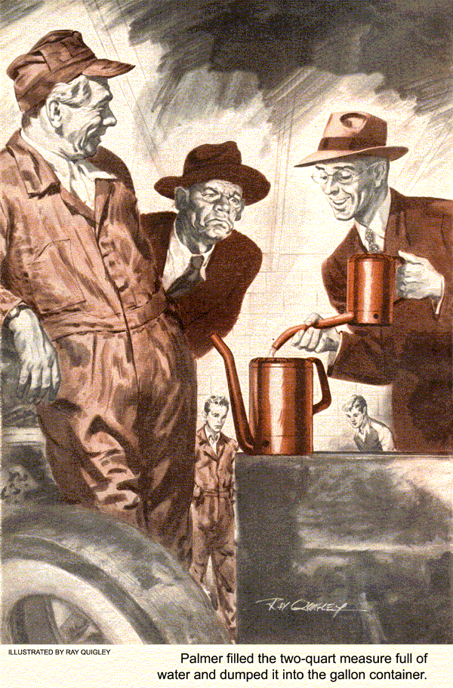
Like most young auto mechanics who are worth what they get out of their pay envelopes, Stan Hicks loves to figure out new ways of doing things. Sometimes his ideas work out swell. Sometimes they don't.
Stan noted the time on the clock in the Model Garage and had to admit that this was one that hadn't worked out. He had masterminded a new method of truing a brake drum. It had looked good, but the work had taken him twice as long as it should have. He confessed as much to Gus Wilson.
The older man smiled. "We'll charge the customer for the time the job should have taken you," Gus said, "and charge the rest of it to experience." Stan didn't say anything - just looked back toward the brake-drum lathe.
"Look here, kid," Gus went on, "I don't want to cramp your style, but you'll duck a lot of headaches if you'll remember that most shop operations have been done so many times that there's darned little chance of improving them. Two and two always add up to four. You can't get away from that fact."
"The dickens you can't," snapped a positive voice behind them. "A lot of people have gotten away from that so-called fact. Einstein has. And so have I."
Gus and Stan turned to stare at the owner of the voice. He was a tall, lean young man whose old-fashioned spectacles gave him a professional look. The stranger grinned at them - a wide and entirely likeable grin.
"Excuse my horning in," he said, "but whenever I hear someone voice a fallacy, I have to up and speak my piece. I admit it's a bad habit and it puts me in wrong with people who aren't used to me. My name's John Palmer. I'm the new high-school chemistry teacher. I'm looking for Gus Wilson." Gus laughed. "No need to look farther."
Palmer looked him over frankly. "They tell me you're a champ mechanic. I've brought my car around to you. There's something wrong with it that you can't fix."
"If you're so sure of that," Gus asked, "why bring it to me?"
"Want to show a friend of mine that he's wrong," Palmer told him. "I'll get the car."
He stopped out of the shop and moments later drove a well-kept coupe into the garage.
"Listen to that engine," he said.
Gus listened for half a minute. "Smooth as cream," was his verdict.
"Right," Palmer agreed. He took his foot off the accelerator. "Listen again."
"Idles perfectly," Gus said.
"Right again," said Palmer. "But how about this?" He pressed his foot sharply down on the gas. For a few seconds the engine galloped and ran roughly. Then it smoothed out again.
Gus nodded. "Not so good when you tramp the accelerator open from the idling position. That could be caused by ..."
"I know," Palmer interrupted. "It could be caused by clogged carburetor jets - but it isn't. The fellow who came up with that diagnosis cleaned the jets."
"May be burned-out distributor points," Gus said.
"Could be," Palmer said, "except another mechanic made that guess a week ago and put in new points."
"Improper valve-tappet adjustment - " Gus began.
"Could make an engine act like that," Palmer finished. "True, but the valve-tappet clearances have been checked and rechecked. They're okay."
"How about a bad condenser?" Gus asked.
"That also could be," Palmer answered, "but the man who swore the condenser was no good put in a new one. Didn't do a bit of good."
"Well...." Gus started to say.
"Wait a minute," said Palmer. "I'll tell you what's wrong. It's the gas we get these days. I've specialized in the chemistry of petroleum, and I tell you that today's gasoline - you know anything about chemistry?"
"Nope," Gus said, "and I don't know much about mathematics either, but I still believe two and two always make four. If you want to leave your car here a few hours, I'll find out what's wrong with it and fix it - or I won't charge a cent."
"Fair enough," Palmer grinned. "But you're wasting your time. I know it's the gasoline. Suppose I come back at four o'clock?"
"Okay," Gus agreed.
KNOW-IT-ALL kind of a guy," Joe Clark observed, coming up to Gus after Palmer had left. "I don't get that business about two and two not making four." And if anybody knows about two and two adding up to four, it's Joe. Ever since he and Gus have been partners, Joe has taken care of the front office and the bookkeeping.
"Oh, he's probably a good egg at heart, though," Gus said. "Maybe I can show him he doesn't know as much as he thinks he does - about gasoline and cars, anyway. I've got a pretty good idea what's wrong with his engine. A little checking - now look what the wind blew in."
Joe turned to see what the wind had blown in. It was old Silas Barnstable, our town's leading tightwad. Silas announced that he wanted some antifreeze.
"You better go see one of those cheap skates you do most of your business with," Gus said flatly. "Try the one who sold you that stuff that clogged your radiator last year." Gus beckoned to Stan to come along and walked back to the brake-drum lathe.
"Wasn't the antifreeze that clogged my radiator," Silas yelled after him. "And you can't blame a man for buyin' cut-rate when he gets a chance. Dollars don't grow on trees, you know."
"Okay, okay, Silas," Joe said quietly. A customer's a customer to Joe, even if he's twice as ornery as old Silas. If that's possible.
"I want a good alcohol antifreeze and I'm willin' to pay for it," Silas said, still talking loud. "If you don't stick me as if I was buyin' champagne," he added.
"We're handling a standard alcohol antifreeze," Joe told him. "Mixed with water, half and half, it'll protect your engine down to twenty below zero. I'd say your radiator'll hold...."
"Four and half gallons. I measured it," Silas said.
"That's eighteen quarts," Joe calculated.
"So you'll need nine quarts of antifreeze."
"How much a quart?" Silas demanded. Joe told him.
"That's outrageous," Silas stormed. "I ain't made out of money and that stuff ain't made of gold." Then, as Joe didn't answer: "All right. But it's profiteering."
Joe laughed. "Drive your car in and Greg'll put it in the radiator for you."
"No he won't." Silas snapped. "It ain't cold enough yet and maybe it won't be cold enough for a couple more weeks. I ain't gonna waste good money boilin' away antifreeze in weather when it ain't needed. That's why I brought this can."
"All right, all right," Joe said. "So take it home with you. When you're ready to use it, just add an equal amount of water."
"That won't do neither," Silas objected.
"I got to use mighty hard well water out where I been livin' since I moved out of that outrageous-priced Hillside apartment. That's what clogged up my radiator - the hard water, not the antifreeze. I want you to mix my antifreeze with city water."
"Okay," Joe agreed patiently. He called Greg Jones, the grease monkey. "Pour nine quarts of antifreeze into this can," Joe instructed, "and add nine quarts of water to it. Be careful now. Nine quarts of antifreeze and exactly nine quarts of water. And screw the cap on good and tight so the antifreeze won't evaporate."
"Yes, sir," Greg said," nine quarts of antifreeze and exactly nine quarts of water."
"That's right," Joe told him. "Hop to it."
Greg did, and as Silas stalked out with his can, Gus looked up from his job.
"I wonder," he mused aloud, "whether he'll be back today or tomorrow."
"What d'you mean?" queried Joe.
"I just remembered that our friend Palmer may be right--sometimes," Gus replied with a mysterious grin. "You're good at math. When does two and two not make four?"
John Palmer and four o'clock arrived at the Model Garage exactly together.
"But you didn't find anything mechanically wrong with my car," he grinned. "I think you'll wind up agreeing with me that it's the gas."
"Your engine's rough acceleration," Gus smiled, "was caused by a weak spring in the vacuum spark-advance unit. That allowed the spark to advance faster than the throttle opened. I fixed it for the time being by stretching the spring, but you'd better have a new vacuum unit put in."
Palmer's long jaw sagged. For a moment he looked deflated. Then he rapped his head with his knuckles and laughed. "Wrong again. How'd you find out what it was?"
"Added two and two," Gus answered.
"They made four just like they always do."
"There's that fallacy again." Palmer said. "I'll prove to you that two plus two doesn't always equal four. Now just suppose...."
The shop door banged open. It was Silas Barnstable, hugging his five-gallon can. His seemed face was red and his thin-lipped mouth a straight line.
"I been cheated," he blazed at Gus.
"You'll make good or I'll stand you a suit in court. That's what I'll do."
"Now what's eating you?" Gus asked quietly. Joe Clark, attracted by the uproar, stepped out of the office, pencil in hand.
"I been defrauded," Silas grated. "That boy of yours short-measured me on this antifreeze. Soon as I got home I tested it with a hydrometer to make sure he'd given me a fifty-fifty mixture. That was all right.
But then I measured it and there wasn't eighteen quarts. No, sir, it was darned near a pint short. I got a refund comin' to me and I'm gonna get it."
Joe looked reproachfully at Greg Jones. "I told you to be careful."
"I was careful, Greg protested. "I measured out nine quarts of antifreeze and nine quarts of water, and I screwed the cap on good and tight so none of it could spill out."
"I believe you, kid," Gus said.
"Then I'm a liar," Silas exploded.
"Keep your shirt on," Gus advised him. "I don't doubt that the mixture was a pint or so short when you measured it. But I don't doubt, either, that Greg measured out nine quarts of antifreeze and nine quarts of water for you."
Joe Clark fidgeted, "I'm afraid he couldn't have, Gus. Nine and nine always add up to eighteen."
"There's that fallacy again," Palmer cut in. "Nine and nine don't always add up to eighteen any more than two and two always equal four. I told you I'd prove it to you. Let me have two quarts of that antifreeze, a two-quart measure, and a gallon measure. I'll prove it right now."
"Go ahead, Greg Gus grinned. "Get him what he wants. I think Joe and Silas have got it coming to them."
Greg brought the things. Palmer filled the two-quart measure full of water and dumped it into the gallon container. Then he filled the measure with two quarts of antifreeze and slowly began to pour it into the water.
"You saw me put two quarts of water in the can," he said," and now I'm putting in two quarts of this stuff. Two and two makes four. Or does it?"
With those words he poured the last of the antifreeze into the water. The mixture was well below the one-gallon mark.
"There's your proof," Palmer went on.
"Chemists call it volume change. When you mix a cup of sugar and a cup of water, the sugar dissolves in the water and the mixture isn't two cups. It's much less. Two quarts of alcohol and two quarts of water don't add up to fully four quarts. They intermingle and there's a shrinkage of about two percent. In nine quarts of antifreeze and nine of water that's nearly twelve fluid ounces - about a cup and a half."
"Well, I'll be doggoned," Joe exclaimed. "I wouldn't," Gus said, "Because I've seen it happen before and I knew Silas and Greg both could be right. But I'm glad we have a chemist here to make it official. Silas mightn't have believed me."
"Humph," snorted Silas. "Don't know at I do yet. Where I learned figurin', two and two always make four."
Gus looked at Palmer. They both laughed.
"I guess that's pretty good arithmetic," murmured Gus, "except when it happens to be wrong."
END

