August 1948

GUS GETS BROKEN IN

BY A NEW HELPER
by Martin Bunn
When Stan Hicks graduates to a full-fledged mechanic
and a new grease monkey comes to the Model Garage,
time hangs heavy on extra hands.

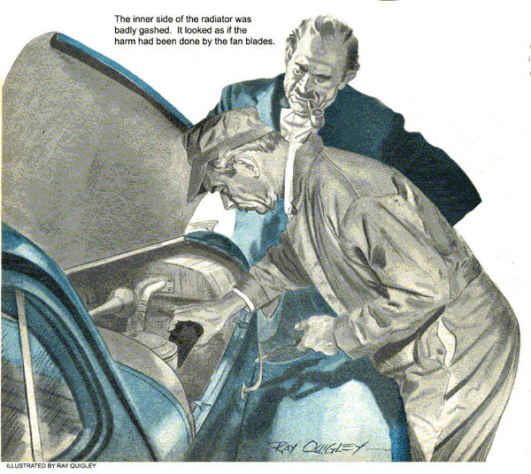
"HEY, mister-what should I do now?" Gus Wilson, flat on his back under the jacked-up rear end of George Knowles's car, looked up at Greg Jones, the Model Garage's new grease monkey. "Well," he suggested, "you might sweep out the shop."
"I've done that," Greg told him.
Gus slid out from under the car and looked around. The floor had been swept thoroughly and the waste boxes had been emptied. As far as he could see, all the routine Monday-morning jobs had been well done. He glanced at the clock. It wasn't nine yet. How was he going to keep this green kid decently busy? Gus promptly made up his mind to sidestep the job.
Stan Hicks, relieved at last of the "boy's work" that had griped him so, was importantly busy over a valve-grinding job. Gus nodded toward him. "Any time you don't know what to do next," he said, "ask him."
"I did ask Mr. Hicks, and he . . . "
"Go ahead," prompted Gus. "What did Mister Hicks say?"
"He told me to ask you."
"Buck passer!" From outside came the squawking of a horn. "Well, go out to the pump and see who's making that noise."
Greg hurried out. Joe Clark, coming from the office to collect Saturday's time and parts slips, grinned at his partner "How's the new boy doing?" he inquired.
"He's left-handed," Gus growled, "and he's got ten thumbs."
Joe laughed. "Give him a chance. The school people say he's a bright kid and a hard worker, and he did well in his mechanical aptitude test."
Greg hurried back into the shop. "Hey mister," he reported breathlessly, 'there' a lady out there wants to buy five gallons of gas. What'll I do?"
"Sell it to her."
"Yeah-but I don't know how to work the-the-the thing!"
Gus groaned. Joe laughed again. "Come along. "I'll show you how.
"Three minutes later Greg dashed back. "Hey, mister-the lady's car won't run! Mr. Clark wants you to come out."
Muttering under his breath, Gus followed him out to the pump, where the downstairs two-thirds of Joe's anatomy was protruding from a shiny coupe. A tall, thin woman stamped her foot angrily. "I'II register a complaint! A brand-new car to act like this! First my husband takes it on a business trip the day we get it. Then, the first time I get to drive it, this has to happen!"
"What seems to be the matter, ma'am?"
"I had five gallons of gasoline put in," she snapped, "and now it won't start!"
Joe ducked his head out. "Deader'n a doornail," he told Gus gloomily.
"Let me try it." Gus stepped into the car and pressed the starter button. The engine caught and purred sweetly.
'Well, I never!" shrilled the angry lady. Gus switched off the engine and got out. She flounced into the driver's seat. A minute of silence was terminated by her outraged voice: "It's just the same! It won't start!"
Joe smiled reassuringly. "Well, now, Mr. Wilson started it without the slightest difficulty, so just let me try it."
She slid over, and Joe took her place. There was another short silence. Then Joe stuck his head out of the window, "She's dead, Gus," he reported.
Gus got in and again pressed the starter button, Again the engine took off promptly. Well, I never!" .The customer thrust her jaw out. "If you can do it, there's no reason why I can't. Let me try again."
Gus got out, and she slid back behind the wheel. There was another silence. "It won't start!" she grated bitterly.
Everyone had forgotten about Greg. Now he twitched at the sleeve of Gus's coveralls and pulled him a little aside. Hey, mister," he said in a hoarse whisper, I know why you can make the motor run and they can't."
"You do, hey?" Gus said. "Why?"
"You push the thing up on top, and they stamp on the thing down on the bottom."
Gus stared at him. Then a grin spread over his face. "By gum," he said, "you've got more sense than any of the rest of us which isn't saying much." He went over to the car and asked the woman to try to start its engine. This time he held the door open. She pawed with her left foot at. the floor to the side of the clutch pedal, and then looked at him aggrievedly. "It's just the same," she said. "It's dead!"
Gus reached in to the instrument panel and pressed the starter button. At once the engine ran sweetly. "The trouble," he told her, "is that you've been trying to start your engine by stepping on your headlight dimmer switch!"
The driver's long jaw sagged. But after a dejected moment the light of battle flared up in her eyes. 'It's ridiculous!" she shrilled, "that all cars aren't arranged the same way." On my old car the starter was on the floor. Why did they have to stick it up there on the dashboard? There should be uniformity!"
She let in her clutch, and the coupe was off to a jack-rabbit start. Gus turned in time to see Joe disappearing through the office doorway. Even at that distance Gus saw that his partner's ears were a fiery red.
Greg again pulled at his sleeve. "Hey, mister," he asked, "what'll I do now?"
Gus fished a dollar bill out of his pocket. "You know that cigar store near the station?" he asked. "Well, get me a half-pound can of 'Delight' tobacco."
Greg hurried off, and Gus went back to his shop. "It'Il take him half 'an hour to walk down there and back," he thought, and I'II have a little peace for that long."
Gus was wrong about that. He hadn't got well restarted on his job when he heard the harsh scream of jammed-on brakes.
Stan Hicks hurried over to the shop door. "A guy in a sedan nearly ran up a truck's tail," he reported. "I don't think he hit it, but there's something the matter - he and the truck driver are having a row."
Gus grunted disinterestedly. Stan continued to observe the ruckus out on the street. "Say, boss,' be said after a few minutes, "that guy's back in his car, and he's drivin' it in here."
"He's all yours, Mister Hicks," Gus told him. He got a worm's-eye view of a red-faced man with a bristling black mustache hopping out of a sedan with a steaming radiator.
"Huh," Stan remarked, "so you did hit that truck. I thought you just missed it."
"I did not hit it!" roared the sedan's owner. "And no thanks to its driver. I'II have the law on his firm if they don't pay for the damage, sure as my name's Gunzenhouser! Stopping smack in front of me, and no stoplight or signal!"
"That's bad," Stan said sympathetically. "But if you didn't bump the truck, what busted the radiator?"
Gus didn't hear much of Mr. Gunzenhouser's heated and lengthy reply-he was distracted by a rustling sound near his feet, and on looking down saw Greg crawling toward him with a package in his hand. "Here's your tobacco, mister," he panted.
"Thanks, "Gus said disgustedly. "How'd you get back so quick-take a plane?"
"I thumbed a ride both ways," Greg explained. "What'll I do now, mister?"
"Go tell Mr. Clark I said for you to help him in the stockroom."
Greg crawled away, but after a few minutes Stan came over to Gus. "You'll have to help me on this one, boss," he admitted. "I can fix the guy's radiator, but I can't find out what busted it. There's not a mark on it outside."
"Oh, all right," Gus said, and went over to the sedan. He examined the inner side of its radiator, and found it badly gashed. It looked to him as if the damage had been done by the fan, but careful checking showed that there was adequate clearance between The fan blades and the radiator, that the blades were tight, and that there was no end play in the fan shaft.
Gus scratched his ear and whistled tunelessly between his teeth. After half a minute he turned to Gunzenhouser. 'You say you didn't hit that truck?" he asked,
"Didn't touch it. Take my word for it."
"I do. Well, now-ever had any trouble with your radiator hoses leaking?"
"I certainly have!" Gunzenhouser, snapped. "They've been a nuisance for the last couple of months. I tightened 'em a couple of times and that didn't do it I even took 'em off and put on gasket cement."
Gus nodded. "Does your throttle stick or fly open on turns?
What are you-a mind reader? Yes - my throttle often sticks when I make a turn at fair speed."
"One thing more," Gus said. "Have any starting trouble?"
"I've had a little," Gunzenhouser replied. "Now suppose you answer a question. What's the matter with my car?"
"Broken or worn-out engine supports," Gus told him. "When certain types of rubber engine mounts get old they soften up or separate from their metal brackets and allow the engine to settle or get out of line. The radiator hose tries to hold it upright, but of course it can't, and the strain opens leaks. On turns, the drag of the engine on the throttle linkage makes the throttle either stick or fly wide open. Hard starting is caused by the bad mounts allowing the rear of the engine to set so low that the kick throttle can't release the automatic choke when the starter is operated. Your mounts are so far gone that when you made a sudden stop, the engine shifted forward and drove the fan blades into the radiator.... New engine mounts-that's the only answer.
"You're the doctor," Gunzenhouser said. "Put 'em in, and fix the radiator. I'll be in for the car tomorrow. Okay?"
"Okay," Gus agreed. He returned to the Knowles job. "Now," he growled, "I hope I'll have a chance to do some of my work!" Then he felt a hand on his arm.
'Mr. Clark's through with me," Greg said. "What'Il I do now, mister?"
END

