February 1947

GUS SLOWS A SPEEDER
by Martin Bunn
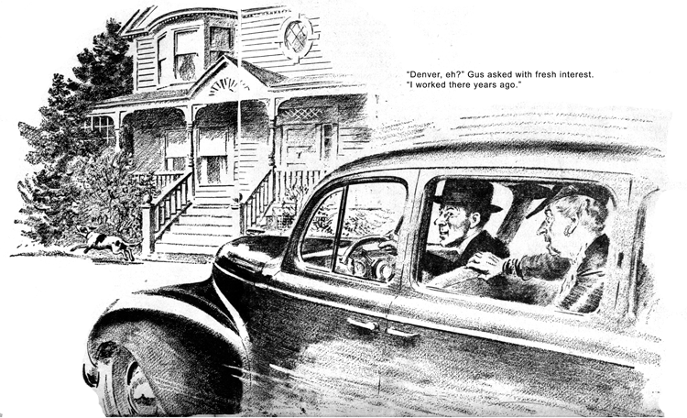
A lot of folks have lived in this town all their lives without knowing or caring that the small, vacant warehouse north of the railroad station belongs to Mrs. Pomfret, perhaps because she owns so many things she needs two lawyers to keep track of her dividends.
But Peter Evans, the new pastor who took over when Dr. Hatch retired, wasn't in town three weeks before he knew all about the building and had a plan for putting it to use. The Rev. Mr. Evans had been selected for this post while he was still an Army chaplain; in no time at all he had people applauding his scheme for establishing a young folds' community center. The whole idea hinged on whether Mrs. Pomfret could be talked into contributing the idle warehouse.
Officer Tom Maloney, a burly, usually cheerful man, had one way of looking at it. He paused outside the Model Garage one morning to greet Gus Wilson with a wan, unhappy smile.
"Why the long face, Tom?" asked Gus.
"Can it be you don't know our school basketball team got nosed out of the county championship by Remsen High? Meaning no reflection on the school, our small, overcrowded gym is no proper place for a good team to practice. It'll be a different story next year when Mr. Evans makes over a floor for the use of our teams."
"That ain't all," put in Stan Hicks, Gus's young grease monkey. "I spent a week's pay taking my girl out Saturday night. Now, that recreation hall -"
"How's it coming?" Gus inquired. "I haven't heard that anything's been settled."
Tom shook his head. "There'll be willing hands to make the repairs once Mrs. Pomfret agrees, but there's no telling with her."
"Crazy as a beetle," Stan agreed emphatically. "Remember the time she got mad when I blew a horn in front of her house 9:30 at night? Took away her repair business because you wouldn't fire me."
"I wasn't sorry to lose it," Gus declared.
"A new chauffeur every week, and every one of them begging me to make her bus less peppy. I hated to see that fine car start up like a wet sponge bouncing off a sofa pillow!"
"That's my worst worry," Tom grunted.
"It has come to my notice that Mr. Evans is addicted to speeding and fast starts."
"That could make trouble," Gus agreed.
"Has anyone spoken to him about it?"
"I have, for one. He says his car has too much pep. Had it tuned up before he left Denver a month ago."
"Denver, eh?" Gus asked with fresh interest. "I worked there years ago."
"He was stationed near there. Look!" Tom waved his club toward the corner, where three cars glided to a stop before a red signal. "That's him, now. The blue sedan on the far side."
The light clicked orange, then green, and Mr. Evans' car promptly shot forward ahead of the others.
"See?" Tom snorted. "There's no law against jack-rabbit starts, but it's just as dangerous as some things I give tickets for."
Pure chance in the form of a stalled car, made Gus a witness to the next round in the Evans-Pomfret match. At about four o'clock that afternoon, he was summoned to Regent Street, the high-toned avenue where our few wealthy families live. He had just finished putting in a new fuel pump when he caught sight of Mr. Evans' car easing slowly toward the Pomfret driveway across the street. Behind the smiling young pastor sat stout, bejeweled Widow Pomfret, talking graciously at the young man's back.
As the sedan nosed over the curbstone, a spotted dog cavorted dangerously toward the wheels, and the driver jammed on the brakes just in time to avoid hitting it. The dog hastily changed his course and bounded up the drive, while Mrs. Pomfret, thrown slightly forward, clutched the seat in panic.
Apparently the young man was able to reassure his passenger, for she craned her head to see the dog. Nervously the driver hunched over the wheel and clashed into first. From a dead stop the car shot forward like a rocket being launched. Mrs. Pomfret was flung against the cushions, her face blanched and terrified. It took a moment to recover her breath, and then it was to utter an ear-piercing shriek.
"Murderer!" she screamed. "You did it on purpose!" With surprising agility, she flounced out. "Don't bother," she shrilled, ignoring Mr. Evans' attempts at apology.
"I'm not interested in anything you have to say! And as for the warehouse, I'd sooner see it burn down than give it to you!"
Just what I feared," groaned Officer Maloney, when Gus recounted the scene to him the next morning
"I've been thinking," Gus went on, "that this is right in my department. Could I have a look at his car?"
"That you could," thundered the policeman. "I'll get it down to your shop if I have to give him a ticket."
Whether he would have done such a thing is doubtful, for Tom Maloney looked embarrassed rather than official as he escorted the Rev. Mr. Evans into the Model Garage.
"We've got an awful nerve butting in on your business," said Gus, shaking hands with big young pastor, "but if your car's been causing trouble... "
"I appreciate your interest," Mr. Evans boomed cordially, "but there's nothing wrong with my car, so it must be me."
"Too much speed isn't usually a trouble." "It is for me," the pastor replied ruefully.
"My car has pretty snappy pick-up, but I can usually keep the speed down. Sometimes, though, I get preoccupied, and the next thing I know I'm sailing along like a high wind."
Gus pondered. "It might be the car. How did it behave when you first got it?"
"I didn't notice that it had more speed than other cars. Not till I was driving back East, at any rate."
"Mind if I look?" Gus asked.
"Of course not." He dug the keys out of his pocket. "It's right outside."
Gus got into the blue sedan, started and stopped it a few times, then drove it into the shop, and got out.
"Ever hear of a Denver head?" he asked, peering down into the engine.
Mr. Evans and Officer Maloney both pondered and their heads in unison.
"Denver is about a mile above sea level," Gus explained, straightening up and dusting his hands. "Up there a regular seaboard engine with a compression ratio of 6 to 1 loses about a quarter of its rated power. To compensate, dealers shave down engine heads to increase compression to 7 to 1 or more. Your car is equipped with one of those Denver heads, and here, at close to sea level, it gives faster pickup and a higher top speed. Of course you don't get that extra power for nothing - you have to use better gas to keep the motor from knocking, and the plugs don't last as long."
Mr. Evans laughed. "So that's what's been making a speed demon out of me!"
"In a way," Gus went on. "You see, a month or so of fast starts has also caused your clutch to grab. That, combined with the higher compression, is bound to result in jack-rabbit getaways any time you're forgetful or something happens to disturb your timing."
"Can anything be done about it?"
"The best idea might be to install extra head gaskets to cut down the compression. It will be better for the car and tires. And maybe Officer Maloney will stop thinking you're a traffic hazard - not to mention Mrs. Pomfret."
"I'm afraid I'll have to do a lot of talking before she'll trust herself in my car again."
Mr. Evans laughed sheepishly. "You go ahead and put in the gaskets. I'll hate to miss the fun of beating everyone in town at the traffic lights. But I guess our new community center'll be worth it."
END

