August 1947

GUS IS TAKEN FOR A RIDE
by Martin Bunn
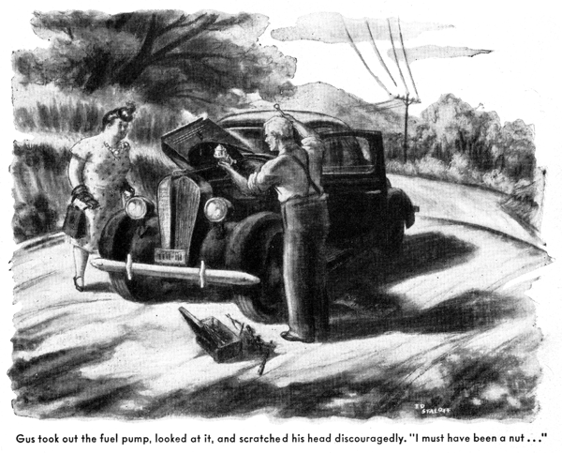
It was just the sort of Saturday afternoon that Gus Wilson had been wishing for all summer. Hot and sticky, the outdoors couldn't tempt him, and the coolness of his Model Garage shop was doubly inviting. For the first time in many months, there was no unfinished job on the floor.
As he packed the bowl of his brier, he laid out his afternoon. He'd be back from lunch by two, and then he'd get busy on his old coupe. Of course, there wasn't anything really wrong with it, but he had been so busy with other people's cars in the past six months that it needed a couple of hours' work to bring it back to the operating perfection he considered only normal.
Then along about four o'clock George Knowles and Doc Marvin, and maybe a few of the other regulars, would drift in and fill the shop with tobacco smoke and argument. It would be, Gus told himself as he scratched a match on the seat of his coveralls, just like one of those lazy summer Saturdays he used to enjoy before the war.
The urgent honking of a horn jarred him out of his pleasant thoughts. A car rolled in through the open door and stopped with a jerk. Gus recognized it as the sedan for which - and a nice piece of cash - the Millers had traded the ancient Rolls-Royce with which Mrs. Miller had for a while outshone her friends and social rivals.
"Now what," Gus thought, his jaw sagging, "does she want?"
According to habit, Mrs. Miller got out talking. "Oh, Mr. Wilson," she burbled, "this is just too, too provoking. I must be in Middleburg by two o'clock - but positively, I mean - and something's gone wrong with my transmission or carburetor or something. But I know you'll be able to fix it for me in a jiffy - you're so wonderful with cars."
Gus had learned from experience never to pay any attention to what Mrs. Miller says about her car. He motioned her to a chair, closed his mind to her nonstop chatter, and started checking. In a few minutes he discovered the clutch was slipping badly.
"Half a day's job," he told her. "I'll start first thing Monday morning."
"But I absolutely must get to Middleburg right away," she wailed. "If you're sure you can't fix my car now, I'll just have to drive it the way it is."
Gus shook his head. "That clutch will never get you over those hills," he warned. "You'll get stalled on the road."
"But I've got to be there by two o'clock," Mrs. Miller insisted, dabbing at her eyes with a tiny handkerchief. "It's vital - you can't realize how utterly vital!"
Gus looked at her suspiciously, but the tears that were beginning to well in her eyes convinced him that she must have some urgent reason for wanting to get to Middleburg, some 40 miles upstate. He would never admit it, but he's a soft touch for a sob story. Foreseeing the ruin of his afternoon of tinkering and talk, he glanced without having to at the shop clock. It was half past twelve, and there wouldn't be a bus or train to Middleburg until three.
"If you really have to get to Middleburg," he said grudgingly, "I'll drive you up in my car."
"Oh, Mr. Wilson," Mrs. Miller gushed, now all smiles, "that's just too sweet of you. But I wouldn't think of putting you to all that trouble. If you'd just work on my car so I could have it when I get back, and let me drive yours.. "
Gus blanched - he knows what Mrs. Miller can do to a car. "Oh, my old jalopy is so out-of-date and cranky it would give you no end of trouble," he hedged hastily. "I'll be glad to take you. But we'd better get going to get there by two."
Clear of town and on the highway, Gus speeded up to the State's 45-mile limit and held his old car there. Mrs. Miller, sitting beside him, chirped cheerily on.
"Your car," she told Gus, "runs like a dream - an absolute dream. Why don't my cars ever run like that?"
Gus could have told her, but he didn't. He was thinking hard about something else. Halfway to Middleburg they had turned into a short-cut dirt road with a series of steep grades, and the car was beginning to lose power, finding each succeeding hill harder than the one before. Gus was thinking that, if he had had a chance to go over his car in the past six months, this would never have happened. Then, 50 yards short of the crest of the longest hill they had come to, the engine sputtered and stopped.
"Now, Mr. Wilson," Mrs. Miller giggled as Gus applied the emergency brake, "don't tell me you've run out of gas."
"Not out of gas," Gus answered ruefully, "out of luck." He pressed the starter button, and the engine turned over but wouldn't take hold. "It seems to be the fuel pump - and we're at least five miles from a garage."
"You don't mean we're stuck, do you?" Mrs. Miller squeaked. "That would be perfectly terrible!
I've just got to be I Middleburg by two, and you promised to get me there!"
Without replying, Gus got out on the dust-thick road. Perspiring in the humid atmosphere, he removed his coat, rolled up his sleeves, raised the hood, and began checking. He removed the carburetor feed line and found what he expected - that the fuel pump wasn't pumping. When he took off the fuel pump, his face turned red - and it wasn't from the hot sun.
"This would have to happen right in front of the gabbiest dame in town," he told himself. "She'll spread it all over. I'll never hear the end."
Mrs. Miller's eyes were becoming moist again. "What are you fooling with that thing for?" she sniffled. "Do something!"
Gus turned redder, and this time it was anger instead of embarrassment. "If you'd just keep quiet for a minute, maybe I could do something!" he snapped. "I can't even think with you jabbering."
"O-o-oh, Mr. Wilson," she moaned, but she cut short her talk, and Gus saw why the fuel pump had stopped pumping. Long wear on the push rod and rocker-arm linkage had progressed so far the movement of the push rod was no longer sufficient to take up the play and still move the diaphragm enough to pump gas.
"No answer to that but a new fuel pump," he told himself discouragedly. "I must have been a nut…" Then he said out loud: "by gum, that might work at that!"
Mrs. Miller forgot her feelings had been hurt. "Why, Mr. Wilson," she gurgled. "I do believe you have an idea."
"Yes," Gus grinned. "It may be a nutty one, but it's worth trying.
She watched him paw hurriedly through the toolbox and then quickly reassemble the fuel pump and lower the hood.
"Jump in," he told her, "and we'll see if it works."
It did. Gus stepped on the starter, and after it had ground for a few seconds the engine took hold and ran smoothly. "Let's go," Gus laughed.
They made Middleburg on time. The clock on the town-hall tower showed exactly two as they drove into the village.
"That's the place," Mrs. Miller pointed excitedly as they reached a tumble-down old house in front of which a small crowd was gathering. "I won't be long."
She darted up the path, and when Gus got out to see what was going on, his eyes caught a sign that proclaimed, "Auction."
He had to laugh. "So that's it," he muttered. "I am a fall guy."
"Ten minutes later a large and opulent limousine stopped at the gate, and a chauffeur helped a large and opulent woman out. As she started up the path, Mrs. Miller came out of the house, an expression of triumph on her face and a large green-glass pitcher in her arms.
"Good afternoon, Mrs. Grigsby," she smiled sweetly to the rapidly purpling Mrs. Grigsby. "I'm so afraid you're late." Then she got into Gus's car. "It's hideous," she told Gus confidentially, "but it's authentic Colonial or early Federal or something, and Mrs. Grigsby has been after it for ages. I was determined to beat her to it, and I knew she had a club meeting that wouldn't let her get here until after two o'clock."
Henry Miller strode into the shop about six that evening while Gus was at last working on his car.
"What's this about you stalling your car on a back road with my wife?" he began.
For the third time that day, Gus turned red. "Now, Henry," he interrupted.
Miller laughed out loud. "What I want to know," he demanded, "is how you fixed a busted fuel pump. I've always thought when one went you needed a new one."
"Oh, that," Gus grinned with relief. "You see, the push rod wasn't enough to work the diaphragm and pump gas. I laid a thin nut on top of the push rod to take up play."
"Say," Miller whistled, "what in the world gave you that bright idea?"
"I was thinking what a nut I had been not to have checked my car sooner" Gus grinned sheepishly.
END

