April 1947

GUS TAMES A BUCKING FLIVVER
by Martin Bunn
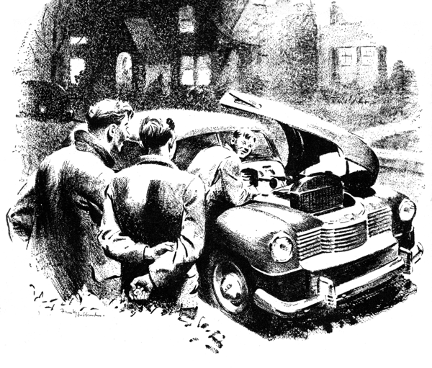
Stan Hicks was on the phone a long time. From where Gus Wilson was working he could see an earnest expression on his young helper's face.
"Probably making a date," Gus grumbled, "but he's sure taking his time about it." With some annoyance he began scraping the carbon from a cylinder head.
Stan finally emerged from the office, looking thoughtful. Gus tossed the scraper onto the bench with a clatter and growled:
"Hop to it, youngster. Scraping out this head is your job."
"Huh? Oh - sorry!" Stan trotted briskly over and took up where his employer had left off. After a few seconds his young face again took on a preoccupied expression. In a suspiciously offhand voice he inquired. "Bad carburetor adjustment can cause bucking, can't it?"
"Uh huh."
"And maybe if the plugs aren't right or a valve is stuck?"
"Yep. Or if the head gasket's blown. Bring the light over here."
"Sure. What else could do it?"
"Is this a quiz kid?" Gus grinned at his feeble joke. "What's up? We don't have any buckers in the shop."
"Oh, nothing. Just curious."
The subject was dropped, and a short while later Gus and his helper got ready to leave for the night. Joe Clark had come in and was checking over sales slips with Gus while Stan washed up.
A horn sounded in front of the garage. "I hope that's not a last minute job," Gus said anxiously. He looked out the window and saw an aging roadster pull up to the curb. Henry Weeks, a boy whom he liked, but knew only casually, flipped open the door to let Stan Hicks hop in. Gus noticed as the car moved off that it quivered and bucked like someone skating through a gravel pit.
"Hello Stan," Henry said with a trace of shyness. "Hope I'm not interrupting anything important."
"Heck, no," Stan tried not to notice the embarrassing bucking of the car. Because it would have been awkward either to mention it or remain silent, he cast around for something to say. "Do you still see Peggy?" he asked finally.
"You bet. She's practically my steady."
Peggy Graham was the leading belle of the high school set. Actually Henry was overstating his claim, but she did seem to like him.
"She's one of the reasons why I called you. Though it's mostly this old bus of mine. I've tinkered with cars a good bit, but sometimes a fellow likes to consult with - er - another expert."
"Of course," Stan agreed modestly. "Why, even Mr. Wilson discusses his tough cases. I know how it is, old man."
"Anyway, this is Thursday, and the big Country Club dance is Saturday. I have a date with Peggy, only she says she won't go unless the car acts better. That doesn't leave me much time to get the old crate running right."
"I should say not, Henry." Stan tried to recall how Gus would go about a diagnosis. "Has it been bucking long?"
"Began the day before yesterday, I went to call for Peggy and her girl friend to take them for a drive. We got bounced around so much Evelyn started making nasty cracks and Peggy got mad at me and made me take her home right away quick."
They arrived in front of Henry's house, parked under a street light, and lifted the hood. An expensive new sedan coasted alongside. Turning, the two boys looked up into the face of Sumner Craven, a chubby youth of about their own age. Seated next to Sumner was lovely Peggy Graham.
"What's the matter, fellows?" Sumner asked. "Having trouble with your jalopy?"
"Hmm!" Listen to him," scoffed Henry. "Just because his old man lets him use his new car, he thinks he can cheer at his betters."
"Gosh!" Sumner pulled his head in briefly. "I'll bet you can't fix this car!" Then he began to laugh, let in the clutch, and glided smoothly away. Stan and Henry returned to their examination of the motor. Suddenly Stan stopped and pointed at the spark-plug wires. "Hey!" he shouted. "What's that?"
Henry stared! "The wires of those two plugs are switched!"
Stroking his beardless chin, Henry announced. "They were okay the last time I checked. I know enough about cars not to make that mistake."
"You mean you smell a mouse in the cabbage?" asked Stan.
"Putting two smells together, I get worse than a mouse. I get Sumner."
It was the work of seconds to reverse the crossed wires. Henry started the motor, and let the car move slowly forward. It picked up briskly, then gasped rocked forward, coughed, and had speed. The roadster was bucking as badly as ever!"
Sumner Craven opened the front door of the Graham house and stepped out. "Good night, Sumner," Peggy's slim young figure was framed in the light from the house.
"Should I call for you Saturday?"
"I can't ask you to do that," the girl replied. "I have sort of a date with Henry. Of course, I told him I couldn't go with him if his car's going to shake out any hair-do."
"Ha ha!" Sumner started down the steps. "I'll call for you at eight on Saturday. Good night!" He climbed behind the wheel of his father's new car, snapped the switch, and pressed the starter. The engine turned over but didn't start.
"Holy smoke," he whispered, "Something's wrong!" Nervously he tried again with the same results. "If anything's happened to the car, Pa will have my hide." Hopping out, lifted the hood and looked helplessly at the engine.
"Having trouble, chum?" A familiar voice drifted over his shoulder. Sumner whirled to find Stan and Henry, looking as casual as they could manage, standing behind him.
"You've done something to my car," Sumner replied. "If you've hurt it I'll have both of you thrown in jail!"
"Do you know what he's talking about?"
Stan asked Henry with an expression of exaggerated puzzlement.
"That's a guilty conscience talking,." Henry rejoined. "The kind of stinker who'd cross someone else's spark plug wires probably thinks honest people would stoop to the same tricks."
Sumner glared at him.
"See?" Henry went on triumphantly. "He admits it!"
"It was just a gag," growled the chubby youth. "Anyway, you found it. What have you done to my fa - my car?"
"Tsk - tsk. D'ya still think we did something to it? Of course that distributor rotor we found up the street might..."
"Give it back!"
"Funny thing, it got lost," said Stan.
"But we might be able to find it," Henry added quickly, "If you could remember what else you did to my car."
"I crossed the plug wires. That's all. Honest!"
"Quit kidding," Henry dropped his flippant tune and stepped in close to Sumner. "We fixed that and the car still bucks."
There was no mistaking the expression on Sumner's face. He was honestly puzzled. A few more questions showed he had nothing further to reveal. The hand Stan had been holding behind his back came forward. It held the rotor from the sedan's distributor.
The two friends made their way back toward the roadster. Grimly Stan rolled up his sleeves. "Looks like there's no way out," he said. "We've got to take off the head. "Working with few tools and little light the two boys took even longer on the job than they had expected. Worse, they could find nothing wrong no valves were stuck and the gasket bore up under scrutiny.
There's only one thing left," Stan confessed wearily, as they begin to reassemble the engine. "Bring the bus around to the shop tomorrow and let my boss look at it.
Boy! How he'll rib me!"
Gus Wilson knew when to leave well enough alone. Despite Stan's fears, he tactfully refrained from rubbing salt on the young mechanic's wounded pride.
"We tried everything we could think of," said Stan.
"In that case," Gus replied, "the trouble must be some place you didn't think of. Let's go over it step by step."
"How about the crossed plug wires?" asked Henry.
"That might have done it easily enough, and whatever the trouble turns out to be, crossing the wires may have helped to bring it out. You checked the valves and the head gasket. Although they don't seem to be the answer, you may still have been on the right track." He raised the hood and instructed Henry to start the motor. It rumbled unevenly and coughed through the carburetor. Gus checked the vacuum at the carburetor and found it low. "That could happen," he said, "if the exhaust and intake were getting together."
"But we examined the valves," Stan protested.
"How about the ports at the side?"
"The ports...?"
"Sure. Where the gas goes in and the exhaust comes out." Gus showed Stan where to back off the units that held the manifold to the block. As it came loose, slivers of blackened copper fell out.
"There's your trouble." Gus pointed to a gap that had been burned in the gasket between an intake and exhaust port. "Put on a new manifold gasket and try it."
The boys set to work. When Gus strolled by a half hour later, the motor was purring.
"Okay now?" asked Gus.
"Like a charm," Henry affirmed. "I can't tell you how much I..."
Gus waved his hand. "Forget it. But wait until I see that Craven kid, I don't say this couldn't have happened if the wires hadn't been crossed, but I'll bet a peach to a pumpkin it helped bring it on."
Henry scraped his foot shyly along the grease-blackened floor. "Please don't say anything to him right away," he said. "If he finds out that my car's been fixed before Saturday night, he'll be able to make another date. I'd like to see that double-crossed get hung up at the last minute. It would serve him right if he had to go dancing with his father's sedan!"
END

