September 1946

GUS CATCHES A GAS THIEF
by Martin Bunn
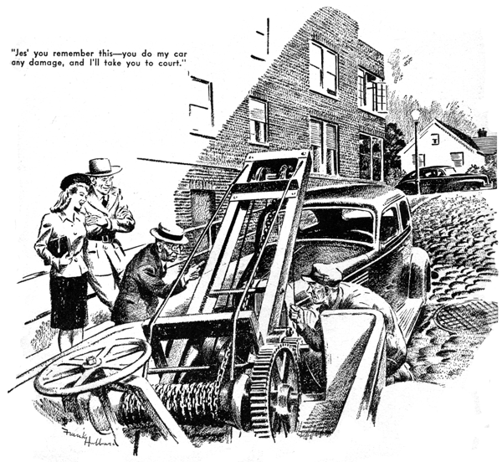
Joe Clark stuck his head through the door leading from the office-showroom to the Model Garage shop and called to his partner: "Hey, Gus! Lady to see you."
Gus Wilson was busy on a valve-grinding job he wanted to finish so he could go bass fishing. "What does she want?" he demanded ungallantly.
The remainder of Joe's anatomy followed his head into the shop, and he shut the door.
"She says she wants to talk to Mister Wilson - and no other," he reported, a grin splitting his thin face. "I don't know what she wants, Mister Wilson, but I do know that she's well worth talking to."
Gus scowled. "Every time I get started on a job, I get interrupted," he grouched. "First it's Stan Hicks wanting to be shown something. Then it's the phone. Now it's you wanting me to stop and see some dame who's probably collecting for some charity." He produced a half dollar from his coverall and spun it toward Joe. "Give her that, and leave me alone."
Joe, still grinning, plucked the coin neatly out of the air and dropped it into his pocket, "She wants to talk to Mister Wilson," he repeated. "I'll tell her you'll be in."
He went back into the office, and Gus, still grumbling, followed him. When he saw the girl sitting in Joe's desk chair, he lost no time in wiping the scowl off his face and replacing it with his best smile.
She was very businesslike in her dark-blue suit and little hat to match, but she had what nylons need to make them look their best, and the gray eyes that smiled back at Gus made him remember things that had nothing whatever to do with automobile engines or the garage business.
"This is our Mr. Wilson, miss," Joe said unctuously. Then, unable to get back to his ledgers while she was sitting at his desk, he went to the showcase and began fussing with the gadgets he displays in it.
"I'm Lucille Andrews, Mr. Wilson - I work for the Child Welfare League," the girl told Gus. "Mr. Corcoran, the state trooper, suggested that you might help me with a problem I have. He says you're fair-minded." Gus reddened, conscious that Joe was listening. "Well, I - I try to be," he sputtered. "But what's this problem?"
"Mr. Corcoran tells me that you know Mr. Barnstable - Silas Barnstable - who lives in the Hillcrest Apartments."
"Yes, I know the old - er - the old gentleman," Gus agreed.
Lucille's cheek dimpled. Then she laughed. "I guess what you were going to say would have been a better description," she said. "Mr. Barnstable is an old grouch. I know him quite well - my sister and I have the apartment above his. Do you happen to know a boy named Tommy Black?"
Gus shook his head.
"Well," Lucille went on, "I'm afraid that Tommy isn't a model boy, but considering the poor chance he's had in life, I don't think he's so bad. He isn't 14 yet, and he's been in minor trouble a couple of times. That's making it bad for him now that Mr. Barnstable wants him arrested for stealing gasoline out of his car. You know Mr. Barnstable. He considers paying garage rent a wicked waste so he leaves his car all night on that steep cobblestone side street beside the Hillcrest."
Gus nodded. "I know the place, "he said. "It's ideal for car thieves - dark, and usually no one around. Of course, old Silas wouldn't spend a couple of dollars for a fuel-tank lock. But why does he blame Tommy?"
"I'm afraid he has something pretty definite," Lucille admitted unwillingly. "The first time he missed gasoline was a week ago. He had his tank filled Friday night, and Saturday morning there was so little gasoline in it he got stuck 15 miles out in the country.
When the service-station man couldn't find a leak, Mr. Barnstable remembered that he had looked out his window about 11 o'clock Friday night and seen Tommy coming up the hill lugging a big, heavy can. He was sure it was Tommy because he saw him under the street light at the corner."
Gus was silent. He tamped his pipe.
"Mr. Barnstable wanted Tommy arrested and called Mr. Corcoran, but he argued him into waiting for stronger evidence," Lucille explained. "So they begun watching the car at night. But I guess the thief waited until they left, because it wasn't until last night that they saw anything suspicious, though gas was missing again each morning."
"What happened last night?" Gus asked. "I was watching from my window last night about 10 o'clock and saw Tommy going down the hill carrying a big can. Just then Mr. Corcoran turned in from the main street and caught him in his headlight. He came down the hill fast, yelling at Tommy to stop, but Tommy dropped his can an ran. And then - " Lucille's dimple returned to her cheek - "then the motorcycle hit a bump, ran up the curb, and threw Mr. Corcoran into a rose bush. When I got down, his face was bleeding where the thorns had scratched. And was he mad!"
Gus chuckled, thinking of Jerry Corcoran's wounded face and worse wounded pride. "This morning," Lucille continued, "I went to see Tommy. He was scared and admitted he had been near the Hillcrest with a big can both nights he had been see, but he denied he had bothered Mr. Barnstable's car. He wouldn't say what he was doing with the can, but somehow I believed him and persuaded Mr. Corcoran to wait before arresting him. It was then he told me to see you - that you might be able to explain why Mr. Barnstable has been losing gasoline."
Gus scratched an ear reflectively. "Both times Tommy was seen near Silas's car were on Friday nights," he mused. Then he apparently remembered something he had forgotten. "Excuse me a moment," he said. "I have to make a phone call." He dialed a number. "Jack's Sport Shop? Get that live bait yet?... He hasn't shown up?... O.K. Maybe I'll do better with plugs."
Lucille looked reproachfully at him. "You think Tommy did steal the gasoline?" she asked, her voice revealing disappointment.
"I'm practically certain he didn't steal it!" Gus grinned with reassurance. "But I'll have to get hold of Silas's car to prove it. Do you think you can get his permission? The last time I saw the old skinflint he accused me of cheating him when I had only charged him half what a job was worth."
Lucille's gray eyes sparkled. She smiled dangerously and held up a slim forefinger.
"I'll twist Silas right around it," she promised. "Then I'll phone you as soon as I can - I know you want to go fishing."
Half an hour later the phone rang. "It's all right," Lucille told Gus triumphantly. "He says you can examine his car."
"I'll be right over," Gus said. "How did you get around that old sourball?"
Lucille laughed. "I just told him it was a chance to get his car checked by an expert without charge."
Within 10 minutes Gus was driving the wrecker down the steep street at the Hillcrest and came upon Lucille, Trooper Corcoran, and Barnstable, a wealthy little retired farmer who looks like a bantam rooster.
"I'm a-goin' to watch you, Gus Wilson," Silas cackled. "You ain't a-goin to save that young scalawag by any shenanigans!"
Gus grinned widely at Jerry's scratched face and walked slowly around the car.
"Can't do anything on this hill," he decided. "I'll tow your bus to my shop, Mr. Barnstable. It won't cost you a cent, and I'll give you enough gas to get you home."
Silas tilted his stiff-brimmed straw hat over his steel-rimmed spectacles.
"Go ahead," he consented. "I don't know what trickery you're up to, but jes' you remember this-you do my car any damage, and I'll take you to court."
Gus winched up the front of the old sedan after its owner got into it. Lucille climbed into the wrecker beside Gus. Trooper Corcoran let the way on his motorcycle.
Back in the Model Garage, Gus maneuvered Barnstable's car into the middle of the shop floor, and then drove the wrecker out. When he came back, he looked at the fuel gauge and saw that the tank was empty.
"How much gas did you have last night?" he asked Silas.
"Mebbe two gallons," the old man said. Gus grunted and, Silas at his elbow, raised the hood. He stood looking at the engine for half a minute, and then leaned over and examined the fuel pump carefully.
"Now I'll show you the thief who has been swiping your gas," he told Silas. "Stan, jack the rear end up."
Gus watched while Stan raised the rear end. When the body was at about the angle it had been on the steep hill where Silas had parked, he told Stan to stop.
"Get me a couple of gallons of gas and a good-sized pan," he directed.
Stan did as he was told. Gus pushed the pan under the engine, poured the gas into the tank, and pressed the starter button. After the engine caught he let it run for a moment before shutting it off. "Take a look at the pump," he said.
A steady stream of gasoline came out at the pump and ran into the pan!
"There's your gas snitcher!" Gus said. "Did you have any work done on your bus just before you started to lose gasoline?"
"I had the motor gone over by a feller down in the city," Silas admitted. "He didn't charge half as much as you would have."
"Probably not," Gus agreed. "But when he cleaned the fuel pump he installed a new cork gasket and didn't center the bowl on it. That left a leak that didn't show until the car was left standing front-end down on that hill where you park it. Then the gasoline siphoned from the tank poured out of the leaking fuel pump and ran between the cobblestones without leaving any trace."
"I'll be hornswoggled!" Silas exclaimed.
"What I want to know," Jerry Corcoran said, "is how you guessed about the leak."
"Well," Gus told him, "I was sure Tommy wasn't stealing it, and as the car was being watched I didn't think anyone else was." "How did you know Tommy wasn't stealing it?" Jerry demanded. "What was he doing with that can if he wasn't stealing?"
"You ought to have guessed that - you're a fisherman," Gus answered. "That pond at the foot of the hill is full of minnows. Last Saturday, I bought some at Jack's Sport Shop, but today the boy who catches them didn't show up. Mr. Barnstable saw Tommy going up the hill last Friday night with a heavy can. Last night you scared him and he dropped the empty can while he was going down the hill. The rest is easy."
"You ought to be on the force," Jerry exclaimed. "I've always said so."
Gus turned to Lucille. "I've been thinking about Tommy. We need an errand boy." "Oh, that would be grand," she said. "I'll send him around."
"No, he grinned. Bring him around."
END

