October 1946

GUS CATCHES A GAS THIEF
by Martin Bunn
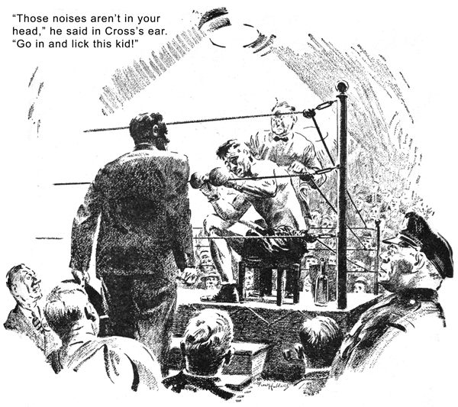
Stan Hicks rushed into the Model Garage shop, his eyes as big as brake drums. "Hey, boss!" he said breathlessly to Gus Wilson, "Jack Cross is outside in a big sporty coupe! He wants to see you!"
Gus grinned tolerantly at the grease monkey. He was a boxing fan himself, and he understood the thrill Stan got out of being spoken to by our town's only famous prize fighter.
Jack Cross never won the welterweight crown, but he came within a second of it the night 10 years ago when he had the champ stretched on the canvas and the gong clanged at the count of nine. He was still rated as a hazard any youngster had to pass before he could get a crack at the title.
"I'm going to see him fight Buzz Billings tonight," Gus said with deliberate nonchalance. "In their last scrap Buzz had him in trouble, but Jack knew too much for him and won the decision. Tell him to drive in."
"But, boss," Stan gasped. "It's Jack Cross! Hadn't you better go out?"
"Scram," Gus laughed. "I've know Jack Cross since you were in three-cornered pants."
A moment later a flashy, newly painted coupe of the late '30's was driven in, and a solidly built man climbed out and swung over to Gus with his hand extended. His face was scarred, his nose was crooked, one ear was thickened, his wide smile displayed expensive and extensive bridgework, but when he spoke his voice was surprisingly gentle.
"Hello, there, Gus," he greeted. "Haven't seen you since Napoleon was a corporal. What do you think of this jalopy I bought?"
Gus eyed the coupe. "It was a good car," he said, "but I can't tell if it still is."
There was a bitter note in Cross's laugh.
"Like me, isn't it? Did you see me in there with Buzz Billings last month?"
"Sure," Gus told him. "I was rooting for you, but you had me worried for a while."
"You were worried!" the fighter said, his smile vanishing. "How do you think I felt?
I'm fighting him again tonight, but maybe I ougthtn't to. It may be time for me to quit - I don't want to end up by walking on my heels and telling people I'm training to fight Mickey Walker. Buzz hurt me with that right, Gus. I've been hearing funny noise since he smacked me with it - and I want you to tell me whether they're in this car or in my head."
Gus stared. "Trying to kid me, Jack?"
Cross shook his head. "I never felt less like kidding in my life," he said grimly.
"O.K.," Gus told him. "What's this about noises? When did you first hear them?"
"The first time I drove the car," Cross replied. "I bought it from a dealer in the city and had him recondition it."
"That proves the noises are in the car and not in your head," Gus reasoned.
"No, it doesn't," Cross disagreed. "They delivered the car the morning after the fight.
"You must know," Gus argued, "whether the car made the noises before you bought it."
"I never drove it before I bought it," Cross admitted. "My old bus had to be junked and I took the salesman's word that this one would be thoroughly reconditioned. The morning after the fight I wanted a vacation. I phoned the dealer to send the car around to the hotel, and I started to drive it down to Atlantic City. In about a block I began to hear the noise - a sort of low tick-tick-tick.
When I got out on the road and speeded up it got louder, and the ticks began to come closer together until the noise was pretty near continuous."
"What did you do?" Gus asked.
"After I had listened to the noise for about an hour," the boxer told him, "it began to get on my nerves, so I stopped at a garage. The mechanic said that the speedometer cable was shot and put in a new one. But I heard the noise again as soon as I got out on the road. I stopped at another garage. That fellow said it was caused by a wheel bearing and spent an hour putting in a new one. But the noise got louder and louder, and after I'd gotten to Atlantic City and checked in at the hotel I kept on hearing it - all night."
"I've had the same thing happen to me," Gus put in. "Just nerves."
"You think so?" Cross asked. "Listen to the rest of it. Next day I took my bus to a big repair shop. I got it back in two days with a big bill and a song and dance about the transmission - and the tick was still there.
Driving back from Atlantic City, it sounded sometimes as if it was in one part of the car and sometimes in another, and after an hour I was sure it was in my head. When I got to the city I took the car to the place I'd bought it. The manager drove with me for a block and said I was imagining things."
Gus scowled.
"I was so scared I couldn't say anything," Cross went on. "Since then I've kept on hearing the noise - in the car and out of it - but I haven't told anyone but you. Maybe I shouldn't fight Buzz again - they're building the kid up and figure he'll kayo me. You know your business, Gus, and I know you're on the level. Locate that noise and cure it, and I'll know I'm all right. If you say there's no noise, I'll know I've taken too many punches."
"That's easy to decide," Gus told him. "Hop in, and we'll take a ride."
Cross looked at the shop clock. "I can't - I've got to get down to the city," he said.
"My manager's waiting outside. Keep the car, and I'll be in tomorrow. Coming to the scrap tonight? Win or lose, it'll be my last. I'd like to wind up with a win, but I'm not going to give Buzz a chance to nail me with that right again - not with me hearing funny noises in my head!"
"Sure, I'm going to the fight," Gus laughed. "And forget the noises. I'll prove they're in the car and not in your head."
After Cross had hurried out, Gus jumped into the coupe and headed up the highway. He heard the noise at once - a well spaced tick-tick-tick that grew louder when he increased speed and became a fast, loud buzz when he worked it up to 50. At first it sounded as if it came from the transmission, then from the rear end, then from the front wheels.
"The noise is there, just the way Jack heard it," he told Stan when he got back. "But finding the cause may take quite a while. If I could tell Jack what it is before he goes into the ring it would ease his mind and maybe help him win. Let's get busy!"
Working quickly but carefully, he checked and rechecked - but after an hour the source of the noise still was unfound.
"We're not getting anywhere," Gus said. He lighted his pipe and blew clouds of gray-blue smoke as he stared at the coupe and dug into his memory for the cause of each mysterious car noise he'd had to run down.
"That could be it," he muttered after five minutes of concentration. "that must be it... He, Stan - forget your dinner and help me pull off this torque-tube assembly."
It was long job, but when it was finished Gus grinned with satisfaction.
"There's what made Jack Cross think he was going nuts," he told Stan, pointing to the taper pin which in that car holds the drive shaft to the driving pinion in the rear end. "The pin is driven tight at the factory but sometimes works loose the way this one did. It can't drop out because of the torque tube, so the shaft still drives the gear, but the rotating pin strikes the tube and makes a ticking noise that is so hard to locate that most mechanics miss it."
He pulled out the loose pin, examined the taper hole in which it had been seated, and checked the torque tube.
"That's good," he told Stan. "The hole hasn't worn, so all we have to do is drive the pin back good and hard. Sometimes a pin cuts a groove so deep you have to install a new tube."
"I get your - I guess," the youth muttered. Gus climbed into his own old roadster. "Jump in," he called to Stan. "I'll buy you a ticket to the fight."
But they had worked so long, the Cross-Billings bout had gone six rounds by the time they reached the arena.
"How's it going?" Gus asked the man next to him as the gong sounded for the seventh.
"Billings all the way," he was told. "Cross seems to be washed up."
Gus watched as Cross came out of his corner. He was brisk enough but painfully cautious, constantly circling to his right in an obvious attempt to keep out of range of his opponent's Sunday punch. Billings, confidently aggressive, snapped the veteran's head back with stinging left jobs.
It was that way all through the seventh and eight rounds. Only Gus knew that Cross was worried sick by fear of becoming punch drunk.
"If I could only tell him!" Gus muttered.
In the ninth, he could stand it no longer and began to work his way toward the ring. An usher ordered him back, but he kept going. He got to Cross's corner as the round ended. A cop grabbed at him and missed.
"Jack!" he yelled. "I've got to talk to you!"
Cross, sitting dejectedly on his stool, recognized his voice above the roar. He turned, saw Gus, and said something to a second, who beckoned. Gus climbed the ring steps.
"Those noises aren't in your head," he said in Cross's ear. "They're in your car - a loose pin. That's on the level, Jack. You aren't getting punchy. Forget it - and go in and lick this kid!"
The veteran's cut lips twisted in a grin, and he managed a wink with a puffed eye.
"Thanks, Gus," he muttered. "Watch me."
The gong clanged. They met in mid-ring and touched gloves in the traditional final-round handshake. Then, his right cocked and his extended left ready, Buzz glided forward, expecting to tag Cross with another jab as he circled away from his right. But this time Jack didn't circle. He stood firm. His left flashed out, and his glove smacked into the pit of his opponent's stomach.
Buzz gasped, and he doubled over and tried to wrap his arms around Cross. But Jack slid back - then forward again - and let go his right. The punch landed on the side of Buzz's jaw. His knees buckled, and he pitched forward on his face.
The referee's arm rose and fell with the count, "... eight... nine...ten!"
He grabbed Jack's right hand and held it up.
"The winnah - Jack Cross!" Jack grinned crookedly at Gus. "I get the credit, but you won the fight."
"O.K.," Gus said. "I'll put it on the bill."
END

