November 1946

GUS STARTS

A STOP-AND-GO CUSTOMER
by Martin Bunn
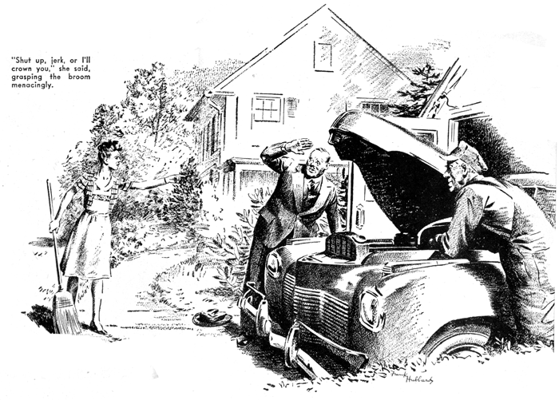
Joe Clark had gone to the bank, and Stan Hicks was left in the Model Garage office-showroom to take a turn at answering the telephone.
"Yeah, all right," he shouted into the transmitter. "What's the name again?"
"Spinker!" snapped the voice.
"Shrinker," Stan repeated confidently. "What didja say the address - "
The line sizzled. "Not Shrinker, you dope! Spinker! S-p-I-n-k-e-r!"
"Oh, now I get you, Mr. Stinker," Stan said in a pleased voice. "Whatja say the address was?"
Expletives answered him. "I've told you three times where I live!" barked the irate Mr. Spinker.
"One-seven-two Orchard Street. Now get moving, will you?"
"Yeah - you bet," Stan said soothingly and hung up. The sports page he had been reading when the telephone interrupted caught his eye. He picked up the paper, elevated his feet on Joe's spotless desk, and took up where he had left off. Then he went on to the comic strips, and he was deep in them when Joe came back.
"Nothing important," the grease monkey reported, and he strolled into the shop.
Gus Wilson looked up from the job on which he was busy. "Check the tube in the left-rear tire of that coupe," he directed. "Tom Barnsley says it acts as if it had a high-pressures leak."
"There's a rush job," Stan told him importantly. "Fellow named Stinker, 72 Orchard Street, just called up. Says he can't get his car started. Want me to go?"
"I'll go," Gus decided. "You find out what's the matter with Tom's tube. Stinker! That's a funny name. Sure you got it right?"
Stan reassured him, and Gus got the wrecker out and drove it the 10 blocks to Orchard Street. Where No. 72 should have been, there was a vacant lot. The precise lady at 88 said that she had never heard of anyone by the name of Stinker and intimated she thought it indelicate of Gus to have mentioned it. A red-faced woman at 60 remarked caustically that none of her neighbors was named Stinker although some should be.
It took Gus 15 minutes to find out that the name was Spinker and the number 172, and he wasn't at all happy about it when he drove the wrecker up the driveway at that address. The doors of the garage were closed, so he rang at the front door. A harried-looking young woman answered.
"It was hours ago that Mr. Spinker phoned," she told him bitterly. "My husband is a busy man, and he couldn't' wait."
"Oh, I see," Gus said, feeling foolish. "So he got his car started?"
"Mr. Spinker has a terrible temper," she said with more than a touch of pride.
"When you didn't come promptly, as you'd promised, he lost it and slammed the car door good and hard. Then, when you still didn't come, he tried the starter again, and it worked. So now we don't need you!" Then she slammed the house door.
He drove back to the Model Garage and took the matter up with Stan - with the result that the grease monkey, who had put a new tube in Tom Barnsley's tire, was as deflated as the one he'd taken out.
But Gus isn't one to nurse a grudge, and within a week the Spinker incident had ceased to be a subject for reproach even if the embarrassment hadn't been forgotten.
Nevertheless, Stan looked sheepish when he came into the shop just after opening one morning and said: "You're wanted on the phone, boss. It's - it's that fellow over on Orchard Street who couldn't get his bus started. He won't talk to anybody but you."
Gus grunted, went into the office, and picked up the telephone. The voice that sprang at him out of the receiver was as prickly with inadequately repressed fury as a radio set is with static in a thunderstorm. About the first printable words Gus heard were: "My car won't start, and I've got to get to the office. Come over here and see what's wrong with it!"
Look here," Gus told him crisply, "I haven't time to go driving around town on fool's errands. If you want me to check your car, stay right where you are until I get there. Understand that?"
Over the wire came a new volume of expletives, and then the voice said: "All right - I'll wait! Make it fast!"
As he drove the wrecker across town, Gus indulged in mentally portraying the terrible-tempered Spinker. He pictured him as a big man with a red face and red hair - and he was right, for that was just the sort of man who was waiting for him.
When Gus drove up, the man stuck out his wrist watch. "Look," he roared. "A quarter to, and I've got an important engagement at my office at nine. About time you got here! And don't call me Stinker!"
"O.K.," Gus agreed grinning. "Let's have a look at this on-again-off-again jalopy."
"Jalopy!" howled Spinker. "It's a '41 model. Don't look at it. Start it!"
He led the way to the garage. "Been kicking the starter for half an hour," he growled, "without getting a turn."
"Why didn't you slam the door? That worked before," Gus said with a grin.
"I did, and - " Spinker's red face got still redder. "How did you know that?"
"You look the type," Gus said dryly, and got into the driver's seat. The ignition was on. He pressed the starter pedal, and the engine took off with a purposeful roar and ran without a miss or sputter.
Spinker was wearing a derby. He snatched it off with both hands, hurled it to the ground, leaped high into the air, and came down on it with both feet. His jaw worked soundlessly for some seconds, and then two bitter words emerged from under his red mustache: "Confounded trickery!"
"Take it easy, or you'll bust something besides your hat," Gus advised. "You aren't the first man who's been made a sucker by an automobile electric system."
But Spinker wasn't to be consoled, and his shouting and expletives finally brought his wife from her sweeping broom still in hand. She gave Gus a nasty look, and then addressed her husband in dulcet tones.
"Hush, Horace dear. Control yourself. Think of the children," she told him.
He went on yelling. Mrs. Spinker's thin-lipped mouth tightened. "Shut up, jerk, or I"ll crown you," she said, grasping the broom menacingly.
Spinker's yelling stopped as abruptly as if he'd been gagged. His mouth opened and closed soundlessly half a dozen times.
"Why does the car start sometimes and not start other times?" he asked huskily.
"Why did it start every morning for a week when I slammed the door, and why didn't it start this morning when I nearly slammed the hinges off? Why did it start for you and not for me? Why? That's what I want to know."
Mrs. Spinker turned her gaze from her husband to Gus, and in her green eyes there was the look of a watchful bobcat. "Tell him why," she said briefly.
Gus grinned. "I'll have to find out myself," he told her.
He poked under the hood at various wiring connections with an exploratory forefinger. After he had got to the starter motor and poked the lug on the starter switch, he straightened up.
"There it is," he said. "That lug is so loose it forms a high-resistance connection - passes enough current to operate the lights and horn, but usually it can't pass the several hundred amperes necessary to turn over a cold engine."
He raised a warning hand as Spinker showed signs of sounding off again.
"In this particular case," he explained, "the lug is so loose it can't pass enough current to operate the starting motor. Slamming the door sometimes jars it together so starting is possible. Lots of times the same thing is caused by loose battery terminals.
Gus removed the loose lug, cleaned it with waste from his coverall pocket, and replaced it. He tightened it until it was snug.
"That will get you to your office," he said, "but you'd better bring your car over to my shop for a check on all the wiring."
Spinker looked at his watch. "Suffering cats!" he yelled. "I've got to get going!"
He jumped into the car and started off, yelling to his wife: "Pay this fellow!"
Gus climbed into his wrecker. "I'll send the bill," he told Mrs. Spinker.
She nodded. There was a far-away look in her eyes. "I hate to see Horace go in the morning," she said.
"It's so - so sort of lonesome when he isn't around."
END

