May 1946

STAN AND A SCHOOLMARM

TEACH GUS A NEW TRICK
by Martin Bunn
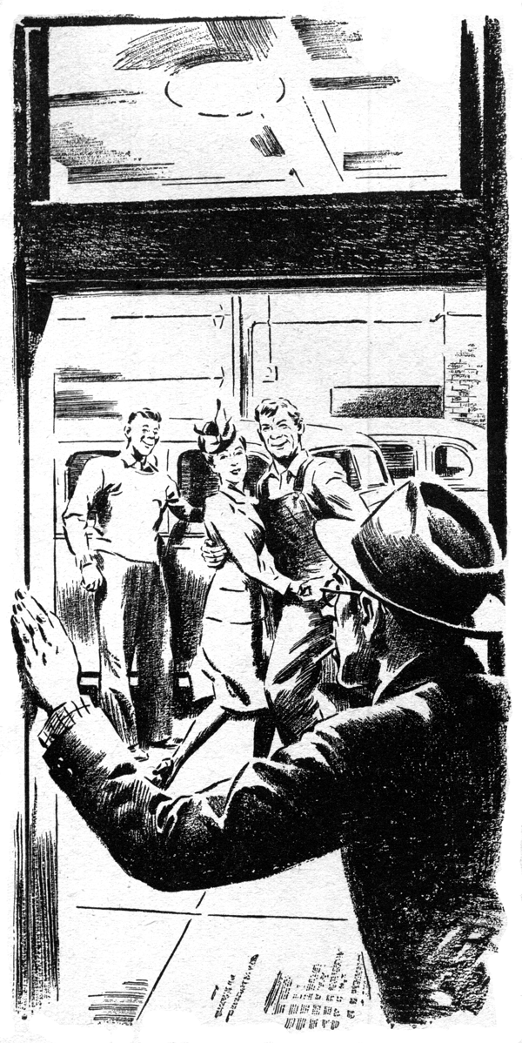
Stan Hicks, the Model Garage grease monkey, stopped whistling as he completed the minor job he was doing, and with a note of preoccupation said: "It's funny."
Gus Wilson looked up from another job. "What's funny?" he asked.
"I was just thinking," Stan explained.
"That is funny - and dangerous, too," Gus cautioned. "It's a habit that could grow. But I guess you needn't worry."
Stan grinned at his employer. "I was just thinking," he went on, "how different things are now from a year ago. Then pretty near every customer wanted us to do something to make his bus last forever.
Now pretty near everyone wants us to do something to make it go faster."
"Well, why not?" Gus said. "A year ago the speed limit was thirty-five miles, and almost everyone was patriotic enough not to exceed it. Now we've got prewar speed limits back, and even if most tires aren't all they should be, most people want to travel at the legal limit. That's only natural after all."
"Maybe so, boss," Stan conceded, "but what is funny is who some of the people are." He pointed at a 1940 sedan near the shop door. "That job was brought I while you were out to lunch. Know whose it is?"
Gus glanced at the car. "Of course it belongs to Miss Flagstone, the school teacher," he said. "What's the matter with it?"
"She's coming in after school to tell you all her girlish troubles," Stan said, grinning.
"But her big gripe is that it don't behave nice when she gets it up over fifty." He looked at Gus with a what-now expression on his callow face. "Imagine, boss - an old white-haired lady like her!"
Gus jumped as if a wasp had tagged him.
"What d'ya mean, old lady!" he yelped.
"Why, Miss Flagstone's younger than I am - and she's got ten times more get-up-and-git in her than any of you young false-alarm fireballs!"
Stan's grin widened. "I didn't mean anything personal. Anyhow, you're different - sort of," he said tolerantly. "Why, Miss Flagstone was my teacher in the eighth grade, and even then she had gray hair and we called her Old Lady Flagstone!"
"That proves she had fresh kids in her class," Gus growled. "Get the hose and a broom, and harness that flaming youth of yours to the job of cleaning up the driveway."
Stan, the sweat of honest if unwilling toil streaking the grime on his face, was busy in the driveway when Miss Flagstone got out of a taxi. He pretended not to see her, but she wouldn't have it that way.
"Why, Stanley," she exclaimed, "I thought you told me you were a mechanic."
Stan's face got redder. "S-so I am, ma'am," he stuttered. "But even a m-mechanic has to do jobs like this once in a while. You can't expect -"
"Of course, you can't," Miss Flagstone agreed sweetly. "Is Mr. Wilson in?"
"Yes'm," Stan told her with politeness in his voice and murder in his heart. "He's in the shop."
Miss Flagstone went in. Gus, who has known her for a flock of years, regarded her with freshened interest and didn't find her crisply waved blue-white hair, fresh-complexioned face, and slim tweed-clad figure at all hard on his eyes. "Old Lady!" he said to himself.
"She's better looking now than she was twenty years ago!"
"How's my friend Stanley doing, Mr. Wilson?" she inquired.
"He's doing all right," Gus told her, "though he'd do it a lot faster if I could talk him into taking an automotive course down in the city three evenings a week.
But he says that when he gets through his day's work here he's too tired to drive to the city. Except for that, he's doing fine. He's going to develop into a real mechanic some day."
"Stanley was one of my pet pupils," Miss Flagstone said, "but I soon found that he needed sitting on every so often. He still does - and I've just sat on him again."
"Good for you!" Gus applauded. "So have I.
That dumb-and-dirty job he's doing outside is a form of sitting on that I save up for times when he shows signs of getting too big for his boots...
Well, what's the trouble with your car, Miss Flagstone?"
"You'll have to tell me that," she said. "My guess is that during the war it got out of the habit of running over thirty-five and can't readjust itself. Whenever I try to drive over fifty the motor misses and sputters and sometimes the car bucks hard."
"Have any trouble starting?" Gus asked.
"Yes," she admitted.
"The same thing happens in both low and second when I try to make a fast getaway when a light goes green. It doesn't make much difference driving to and from school, but beginning tomorrow I'm doing what you want Stanley to do - taking a - well, a course down in the city. I have to be there by six o'clock two days a week, and as I seldom get away from school much before five I'll have to step on it."
"So that's it," Gus said.
"When I tell Stan you're taking a course, it may shame him into doing the same. If you can do without your car until tomorrow afternoon, I'll have it at the school before five."
Gus had the best intentions, but rush job after rush job came in, and about four the next afternoon he woke up to the fact that he'd done nothing on the car.
"Hey, Stan!" he called. "Help me check this Flagstone bus. We've got to get it out in a hurry. Let's see, now - engine misses at high speeds and on quick starts in first and second gear. It could be the coil."
He connected an ammeter in series with the battery and the primary terminals of the coil. The indicator hand moved to the 5-amp. mark and when the coil had warmed it moved back to 3 amp, and stayed there.
"No ground or open circuit in the primary winding," Gus said. Then with the engine running he held one spark-plug cable near the motor block. A fat, hot spark jumped the gap.
"Nothing the matter with the coil," he decided. "And the condenser seems O.K."
"How about spark plugs?" Stan asked.
"You check 'em." Gus told him. "I'll take a look at the wiring and connections."
The plugs gave good sparks, and the wiring and connections were in A-1 condition.
Gus looked at the shop clock. "Maybe the grief is in the distributor, or maybe it's in the high-speed jet of the carburetor, or it might even be in the fuel pump," he said.
"Wherever it is, I'm not going to be able to find and fix it in half an hour."
"Wait, boss," Stan cut in. "I got to thinking about that old gal taking an evening course, and I figured if she can stand it so can I. Tonight's the deadline for signing up for the next term, and I'm going down to the city to register. I could take her with me and pick her up after her class."
Gus went down to the Park House and ate his dinner, and then went back to his shop and retackled the troublesome Flagstone job.
"A worn distributor shaft could be causing the trouble," he reasoned. "If it left the distributor shaft free enough for it to wobble, the cam wouldn't touch the points when the shaft was on the out-wobble."
He disassembled the distributor, but all its parts seemed to be in perfect condition. Next, he checked the carburetor and the fuel pump without result. Nine o'clock found him badly puzzled.
Just then Stan came in. "You're back early," Gus grunted.
"It didn't take long," Stan said. "Miss Flagstone will be in for her car in a few minutes. Got it fixed?"
"No, I haven't," Gus growled. "It's got me pretty well stumped." He scowled at the sedan as he filled and lighted his pipe. After a few puffs his face brightened. "By gum," he muttered. "I'll bet that's it."
He went over to the cabinet in which he keeps his instruments and came back with a spring-type scale. With it he tested the distributor-point springs.
"Ten to twelve ounces," he said, "and they should show at least fifteen."
"What's all this?" Stan demanded.
"Something for you to remember - and I should have remembered sooner," Gus told him. "Weak point springs - one of the very toughest troubles to diagnose. The point springs in this distributor have lost their strength and snap. They don't close as fast as they should, so the coil is robbed of its normal build-up period, and there isn't enough spark to fire the engine."
Stan thought that over. "I get it," he said. "But what I didn't get is why the engine misses only at high speeds."
"That's easy," Gus explained. "At low speeds even weak springs have enough snap to close the points promptly on the slower revolving distributor cam. We'll put in new springs, but we'll test them first. Sometimes new springs haven't strength enough."
Gus installed good new springs - and the engine ran smoothly at all speeds.
"Say, boss," Stan asked, "what course do you think that old gal is taking?"
"Something high-brow," Gus replied.
Stan grinned. "She's taking dancing!"
"What?" Gus asked. "Well, she's got a right to take dancing if she wants to. But she doesn't need lessons. I know - I danced with her at the Town Club's ball."
"Yeah," Stan retorted, "I saw you. You were good, too - in a slow sort of way."
Gus reddened. "I can waltz and fox-trot well enough, but no fool jitterbugging."
"You're missing something!" Stan told him. "Now, you take the samba -"
"You take it - and welcome," Gus said.
"Now, lookit," Stan insisted, demonstrating. "Left foot forward - right foot farther forward - left foot sideways - right foot over beside it - left foot -"
Gus did the step. "Nothing to that."
"Oh, Stanley's showing you all wrong!"
Miss Flagstone's voice said from the shop door. "Watch! It's this way! But you need music. Switch on my car radio."
Twenty minutes later the door opened again and Joe Clark came in. "I saw the lights," he said. "I didn't expect this!"
Gus face split into a wide grin, and as Gus and Miss Flagstone whirled past him he tapped his partner's shoulder.
"Excuse me," he said. "I'm cutting in."
END

