December 1946

GUS BEATS THE CLOCK

BY TWO CYLINDERS
by Martin Bunn
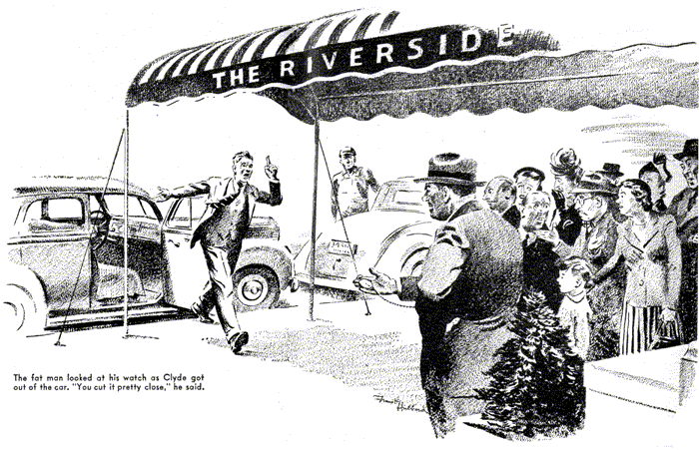
Without warning the street door to the Model Garage office was thrust open and a breathless voice shouted: "Where is everybody? Can I use the phone?"
Gus Wilson looked up from the car he was working on and into the office through the open shop door.
"Sure," he told the newcomer, a young man in a brand-new conservative gray suit, and he put down his wrench and walked into the office, wiping his hands on a piece of waste.
Joe Clark had knocked off an hour early that afternoon, and Gus was keeping his eye on his partner's office while finishing up a job on the shop floor. The young man, obviously a veteran even without the discharge button in his lapel, had already given a number down in the city and was nervously watching the clock on the office wall.
"That you, Mr. Beldon?" he said anxiously into the phone. "This is Clyde - Roger Clyde… Yes - yes, I'm on my way, but I'm having - I mean, something came up that delayed me… What's that?"
His face lost all remnants of its ruddy outdoor glow, and heads of perspiration broke out on his forehead.
"But you can't do that!" he pleaded. "You promised.. Well, I'll make it."
He hung up the phone with a look of almost desperate determination on his face.
"Know the Riverside Apartments in the city?" he asked Gus. "I've got to be there in exactly 45 minutes, and you've got to get me there!"
"Why me?" Gus wanted to know. "You've got a car. I hear its motor running outside. You can easily drive it in a half hour."
"But you don't understand," retorted Clyde. "Two cylinders are missing.. "
"Don't argue with me," Clyde shouted. "I want it hitting on all eight."
Gus began to suspect that his visitor was AWOL, from some psychiatric ward. "Take it easy, son," he said soothingly. "I'll be glad to help you, but.. "
"Quit stalling," the man said and dragged him outside. "There can't be anything serious. The car's just out of the shop."
Gus listened to the motor of the sedan. "Two cylinders are missing, all right," he agreed. "When did you lose them?"
"What difference does it make when I lost them?" Clyde returned. "Do something!"
Gus is usually even-tempered, but he decided the time had come for plain talk.
"Look here," he said. "If I do this job, I'll do it my way. There isn't time to check your engine, so answer my questions or take the car somewhere else."
Clyde tried to smile. "You're right," he admitted. "I've come from Hilton just after having the motor overhauled. The car ran fine for about 10 miles, and then began to miss. First it hit on seven cylinders, then on only six. I stopped at the first garage, and the mechanic put in new spark plugs.
Everything was fine again - for another 10 miles. Then the motor began hitting on only six again. At the next garage, the mechanic tested all the plugs and the ignition wiring, and finally decided there was dirt in the carburetor."
Clyde paused to catch his breath.
"He charged me plenty for cleaning and adjusting the carburetor - and what was the result? Here I am, and on six again."
He looked at his watch. "Man, we're wasting time!" he yelled. "Get busy!"
"O.K.," Gus told him and lifted the hood. For thirty seconds he peered beneath it. "Stan," he called in to the Model Garage grease monkey, "get me some tape."
Even as he did mysterious things with the tape, the rough-running engine settled to a smooth pace. Gus straightened and dropped the hood back in place.
"All right, mister, there are your eight cylinders," he grinned. "That's 50 cents - and you've still time to get to the Riverside."
"No, you don't," Clyde told him. "Those other fellows fixed it so it ran all right for a while. You're coming with me in case it starts missing again."
"Say, what is this?" Gus demanded.
"It's a - a matter of life and death, almost," Clyde pleaded. "Please come."
Gus knew he shouldn't, but he felt sorry for the young fellow and agreed. He told Stan to look after the shop.
"I'll drive my own bus," he said. "You follow. I know a short cut, and I know the cops."
Ordinarily Gus Wilson doesn't drive fast, but when he wants to get some place in a hurry, he can do it. When he pulled up at the Riverside with young Clyde just behind him, they had two minutes to spare.
A fat man was standing on the sidewalk with a dozen or more people grouped around him - all with that same harried, anxious look that had been Clyde's.
The fat man looked at his watch as Clyde got out of the car.
"You cut it pretty close," he said. "That the car?" And he got in and drove away.
Gus looking at the disappointed faces in the crowd, couldn't hold in any longer.
"What is this, anyway?" he asked.
"Beldon's got an apartment he's going to sublet to me in return for selling him my car," Clyde told him. But the relief on his face gave way to anxiety again, and he muttered: "I hope it doesn't start missing."
"It won't," Gus assured him. "But what's this apartment deal?"
"Beldon and I are salesmen for the same company," Clyde explained. "I'm being transferred from Hilton to the city, where I don't need a car, and Beldon is being transferred upstate where he does need one. I offered to sell him my car in exchange for his apartment. But he's a tough customer, and he'd give me only until 5:30 this afternoon to deliver the car. If I hadn't shown up, he'd have traded with one of these other people.
"Now I see," Gus laughed. "I knew cars were hard to get because I'm sort of in the car business, but I never dreamed the housing shortage was this bad."
Beldon drove back in Clyde's car and got out. "Sorry, folks," he called to the crowd.
"Clyde here has a priority on my apartment, since his car's in good shape. I gave him my word. But if he'd been a minute late -"
"Gee, thanks, Mr. Beldon," Clyde beamed. "You keep the car, and I'll be down Thursday to take over the apartment and close the deal with you."
He looked at his watch, "I've got to catch the six o'clock train back to Hilton. Will you drive me to the station, Mr. Wilson?"
They climbed into Gus's old but well-kept coupe, and Clyde asked what he owed. Gus added the time for the trip to the original 50 cents and pocketed the money.
"It's Beldon's worry now," Clyde said as they neared the station, "but what was the matter with the car?"
"Oh, nothing much," Gus laughed. "The mechanic who overhauled your engine was careless in replacing the hose that feeds hot water to the heater. In your car it passes straight over the engine and, as soon as I lifted the hood, I saw it was sagging and touching two spark plugs. Besides, you had just had your engine tuned, the spark plugs were new, and the carburetor had been cleaned, so I was looking for a short."
"But the hose is rubber," Clyde protested, "a nonconductor. It wouldn't short."
"No?" Gus grinned. "But yours must have had a little leak. I felt it, and the outside was wet - and water is a conductor. But taping the hose to a radiator tie rod kept it from sagging onto the spark plugs. That corrected the short."
"But why did it run fine for a few miles each time it was fixed?"
"Oh, those mechanics pushed the hose aside to check the plugs," Gus replied. "But it jogged back again on the road."
They pulled up at the station, and Clyde got out.
"Maybe I ought to tell you, Mr. Wilson," he said hesitatingly. "The real reason I needed that apartment so bad is because I'm going to be married Thursday, the day I'm to transfer to the city, and we would have had to postpone it if we couldn't have found a place to live. Wait until I see Eloise tonight! Won't she be happy!"
END

