September 1945

GUS CURES A WAR HEADACHE
by Martin Bunn
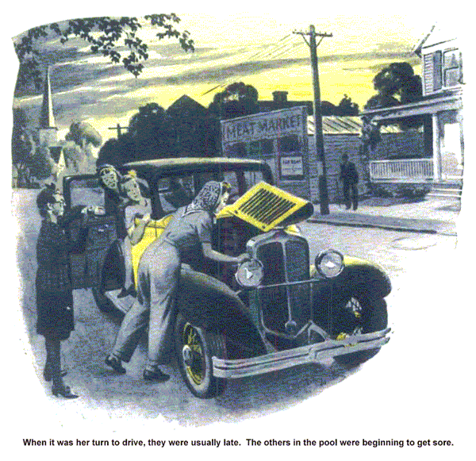
"Hey, boss," Stan Hicks said with somewhat forced breeziness. "I've dug up a new customer for you!"
Gus Wilson's expression was noticeably lacking in gratitude as he regarded the Model Garage's grease monkey and blossoming mechanic. "Well, now, that's just dandy," he told him sarcastically. "Here I am working four or five evenings a week trying to keep our regulars happy, and you go out and dig me up a new customer. I'll tell you what, Stan - get out your shovel and cover him right up again!"
Stan grinned sheepishly. "Well," he admitted, "maybe I'd ought to have said that this party is a sort of personal friend of mine, and would you do me a favor and take a look at -"
"Who is he?" Gus interrupted.
Stan's face got red under its habitual coating of grease. "Well," he stammered, "it ain't a he - it's a she." "Oh," Gus smiled, "so that's it?"
"No, that ain't it!" Stan protested. "I used to go to high school with this Barbara Milligen. She's always been car crazy, and ever since she was a kid in freshman class she's been saving up her dough to get herself one. When she got a job in a war plant about a month ago she had to have a bus, so she took her coin out of the bank and bought an old sedan from one of those big used-car dealers down in the city. She ain't as dumb about cars as most girls, but it looks to me like they sold her a quince. Can I bring her in? She's outside now."
A minute later a much-shined-up 12 year-old green sedan was driven into the shop. Gus noticed that its tires were good and that its engine was running smoothly. Stan got out on one side and a red-haired girl with a flock of freckles and an expression of concentrated fury got out on the other. She looked at Gus unsmilingly and announced. "I wish I'd never set eyes on this junk wagon, and I'll bet you will, too, after you've worked on it."
"Don't mind Barbara, boss," Stan put in diplomatically. "She's always been a sourball."
Barbara's green eyes blasted him. "Keep out of this, jerk!" she snapped. "I'm talking to Mr. Wilson."
Stan's feelings were outraged. "Yeah, you're talking to him because I did you a favor getting him to bother with your broken-down old bus!" he yelled. "And now the gratitude I get - "
Gus laughed. "Don't quarrel kids," he advised. "There's no sense in getting sore at a car, miss - I've done it hundreds of times, and it never did a bit of good. Suppose you tell me just how yours has been acting up and what you've done about it."
Barbara's face crinkled into an attractive smile. "O.K., Mr. Wilson," she agreed.
"Well, I knew enough about cars - mostly from always wanting to own one - not to expect to get a super-duper deluxe job for what I paid - and I didn't. I did expect something I could drive back and forth to the plant without continual trouble - but I didn't get that either.
"The first few days, it ran fine. Then the battery got weak, and one morning it didn't have enough kick to turn the motor over. I had it recharged, but the next week it ran down again, and the man at the garage said it must be the generator. He went over it and put in new brushes and everything, and nicked me plenty. Inside of a week the battery was down again, so I took the car back to the place where I'd bought it, but they wouldn't do anything - and got fresh about it, too.
"I have to be in a car pool, of course and every time it's my turn to drive I have a lot of trouble getting started - and usually we're all late for work. The others in the pool are sore and say they'll drop me if I don't get my car fixed. Others will hear about it and won't want me in their pools, and I'll have to give up my job - and, believe me, Mr. Wilson, those fellows fighting in the Pacific need what I'm helping to make!
"Well, while I was wondering what I could do," she went on. "I ran into Stan, and here I am. I'll have to leave the car here - my shift goes on at four o'clock. I can take a bus to the plant, and coming back tonight -"
"Never mind about tonight," Stan told her. "If we can get your car fixed, I'll drive it over and pick you up at the gate, and you can drop me at my house on your way home."
"Why, Stan, that's real nice of you!" Barbara said.
"Oh, well - I haven't got anything to do tonight," Stan muttered in embarrassment.
Barbara's green eyes blazed again. "If that isn't just like you!" she cried. "You always spoil everything by being so - so ungracious!"
"Scram!" Gus shouted. "You two do your scrapping outside. I'm a busy man."
Five minutes later Stan came back grinning and found Gus checking each cell of the battery of Barbara's car with a battery voltmeter.
"They're all run down a bit, but they test even, so there can't be anything much wrong with the battery," Gus commented when he had finished. "Guess we'd better take a look at the cutout."
Finding nothing wrong there, he turned to the generator. So far as looks told, it was in excellent condition, but when he checked it he found that it wouldn't charge the battery properly until the engine was turning over at a speed rate of 40 miles an hour.
"There it is," he told Stan. "Your friend Barbara's battery runs down because the generator doesn't charge it while she's driving. The juice that's drained out isn't replaced. Well, we've found the cause of the trouble; now we've got to find the cause of the cause. Take the generator out and put it on the test bench."
Stan did as he was told. Gus put in 10 minutes going over the generator carefully, looking for mechanical defects which he didn't find. Then he hooked it up with the test-bench drive motor for an electrical check. When the tachometer showed that the generator was being driven at a speed of about 600 r.p.m. - corresponding to a car speed of about 10 miles an hour - it began to charge, and as Gus gradually increased the drive-motor speed to 1,400 and then 1,800 r.p.m., the ammeter hand moved over to 10 and then to 12 amp. Gus looked puzzled as he switched off the drive motor.
"There's nothing the matter with this generator," he told Stan. "It works perfectly when it's driven by the test-bench motor, so there's no reason why it shouldn't work perfectly in the car. But it doesn't! Well, we'll try again."
They reinstalled the generator in Barbara's car. Then Stan stepped on the starter and gradually increased the engine speed as Gus checked the generator output.
"Switch her off," Gus directed after half a minute. "It's exactly the same as it was before. The generator doesn't start to charge the battery until the engine is running at almost 40. There's something screwy here - and maybe it's me!"
Staring at the generator, he slowly filled and lighted his pipe. After a couple of puffs, he snapped his fingers loudly.
"That might be it," he muttered. He copied the generator serial number on the back of an envelope, went over to his workbench, and reached down his service manual from the shelf above. Then he checked the serial number against the generator numbers in the manual. Stan was peering over his shoulder.
"It's the right generator for that model car, all right," Gus said. "The same generator is used on several other makes too - but look here! A lot of the parts of this generator are interchangeable with the parts of other generators made by the same manufacturer. Maybe that's it!"
"Maybe what's it?" Stan demanded.
Gus didn't answer. He went back to Barbara's car and again examined the generator. Suddenly he laughed.
"There's the cause of Barbara's grief," he told Stan, pointing to the generator pulley. "And maybe I'm dumb not to have spotted it half an hour ago - especially since I ran up against the same thing just last year. I must be slipping."
"Huh?" Stan grunted.
"I don' t get you. What's the matter with the pulley? It looks O.K. to me."
"There's nothing the matter with the pulley," Gus told him, "except that it's much larger than the one called for by the specifications for this car.
Naturally, the larger the pulley, the slower the generator is driven and the more engine speed is necessary to make the generator charge the battery. This pulley is so large that this generator doesn't start to charge until the car is being driven close to 40 m.p.h. Your friend Barbara probably never drives fast, so her battery never gets recharged."
"I get you," Stan said. "But what I don't get is how this oversize pulley got there."
Like a lot of other headaches," Gus explained, "that's a result of war shortages.
Auto electrical concerns are reconditioning all types of generators these days, and when you send in one for service or exchange you run the risk of getting back the right type of generator with a pulley of the wrong size on it unless you are careful to specify the car it's to be used in. Evidently when Barbara's car was reconditioned for sale, the right generator was picked up, but the man doing the assembly didn't notice the size of the pulley. That's an easy mistake to make. On a secondhand job the fan belt usually is old and stretched so much that it will easily slip over an oversize pulley before the generator is tightened.
"I'll find a pulley of the right size in my junk box. You put it on, Stan, and then take the car over to Barbara and tell her about it. That'll give you something to talk about while you're driving home."
"O.K.," Stan grinned. "You can depend on me to take all the credit."
END

