October 1945

GUS GETS INTO A TIGHT SPOT
by Martin Bunn
No Specialist on Boats, He Has His Trial By Fire.
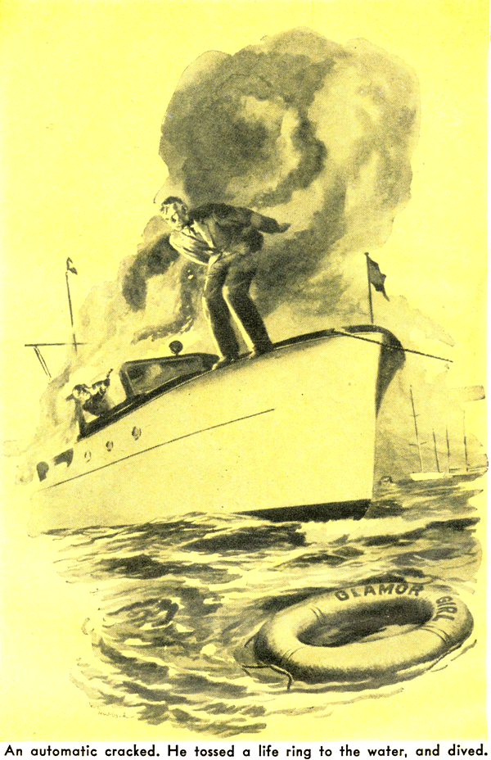
Several of us regulars were sitting around the Model Garage shop watching Gus Wilson work when State Trooper Jerry Corcoran came in and handed him a newspaper clipping.
"News of your old friend," he grinned.
Gus read the clipping and whistled softly.
"So they got him at last," he said.
"Who got who?" somebody wanted to know.
"The G-men got Slicker Bailey," Jerry told him. "They've been after him for...
How long is it since your boat ride, Gus?"
"Seven years," Gus replied. "Well, he won't plan any more bank robberies. He made a mistake trying to shoot it out."
"Fatal," Jerry agreed. "But he was the smoothest caser in the business."
"What is this?" Doc Foley demanded.
"What's a 'caser'? And why is he Gus's friend?"
"A caser," Jerry explained, "is a fellow who works ahead of a bank-robbing mob - plans the stickups and getaways. As for 'Slicker' being a friend - Gus won't deny he and 'Slicker' were once very close."
"Two close for comfort," Gus grunted.
"Remember the stickup of the First National in Greenport Harbor?" Jerry went on. "It was pulled on the Wednesday of Race Week. They got 10 grand, and there was only one clue - one of the mob appeared to have an artificial arm. By Saturday we didn't have a thing. Then Gus stepped in."
"I was aboard," Gus protested. "Forget it."
Of course we wouldn't forget it, and before we went home we had the story - part from Gus but most from Jerry. Here it is!
Before the war even as industrious a man as Gus could take time out to relax once in a while, and he was doing just that in the shop doorway late that not Saturday afternoon when a Greenport Harbor taxi drove up. The man who got out was a sporty-looking individual in ice-cream pants and a brass-buttoned blue coat, and the visor of his white-topped yachting cap was pulled down over a pair of penetrating gray eyes.
"You look comfortable," he smiled.
Gus grinned back, "I was about to close."
"Know anything about marine engines?" the visitor asked.
"Well," Gus said cautiously, "they're a little out of my line. Greenport Harbor is where you find the experts."
"I just came from there," the yachtsman nodded. "Every mechanic in the place is up to his ears in work. And I want to be on my way tonight. My name's Gillingham - J.C. Gillingham, Chicago. I've got a motor yacht over in the harbor. Been there all week watching the races. Last night my engineer came aboard drunk, and I had to fire him. I don't know a lot about engines, but once we get going I'll do all right. The trouble is I can't get the engine started. Drive over with me and start the engine, and then name your own price."
Gus hesitated, and Gillingham laughed. "Be a good guy!" he urged and Gus gave in.
Through the drive to Greenport Harbor and during a good dinner at a roadhouse, Gillingham talked familiarly of men Gus knew to be prominent in the shore community.
"Most hospitable crowd I've ever run into," he declared. "Made me feel as much at home in their club as I do in my own. Even old Jonas Manderville, when I dropped into see him about a little business matter.
I figured he was just another small-town banker, but after we'd talked for half an hour he offered me a guest card at his golf club. Too bad his bank was robbed."
It was evident when they reached the yacht club that Gillingham was popular there. He replied jovially to the hails of a dozen or more members, most of them dressed exactly as he was, but he kept on going. "Here's my dinghy," he said when they reached the dock.
They got into the boat, Gillingham again the outboard motor into activity, and they put-putted down the harbor past stock tall-masted racers and smart power yachts that bounced vaguely in the warm, growing darkness. Finally they came alongside a big motor cruiser that lay at the mooring busy farthest out. When they climbed aboard, a man came along the dock toward them.
"Fellow to fix the engine," Gillingham told him, and led the way into a dimly lighted main cabin where three men were playing cards. Their faces in shadow, they stared silently. "Fellow to fix the engine," Gillingham said again and Gus followed him through a passageway, with closed stateroom doors to the bulkheads at either side, and into the engine compartment.
Gus took off his coat and went over the engine. It was an old one that hadn't had too good care, but there didn't seem to be anything seriously wrong with it. After five minutes of checking he found out why it wouldn't start the fuel-pump filter was clogged. He cleaned it and asked Gillingham to press the starter button. The engine roared into life at once.
"That's fine," Gillingham said. "I'll fix it with one of the boys to take you ashore . Be right back."
"I'll have to wash up first."
"Yes, of course," Gillingham said over his shoulder. "First door on your - "
The cabin door slammed, and Gus didn't hear the rest. He picked up his coat, went into the passageway, and waited. After a minute he got impatient and tried the knob of a door. It turned, and he pushed the door open. A light was on, and he stepped into a small stateroom. He looked around for a wash basin - and his jaw dropped.
On top of the built-in chest of drawers lay a human arm, its hand in a black glove!
Gus's heart skipped a couple of beats. Then he grinned. It was an artificial arm, of course. Then his heart skipped again as he remembered something Jerry had told him - that one of thugs who stuck up the Greenport Harbor bank had an artificial arm!
A rasping voice made him start. "What are you doing in here?" A sallow, hard-faced man was getting out of a bunk in which he had been lying fully dressed. He had only one arm - and in his lone hand he had a wicked-looking automatic.
There were quick footsteps in the passageway, and Gus turned to see Gillingham, his face still smiling but his gray eyes hard.
"I'm sorry," Gus said. "I was looking -"
"You're going to be sorrier!" the one-armed man grated. He too, looked at Gillingham. "No use trying to bull him, Slicker," He's wise - I seen it in his eyes. Get outta the way while I plug him."
"We're still in the harbor, you bophead," Gillingham snapped. "When we get outside we'll drop him overboard - with something heavy tied to his feet."
The one-armed man grunted grudging assent, and he and Gillingham went out, locking the door behind them.
Gus had good reason to be scared - and he was. He sat on the bunk and tried to figure a way out. Then he heard the engine start, and in a short while the motion of the boat told him they had reached open water. There were cigarettes and a lighter on the bunk. He lit one and looked around. His eye caught a small-diameter copper pipe running along the bulkhead. He examined it closely, and hope flared. "Looks like the fuel line," he muttered. "If it is. - " He snapped the lighter and held its flame against the pipe.
For what seemed like a minute nothing happened. Then the engine stopped. Gus grinned. "Thought so-vapor lock," he whispered. He kept the flame against the pipe until he heard footsteps, and then he sat quickly on the bunk. The door opened, and Gillingham and the one-armed man comin' in.
"Something's wrong again," Gillingham told Gus. "We'll make a deal. You get the engine running, and keep it running, and we'll put you ashore safe and sound."
"All right," Gus said, "I'll do it."
With the one-armed thug at his heels, he followed Gillingham to press the starter button. He did, but nothing happened.
"Wait a minute," Gus said - and he noticed that Gillingham left the ignition on. He disconnected the fuel line, primed the carburetor with enough gas t run the engine for 10 or 15 seconds, and set the throttle wide open. Now he was sure that enough time had passed for the vapor look to have cleared away. He pointed the disconnected end of the fuel line at a spark plug and said: "Try again."
Gillingham pressed the starter button. Gus spurted on the spark at the plug and instantly there was a flash of blinding flame. Gus jumped backward and crashed into the bulkhead. Fresh gas, pumped through the disconnected fuel line by the racing engine, burned viciously. Gus picked himself up to grope his way to the deck. Someone yelled, and an automatic cracked. Gus leaped across the deck, wrenched free a life ring lashed to the rail, threw it far, and dived.
He stayed under water as long as he could. When he came up the cruiser was blazing from stem to stern. He saw the life ring a dozen yards away, swam to it, and worked his way out of the glare of the burning boat. Half an hour later he was picked up by one of the motorboats attracted by the fire.
Doc whistled. "What's the end?"
"This is the end," Jerry said, holding up the news clipping. "What was left of the one-armed thug and one of his pals was found on the boat. Two others got away in the dinghy, but we were waiting for them when they landed. Both had big rolls, and they squeaked on "Slicker" Bailey.
"Gus's story was kept out of the papers so "Slicker" - if he was alive - wouldn't find out he'd been squealed on. He was alive all right - he could swim like a fish. And pretty soon some more bank jobs turned up that he might as well have signed his name to. But he was slick, and it took the G-men seven years to catch up with him."
"Yes," Gus said, "they always get their man, though. But since you fellows took to making a club out of this shop, I never get a decent dinner - I always get down to the Park House after the meats gone. Scram!"
END

