March 1945

THINGS BOIL OVER
AT THE MODEL GARAGE
by Martin Bunn
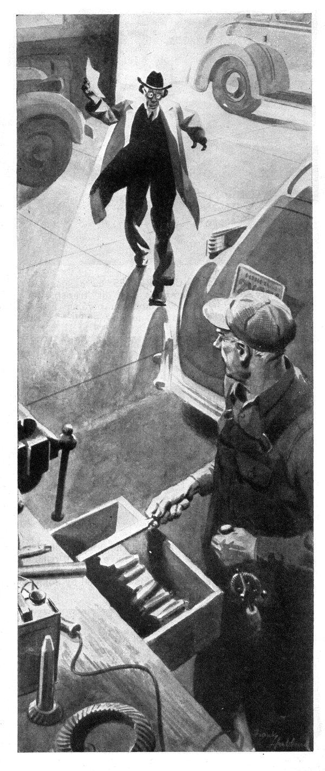
No matter how busy a day he has ahead, Gus Wilson tries to start it slowly. He takes his time eating a he-man breakfast, and when he gets to his Model Garage shop he begins operations by doing some easy job before he tackles a hard one.
"It's common sense," he says when we kid him. "If you want an automobile engine to work right and last a long time, you don't drive it hard before it gets warmed up. It's the same way with human machinery. If you start easy in the morning, it'll do more work for you before night-that's been my experience, anyhow."
But the morning that old Silas Barnstable picked to put up a squawk about the statement Joe Clark had mailed to him, Gus didn't get a chance to start slowly. When he got down to the shop he found Doc Marvin waiting with a job he wanted done quickly because he had to get out in the country to attend a sick kid. It was bothersome, dirty, hard-to-get-at job, and when Doc drove away Gus's normally good temper was wearing thin at the edges.
Then Silas came in, looking even more like a bantam rooster than usual. He's our town's most notorious skinflint-a dried-up little ex-farmer who sold off his rocky acres for suburban building lots during a boom 20 years or so ago.
Silas smacked the bill down on Gus's workbench, "I won't pay it!" he snarled. "It's robbery!" "Jes' because a body's been foresighted enough to lay by a few dollars ain't any reason he should be cheated right and left."
"You've got to shade that bill down, Gus Wilson, or I'll never give your shop another job!"
If Gus had been in his usual good humor, he would have grinned tolerantly at the old crab, kidded him a little, and soon made him admit there wasn't anything wrong with the bill. But he wasn't in his usual good humor, and his temper slipped the leash.
"I'm sick and tired of hearing you yap about every bill Joe Clark sent you!" he snapped. "If you never come in here again It'll be soon enough to suit me.
For a moment old Silas thought Gus was fooling. When he saw that he wasn't, he started to say something, thought better of it, snatched the bill up off the workbench, and stalked out with his skinny little back as stiff as a ramrod.
Gus watched him go and he began to feel sorry. He hesitated a moment, and then started for the door. But before he got to it, an engine took off outside, and Silas's sedan shot out of the drive and headed up the highway. Gus stared after him.
"Now," he asked himself, "what the dickens made me boil over? That's what comes of breaking my rule to start slow and easy in the morning. Well, it's nothing to worry about-he'll be back in a week or so, ornery as ever.
But weeks added up to a month and more before Gus saw Silas again. Then it wasn't in the Model Garage, but downtown as he was going into the Park House for the weekly Kiwanis luncheon. He noticed steam clouding out of the radiator of Silas's sedan, which was parked at the curb, and then saw Silas hurrying across the sidewalk with a pail of water and an anxious look.
Gus walked over, "Hello, Silas," he said cheerfully. "Want a hand?"
Silas looked at him as if he'd never seen him before. Then he poured the water into the radiator, replaced the cap, tossed the pail into the back of his sedan, climbed stiffly into the driver's seat, slammed the door after him, and drove away.
Gus's face turned red. Policeman Jim Devine, who had been watching, grinned widely, "The old rooster's sure got his ax out for you, Gus," he said. "He's telling everyone you overcharged him and then insulted him when he kicked, and that he's off you for life. Of course, nobody pays any attention to him, but-." Gus grunted and went into the Park House. He didn't enjoy his lunch that day.
One afternoon a couple of weeks later, Joe Clark came into the shop looking peeved. "That fellow Brindley's on the phone," he told Gus. "Says he can't find out what's the matter with a job he has in his place, but he knows you can, and he wants to bring it over. The nerve of him! What'll I say-that you're too busy?"
Brindley is a young chap with a medical discharge from the Marines. He has opened a neighborhood garage on the other side of town from Gus and Joe's place.
"Tell him to bring it along, of course," Gus replied. "I'm busy-but not so busy I can't take time to give a hand to a kid who's trying to get started."
"Now, look here, Gus," Joe said earnestly. "There's a limit to good nature! I haven't kicked-much-about you telling a lot of fellows how to do jobs they ought to bring to us. But, when it comes to helping an out-and-out competitor-."
Gus grinned. "We're turning down work every day because we can't handle it. And as for helping young Brindley, well, it seems to me that he was helping us when he got himself shot up on Guadalcanal."
Joe went back to the office growling, but half an hour later Brindley drove in a sedan that Gus recognized at once as Silas Barnstable's. Its radiator was steaming.
Brindley was embarrassed, "I'll bet you think I've got a nerve, Mr. Wilson," he said. "and I guess I have. But you're the top man on car troubles around here, and I thought maybe you'd help me out. I told the man who owns this car that I could fix it, and now I can't even find out what's the matter with it!"
"We all got 'em that way once in a while," Gus said. "The radiator's boiling-no doubt about that, anyway. Suppose you tell me what you've done." "Sure," Brindley said. There was relief in his voice, but an undertone of embarrassment, too. "there was quite a lot of work done before the owner brought the car to me. When the boiling started, he took the bus to a big shop down in the city. They checked the spark and valve timing. When they couldn't find anything wrong there, they thought that maybe the overheating was being caused by too lean a mixture so they had their carburetor expert check the intermediate and high-speed jets. They were all right, too, so they sent the radiator to a radiator specialist to have it boiled and then they pressure-cleaned the entire cooling system with live steam to get rid of all the inside scale. They charged a good high price for the job, and when the radiator began to boil again a couple of days later, the owner really popped off.
"Someone told him about my place, and he brought the car in." "When I took the engine head off and found several of the valves burned, I figured they were causing the overheating and that regrinding would cure it." "But after the valve job, the radiator was boiling as bad as ever."
"O.K.," Gus said, "I'll have a look." He got in and started the engine. "What clearance did you give the valves?"
Brindley snapped his fingers. "I am dumb" he said "I clean forgot to tell you that two of the valves were burned so badly I had to replace them."
Gus switched off the engine, "You did?" he said. "How about the spark plugs?" "Pretty well burned," Brindley said.
Gus got out of the car and called: "Stan! Get me the vacuum gauge!" When the grease monkey brought the gauge, Gus attached it to the intake manifold at the windshield-wiper connection, started the engine, and let it idle. He saw the gauge read 16," "Not very high," he commented. "Take the muffler off, Stan."
Gus got back into Silas's car after Stan had finished. This time the engine took off with a roar. He throttled it down to idling speed, got out, and looked at the vacuum gauge, which now showed 20."
"I thought so," Gus said. "Switch her off, will you Brindley?" Your troubles are over-or they will be when you install a new muffler and collect your bill."
Brindley showed astonishment. "What you say is good enough for me, of course-but I don't get it. What's the muffler got to do with the radiator boiling-and how can you tell, without even lifting the hood, what caused the trouble?"
Gus grinned. "Oh, it's just a matter of adding one thing to another and getting a sensible answer. That's where experience comes in-and experience is something a mechanic picks up as he goes along.
"To start with, every car cooling system is designed to handle just so much heat, and not much more. When the engine generates more heat than the system can dissipate, the radiator boils. "I know from what you told me about the work that had been done before the car was brought to you that the radiator couldn't be clogged and that the timing hadn't gone haywire. When you told me that the valves were burned so badly you had to replace two of them and that the spark plugs were burned, I knew that the extreme heat from burning gases around the valve and valve ports wasn't being carried away quickly enough. The most likely cause of that is backpressure in the exhaust system caused by a restriction in the muffler. When the gauge registered 16" of vacuum with the muffler on and 20" with it off, it showed that the muffler caused the overheating. Let's look."
Gus got the muffler and opened it. It was almost full of scale and corrosion, "There," he said. "Put on a new muffler, and you won't have any more trouble."
"Say, that's remarkable," Brindley exclaimed. "Well, now-what do I owe?"
Gus laughed, "Forget it. Some day you'll give me a lift."
The ex-Marine hesitated; then he said: "There's something I ought to tell you. The man who brought this car to me was customer of yours."
Gus laughed again. "I never forget a car," he said. "Do me a favor-don't tell the old grouch I had anything to do with it."
Two weeks later Gus looked up from his workbench and saw Silas Barnstable standing beside him. Well," he asked uncordially, "what do you want?"
"Want to pay my bill," Silas told him, fishing it and a check out of his pocket.
"You're in the wrong department," Gus retorted, "Go see Joe Clark."
"No reason to snap a feller's head off!" Silas complained. "Look here, Gus-I got it out of that young Brindley that you fixed my car up when nobody else could. Let's forget and forgive."
"Oh, all right-all right," Gus said.
Silas appeared relieved. Then he got a worried look. "That don't mean that I'm goin' to put up with any overcharges, jes' because a man's laid by-" "Scram!" Gus grunted. "I'm busy!"
END

