June 1945

GUS MAKES A QUICK COMEBACK
by Martin Bunn
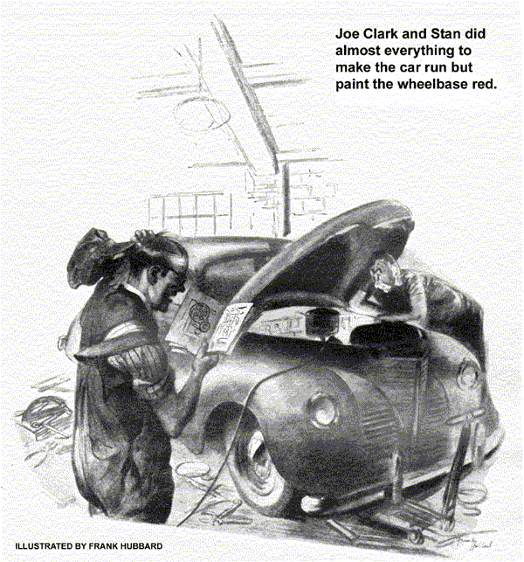
Just after Joe Clark had opened the Model Garage office one morning Doc Marvin telephoned him that his partner Gus Wilson had the flu.
"What!" Doe yelped. "Gus sick? You're kidding me, Doc! Gus has never been sick a day in his life.... When will he be in - tomorrow?"
"No, he won't be in tomorrow, or the next day," Doc said. "He'll be all right in a day or so, but to be safe I'm keeping him in the house for a week - if I can. Right now he's worrying his head off about the shop."
"What's he worrying about?" Joe demanded belligerently. "I'm here, ain't I? Where does he get the idea he's the only one can keep this business running?"
The result of his psychology caused Doc to grin. "That's just fine!" he said heartily.
"Why don't you stop in on your way home this afternoon and tell him that? It'll relieve his mind."
Doc wasn't a bit worried about Gus's condition, but that evening he went in to see him. He found his patient in a decidedly bad humor.
"What's this Joe Clark was telling me about you wanting to keep me cooped up for a week?" he wanted to know. "I feel fine right now, and tomorrow morning, so help me, I'm - "
Doc slipped a thermometer into his mouth. "Tomorrow morning," he said, "you're going to stay in bed. Look here now, Gus - when I bring my bus into your shop, I don't try to tell you how to do the job, do I? No, siree - I give you credit for knowing your business. Well, now, you give me credit for knowing my business." He withdrew the thermometer, looked at it for a deliberate second, and began swabbing it off slowly with alcohol-soaked cotton. "That's only fair, isn't it?"
"Well, if you put it that way - oh, all right," Gus agreed unwillingly. "But it scares me when I think what's going to happen in the shop - with a guy who's a swell bookkeeper running things, and a grease monkey doing the work... I tell you, Doc, there'll be so much grief around the Model Garage when I get back that a week of rest in bed is going to be a total loss!"
Gus growled and grouched every day, but Doc had his way, and it was a full week before Gus got out of the house. Then he made a beeline for the Model Garage. He fully expected to find the shop in an unholy snarl and, feeling full of pep after his enforced vacation, he rather looked forward to untangling it.
Barely pausing to say hello to Joe Clark, he hurried into the shop. To his surprise he found no more than the usual number of cars on the floor awaiting attention, and Stan Hicks, busy over a bench job, was whistling cheerily. The grease monkey greeted him with a delightful grin.
"Gee, boss," he said, "I'm glad you're back!"
"That's all right," Gus told him with an attempt at casualness. "You've done a swell job keeping things going, and it was only to be expected that you'd run into some grief. We'll soon get -"
"Grief?" Stan interrupted. "We haven't run into any grief.
Everything's been as smooth as cream. What I meant was that I'm glad you're back because it was lonesome."
"Oh, I see," Gus said. A horn sounded at the gas pump. "You go ahead with what you're doing. I'll take care of it."
It was Mrs. Miller. "Oh, Mr. Wilson, it's so nice to see you back!" she gushed. "Not that Mr. Clark and Stan haven't done wonders - why, there was something the matter with the differential or universal or something or other on my car, and Mr. Clark diagnosed the trouble and Stan fixed it in a perfectly marvelous way. I told Henry that I think you deserve loads of credit for training that boy to do work as well as you do it yourself!"
It went on that way all morning. One regular customer after another came in, said he was glad to see Gus back, and then told him about some job that Joe and Stan had taken care of. Gus noticed that all had been simple jobs, but nevertheless when he went down to the Park House for his lunch, he was feeling considerably deflated.
"It just shows," he told himself a little ruefully, "how a fellow builds himself up to himself until he begins to think he's the whole works until something shows him that he isn't."
By the time he had finished eating he was feeling so little needed that he put in half an hour reading the newspaper in the lobby instead of hurrying back to the shop in the usual fashion. While he was still busy with his paper, Jim Fraser, who owns our town's leading candy store and ice-cream parlor, plumped his 200 pounds in a chair beside him.
"Back on the job, huh?" Fraser wheezed. "I'll say it's about time! I've been waiting for you to show up to bring my car back after the bum job your place did on it while you were sick."
Gus experienced a pleasurable sort of mental glow, but he didn't let Fraser know it. "What's the matter with your car?" he asked innocently.
"Nothing," Fraser told him sarcastically.
"Nothing at all - except that it burns twice as much gas as it ought to, and that when I try to drive it over 30 miles an hour it's got all the pep and punch of a wet dishrag.
Now, understand me - I am not claiming that dumb partner of yours and your dimwitted helper did it any harm. What makes me sore is that they socked me six bucks for not doing it any good. I ain't satisfied, Gus - I really ain't!"
"Well, I can't blame you for that," Gus conceded. "I saw your bus outside, Jim. Let me drive it back to the shop."
Joe and Stan winced when they saw Gus arrive in the four-wheeled headache, but Gus repeated Jim Fraser's beef in the most natural tone he could master. "What did you do with it, anyhow?" he concluded.
Stan grinned and looked at Joe. "We did almost everything except paint the wheelbase red," he said.
Joe looked sheepish. "To tell the truth, Gus," he confessed, "that job sort of had us stumped. We just couldn't find out what was the matter. We checked and rechecked everything we could think of, and cleaned the motor and tightened up the wiring connections, and so on. It seemed to run a little better after that, and because Fraser was calling me up about every hour, we gave it back to him."
Gus snorted. "How the dickens did you ever figure you could fix a car up before you even knew what was the matter with it?" he demanded.
He started the engine and listened intently for a minute. It ran smoothly. He went over the carburetor and fuel pump carefully without finding anything wrong with either. Then he checked the spark plugs, they were all right - and so was the point setting.
"Let's have the vacuum gauge, Stan," he said. He attached it, and found that it registered between 20" and 21" of vacuum at idling speed - which was just perfect. But then he took the car out on the highway and discovered that Fraser was dead right - that at speeds over 20 miles it was noticeably sluggish.
He drove slowly back to the shop, got out his Neon timing light, attached the ground head near the flywheel housing, clipped the other to the No. 1 spark plug, and whitened the ignition timing mark on the flywheel with chalk. Then he started the engine, and as the light flashed he watched the chalked mark, which appeared to be standing still in line with the timing pointer on the flywheel housing.
"Speed her up," he told Stan after half a minute. Stan opened the throttle and the whole mark appeared to be to the right of the pointer.
"Switch her off," Gus ordered. "It's what I thought - the timing is all right at low speeds, but it's slow at high speeds. That makes the cylinders fire on the down stroke of the pistons, which results in loss of power and waste of gasoline. The automatic advance governor in the distributor must have gone haywire."
He took the distributor apart, expecting to find the automatic governor wrights rusted and stuck. To his surprise they weren't and all the other parts in the distributor seemed to be in perfect condition. He cleaned them carefully, reassembled them, replaced the distributor, and retested it.
The timing still was correct at low speeds - and still late at high speeds
Gus muttered under his breath, took the distributor apart again, inspected all its parts, reassembled them, put the distributor back, and again tested it. The result was the same!
This time Gus expressed himself out loud. Then he lit his pipe and did a few minutes of hard thinking.
"That's it," he said, "Can't be anything else.... Hey, Stan! Give me a hand. We've got to rip this engine apart!"
They ripped it apart until they could get at the timing gears. Gus examined them and nodded. "That's it," he told Stan.
"What's it?" the grease monkey demanded in an injured voice. "It's past quitting time, and I dunno what we're doing on this job, or why!"
"Take a look at those timing gears."
Stan looked at them. "They look a little worn," he said.
"They're badly worn," Gus corrected him.
"That's the cause of the trouble. Ever hear of torque vibrations?"
Stan grinned. "I ain't read that far in the book."
"Well," Gus said, "it's sort of twisting vibration that occasionally causes plenty of hard-to-locate grief. In this particular case it keeps the automatic-advance governor from advancing the spark at the speed of the car increased. That's why this bus hasn't had any pep and has been burning up Jim Fraser's gas fast.... We'll have to put in new timing gears, and that'll be quite a job. How do you feel about a little overtime this evening?"
Doc Marvin, passing the Model Garage about 11 o'clock, noticed the lights and went in. He found Gus washing up.
"By George," he squawked, "I might have known it! Didn't I tell you that the only way to get over flu is to take it easy?"
Gus grinned. "Flu?" he said. "Honest, Doc, I forgot all about it. There's nothing like a good tough trouble-shooting job to help a man make a quick comeback!"
END

