July 1945

GUS TURNS
HIGH-PRESSURE SALESMAN
by Martin Bunn
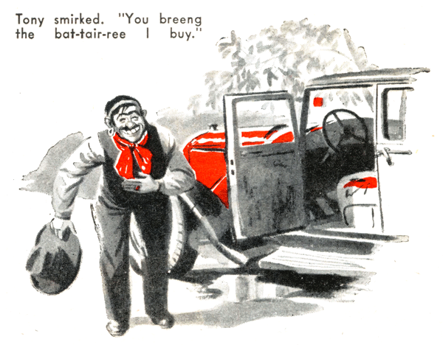
"Hello, Mis-tair Veel-son!"
Gus Wilson looked up from his workbench toward the Model Garage shop door where a bright, spring sun revealed a squat, dark figure in stained clothes. The visitor took off a floppy hat and, with an exaggerated gesture, swept it to the floor as he bowed low. Then he advanced into the shop, teeth gleaming white in an ingratiating smile under a long black mustache.
"Oh, hello, Tony," Gus said, returning the greeting with little cordiality. "So spring's here. When you gypsies show up, that makes it official. What did you come in for –to bring back that monkey wrench you snitched the last time you were here?"
Tony's swarthy features registered bland innocence. "Monkey ranch?" he asked,
"What ees a monkey ranch?"
Gus shrugged. "Well, what do you want now?" he demanded.
Tony edged up to the bench, and Gus saw a covetous gleam in his dark eyes as his glance ranged over the tools on it. "I come to buy a bat-tair-ree, Mis-tair Veel-son," he said. "Mine, he go flooey all the fay from Sout' Car'lina." A grimy hand moved stealthily toward a peening hammer. "You got goot bat-tair-rees, Mis-tair Veel-son?"
"Get your mitts off that bench, and keep 'em off. See?" Gus snapped. "Batteries? Sure, we've got swell batteries. You go into the office and pay Mr. Clark 14 bucks, and I'll put one in you bus."
"You put heem in," Tony suggested, "an' I pay you five dol-lair now an' the rest to morrow. Ho-kay, Mis-tair Veel-son?"
"Scram," Gus laughed. "I'm busy."
Tony was silent for a moment. Then he tried again. "Mis-tair Veel-son, you sell a five dol-lair bat-tair-ree? Ho-kay?"
"We haven't any secondhand batteries," Gus told him with finality.
Tony went into a lengthy lamentation about the trouble he was having with his worn-out battery. It was interrupted by the appearance of Joe Clark who glared when he recognized the gypsy.
"Get out of here," Joe yelled. "Last year you thieving gypsies swiped a box of spark plugs and an inner tube. Get a move on! Beat it, or I'll call the cops."
Tony saw the game was up, and he made a complaining but hasty retreat.
Joe turned to Gus, "Jerry Corcoran just phoned," he told his partner. "He wanted to remind you that the trout season opens tomorrow and suggested that you take the morning off and go to Brawley Brook with him. He doesn't have to report to the State Police Barracks until afternoon. Well, what do you say? It will do you good. Shall I call back and say you'll go?"
Gus went into a long speech about why he couldn't go - too much work to be done in the shop, the water too cold for trout to take a fly, and, as a clincher, too many fishermen on opening day.
Joe laughed at him. "You say all that every year," he pointed out, "and every year you wind up by going. I'll tell him you'll be along tomorrow morning - as usual."
"Oh, all right," Gus weakened, none too reluctantly. "I'll be a sucker again. Tell him I'll pick him up about six."
Brawley Brook at seven o'clock the next morning was, as Gus told State Trooper Jerry Corcoran, even worse than he had expected. Every pool was rimmed solidly with fishermen, and on every bank they were bumping into each other. A flood of ice-cold and badly roiled water was swirling turbulently down the stream, and the fish were staying on the bottom.
After a miserable half hour spent trying - most of the time unsuccessfully - to find enough free space for a cast. Gus waded ashore and began taking his rod apart.
"Quitting?" Jerry demanded.
"Call it that if you want to," Gus told him. "I call it having a bit more sense than I had when I came out here."
Jerry started to adjust his rod too. "I guess there's no chance here," he agreed.
"Let's go over to Rocky Creek - back to the woods where we won't have company. I know a hole that ought to have fish in it."
"Waste of time," Gus said. "No self-respecting trout will take a fly with the water the way it is today."
Jerry grinned. "I've got a can of worms - brought them along just in case," he confessed. "You're not too proud to fish with worms, are you?"
"Let's go!" Gus retorted.
They got into his old but sweet-running roadster and started for the upper ranch of Rocky Creek. When they came through a big patch of woodland, they saw a number of cars parked in a field ahead.
"More fishermen," Gus growled. "Why don't they park at the end of the road?"
"They're not fisherman - they're gypsies." Jerry put in. "There's a gang that camps there every spring. We have to keep an eye on them or they wouldn't leave a chicken in the county."
There were half a dozen battered jalopies in the field. A crowd of women in long, bright-colored skirts and dirty children in assorted rags mulled around a cooking fire a short distance away. Tony was standing at the side of the road, and he grinned and waved his hand at Gus as the roadster passed him.
"Friend of yours?" Jerry asked.
"Not so much so that he didn't swipe some stuff from the shop last year and try to talk me out of a battery yesterday," Gus told him. "But I sort of like the old pirate."
The road ended at the edge of the woods halfway up a fairly steep hill. Gus turned his roadster before they got out. "Somebody else might park here, and we might have some trouble turning around," he remarked. They took their tackle and followed a half-overgrown path over the ridge and down the far slope.
"This is the place," Jerry said when they came to a creek after 15 minutes of walking. "There's a deep hole under that high bank." He produced his can of worms. "Now we'll catch some fish."
An hour later Gus landed his third trout. "Let's leave some for somebody else," he said with satisfaction.
They disjointed their rods and started back. At the top of the ridge Jerry pointed to a car parked alongside theirs. "Somebody's doing something to your car," he warned.
They saw a man lift something out of Gus's car, hurriedly put it in his own, and drive away. By that time they wee running. "It's that Tony," Gus panted.
Jerry is young and he beat Gus to the car. "He got your battery. We're stuck."
Gus didn't pause to regain his breath. He grabbed the battery cable, quickly wrapped a handkerchief around the terminal, and wedged it in the empty battery carrier. Then he released the brake and told Jerry: "Give her a push and jump in!"
The car began to coast down the grade with increasing speed. At 15 miles an hour Gus switched on the ignition, shifted into high, and gently let in the clutch. The engine coughed and started.
Although Tony had a half-mile start, they overlook his old, worn-out bus rapidly.
"Pull over," Jerry roared, opening his fishing coat and pointing to his badge.
"Ah, Mis-tair Veel-son," Tony smirked as he stopped. "You breeng the bat-tair-ree I buy yesterday, so I take heem out your car.
Ho-kay? I hope I make no mees-take."
"It's not O.K., and you made a big mistake. You're under arrest," Jerry growled.
"Wait a minute, Jerry," Gus said with a wink. He turned to Tony. "Are you sure you're satisfied with the battery?" he asked.
"Remember, any battery in the shop is $14. Did you get the one you want?"
Tony grinned ruefully and brought out a fat, greasy roll of bills. "Sure, he's a fine bat-tai-ree," he said and peeled off $14.
Gus took them. "No complaint," he said.
Jerry chuckled, but he told Tony seriously; "Now, you - I'll be out this way tomorrow morning, and when I get here you and your gang had better be somewhere else." Admiration crept, into his voice as the squat man drove away. "Gypping a gypsy - 14 bucks for an old battery!"
"I didn't gyp him. It was a new battery - I put it in just last week. But it'll do his soul good to think that he may have been gypped for once. It's lucky I kept the motor running while we were talking to him or we'd be the ones stuck."
"Say!" Jerry cut in. "How did you run this far without a battery?"
"It's nothing remarkable," Gus laughed.
"But I wouldn't advise it except in an extreme emergency. You remember we actually started on a grade when you gave me a push. I had wrapped the battery-cable terminal to prevent shorting, and the generator supplied current after the engine began turning over fast enough. But if you ever have to try it, don't drive too fast, for it's hard on the points, coil and condenser.
"Without a battery in the circuit, a generator is likely to build up too high a voltage. That burst of speed that overtook Tony may have cost me more than the profit on the battery. I'll check as soon as we get back to the shop. And don't yell at me to get you to work in a hurry - I'm staying under 25 until I put in another battery."
END

