December 1945

CHRISTMAS EVE
AT THE MODEL GARAGE
by Martin Bunn
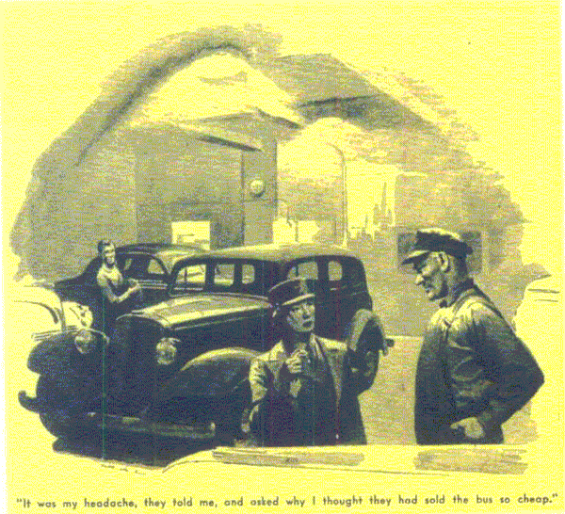
With a wide grin, Gus Wilson reached up to the wall calendar that hangs over his workbench. He tore off a leaf and indicated the big red "25" he had disclosed.
"Knock off, kid," he told Stan Hicks, the Model Garage's grease monkey and slowly developing mechanic. "It's close to five o'clock of another Christmas Eve and time to celebrate... Now, what's this?"
The shop door had opened, letting in a wintry blast, and closed again. Inside stood a pint-size figure in olive drab. Gus was surprised to see that it was a girl - the smallest WAC he'd ever come across. When she opened her overcoat to flap off the wet snow, he noticed an ETO service ribbon over one pocket of her blouse and an honorable-discharge insignia over the other.
"Yes, miss," Gus said, "is there something we can do for you?"
She was unsmiling. "You don't recognize me, Mr. Wilson," she said. "I used to sell you newspapers at Pop's stand. Ann Perkins - Charley Perkin's kid."
Gus remembered her then. Charley Perkins is a gaunt, silent man with a bad limp who has run a sidewalk newsstand outside the Park House for the last 20 years. Old-timers say he got his game leg, with a double lungful of poison gas thrown in, in the Argonne back in 1915, but Charley never talks about it - or about anything else, for that matter. Until a few years ago his motherless daughter - a skinny, shabby kid with a nice smile - helped him at the stand sometimes. Then we began to miss Ann, and people who asked about her got no more than a grunt from Charley.
"Oh, sure," Gus told her, "But you look so different in uniform, and your father never told us you had enlisted."
"He wouldn't," Ann said briefly. "I suppose everyone in town thought I'd walked out on him. Well, I hadn't. He wanted me to go - not having a son to send."
Gus thought of several things to say, but he couldn't put them into words.
"Well," he said lamely at last, "I'm glad to see you back. We'll have to put your name on the Honor Roll outside Town Hall. We're mighty proud of you kids."
"Skip it, Mr. Wilson," Ann cut in. "I didn't come to get a bouquet - I came because I'm out of luck about something that means a lot to me and because you're the only person I know who might help. But I guess even you can't."
"I can try, anyway," Gus told her. "What is it that you're out of luck about?"
"It's a car I bought for pop - for this Christmas," Ann said. "He needs one so badly - his bum leg's worse, and it's pretty tough for him to have to walk to the Park House and back every day. I was going to have it waiting for him in front of the house tomorrow morning. But I guess that's washed out now. I'm told I've bought a lemon with a good paint job."
Ann dabbed at her eyes with a large khaki G.I. handkerchief.
"Cheer up," Gus said. "Maybe it isn't so bad. Anyhow, I've taken the sourness out of many a lemon in my time. Where did you buy it, and what's the matter?"
"Excuse me," Ann said. "I didn't mean to stage a baby act. I bought it from a used car place in the city. It had to be cheap, because I didn't have much money. The bus is 10 years old but looks real nice. They let me try it, and it ran fine, but the boss told me I'd have to take it 'as is' - no guarantee. I knew I was taking a chance - but I wanted a car for Pop's Christmas, and I thought it would turn out all right.
"Well, I drove it home and left it in a neighbor's garage so Pop wouldn't see it.
Next day I drove it down to the city where I'm trying to find a job. When I got there I stopped for gas, and the oil was low. I thought that was queer, but I had a quart put in. The next time I got gas the oil was two quarts low. I started watching it then and found I was only getting 25 miles to the quart."
"That" Gus said unexcitedly, "does seem sort of unreasonable."
"I don't know much about automobiles," Ann went on, "but that's what I thought, too. It made me afraid that something really serious was the matter, so I took the car to a big repair shop in the city. The manager told me the only way to avoid bad trouble would be to have the cylinders rebored and new pistons put in. They wanted a lot more for the job than I could pay, so I took the car back to the place where I bought it. The boss there just laughed, told me it was my headache now, and asked why I thought they had sold it so cheap.
"That was this afternoon. I came home feeling sunk and made up my mind that there wasn't anything I could do about Christmas but just sweat it out - that I wasn't going to stick Pop with a present that wouldn't be anything but a disappointment and no expense. Then I remembered how people used to say that if anyone could make an automobile run right, you could. So I brought the car over. I don't have much hope you can do anything, but if you'd just look at it -"
"Drive it in," Gus said. "That's easy."
Stan opened the big shop doors and Ann drove a black sedan into the shop. Gus's ears told him the engine would be better for an overhaul, but it sounded no rougher than plenty that are on the roads every day.
"Leave the engine running, please." Gus said.
He raised the hood, and stood watching for half a minute. "Switch her off," he told Ann. "Your engine could stand having some work done on it, but there's nothing seriously wrong. There's just an oil leak somewhere. It probably won't be hard to fix, but it may take a while to find. Leave the car here and come back for it this evening - say about 10 o'clock."
Ann's face crinkled into her nice smile.
Why," she cried, "that's wonderful! Tomorrow I'll be able to-but isn't it past your quitting time, Mr. Wilson?"
Gus gave Stan a surreptitious wink. "We always stay open Christmas Eve," he said.
After Ann had gone he grinned at Stan and asked. "What are you planning to do this evening, kid?"
"Same thing you are, boss," the grease monkey replied gravely. "Without getting paid for it, you understand. What are you going to do to the gal's car?"
"The first thing," Gus said, "is to find and fix that oil leak. That ought to be easy enough. Then we can do a few little jobs that'll make the old bus run better - but we needn't tell her we've done them. She's the kind of kid that deserves a break - especially on Christmas Eve."
"You said it," Stan agreed. "While you're getting your dinner at the Park House, I'll look for the leak. Soon as I find it I'll go over to the diner. Then when you get back, we can get on the job."
When Gus got back, he found Stan munching a sandwich and looking gloomy.
"There's something screwy about this car," the grease monkey confessed. "I've checked everything two or three times, but I can't find an oil leak. There's an awful lot of oil around the pan and the bottom of the crankcase, but I can't find where it comes from."
Gus grunted and went over to the car. He filled and lit his pipe. Then he leaned over, removed the oil-filler cap, glanced inside it and handed it to Stan.
"I guess you've never seen a filler cap just like this one," he said.
"They were before your time."
"What's this stuff inside?" Stan asked.
"It's a metal-wool filter - same as there is in an air filter over a carburetor," Gus explained. "On some of these old cars the oil-filter cap also serves as a breather."
"So what, boss?" Stan wanted to know. "How does that help find the leak?"
"We don't have to look now," Gus said. "There isn't any leak. This cap caused the trouble. As you see, the filter in the breather is clogged. Since there's always some blow-by past the pistons, the clogged breather lets this build up pressure in the crankcase. This forces oil past the rear main bearing, and also past the rings into the firing chambers. Clean out the filter, and the pressure will be released."
They replaced the clogged filter with new metal wool. Then they really went to work. At half past nine Gus took the car out for a test, and came back grinning.
"Good for another five years!" he gloated.
Stan went into the office and switched on Joe Clark's radio. When Ann came in a few minutes before 10 she found the two listening to Christmas carols.
"Did you get the leak fixed?" she asked.
"You haven't a thing to worry about. It didn't take Stan 15 minutes. Where's your time slip, Stan?" He took a slip and did some figuring on the back. "Thirty-five cents - and I'm overcharging."
"That seems very little," Ann said, and put the money on the bench. "I won't even try to thank you - I'll just wish you as nice a Christmas as Pop and I are going to have." She got into the car and stepped on the starter. "Why, what's happened?" she cried. "The motor is smooth!"
"Oh, that's because the oil isn't leaking," Gus said vaguely. "Merry Christmas!"
END

