October 1944

GUS AND THE CAR
THAT HATED RED LIGHTS
by Martin Bunn
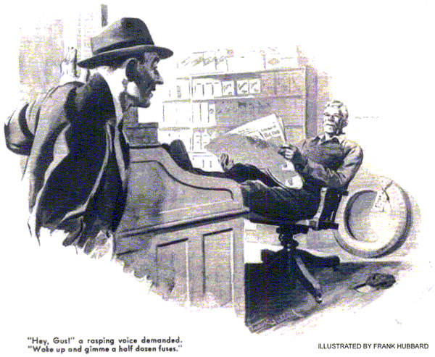
Joe Clark had gone down to the bank that morning, and Gus Wilson was pinch-hitting for him in the office. Gus is as industrious a man as we have in our town - when he is in his shop. But because he hates offices and office work, he's always been more than satisfied to leave the business and bookkeeping and of the Model Garage to his ambitious and energetic partner, and on the rare occasions when he has to take Joe's place "out front" for a few hours, he always grouses first and then indulges himself in a spell of good old-fashioned loafing.
That's what he was doing now - loafing.
His pipe in his mouth, his chair tilted back at a precarious and comfortable angle, and his feet on Joe's orderly desk, he was reading the paper with a thoroughness that ordinarily he is able to indulge in only on Sundays.
A rasping voice brought him back from the war. "Hey, Gus!" it demanded. "Wake up and gimme a half dozen fuses."
Gus looked over the top of his paper and saw Vern Hopkins' long, lean, and grouchy face.
"Hello, there, Vern," he said cheerfully.
"What the heck do you want a half dozen fuses for? Never thought you'd turn out to be a hoarder!"
"I'm not a hoarder, and you know it," Vern growled. "I need a lot of fuses because fuses keep blowing on me."
Gus dropped his feet from Joe's desk and employed them in taking his 190 pounds into the stockroom and back.
"Here are your fuses." He handed them over. "And here's a thought that maybe you'll find worthwhile to allow to percolate slowly through your mind:
When a car blows a lot of fuses, there are just two things that you can do about it - you can find the cause and fix it, or you can go on buying fuses and cussing. The first way is cheaper and a lot less trouble."
Vern grunted disdainfully, "I suppose you think I never thought of that," he said.
"Well, I did - I took your advice before you gave it. For the last week I've been spending half my time trying to find out what the heck's the matter with this darned car. "Nothing's the matter with it, so far as I can see - and still it blows fuses."
Vern paused a moment to let this sink in, and then, with a sneering tone in his rasping voice, he added slowly and meaningfully: "But you're the automotive whiz of this burg. Suppose you try now, and see what you can make of it."
Gus sat down, hoisted his feet back on Joe's desk, and reached for his paper. "Can't you see I'm busy?" he said. "I'm holding the fort while Joe's downtown. I promised him I wouldn't stir out of the office until he got back. I haven't got time to bother with details - I'm managing this concern! Stan's in the shop - ask him to take a look at your bus."
"Stan!" Vern said contemptuously. "That grease monkey! This isn't some simple little thing that Stan can find. It's a real brain twister!"
"What do you mean - a brain twister?" Gus scoffed. "You don't think you're the first driver who's had a fuse blow do you?"
"No," Vern retorted, "I don't. But I'll bet anything you like that I'm the first driver who's had his car blow a fuse every single time it's stopped by a red light!"
This was right down Gus's alley. He tried to look disinterested, but he couldn't help dropping his feet gently to the floor. He knew Vern wasn't kidding him - Vern is an impatient, hot-tempered fellow who is too much of a chronic grouch to be a kidder.
This was going to be a trouble-shooting job that would be really worth while!
"Do you mean to tell me," he asked, "that you blow a fuse every time you stop for a red light, and that you never blow one any other time? That sounds 100-percent screwy."
"Well, it's not just like that," Vern admitted. "But I've had maybe half a dozen fuses blow out in the last week, and four times it's happened when I've been stopped by a traffic light.
I'm on the night shift now, and what makes me mad is that it always happens when I'm hurrying to get to the plant."
"You've got your car outside, haven't you?" Gus said. "O.K. - drive it into the shop.
I'll take a look at it - just to prove you're nuts."
Leaving the office to look after itself, Gus went into the shop, and Vern followed shortly, driving his sedan.
"Going to wait?" Gus asked him. "Chances are you've got a short somewhere in your lighting circuit. I might find it right away, and then again I might have to hunt for it for quite a while."
Vern grinned sourly. "Take it from me," he said, "you'll have to hunt. I did! But I'll wait, I want to use the car - and besides, I want to see you sweat!"
"O.K." Gus said. "Enjoy yourself. Just keep out of my way."
Switching on the lights, he checked over the parts most likely to cause the trouble.
The headlights burned satisfactorily, both on the high beam and dimmed. There were no loose or dirty connections at the ammeter or between the generator, the ammeter, and battery to cause generator voltage to be built up. Both the headlight switch and the dimming switch were in perfect condition. So were the lamp bases. The leads were of adequate size, and Vern grinned a gruff "no" when Gus asked if any of them had been replaced recently. He took the fuse out of its clips on the inside of the dash and examined it. Its capacity was large enough to carry the circuit's normal current.
The fuse clips were clean, and the ends or the fuse made good contact with them.
Gus paused to scratch his ear reflectively.
"Up a tree, aren't you, Hawkshaw?" Vern sneered.
"Looks like it," Gus admitted good-humoredly. "So far as I can see, your lighting circuit's in perfect condition. But let's see what happens with the engine running."
He started the engine, allowed it to idle, and checked the generator voltage. It was normal. He speeded up the engine, and checked the voltage again. It still was normal.
"Well, I hope you're satisfied," Vern snarled when Gus got out of the car. "You haven't done anything that I haven't done a dozen times. I told you that everything was O.K. - except when I have to stop for a red light. I'm not going to waste any more time hanging around here - I've got some errands to do for my wife, and then I've got to get some sleep. What do I owe you?"
"You don't owe me anything - except for the fuses," Gus told him. "But you'd do a lot better to leave your car here. Fuses don't blow without a reason, and putting in a new one without finding out what made the old one blow isn't curing anything - it's just being dumb. You'd better -"
"I'm going!" Bern snapped. He paid for the fuses, jumped into his car, and started backing off fast toward the shop door. Gus noticed the lights hadn't been switched off and called to him, but he wouldn't pay any attention. As he neared the door he had to jam his brakes on to avoid another car that was being driven in. Vern honked his horn three or four times and raced his engine impatiently - and Gus saw the headlights go out. He shouted again, but Vern backed out, turned quickly, and drove off.
"By George, he's blown another fuse!" Gus muttered. "I wonder what the dickens... Well, I'm glad I haven't got that guy's temper. Fuse ... temper...red light.
By gum, that might be the answer!"
The next morning Gus phoned Vern.
"Have any fuse trouble last night?" he inquired innocently.
"Nothing but trouble!" Vern growled.
"The fuse was blown when I started for the plant. I put in a new one, and that blew too."
"Where"? Gus asked.
"Where do you think?" Vern yelled. "At a red light, of course!"
Gus laughed. "What time are you leaving for the plant tonight?"
"Half past eleven," Vern told him.
"Make it an hour earlier," Gus said, "and let me ride with you. I think I've got your fuse trouble licked, O.K.?"
"Oh, all right," Vern agreed ungraciously.
When Vern came out of his house to start for work that night, Gus was waiting on the sidewalk.
"What's the big idea of making me get up an hour early?" Vern grouched.
"You'll see," Gus said. "Let's get going."
Vern drove out of the garage, and Gus got into the car. "Fuse all right?" he asked. Vern grunted assent.
They drove out of the side street and headed down the down busy highway. Several blocks ahead of them a traffic light showed green. Vern increased the car's speed, and Gus knew that he was trying to beat the change of the light. But the traffic was sticky, and before they got to the intersection the light showed yellow and then red.
Vern kicked on his brakes and swore; then he began to race his engine impatiently.
Suddenly the headlights went out.
"What did I tell you?" Vern yelled. "Another fuse blown! It's that red light that does it!"
"Keep your shirt on," Gus told him. "It's not red lights that make you blow your fuses - it's a combination of something mechanically wrong with your car and your hot temper. Pull over to the curb while we put in a new fuse. Then take it easy until we get down to the shop, and I'll soon find out what's wrong."
When they got to the Model Garage, Gus switched on the shop lights and went to work. Convinced now that the blowing of the fuses had been in some way caused by the racing of the engine, he raised the hood, told Vern to gun the engine, and watched closely to see what happened.
The headlights went out almost immediately.
"There goes another fuse," he told Vern.
"All right - keep her turning over." He watched for half a minute. "Switch her off," he said then. "I think I've got it."
Vern got out of the car. "Your fan moves back and forward when you gun the engine," Gus told him. "And when it gets to its extreme forward position the tip of the fan blade hits the headlight cable. That causes a short, and the fuse blows. Here's the cause of the grief. Your water pump is so shot there is excessive end play in the shaft, and that lets the fan move forward.
"I'll shift the headlight cable now so the fan blade can't touch it. That'll do for tonight, but tomorrow you'd better bring the car in and let me repair that pump before it begins leaking so bad your engine runs as hot as your temper."
END

