May 1944

GUS TAKES OVER FOR PAUL REVERE
by Martin Bunn
His Midnight Ride Speeds a Convoy and Foils a Saboteur
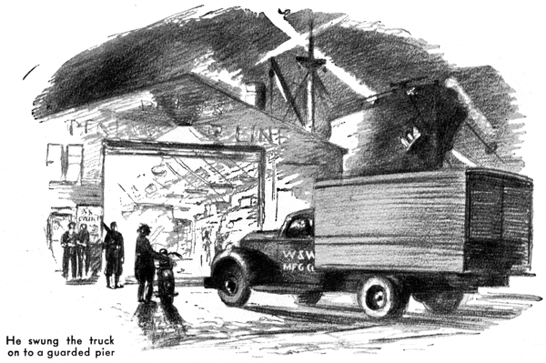
Gus Wilson finished installing a re-conditioned carburetor, stood back to regard the completed job with honest satisfaction and decided he'd done enough for one day.
Just then, the roar of a motorcycle shattered the night. Gus looked up and a moment later State Trooper Jerry Corcoran came into the Model Garage, his browned face serious under his rakishly tilted, wide- brimmed felt hat.
"I'm checking on a truck that's missing," he said, and jerked a notebook out of the breast pocket of his tunic. "Name of W &W Manufacturing Company, Middletown painted on it. Driver name of Joe Pickett, 40, five foot 10, dark hair, dark eyes, clean shaved, wearing a windbreaker, work pants, and a cap. Has he been in here?"
"Nope," Gus told him. "What's it all about, Jerry?" Corcoran replaced his notebook, fished a pack of cigarettes out of his other breast pocket and lighted one. "This Joe Pickett pulled out of Middletown about four o'clock this afternoon with a half-dozen cases of W. & W. radar or something even more hush-hush-to be delivered at a pier in the City to a ship sailing at midnight," he explained. "When he hadn't showed up at 11, the Army got worried and sent out an alarm. He's been traced as far as this county-stopped for gas about nine o'clock. That puts it up to us." Then Jerry roared away.
Fifteen minutes later, as Gus was washing up, the phone rang. Jerry Corcoran's voice snapped over the wire: "I've located that truck, Gus, and you're the man to help me out. It's stalled a mile in on the dirt road from the highway to Springdale."
"I know the road," Gus said. "But what the dickens was it doing there?" "That's what I'd like to know," Jerry said grimly. "The driver says someone told him it was a short cut." "There's something fishy about the guy, Gus." Come and give me a hand."
"O.K." Gus said. "I'll be there in 20 minutes." As he turned off the highway into the dirt road, his headlights knifed into pitch blackness, and a mile further a flashlight flagged him down.
"It's me, Gus," Jerry Corcoran said. "The truck's down the road, but I want to talk to you. I'm sure this guy Pickett is lying. He says his motor began to miss and then went dead, and that he spent an hour checking the gas line, without finding anything. Now he's back there fooling with the ignition."
"Well," Gus said, "we'll soon find out."
Fifty yards farther on, Gus's headlights picked up a truck at the side of the road. A man, who had had his head under the hood, looked up. "I've found the trouble," the fellow said. "The condenser's burned out."
He pointed at something lying on the running board. "Bring your flashlight," Gus said to Jerry. They went over to the truck, and the trooper flashed the beam on the running board. A condenser case was lying there. Beside it was the condenser, its series of alternate sheets of tinfoil and insulation roughly pried apart in several places. Gus examined it carefully. Then he turned to the driver.
"You're lying." He said sharply. "This condenser wasn't burned out; it was deliberately ruined."
"I wanted to see what was the matter with it-I thought I could fix it," the man muttered.
"That's another lie," Gus snapped. "Anyone who knows enough about automobile ignition systems to locate condenser trouble and dismount the condenser also knows that taking a condenser apart ruins it." "You've stalled this truck purposely."
"That's right," Jerry cut in. "You're under arrest, Joe Pickett. You're going to get a chance to tell the G-man just why you've held up an Army rush shipment," He turned to Gus. "How are we going to get this truck going?"
Gus scratched his head. "Going to the shop for a new condenser will take too much time," he said. "I might take the one out of my car, but that would leave me stalled."
Then after a pause, "I've got it," he said. "If I can find..." He pointed the flashlight into the truck, then reached in and pulled out two foot-long two-by-fours that obviously had been used as wedges for packing cubes.
"You take off the front license plate," he told Jerry, handing him a screwdriver and a pair of pliers, "while I take off the rear one."
"What for?" Jerry said, "This job is your baby now." He turned to the driver, "You get in the truck and stay there," he ordered Gus took off the rear license plate. A moment later Jerry brought him the front plate. "Let's have your handkerchief," Gus said. Jerry handed his handkerchief over. Working in the beam of his roadster's headlights, Gus put one of the two-by-fours on the ground, placed a license plate on it, folded the
handkerchief and put it over the license plate, laid the other license plate over the handkerchief, put the second two-by-four over that, and tied them all securely together with a length of twine. With his pliers he bent the corners of the license plates so that they were well apart, and then scraped the paint from around the bolt holes.
Then he took the contraption to the truck, and using the bolt holes in the plates to attach the wires installed it in place of the ruined condenser. "Switch on your ignition and step on the starter," he called to the driver. A moment later the engine was running.
"That'll hold," Gus told Jerry, "You'll have to drive my car."
"O.K." Jerry said. He wheeled his motorcycle over and lifted it into the truck. Then he said to the driver: "You're riding with me, Mr. Saboteur." Pickett climbed out of the truck looking frightened. "You guys got me wrong," he protested through a wad of gum. "I ain't any saboteur. I'm just sick of being pushed around and overworked."
"Stow it," Jerry cut in sarcastically. "The G-men may want to hear it."
They stopped at the State Police station. Jerry turned Pickett over to the sergeant and did some telephoning. Then he came out and got his motorcycle out of the truck. Near the city line an approaching jeep made a U-turn and swung in ahead of them.
"O.K.," an officer called to Jerry. "We'll take him the rest of the way."
Jerry waved his hand and swung over to the side of the road. Gus followed the jeep.
Twenty minutes later Gus swung the truck onto a guarded pier. Husky soldiers manhandled its load up a gangplank of a cargo ship. As soon as the last box was aboard, the dark ship slipped quietly away.
Some time later Jerry Corcoran answered the station-house phone. It was Gus Wilson.
"Get home all right?" Jerry asked.
"No, I didn't get home all right," Gus snapped. "I'm in the city jug for driving without tags. What are you going to do about it?"
Jerry laughed, "Put the sergeant on the wire!" he demanded.
END

