January 1944

GUS CLEARS UP
A CASE OF SABOTAGE
by Martin Bunn
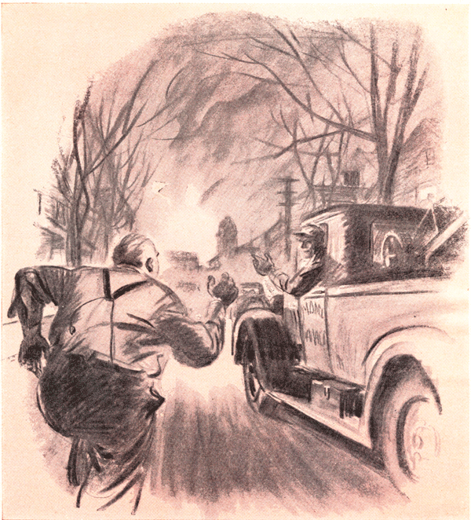
Gus Wilson was bringing back the Model Garage wrecker a little before seven o'clock of a cool fall evening. Lighted dining rooms along the quiet suburban street reminded him that if he didn't hurry there wouldn't be anything left at the Park House for his dinner.
Just as he was pressing a little harder on the accelerator, a banshee shriek assailed his eardrums.
"Whoo-o-whee-e-who-o-o!" moaned the siren in the courthouse tower down on Railroad Square. "Whoo-o-whee-e-wgi-o-o! Whoo-o-whee-e-who-o-o!"
"Three," Gus counted. "That's a fire." He drove on. Down the street, lights flashed on in a garage that stood beside a white Colonial house; seconds later other lights went on in the garage of the cottage next door. Gus grinned. "Jim Allen and Fred Spratt," he thought. "Fighting each other for the Buffs' Medal because the one who wins it will be the next chief of the Volunteer Fire Department." Headlights flared beside the white house: a car shot down the driveway and into the street.
"There goes Jim," Gus told himself. "Always backs into his garage for a fast getaway if the siren blows. Fred'll be right on his tail."
He pulled in to the curb and stopped so as to give Fred Spratt a clear road. But no car came dashing out of the open garage. "That's funny," Gus thought. "I wonder -"
Suddenly a dark figure darted across the lawn and ran down the street. "That's Fred," Gus thought as he let in his clutch. He honked his horn as he pulled past the runner, a stout man in his shirt sleeves, already puffing hard. He swung aboard as Gus brought the wrecker to a stop.
"Step on it, Gus! I gotta get to the firehouse before the engine pulls out!"
Gus stepped on it. Overhead wailed the siren. The sky at the end of the street had reddened to a sullen glow. "There's the fire," Gus said.
"Damn the fire!" Spratt snapped. "You've got to get me to the firehouse before the engine goes out. If you don't, Jim Allen'll win the Buffs' Medal. The dirty rat! Step on it, Gus!"
Once in Railroad Square, they could see the firehouse and a half dozen men running toward it. "What's the matter with your car?" Gus demanded.
"It wouldn't start," Spratt growled. "I dunno why, but I've got my suspicions."
Gus kicked on his brakes by the firehouse just as the engine emerged with its siren yowling. Fred Spratt! Jumped off, landed running, and swung himself onto the engine.
"I wanta see you after the fire!" he yelled back at Gus.
Gus told the Park House waitress he'd have a rare steak.
He got a pitying look and a green pepper stuffed with assorted vegetable matter. Later he drove back to the Model Garage to finish a job. He was washing up when the office telephone jangled.
"I'm glad I was able to catch you," Fred said over the wire. "The fire's just out - it was a tough one. You doing anything special, Gus?"
"Yes," Gus told him. "Something very special, I'm going home, and I'm going to bed. Call me the first thing in the morning.” "Now, Gus, you can't do that!" Spratt pleaded. "This is important - a real emergency call. Stop at my place on your way home, will you? My car's been tampered with, and I've reason to believe a certain party is responsible - the double-crossing rat! Have I got proof? I've got enough to bring charges against him at tomorrow's meeting of the V.F.D. But I want to be fair, so before I do, I want an expert to go over my car and find out exactly what's been done to it."
Gus did some fast thinking. He isn't a member of the Volunteer Fire Department, but he has helped it over mechanical rough spots without taking a cent for his services because he realizes its value to the community. Its efficiency was bound to suffer if strife broke out between Spratt and Jim Allen. So he decided he'd try to straighten things out.
"O.K. Fred," he said. "I'll be over in fifteen minutes."
When he stopped his roadster in front of Spratt's garage the doors had been closed, but lights were burning inside. Spratt opened the side door to his knock.
The hood of the green sedan inside was raised. Spratt banged it down. "My car's just the same as it was when I tried to go to the fire," he said. "Now you try to start it."
"All right," Gus agreed. He got into the sedan and switched on the ignition. The starter ground over sluggishly, but the engine didn't take hold. Gus waited a half minute, then tried again. Finally he switched off the ignition.
"Your starter isn't getting enough juice to crank the engine fast enough."
"Why not?" Spratt demanded.
"Offhand, I'd say your battery probably is run down. That may be your trouble."
Spratt grinned crookedly. "Yeah?" he scoffed. "Well, it isn't. I had it recharged only last week, and it didn't really need it. But don't take my word for it. Check it yourself."
Gus nodded and did so. The gravity reading for each cell was well over 1.250.
"Well?" Spratt demanded again.
"Your battery seems all right," Gus said.
"But hydrometer readings don't tell the whole story. The only way to be absolutely sure of a battery is to check it under operating conditions."
"All right," Spratt said. "Go ahead and check it your way."
"I've got a low-reading voltmeter here," Gus told him. "Switch on the ignition and keep your foot on the starter, will you?" As the starter ground feebly, Gus placed the voltmeter prods on the posts of each cell. The readings, with the battery discharging some 200 amperes, showed good voltage at each cell and very little difference between each cells. "Turn her off!" Gus called.
"Was I right?" asked Spratt.
"You were. Gus admitted. "Your battery has plenty of juice, but a lot is being lost somewhere between it and the starter." He examined the terminals, cable, and ground strap. "Everything seems tight," he said, "but suppose you try turning her over again."
With the starter churning feebly, Gus put one voltmeter prod on the frame and one on the grounded battery terminal. The meter indicated a voltage drop of less than a tenth of a volt. "O.K. there, at least," he said. Quickly he put one prod on the starter motor housing, leaving the other on the frame, and again the meter showed an insignificant drop. "There's a good ground connection between the starter and the mount," he remarked. Finally he placed one prod on the starter motor terminal and the other on the ungrounded battery terminal and then whistled as the meter hand swung over to two volts. "That's where the trouble is," he said, "in the starting-motor cable."
Well, that cable isn't the same one that was in my car this morning. It was put in my car right in this garage this afternoon."
He went to his workbench and took a battery cable out of a drawer. "Here's the proof - this is the cable that was in my car. I found it in the trash box over there. And here's the worst of it. My wife saw Jim Allen sneaking out of the garage this afternoon. She was looking for our daughter Marge when she saw Allen close our garage door and walk away. I'm going to bring charges and I'll run him out of -"
"Wait a minute," Gus said. "Let's see where we stand before you start a war." He disconnected the starting-motor cable and compared it with the cable Spratt handed him. His face clouded. "It's hard for me to believe that it was Jim Allen," he said, "but it looks as if someone has done you dirt. This new cable is the same outside diameter as the old one, but instead of being No. 1 gauge it looks as though this were No.4 gauge, which has only half as much copper, and so only half the current-carrying capacity of No. 1. Less copper means more resistance, so your starter couldn't get enough juice to spin the engine."
There was a rap on the door, and Jim Allen came in with a pair of tree-pruning clippers in his hand. "Hello, Gus," he greeted. "Trying to fix up Fred's old wreck? Fred, I saw your lights on and thought I'd bring back these clippers I borrowed this afternoon without asking-knew you wouldn't mind." He noticed the silence of the others then. "What's the matter? You look as if you'd caught me in your chicken coop in the dark of the moon!"
"Chicken stealing is honest," sputtered Fred Spratt, "compared to - ouch"
Gus's heel had landed on his shinbone. "Here comes someone else," he said. A car had stopped in the driveway. The door opened and a girl came in, slim and smart in a WAC uniform. It took Gus a couple of seconds to recognize her as Fred's daughter Marge.
"Hello, pops," she said cheerfully. "Hello, Mr. Allen. Hello, Mr. Wilson - don't you know me?"
"I didn't for a moment," Gus said. "So you're in the Army now. That fine."
Marge giggled. "I hope you keep on feeling that way," she said. "Because after the war I may ask you for a job. I'm a grease monkey, you know - just finished my automotive mechanics course."
"That's fine," Gus said. "How do you like getting all dirtied up around cars?"
"I love it" Marge said. "Why, I can't keep away from it, even when I'm home. Pops didn't take his car out this afternoon, and I went all over it for him." She turned to her father. "You ought to be more careful about your wiring," she told him. "That starting-motor cable you had would never get by a motors sergeant. It was all frayed and its insulation was half worn away. I got a new cable downtown and put it on for you. Well, I'm going to turn in. Good night, everyone."
She went out. So did the conversation. Spratt looked at Allen, and his face turned from red to purple. Gus cleared his throat noisily. "Fine girl, Fred," he said. "You can't help admiring these modern kids."
"She - she - she - " Spratt sputtered.
From outside came a banshee wail. "Whoo-o-whee-e-who-o-o! Whoo-o-whee-e-who-o-o! Whoo-o-whee-e-who-o-o! Whoo-o-whee-ewho-o-o!"
"Another fire!" Jim Allen yelled. "Come on, Fred - we'll go in my car." He started for the door, Spratt at his heels. "Want to come along Gus?" Allen called back.
"Nope," Gus said. "I'm going home and go to bed. I've had too many emergency calls today, by gum!"
END

