May 1943

GUS HELPS THE ARMY
BY REMOTE CONTROL
by Martin Bunn

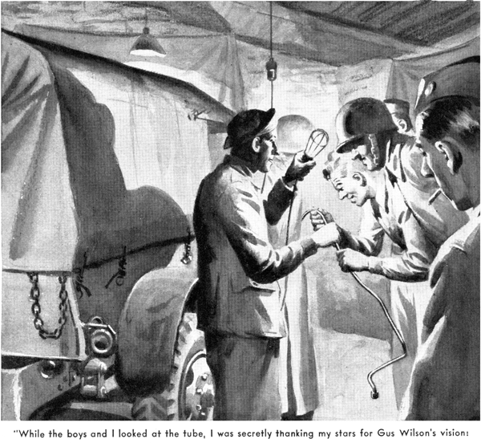

When Harry Blake first came home on leave, we Model Garage regulars didn't know just how to treat him. Back before the war he'd taken a job as Gus Wilson's grease monkey a couple of weeks after graduating from high school, and naturally we older men had fallen into the habit of kidding him a good deal. As the years had drifted by and he had developed into a first-class mechanic, we hadn't changed our half friendly, half patronizing attitude toward him. Even when his National Guard regiment had been called into Federal service, we hadn't taken it very seriously.
But the afternoon not long ago that a few of us drifted into Gus's shop and found Harry Blake there, we realized that he wasn't the same old Harry. He had the kiddish grin we all remembered, but he also had the yellow, blue, and red triangular insignia of an armored division on his shoulder, the silver bar of a first lieutenant on his overseas cap, a couple of ribbons on his chest, and lines around the corners of his mouth that hadn't been there before.
Gus made a sort of introductory motion, and said without any kidding in his voice, "Lieutenant Blake - home on a month's leave after getting himself shot up in Africa." But when we asked about his adventures in Africa and how he got wounded, Harry just shut up like a scared clam.
A few afternoons after that we dropped into the Model Garage again and once more found Harry there. This time he looked more natural. His uniform coat was draped over the back of a chair. He had pulled an old pair of overalls over his pants. There was something wrong with Ez Zacharias's car, and he'd been helping Gus check it. Having just located the trouble, they were feeling pretty triumphant.
"That was a tough one," Harry said.
"It was the toughest trouble-shooting, job I've tackled since - since - "
"Since when?" Gus demanded.
"Well, since I was over there in North Africa," Harry said unwillingly. "I had a trouble-shooting job over there that had me on a spot, and Gus Wilson got me off it. I mean his vision got me off it."
"Huh?" Gus said. "What the dickens do you mean - my vision?"
"Well, that's what it was," Harry insisted. "It's sort of a long story."
Gus gave him a push toward a chair.
"You're going to tell it, even if it is," he said. "I've been called lot of things in my time, but this is the first time I've ever been called a vision, and I want to know how come."
Harry sat down and lit a cigarette.
"Well," he said. "It was this way. My armored division was attached to the British First Army when it went into Tunisia to try to capture Bizerte. This night I'm telling you about my tank company was in an assembly area a few miles from the burg they call Medjez-el-Bab.
"I was maintenance officer, and I had my section quartered on an abandoned Arab farm about a mile back from the rest of our outfit. The Luftwaffe was doing a lot of bombing, so everything had to be blacked out at night, but we had fixed up a barn with lights and blankets so we would be able to handle an emergency repair job if we had to. We were billeted in the farmhouse, which was close to the road.
"Well, about twelve o'clock that night I was sitting on my bedroll with my back against the wall, watching my sergeant and one of the men playing two-handed pinochle. I'd a lot rather have been in my bag asleep, but I had to guide a couple of trucks loaded with gasoline up to where our tanks were and the trucks hadn't showed up yet. Pretty soon I heard the guard outside shout and a lot of loud talking in the road. Thinking that the gasoline trucks had showed up at last, I put on my slicker and started for the door. But before I got to it someone jerked it open and three men came in.
"They were the three muddiest fellows I've ever seen. The first man in was the muddiest of them all. He was a big, beefy guy, and I could see that he was boiling mad. When he pulled off his trench coat, I saw that he had two stars on his shoulders. So I gave him a snappy salute. He returned it as though he hated to do it. "You in command here?" he sort of snarled at me.
"Yes, sir,' I said, and told him my name and outfit.
"What are you doing back here?" he snapped. "Why aren't you with your company?"
"I explained to him that I was maintenance officer, and that my section was at the farm because it was a better place for us to do our work than any we could find up with the tanks.
"'Maintenance officer, hey?" he said. 'Know your job?'
"'Yes, sir,' I told him.
"'Know how to fix a Dodge pickup so it'll run?"
"'Yes, sir,' I said.
"He sat down on a box and began to pick clods of mud off his pants. 'All right, lieutenant,' he said. 'Fix my pickup. And fix it fast. I'm in a hurry.'
"'Yes, sir,' I said. 'What's the matter with your car, sir?'
"The general glared over at one of the men with him. 'Ask the sergeant there,' he said. 'He knows all about cars. He told me so himself, right after we broke down - the first time.'
"The sergeant's face reddened. 'Some trouble with the fuel line, sir - I guess,' he told me.
"'You guess!' the general roared at him.
'You guess wrong just once more tonight and I'll take those stripes off your arm! Go with the lieutenant and tell him what you can about this dang-blasted crate of yours!'
"Well," Harry continued, "the sergeant and I went outside. It was raining cats and dogs. A battery of guns was firing not far away. The sergeant sort of groaned. "My God, sir, what a night", he said.
"'This isn't bad,' I told him. "'The weather's too thick for bombing, and those guns aren't shooting our way.'
"'Oh, it ain't the war I mean,' he said. 'It's the general...Say, lieutenant, we had to push that jalopy a mile to get here, and the general fell flat on his face twice. And I got to go on living with him!'
"My sergeant had routed out some of our fellows, and I told them to get my pickup and tow the general's, which was standing in the road, into the barn. I asked the staff sergeant what had happened the first time his car had quit on him.
"'I dunno, sir,' he told me. 'We started out early this morning on one of the general's inspection trips. I told him the mud was so bad we'd better take a half-track, but he's a pigheaded old - excuse me, sir - I mean the general said to take the pickup.
We didn't have any trouble all day. Along about sundown we were on a hill close to the front line, and some Fritz machine gunner spotted us and sent a burst so close that it spattered us with stones and mud. We went off that hill like a bat outta - well, fast. About half an hour after that the engine began to sputter. Then it quit dead.”
"Well, I figured first off that a bullet had punctured the fuel line and let water get in the gas somehow, but there wasn't any bullet hole. We had a five-gallon can of gas with us, so I drained the tank and the fuel-pump filter and put a couple gallons of fresh gas in the tank. When I stepped on the starter, she took off fine. After we'd gone for maybe five miles the engine stopped again. I drained the fuel line and the tank again, and put the rest of the gas in. She ran fine for a couple of miles. Then she sputtered and quit on me again. We didn't have any more gas, so there wasn't anything else I could do. Then the other officer - he's the general's aide - remembered that your outfit was up this way. So we pushed the old jalopy here.”
Harry lighted another cigarette and looked around at us. "Wait a minute," Gus told him, and went into the office. He came back with a bottle of coke and handed it to Harry. "Fill up your fuel tank before you go on," he said. Harry grinned and took a long pull.
"We got the general's car into the barn," Harry went on. "and went to work. We checked the ignition, the spark plugs, and the wiring. They all were O.K. We drained the fuel-pump filter and tried the engine, but she wouldn't start. Then we cleaned out the carburetor and drained the gas tank. There wasn't any sign of water in the gasoline. There wasn't any hole in the tank or filter cup through which water could have been getting into the tank. The fuel line seemed perfectly tight. So we filled up the tank and stepped on the starter - and the engine took off and ran smoothly.”
"That's got her, sir,” my sergeant said. “I don't know what was the matter with her, but she's all right now.”
"So I said O.K. and started for the house to tell the general that his car was fixed. But I'd no sooner got out of the barn than I saw Gus Wilson's vision! We were working in the shop here, and I'd just finished a job, and he was telling me, 'Kid, getting a bus to run don't mean a thing if you don't know why you've got it to run. Don't ever let a job go out of this shop without knowing what caused the trouble in the first place. If you do, it's ten to one it will be back again, and the customer who brings it in won't be happy.”
"Gus's vision faded out then, and I realized that I was remembering something he'd told me when I first came to work for him. I went back into the barn. 'We're going to do some double checking on this job before it goes out,' I told the boys. 'Let's get at it.'
"We went over that fuel line inch by inch without finding anything wrong with it. The gasoline tank checked O.K. There is a kick-up in the frame over the rear axle. I felt along that fuel line one last time for luck. At the top of the kick-up, at the highest point of the fuel line, I found something. It was a hole - a little hole, but water from the wheel splashed up on the line at this point, and the hole let enough of it leak into the fuel to stop the engine!
"I thought of what the general would have done if I'd let that heap go out and it had stalled with him again, and believe me, I thanked Gus Wilson's vision! We replaced that tube with a new one, and I went in and told the general that his car was O.K
"'Sure of that?' he growled.
"'Yes, sir," I said.
"'You'd better be!' he snapped. 'Tell that fool sergeant of mine to get going!'"
For a moment after Harry finished nobody spoke.
"What I don't get," Ez Zacharias said at last, "is what made the hole in the fuel line."
"Well," Harry told him, "the staff sergeant and I figured that that machine-gun burst knocked up a stone that hit the fuel line over the rear axle and punched that hole in it. What do you think, Gus?"
"That probably was it," Gus said, "Harry, how about having dinner with me? I want to celebrate. After all, it isn't every night I get a general out of a jam in Africa by remote control!"
END

