March 1943

ONE ON THE HOUSE
by Martin Bunn
Gus foots the bill as a new mechanic bungles the job
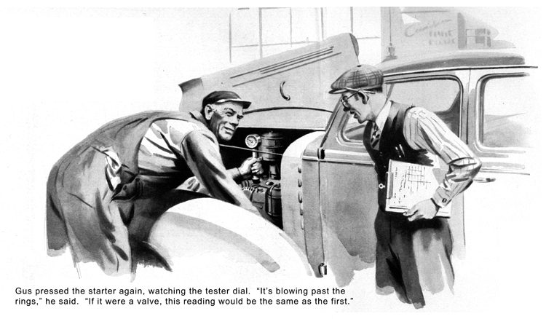
It was a fine sunny morning, and Gus Wilson should have been whistling as he went about his work in the Model Garage shop. But he wasn't.
George Knowles noticed this the moment he came in. "What's biting you this grand and glorious morning?" he wanted to know.
"First time I've ever seen you looking as though the world was too much for you."
Gus looked at him glumly; then his face broke into a crooked grin. "I guess I'll have to admit I'm not up to par," he confessed.
"Trying to run an auto repair shop these days is a headache."
"Headache!" George said feelingly. "You ought to try running my business in war-time! But what's your particular trouble?"
"Getting spare parts and materials, for one thing," Gus told him. "But my toughest problem is finding a mechanic who won't do more harm than good. Wally, the grease monkey we've had for the last year or so, was drafted last week. I'm not kicking about that - the Army needs men - but it did leave us in a hole. Joe Clark put an ad in a city paper, and snapped up the only fellow who answered. But the man wants to do everything his own way. Well, that's enough about my troubles, George. How about yours?"
"The one on my mind right now," Knowles said, "is my car. It runs well enough at thirty on the level, but it misses badly when I tramp on the accelerator to pick up at lower speeds and whenever I go up a hill. I know you're busy, Gus, but I'd appreciate it if you could get it fixed up by late afternoon. I've got to drive to an air-raid wardens' pow-wow." A horn honked outside. "There's Peggy. See you later, Gus."
Knowles went out. Gus kept on working on a job he'd promised for noon. Presently Henry Knight, the new mechanic, came in from the office, where he had been arguing with Joe Clark. "Well, what do you want me to tackle next?" he growled at Gus.
"You might bring in that green sedan, and check it." Gus told him mildly. "It belongs to one of our oldest customers. He says the engine misses at low speeds and on upgrades. It might be a burned valve."
"It might be a lot of things!" Knight grumbled. He got the car and drove it into a corner as far away from Gus as possible, and after some time Gus saw that he was removing the cylinder head. That done, Knight drained the crankcase. Gus had told him to check the car, not to do a job on it, but he said nothing. Knight then went into the storeroom back of the office, and came out with a new cylinder-head gasket.
Gus finished his own job, then drove out for a road test. When he got back the Knowles car was standing outside. Knight was in the shop writing out a material slip.
"I finished that job," he growled. "There was nothing the matter with the valves."
"No?" Gus said. "Well, I guessed wrong."
"When I took the head off to check the valves," Knight continued, "I saw some drops of water in No. 3 cylinder. So I drained the crankcase, and a lot of foamy oil and some water came out. The block wasn't cracked, nor was the cylinder head, so it had to be the gasket - I'd noticed it looked bad. I put in a new gasket, and filled her up with oil. Here are the slips on the job, filled out the way you want 'em."
"O.K.," Gus said. "Take them in to Joe."
All the rest of the day Knight went on doing things in his own way. Gus made no suggestions, but he was glad when, at five o'clock sharp, the new mechanic put on his coat and went home. When George Knowles came in a half hour later he found Gus whistling cheerily.
"Got over your grouch, hey?" Knowles grinned. "That new man must have turned out better than you expected."
"I think he's a good mechanic, but I know he's a pain in the neck," Gus said. "He worked on your car - put in a new gasket, and filled the crankcase with fresh oil. You shouldn't have any more trouble."
Knowles went out of his car. Gus heard the engine start, and knew from its sound almost at once that it was missing. He hurried to the door, but Knowles was already in the street and didn't hear his shout above the noise of the motor.
Gus watched him drive off, shrugged, and went inside. He had supper late, then returned to finish a job. It was close to midnight when he decided to quit.
Just as he was washing up, the telephone rang. George Knowles' voice came over the wire. "I'm in trouble over at the county courthouse. My motor missed all the way here and now it sounds as if it might shake itself apart. I'm afraid to start home - I don't want to get stuck. All the garages here are closed."
"Stay right where you are," Gus told him. "I'll be there in half an hour."
When he got to the county seat, he found Knowles apologetic for having brought him out so late. "Forget it, George," Gus said. "You ought to be cussing me, not apologizing. I should have checked your bus myself. Need it early tomorrow?"
"No, but I'd like to have it by six."
"I'll get at it first thing," Gus promised.
He got down to the shop an hour early, and tackled Knowles' car. When he stepped on the starter the engine took off promptly. After letting it warm up, he switched off the ignition, took out all the spark plugs, poured a spoonful of penetrating oil into each cylinder, and turned the engine over with the starter to distribute it. Then he got out the compression tester, pressed its rubber adapter into the No. 1 spark plug hole, opened the throttle all the way, and punched the starter button.
The hand moved up to the 100-pound mark. Cylinder No. 2 registered 102 pounds. But on No.3 the reading was only a little over 50. The remaining cylinders tested 100 or more.
As Gus was pouring in a little heavy oil on top of the No. 3 piston, being careful not to get any on the valves, Joe Clark came in. "What's the matter?" he asked on seeing Knowles car. "Knight took care of that job yesterday, didn't he?"
"So he said!" Gus answered. He pressed the starter button again, and watched the dial. The tester showed 80 pounds. "Leaky rings," he said. "The oil seals 'em. If it were a leaky valve, the second reading would be as low as the first."
He took off the head, dropped the crankcase, and removed the piston and rod from the No. 3 cylinder. "I'll be darned!" he said. "Look at this, Joe. About an inch of that middle ring broke off, and as it happened didn't damage the cylinder wall, but stuck fast in its groove directly under the gap of the top ring. The result was a blow-by that killed compression and caused missing. Well, George will have to pay for a ring job. By gum, Knight was right about the cause of the trouble at that - a hundred to one it was water leaking past that bad gasket that made the ring break."
Joe looked at the shop clock. "Where the dickens is Knight?" he asked. "He's half an hour late. There's the phone."
He went into the office. A minute later he came back. "Bad news, Gus," he told his partner. "Knight has quit. He phoned to say he's taken a job in the city."
"I'll say it's bad news," Gus growled. "I wanted to fire him! He knew he hadn't fixed Knowles' engine, but just wouldn't admit it. When you make out George's bill, leave off what Knight did. That'll have to be on the house."
"Profit and loss," Joe said, "mostly loss."
"Yes," Gus agreed. "Like Henry Knight!"
END

