July 1943

GUS TACKLES A JOB FOR A GENIUS
by Martin Bunn

The Model Garage Expert Solves a Problem

That Has Everybody Guessing.
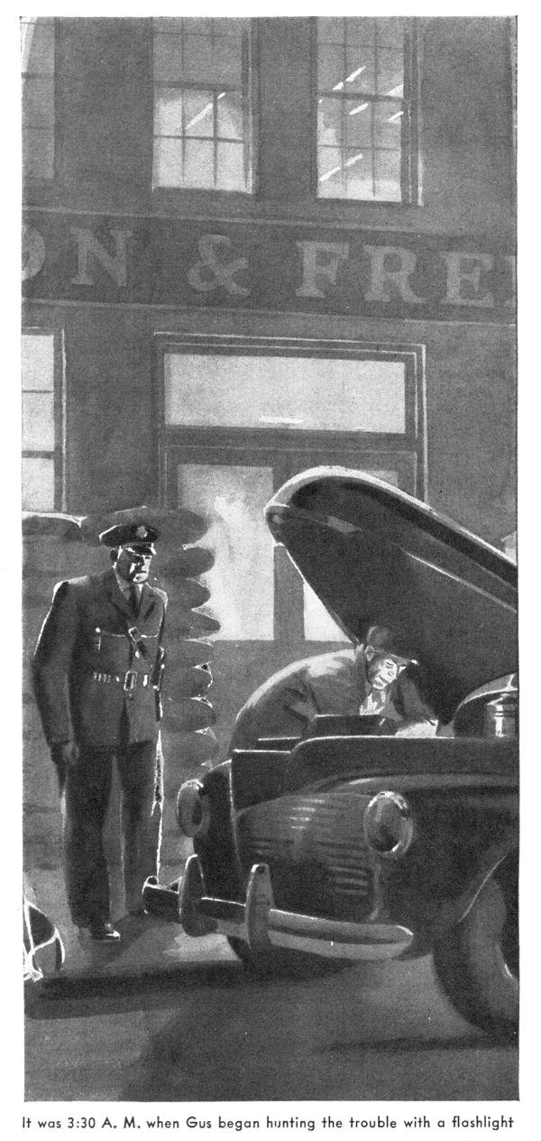
"Mister," said a voice at the open shop door, "I hear you're a genius. Well, I've got a job for a genius."
Gus Wilson looked up and saw a fat man standing there smiling as he mopped his perspiring red face with an oversize handkerchief. Gus grinned back at him. "It's a bad habit to believe everything you hear," he observed. "Come in, won't you?"
The fat man came into the shop, stripped off his coat, and settled himself comfortably in the only chair. "My name's Warren" he announced. "I work in the Johnston and Fredericks plant.
"Oh, so you're the Mr. Warren, are you?"
Gus said. "Mr. Johnston has been telling me about those special machines you've designed for him. Well, if there's a genius in this shop just now, you're it, Mr. Warren."
Warren waved a disclaiming hand. "I'm no genius - far from it," he said. "Except for machine tools I'm just a dumb cluck, or, as my young daughter might put it, a drip."
"Well," Gus told him, "you have it your way, and I'll have it mine. But what's this job you were speaking of?"
"It's precisely what I said it was - a job for a genius," Warren insisted. "I told Mr. Johnston about the troubles I am having with my car. "Take it to Gus Wilson at the Model Garage,' he advised me. "He's a genius at trouble-shooting.' Well, I'm here, and the car is just outside your door."
"Fine," Gus said. "but what's the matter with it?"
"That's what I don't know, and what no automobile mechanic who has looked at it - and I've taken it to a lot of them during the past two months - has been able to find out," Warren told him. "I do know that the engine stalls frequently, but I don't know why it stalls. Sometimes it will run perfectly for days and even weeks, and then without the slightest warning it suddenly stops and refuses to restart. Other times it will stall half a dozen times in a single day.
"Usually, if I let it stand for an hour or so, it will restart without any trouble and run as smoothly as a man could ask. But on several occasions I've had to have it towed to a garage - and then suffer the embarrassment of having it take off the instant some supercilious mechanic stepped on the starter. Because no one has been able to find out what makes it behave as it does, no work has been done on it. The entire matter is a confounded mystery that I'm delighted to turn over to you."
Warren beamed at Gus, settled himself even more comfortably, and began to cram tobacco into the bowl of a large pipe.
"Well, I'll bring your car in and do some checking," Gus told him.
"I'll be highly interested in watching you," Warren approved. "I always enjoy seeing a top-notcher at work."
Gus went out and got into the '42-model coupe of a popular make that was standing at the door. Switching on the ignition, he pressed his foot on the starter. The engine at once purred smoothly. He drove into the shop and got out. With Warren eyeing his every move, he checked the ignition and the fuel line. Then he went over the engine carefully. Everything seemed to be in perfect condition. Puzzled, he shook his head.
"Stumped?" Warren asked.
"Stumped," Gus admitted. "So far as I can see, your car is in perfect mechanical condition. To find the cause of the stalling, I'll have to check the engine after it has stalled. Let's leave it this way, Mr. Warren. The next time you have trouble, don't do anything about it except phone me right away." Gus jotted two telephone numbers on a card. "Top number in daytime, bottom one at night. I'll tow your car over here from wherever it is and check it thoroughly. That way I'll be able to find out what's wrong without wasting time guessing."
"I'll do that," Warren agreed.
It was less than a week later that Gus's bedside telephone jangled once, twice, three times in the darkness. Finally its disturbance hammered through sleep into his consciousness. He rolled over, propped himself up on one elbow, switched on the light, saw by his alarm clock that it was three o'clock, and finally picked up the receiver.
A voice at the other end of the wire said: "This is Warren. You told me to call you the next time I had trouble with my car. Well, I'm having it. The engine wouldn't start when I wanted to go home... What? It's right in front of the plant… No, I haven't done a thing to it… You'll be over in half an hour? Good. I'll leave the car keys with the guard at the gate - I'm going home in a taxi and to bed. Your baby now, Mr. Wilson! Give me a call when you've got it fixed, will you?"
Gus yawned and stretched, got into some clothes went downstairs and climbed into his car, and drove the few blocks to the Model Garage. There he took out the wrecker. He drove to the Johnston and Fredericks plant, which was running full blast. Warren's coupe was standing at the curb in front of the office gate. As he got out of the wrecker, a uniformed guard came over to him and said, "You Mr. Wilson?" Gus grunted in answer, and the guard handed him a couple of keys.
The first thing Gus did was to turn on the ignition and step on the starter. The starting motor whirred, but nothing else happened. He got out of the car and using his flashlight, made sure that the gasoline tank vent wasn't clogged up and that there was plenty of gas in the tank. Then he checked the spark plugs. They were delivering good, hot sparks.
Next, he had a look at the carburetor - and found that there was no gas in its bowl.
"Well, I still don't know what the trouble is," he told himself, "but at least I know that it's in the fuel system somewhere between the gas tank and the carburetor. That's something gained."
He towed Warren's car through the deserted streets to the Model Garage and maneuvered it into his shop. On an impulse he couldn't have explained, he turned the engine over with the starter a few times, the ignition off. Then he looked at the carburetor again and got a surprise.
There hadn't been any gasoline in its bowl when he had examined it in the street in front of the Johnston and Fredericks plant, but there was plenty of it now.
Gus scratched his ear thoughtfully for at least two minutes before he made his next move. That was to get into the car and step on the starter, with the ignition on this time.
The engine took off promptly!
"Right back where I started from!" he growled disgustedly. "No - not quite that bad; I know where the trouble was. Well, now, let's see. That carburetor is O.K. now, but it wasn't O.K. when I checked it twenty minutes ago, so in all probability it wasn't working right when Warren couldn't start his engine a half hour before that."
He examined the carburetor again, but still couldn't find anything wrong with it. Then he removed it from the car, carried it over to his workbench, took it apart, carefully examined and cleaned each of its parts, reassembled them, and replaced the carburetor on the car. "Nothing wrong with it now, I'll swear," he assured himself.
Next, he checked the fuel pump. It was working perfectly. Inch by inch he went over the fuel line from the gasoline tank to the carburetor. It was tight and clean.
He got back into the car and stepped on the starter. Again the starting motor turned over without as much as a sputter from the engine.
Examination showed that once again there was no gasoline in the bowl of the carburetor.
"Whatever it is," Gus muttered, "it must be in the fuel tank - it can't be anywhere else. I'll have to take the tank out."
He started to do this by disconnecting the fuel line from the tank, keeping a can handy to catch the gasoline which he expected to gush out of the opening the moment the line was detached. But only a few drops dribbled out.
Gus turned his flashlight, so that it shone into the opening. In its white beam something brown appeared. He poked at it with his finger tip. It moved – and gasoline spurted out as he had expected it would.
He drained the tank. Then, with a piece of fine wire one end of which he twisted into a hook, he began to fish. Before long he felt the hooked wire catch something soft. Manipulating it carefully, he worked out a piece of wrapping paper about the size of a business card.
About noon, Warren came into the shop smiling broadly. "I got your phone message," he said.
"So you lived up to your reputation! Well, what caused all my troubles?"
Gus handed him the bit of wrapping paper. "That did," he said. "Somehow it got into your gas tank. Whenever it floated over the outlet where the fuel line is connected, it cut off the flow of gas to the carburetor, and of course your engine couldn't run. When it floated away from the outlet, the flow of gas was unimpeded, and the engine could run."
"Simple, wasn't it?" Warren said, "but locating the cause of the trouble wasn't simple. You see, it was just what I said it was in the first place - a job for a genius. Don't forget that when you bill me, Mr. Wilson!"
END

