January 1943

GUS LISTENS TO CLUTCH CHATTER
by Martin Bunn

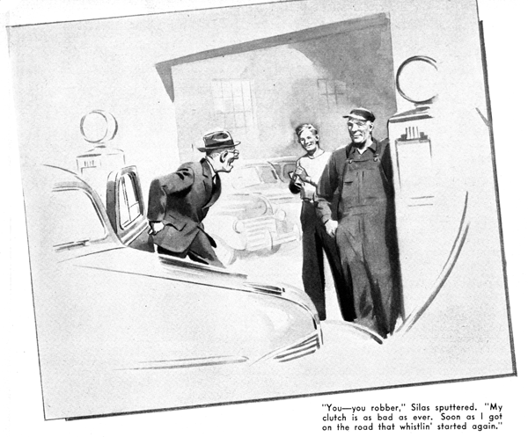
Old Silas Barnstable drove his sedan into the Model Garage looking even more than usual like a shopworn bantam rooster. "Gosh dang it, Gus Wilson," he snarled, "my clutch s out of whack again.
"Tain't six months ago I paid good money for you to fix it. I ain't no millionaire, an' I ain't goin' to be hornswoggled. By gosh, you've got to fix this clutch up right without chargin' or I'll - I'll stand you a suit!"
Gus Wilson is one of the very few people in our town who really like Silas, the old skinflint. So instead of losing his temper, he grinned and asked mildly what was wrong.
"I dunno what's wrong - that's your business!" Silas barked. "All I know is that you overhauled it - or said you did - and told me it was as good as new. And now every time I back up the danged car shakes the liver out of me. An' what's more, around twenty-five that clutch gets a-whistlin' till it sets my teeth on edge. Well, what you goin' to do?"
"Find out what's the matter first," Gus told him. "Back up as far as the doorway."
Silas started his engine, shifted into reverse, and let in his clutch. As the car moved, it began to chatter and shake. "See there!" he yelled, and put on his brakes.
Gus laughed. "Now put her in low and come forward," he said.
Silas did, and the car moved smoothly. "One reason why you get that chatter," Gus told him, "is that you keep your foot on the clutch pedal while you're backing - you never let the clutch all the way in. I've warned you a dozen times that doing that wears out your clutch. But, at that, there's more chatter than there should be. You'd better leave your car here overnight."
"You ain't goin' to have the brass to charge me anythin', are you?" Silas demanded.
"If the trouble is the result of our slipping up on anything when we reconditioned your clutch, we won't charge you a red cent," Gus told him. "But if it's anything else, we'll charge exactly what we'd charge any other customer."
Silas pulled at his lower lip, then assented with an unwilling nod.
Next morning Gus found Wally, the Model Garage's current grease monkey and would-be mechanic staring at Silas's car with a scowl on his usually grinning face. "What's the matter with that old sourpuss's crate now?" he wanted to know.
"He thinks there's something wrong with his clutch," Gus said, "and I'm inclined to agree, although I'm not so sure as he is. We'll give it a road test. Come along - maybe you can learn something." They got into Silas's car and headed down the road. The engine ran smoothly, and so did the car. But as soon as Gus speeded up to thirty, the noise of which Silas had complained began - a high-pitched, ear-penetrating whistle. "What the dickens is that?" Wally wanted to know.
"Silas says it comes from the clutch," Gus told him. He eased up to twenty, and the noise stopped. When he increased speed again the noise recommenced, but apparently he didn't pay any further attention to it.
"No sign of the clutch slipping, so far," he decided. "The instant I speed up the engine, the car picks up speed. That's a pretty fair test. When your car doesn't run as fast as your engine, it's a good bet that your clutch is slipping - and that you're wasting gasoline and power and putting an unnecessary strain on your engine... Let's see, now."
They had descended a short but rather steep decline. At the foot of it Gus stopped the car, shifted into reverse, and backed up the slope. He kept his foot off the clutch pedal, but the car shuddered and shook. "That makes it look as if old Silas was right - but I'm going to try another test."
He drove down the hill again. On a level stretch he stopped, pulled the emergency brake on hard, shifted into low gear, and carefully let in the clutch. The engine stopped suddenly.
Gus nodded. "Thought so," he said. "The clutch is all right. That'll be bad news for Silas - he's going to have a bill to pay."
"How do you know there's nothing the matter?" Wally demanded. "It didn't work right when we backed up that hill."
"Something didn't work right," Gus told him. "But that something wasn't the clutch. The test I just made comes close enough to being sure fire. When you put on your brakes, shift into low, and run the engine against the brakes the engine will keep on turning over if the clutch is slipping, but if the clutch is in really good condition, it will stall the engine."
He started back to the shop. The whistling began again, but he didn't pay any attention.
Wally did some hard thinking. "Say boss," he asked, "suppose the clutch had been making the car shake - what would that have been a sign of?"
"Future trouble," Gus said. "And, generally speaking, trouble not so far in the future. Shudder - that shaking when we backed up the hill - usually, but not always, is caused by the clutch. When it is, it usually is the first warning that the clutch is beginning to slip. If a clutch that has started to slip isn't reconditioned, the pressure plate often warps or heat-cracks, and the inevitable result is grabbing. And a grabbing clutch raises the very dickens. Most often it rips out the splines in the drive shaft and universal joint - I've seen drive shafts with their splines completely cut off by a grabbing clutch. Sometimes it will yank the teeth right out of the crown gear - and sometimes it will snap an axle. Reconditioning a bad clutch will lengthen the life of any car - especially its transmission and rear-end parts."
"What makes the clutch shake the car?" Wally asked.
"Well," Gus said, "as a usual thing, shudder - or chatter, as some people call it - is caused by glazed spots on the clutch plate slipping to rougher, less glazed surfaces on the pressure plate. Sometimes it's caused by the springs and release fingers of the pressure plate losing the equal tension they should have.
And sometimes it is caused by grease monkeys like you shooting too much grease into the shaft that holds the thrust bearing. A lot of that grease works inside the clutch, so that the plates get covered and slip. When that happens you usually have to put in a new driving plate; you can't wash out enough of the grease to stop the shudder."
"And how about that whistling - what makes that?" Wally persisted.
"Oh - that," Gus said. "We'll have a little fun out of that."
Gus turned into the shop, and drove up on the greasing rack. After checking a few minutes he called Wally.
"Here's the cause of that shudder," he told him. "Take a look under here at those rubber engine mountings. See how soft and worn they are? The transmission mountings are just as bad. They let the engine and transmission sag just enough to cause a slight misalignment that makes the car shudder and shake in reverse, especially going up an incline. It isn't bad yet, but you'd soon get the same shudder going forward when the engine had a hard pull. The answer is new engine and transmission mountings."
The next afternoon Silas walked into the shop looking as if he'd lost his last friend.
"Got my car ready?" he growled.
"Sure - it's ready," Gus told him cheerfully.
Silas got into his sedan. "I'm going to try it out before I pay you a cent!" he snarled.
"I'm sick and tired of being cheated."
Gus grinned. "Go ahead - give her a run. You'll think you're in a new car."
Silas backed out with no shaking. Wally looked at Gus. "Gosh, boss," he said, "we forgot all about that whistle."
"I didn't," Gus said. "He'll be back, and you'll hear plenty."
He was right. Silas came back, and when he hopped out of his car he was spitting like a tomcat. "You - you robber!" he sputtered. "You ain't fixed my clutch. It's as bad as ever. Soon as I got on the road that whistlin' started again!"
"Whistling?" Gus aid. "You're letting your imagination get the best of you, Silas."
"So I'm crazy am I?" Silas snarled. "It does whistle, I tell you! You come out and hear it for yourself."
"O.K," Gus agreed. "Joe Clark wants to see you first, though - says it's important."
Joe had been coached to keep Silas busy for five minutes over a faked mistake in a paid bill. The moment the old fellow disappeared in the office, Gus ran to the car. Working fast, he attached a piece of tape across the front and through the center of one of the bars of the radiator grille. When Silas returned, Gus was puffing contentedly at his pipe.
They got into Silas's car and drove down the road. Silas gradually increased speed to twenty-five miles an hour. There was no whistle. Then he went up to thirty-five. Still no whistle.
Gus looked at him, and shook his head. "I told you that you were imagining things," he said.
Silas scowled. "I wasn't imagining nothin'. I heard that whistle plain as the nose on your face. It ain't there now, but I heard it, and I'll hear it again. I ain't paying until I'm sure it ain't comin' back, an' you can put that in your pipe and smoke it!"
"O.K.," Gus told him.
Silas dropped him off at the Model Garage and drove on his way.
"Hey, boss, what was that tape for?" Wally demanded as soon as he saw Gus.
Gus grinned. "To stop that whistling noise," he explained. "It didn't come from the clutch - didn't have anything to do with the clutch. It came from a loose bar in the radiator grille that was vibrating like a fiddle string - that happens quite often on that make of car. Next time Silas brings his bus in I'll fix it permanently with a door spring. Until then, it'll be good for him to have something to wonder about!"
END

