February 1943

GUS GIVES THE PROFESSOR
A LESSON
by Martin Bunn
When a Plug Went Bad in Scruggs' Car, the Sparks Flew.
but the Mechanic of the Model Garage Fixed Things Up.
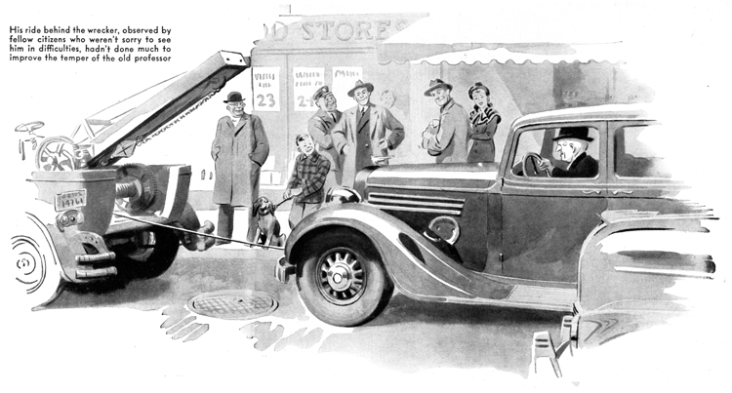
For quite a few years, Professor Hiram Scruggs, the principal of our high school, has had - and richly deserved - the reputation of being the biggest grouch in town. When he drove into the Model Garage the other afternoon, Gus Wilson's ears told him that the professor's engine was missing.
Scruggs got out and scowled at Gus. "Another example of the widespread inefficiency which is the curse of this country-" he sounded off. "In spite of the fact that I had my carburetor repaired only a week ago, my motor is missing badly."
Gus grinned at him. "Just what seems to be the matter with your antique chariot?"
"I've already told you what the trouble is," Scruggs said impatiently. "I said that I had my carburetor repaired -"
"Why?" Gus asked.
"Because my motor wouldn't idle. every time I stopped for a red light the motor raced. I was at my country home at Coldspring Lake, and the garageman up there said that the carburetor must be causing the trouble. He removed it from the car and examined it carefully, but all he could find wrong was that there was a small brass screw missing from the - the butterfly valve, I think he called it. He replaced the missing screw, and the motor ran beautifully until this morning, when it started to miss."
Gus got a screwdriver, held its metal shaft to the top of the No. 1 spark plug terminal and its point against the engine. No. 1 cylinder stopped firing, and the engine labored. He checked two more cylinders with the same results. But when he did the same thing with No. 4 there was no change. He unscrewed it from the engine head.
"Here's the trouble," he told Scruggs. "Number four spark plug isn't firing."
Then he saw something that made him whistle. Wedged in between the center electrode and the base of the plug was a little brass ball. "Now where the devil did that come from?" he asked himself. He held the plug out for Scruggs to see. "Looks as if some of your affectionate pupils have been playing tricks on you again - the way they did that time they put the sugar in your oil," he told him. "Ever see that little brass ball before, professor?"
"Certainly not!" Scruggs snarled. "And if I find that any of those young hoodlums have been -"
"Wait a minute - wait a minute," Gus cautioned. "Remember that missing screw, professor?"
"Of course I remember it," Scruggs said. "But what in the world has it to do with this brass ball?"
"It's got a lot to do with it," Gus said.
"Use those little gray cells of yours, professor - switch on that high-voltage brain power of yours. What? You still don't get it? Why, this little brass ball is the missing butterfly-valve screw. After it came loose it got into the cylinder, and then it was battered against the cylinder head by the piston until it got hammered into its present shape. After that it got jammed into the base of the spark plug, and caused a short circuit which kept your No. 4 cylinder from firing."
Gus saw a skeptical look on the professor's face. "You don't believe it, hey? All right - I'll prove it to you."
He went into the stockroom, and came out a half minute later with a new spark plug which he screwed into the engine head.
"Step on her," he directed. Scruggs did as he was told. The engine started easily, and ran as smoothly as could be expected of a piece of machinery of its advanced age, which never had been given intelligent care.
Professor Scruggs grunted, smarted over the price of the new plug, and at last got into his car and drove away.
Gus was finishing a job later that afternoon when he heard the office telephone jingling. A moment later his partner, Joe Clark, called out, "It's for you, Gus." When he walked into the office he found Joe grinning and holding his hand over the transmitter. "It's Professor Scruggs," he said, "and he's so darned mad he's sputtering."
Gus picked up the 'phone and said "hello."
Five minutes later he hung up. "Apparently someone has put an infernal machine in the professor's car," he informed Joe. "Well, he had it coming to him, but I guess he's really in some sort of jam. Hey, Wally, take the wrecker and tow Professor Scruggs's car in. He's out past the old Craig place."
Wally, who holds the principal in the same low esteem as do most of his former pupils departed with a broad grin on his grease-smeared face.
The grin was even broader when he returned about a half hour later hauling the Scruggs sedan with its owner seated grimly behind the wheel.
The ride behind the wrecker, observed by numerous fellow citizens who obviously hadn't been sorry to see him in difficulties, hadn't done anything to cool Scruggs's temper. "This is an outrage!" he roared at Gus. "Either sheer, downright incompetence on your part, or plain dishonestly. How dare you send me out on the road in a car in that condition? I might have been killed!"
"Well, you weren't," Gus told him calmly. "But just what happened, anyhow?"
There wasn't much to the story. The professor had started out for his cottage at Coldspring Lake. Five miles out of town, while he was doing about 40, his engine had started to miss badly. Then he had been started by a loud bang. He had got out of the car and, happening to look back, had seen a spark plug lying in the road. Picking it up, he had burned his fingers on it. Then he had raised the car's hood, and found a spark plug missing.
"And please understand that I haven't the slightest intention of paying a single red cent for this!" he shouted, getting mad all over again. "A disgraceful way to do work! You install a new spark plug, charge me a high price for it, and then within a few miles it blows out of my motor and endangers my life!"
Gus looked the plug over carefully, and then thoughtfully ran his thumbnail along its threading. Then he raised the hood and examined the engine. And then he laughed.
"This isn't the plug I put in," he told Scruggs. "I knew that as soon as I looked at it. This plug has been used for a long time. See how its electrodes are burned?
It's out of your No.6 cylinder. I put the new one in No. 4 See this cement on its threads? That's the tip-off. I can tell you just what has happened. Someone working on your engine - it might have been the garageman who fixed your carburetor, or it might have been someone before him - stripped the threads in the aluminum cylinder head when he was replacing the No.6 spark plug. Trying to cover up, he cemented the plug in with iron cement, or something of the sort."
Professor Scruggs expressed his opinion of the entire automotive-repair clan luridly and at full length. Then he told Gus to fix his car up immediately. He was in a hurry.
Gus shook his head. "Sorry, professor." he said, "But I can't do a quick job on it.
There are two ways of doing it. One is to rebore the cylinder head for a larger plug. The other is to install a new cylinder head. The first way is a lot cheaper, but a larger plug would destroy the heat-range balance. Using your original-size plug with an adapter is a special machine operation and we would have to have the adapter made. The only real answer is a new cylinder head because by the time I had the adapter made, the expense involved could be used to much better advantage toward buying a new head. Besides, your cylinder head is probably badly corroded by this time. If you want one installed, I'll be glad to do it for you, but it will take a day or so to get it from the city."
Scruggs ranted some more, but at length told Gus to install the new cylinder head. Then he started for the railroad station on foot and in a vile humor.
Gus shrugged his wide shoulders. Then he wrote out an order for the engine head and took it in to Joe Clark. Joe read it, and whistled. "A bad break for the professor," he said. "Well, if anybody has to have bad luck, it might as well be old Scruggs!"
END

