September 1942

GUS HAS A VISITOR
by Martin Bunn
And, as usual ... when one of Gus Wilson's old friends shows up,
he brings along a yarn to swap with the Model Garage's mentor.
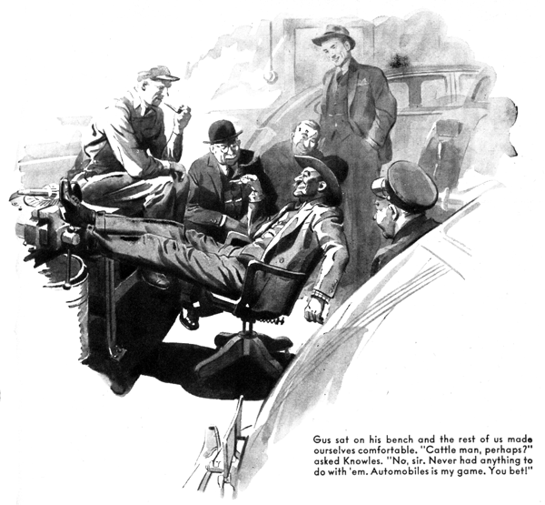
For quite a few years before Gus Wilson teamed up with Joe Clark and started the Model Garage in our suburban town he knocked around the country, holding down one automotive job until his feet began to itch, and then moving on to a new job in a new place. Being Gus Wilson, he made a lot of good friends. Every now and then one of them stops off in our town to visit with him and exchange reminiscences.
The other evening a few of us Model Garage regulars saw the lights burning in Gus's shop and decided we'd drop in for a little fanning session. A man who had a black ten-gallon hat on the back of his head was sprawled out in Joe Clark's private swivel chair and had his feet cocked up on Gus's workbench, and looked too much at home to be an ordinary customer.
"Hi!" Gus hailed when he saw us. "Glad you fellows stopped in. I want you to meet an old friend of mine, Sam Chivers - we were pals out on the Coast, years ago."
Sam Chivers took his feet down off the workbench and got up out of his chair. He was about six foot three and wide in proportion. His fashionably cut, double-breasted, gray suit didn't go with that ten-gallon hat. It didn't go with his tanned face, either nor with his frontier-model mustache. Gus introduced us to him, and as he shook hands he said the same thing to each of us: "Glad to meet you. You bet!" Gus sat on his bench and the rest of us made ourselves comfortable.
George Knowles takes pride in being able to guess people's business from their appearance. "Mining man, Mr. Chivers?" he asked.
"No, sir," Chivers told him. "Never had anything to do with mines, outside of buying stock in 'em and losing my money."
"Oh," George said. "Cattle, perhaps?"
"No, sir," Chivers said. "Never had anything to do with cattle. Automobiles is my game. You bet!"
Gus laughed. "In his younger days," he told us. "Sam was one of the best auto mechanics I've ever worked with, even if he always did look like a cow-puncher. Now he runs one of the biggest motor-trucking businesses on the Coast. But don't ask him what kind of loads he's trucking these days - he's working for the U.S.... Remember the time we got stalled at that take up in Nevada, Sam?"
"I sure do," Chivers said. "And I remember how you got us un-stalled. I've heard of women fixing cars with hairpins, but that's the only time I ever saw anyone make one run with a fish line."
"Let's hear it," someone asked.
"Well, Sam and I had been fishing in a lake up in Nevada," Gus said. "After three days we hadn't caught a fish. We hated to get skunked like that, so the last day we stayed out late hoping to get a strike - but we didn't. By the time we got ashore and paid off our Piute Indian guide it was after seven. The railroad station was 35 miles away and we had to make the evening train for San Francisco. Before we had started fishing that morning we had packed our camp stuff in the old Ford we had borrowed for the trip, so all we had to do was hop in. I stepped on the starter. Nothing happened. Dead. We did a quick job of checking, and found the trouble inside of five minutes. The braided battery strap had corroded right through and broken into two pieces, so there was no ground.
"Well, that seemed easy enough to fix - until we started to fix it. We tried to twist the broken ends of the wire braids together, but that wouldn't work. Then we hunted through the tool box, and then through our camping outfit, to find something that we could use as a substitute for the strap. There wasn't anything that would do the job.
"Our Indian guide had put-putted off in his skiff as soon as we had paid him. We decided that we were stuck until someone came along the road - which might be for a couple of days. We were hungry, and Sam began throwing our cooking stuff out of the car. To get at something under our fishing tackle he picked up our reels. You have to troll deep for the trout in that lake, and almost everyone used a light copper line. Seeing that copper line on the reels gave me an idea.
"Hold it, Sam,' I said. I told him what was in my mind and we cut a yard or two of wire off one of the lines. Then Sam helped me lace the copper wire through the two ends of the broken battery strap. That carried the juice all right, and we made town without a stop and in plenty of time for our train."
"Getting stalled out in my country ain't much fun for folks who ain't used to there being so much of it," Chivers said. Sometimes they get pretty panicky when a car stops runnin' maybe 50 miles from the nearest garage. Drivin' around as much as I have to, I often run into dudes - tourists - who are havin' grief, and I always try to help them out. I did that a while ago and got myself up against one of the toughest car mysteries I've ever tackled - and I've gone up against my share of brain-teasers.
"It was over in western Nevada, not so very far from that lake where Gus and I got ourselves layed out. Long about sundown one hot day I was drivin' along a dirt road through a wide valley, headin' for U.S. 30. I ain't a scenery hound, but that valley was somethin', and when I came to a place in the road where you can see a lot of mile of it I stopped and got out to have a good look. Any of you gentlemen know that part of Nevada? Well, she's a big country. And she's dry. The mountains on both sides of that valley were mighty high, and there weren't any trees on them - just sagebrush and greasewood that made 'em sort of gray-green and purple.
"I stood there lookin' for quite a spell. Then I happened to glance back over the way I'd come. There was a car comin' along the road, and it sure was actin' locoed. It'd run for a couple of hundred yards, and then stop, and three people would get out and stand around it for maybe five minute. Then they'd get in and the car'd start - and they'd do the same thing all over again. After a while they got close enough for me to see that the people in the car were women. I figured they were havin' trouble and that it wouldn't be more than decent for me to go back and try to help them. So I did.
"After I'd been drivin' for a couple of minutes I saw the car comin' toward me. It was a '42 sedan of a real good make. All of a sudden it slowed down and pulled off to the side of the road, and the women got out and stood starin' at it. They were sort of elderly. Two of them looked tired and sort of discouraged. The other one was what my old man always called a right upstandin' lady. She was big and husky, and she looked like she'd been used to bein' boss. She'd been cryin', and the tears had made muddy streaks down the dust on her face. But she'd been cryin' with rage - there was static cracklin' out of her eyes.
"I got out and asked them if there was anything I could do to help them.
"The two discouraged-lookin' ladies began talking at once, and they stopped when the big one looked at them. Then she looked me over and said she'd graduated from a Civilian Defense motor-mechanics school and she didn't guess any cow-puncher would know any more about cars then she did.
"So I said easy like that I'd picked up a little about cars, and what seemed to be the matter? That sort of smoothed her down, and she told me that they were from Bawston, and they were touring, and they'd driven up that way to have a look at some real desert country. Their car had been running fine until a couple of hours ago. Then the engine had started missing, and then it had gone dead. They'd fooled with it for a few minutes, and had been able to start it. But it wouldn't run more than a couple of city blocks at a stretch, and they'd been two hours comin' the last five miles. And then the two other ladies managed to get a word in, and say they were scared.
"I told them I reckoned I could find out what was wrong with their car and fix it, and started checking. There was plenty of gas in the tank. The condenser was good. So was the coil. The points were O.K. And the wiring was perfect.
"Must be carburetor trouble,' I told them. "Ten to one your carburetor screen is choked up. That often happens - little bits of rubber slough off gas-pump hoses and work through the tank and fuel line to the carburetor screen.
"I took out the screen, and held it up. And did my face get red! That screen was as clean as a whistle!
"That big woman sort of grunted, and I went back to work without saying anything more. I was pretty certain that the trouble was somewhere in the carburetor - but where? I checked the float, and found it O.K. Then I decided to check the fuel line back from the carburetor toward the tank. I disconnected the copper tube, and something dropped out of it. I picked it up. It was a little piece of solder - and round, but sort of lopsided.
"I showed to the ladies. "There she is,' I told them. "That little piece of solder is what's been causin' all your grief. Don't ask me how it got there. Must have been there when the pipe was installed. It's started to cut off the gas, anyhow.'
"Nonsense!" the big woman sort of snarled at me. 'If it cuts off the gasoline supply, how can the motor run at all?"
"I showed her how the piece of solder was lopsided. 'Being that shape,' I told her, 'it let a little gasoline into the carburetor. But the float bowl drained faster then the gas flowed into it. When the accumulated gas was used up, your engine would stop. But when the engine idled a little more gas would accumulate in the carburetor. Savvy, lady?"
"She still wouldn't believe me, but after I'd connected up the carburetor again, and the engine had run for five minutes without a miss, she had to admit that I'd fixed whatever was wrong. Then all of a sudden she smiled real pleasant like, and said if I was bound for the town where they were goin' to stay the night, would I have dinner with them!"
"Did you?" Gus asked him.
Sam Chivers rolled himself another cigarette. Then he shook his head. "No, sir, I didn't," he said. "When I find trouble on the desert, I leave it there. You bet!"
END

