September 1941

GUS CHECKS UP ON IGNITION
by Martin Bunn
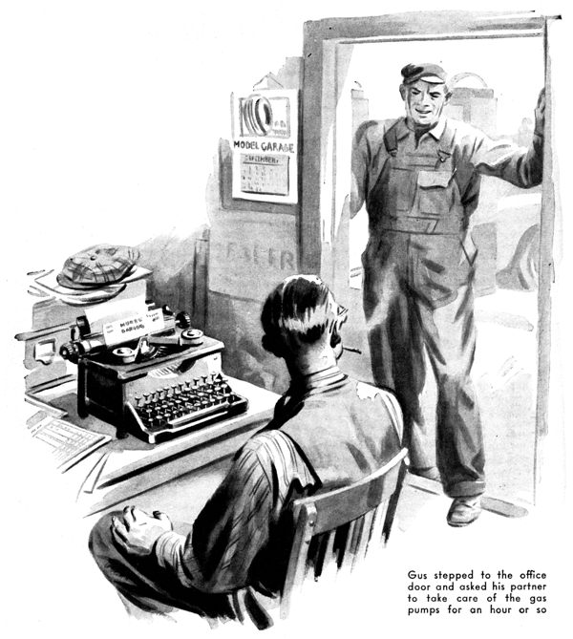
Back in his shop from the weekly Kiwanis Club luncheon, Gus Wilson finished shifting into his work clothes, fired up his pipe, and walked over to where a pair of long legs incased in grease-smeared over-alls were sticking out at the open front door of a mud-splashed sedan which he recognized as the trusty chariot in which Ez Zacharias carries Uncle Sam's mail over his R. F. D. route in spite of hell and high water. When he got close he heard a steady stream of low-voiced but earnest cussing coming from under the car's dash, and when he looked in he saw that Johnny Tobin, the Model Garage's new grease monkey, had the floor boards up and that he was examining two badly corroded battery-cable clamps.
"Hi there, Johnny!" Gus said, "What's the matter? Why all the bad language? That job got you down?"
Johnny wriggled his lean and lengthy body backward, got his oversize feet on the shop floor, and straightened up. "It nearly got me down!" he grumbled. "Those cables were stuck tighter'n I ever saw any before."
Gus stuck his head into the car and took a look at the battery clamps. "They're sure plenty corroded," he agreed. "Before you put the battery on the charger clean those terminals with a solution of bicarbonate of soda and water. Don't let any of it get inside the battery, though. Ask Mr. Clark to let you have some of his bicarb - he keeps a bottle of it in his desk for his indigestion. What's the matter with this battery, anyway?"
"I dunno," Johnny said. "That feller with the postman's cap who owns the car said it was run down and Bill told me to take it out and put it on the charger and put in a rental."
"Where's Bill?" Gus asked.
"Mr. Clark sent him out on a job," Johnny told him, "But here comes the feller who owns the car, now."
His hands in his pants pockets, and his cap on the back of his shaggy head. Ez Zacharias had strolled into the shop. He came over to them, lifted one bushy eye-brow in greeting to Gus, and lobbed a shot of tobacco juice into the waste box. "Ain't you got that rental in my bus yet?" he asked Johnny. "Bill said you'd do it while I went over to the diner an' eat. Step on it, will you - I wanta go to the ball game."
"What's the matter with your car, Ez?" Gus asked.
Ez grinned. "She's like me - hot weather's kinda got her, I guess. Had to get her started, and when she's started she runs sort of jerky and ain't got much pep. I figgered the battery must be run down, and Bill sort of agreed with me."
"Oh, I see," Gus said, and took time out to wish that Harry, his old assistant who's a sergeant in the Army now, was back on the job. Bill is a good-enough mechanic but he's not so hot on taking time to find out what's the matter with a car before he starts fixing it, and so far young Johnny hasn't been over successful in applying what he learned from an evening high school course in automotive mechanics to the realities of a busy shop.
Ez rang the bell, with another magnum charge of tobacco juice. "I wanta see the first innin'," he suggested.
"You take my car to the ball game, and stop by here for yours on the way home," Gus told him. "Maybe the trouble with that old puddle jumper of yours is in the battery, and maybe it isn't. I'm going to give the ignition a good checking to find out."
"O. K. with me," Ez said. "I don't know what's got into her, but the old hack certainly ain't got nearly the pep she ought to have."
After Ez had driven out Gus stepped to the office door and asked his partner Joe Clark to take care of the gas pumps - Johnny's usual job - for an hour or so. "I want to teach the kid something about ignition checking," he explained.
"All right," Joe said. "But you're wasting your time. That boy's a misfit."
"Sure he is," Gus agreed. "So was I a misfit when I started. So were you. Why not give him a chance? Remember how dumb you thought Harry was when he fist started to work for us - and where can you find a better auto mechanic now?"
"I wish his time in the Army was up and he was back with us," Joe said.
"Me too!" Gus snapped. "But until he comes back we'll have to do the best we can wish what we've got - which is Bill and Johnny."
He went back into the shop, checked Ez's battery and found it in excellent condition, and told Johnny to leave it in the car. "What did they teach you in school about ignition systems?" he asked.
"Oh, all about 'em," Johnny said comprehensively.
"That's swell!" Gus applauded. "Then you'll be able to give me a few pointers as we check Ez's car. But just for a starter you jump in and switch on the ignition and we'll test the condenser."
Johnny hesitated. "The condenser," he repeated, then added: "Say, Mr. Wilson, I want to tell you that . . ."
"One thing at a time, son - one thing at a time!" Gus interrupted. He separated the distributor contact points with a screw driver. As they opened there was no spark, and the ammeter hand didn't drop back to zero. "There's the trouble! The condenser is occasionally shorted - the way it is right now - so that the current flows right through it. That's what has been causing the hard starting and the jerky running that Ez was complaining about. We'll have to put in a new one. By gum, every driver should carry a spare condenser with him. Then if he has trouble on the road he can install it, temporarily without even removing the top of the distributor. All he has to do is scrape off an inch and a half of insulation from the wire running from the coil to the condenser, at a point near the coil, and then wrap the lead of the condenser around the wire and attach the condenser to any part of the motor block where there is a good ground."
Together, they installed a new condenser, then Gus directed Johnny to turn on the ignition. Johnny did as he was told, and Gus started giving the cables and wires the once-over. He pulled the cables leading to the spark plugs out of the manifold and examined them intently. "They look as good as new," he told Johnny, "but it isn't safe to go altogether on looks. When you're checking wiring, look for broken insulation, but feel for hard insulation. If you find either, replace that cable. Sometimes the heat from the engine bakes the insulation of wires right through the metal plates covering them. As a result, the cable manifold itself may become charged or voltage may be induced in the wrong cables and wiggling the wires and cables. "How's that ammeter hand - still steady? Then there's nothing wrong with this wiring. All right - switch her off and come down here. I want to show you something."
"Gus began to examine the cables running from the coil to the distributor. "Any of these cables with insulation that is even a little worn, frayed, dried out, cracked, or oily should be replaced," he said. "And be sure to keep your eyes peeled for cables that have gone bad. Here's one - see how the copper core seems to have shrunk back? That's the tip-off that deterioration probably has started throughout the cable. Let's see you put a new one in."
Gus watched approvingly while Johnny did a workmanlike job. "Fine!" he said.
"Now we'll check the coil," he pulled the center lead out of the distributor cap.
"Switch on the ignition and step on the starter - and watch this lead."
He held the end of the lead close to the engine block. When Johnny stepped on the starter he saw a spark jump the quarter-inch gap. "Switch her off," Gus told him. "That spark shows that the coil is O. K. - if it wasn't there wouldn't be any spark."
"If a coil is bad, or even a little weak, put in a new one. But on cars which have coils with an armored ignition-cable fastening at the base, make sure that a coil which seems weak is weak before you discard it. Pry the base open, clean the primary connection, and tighten the nut securely. Dirty or loose connections sometimes make a coil of that type seem weak when it is perfectly good.
"One cause of hard starting and poor running is an excessive voltage drop somewhere in the primary circuit - usually the result of high resistance caused by loose or dirty connections, broken or deteriorated wire, or wire which isn't large enough - all primary ignition wire should be No. 10 gauge."
He got a voltmeter from the glass-fronted cabinet in which he keeps his instruments and precision tools. "We'll check the part of the circuit between the starting motor and the coil. Close the ignition switch, and make sure that the distributor points are closed and that the ammeter shows a discharge - O.K."
He placed the prod of the voltmeter on the battery-cable terminal at the starting motor, and the other prod on the battery connection at the coil. Then he looked at the voltmeter. It showed a voltage drop of less than a fifth of a volt. "The trouble isn't in this part of the circuit," he told Johnny. "If there were excessive resistance the voltage drop would be more than a fifth of a volt. But here's something that should be fixed. See the way those strands of wire are wrapped around that terminal screw?
Sloppy! Clean the wire, insert it in a lug, and solder it. . .
Good. But what if you didn't have a lug?"
"I - I dunno," Johnny admitted. "Say, Mr. Wilson, I got something to tell you. I - "
"Let's stick to what we're doing," Gus interrupted. "If you haven't got a lug, you should dip the end of the wire in solder before you make the loop. That'll do in a pinch. Well, the primary-circuit wiring is all right. Now we'll check the plugs. Switch on the ignition, and start her when I say."
He held a screwdriver so that it rested on both the engine block and on the wire connection on top of a spark plug. "Step on her," he told Johnny. With the engine running he checked each plug in the same way.
"Switch her off," he said finally. "The plugs are all O.K. If any of them had been bad we wouldn't have noticed any 'miss' as we checked each one."
He removed the plug cables from the distributor. "All the terminal clips are tight, as they should be," he said. "The sockets in the distributor cap should be clean and free from corrosion. Here's one that isn't - pick the corrosion out with the pointed end of a small round file. . . That's good. Now put the cables carefully back in their sockets."
Once more, Gus took off the distributor cap. "Now, Johnny, you turn the engine over," he said. Gus watched until he saw the breaker points come together. "Stop! Switch the ignition on." He broke the contact-point connection with the tip of a screw driver. There was a slight spark and the ammeter hand fluctuated. "The distributor is O.K.," he decided. "If we didn't get a spark, or if the ammeter hand didn't move, it would mean that there was an pen somewhere between the battery and the primary circuit - probably a bad switch or cable."
Gus examined the contact points carefully. "They're not burned or pitted," he said.
"The spacing of the points is correct. The cam is all right. There's no crack in the distributor cap which might allow high-tension current to leak, and so cause misfiring. That about winds things up."
"Say, Mr. Wilson, I got to tell you something!" Johnny insisted. "I joined the Air Corps this noon. I'm quitting tonight!"
Gus's lower jaw drooped and his face got red. "Then - then why the devil did you let me waste an hour giving you a course in ignition trouble-shooting?" he demanded.
"I tried to tell you," Johnny said defensively. "Twice. But you wouldn't let me."
Gus grinned. "You're right - you did try. Well, go and tell Mr. Clark, so he can get your pay ready. And lots of luck, Johnny!"
END

