May 1941

GUS LEARNS SOMETHING NEW
by Martin Bunn
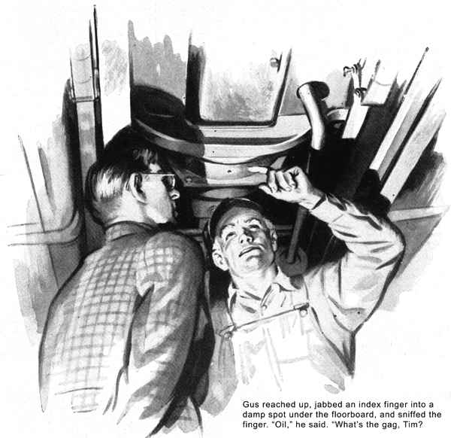
A horn honked raucously outside the open shop door of the Model Garage. As Gus Wilson looked up from the carburetor adjustment on which he had been intent, a coupe, vintage of 1935, which he had never seen before, was driven in. From it emerged a cheerful-looking pooch of obviously scrambled ancestry, which ran over to him with shrill yaps of greeting, followed by a tail and lean young man whose thin-cheeked face was topped by a shock of tousled yellow hair and decorated by a pair of rubber-tired spectacles. "Hello, Gus," the young man said, "Long time no see."
There's no one that Gus Wilson thinks more of than Tim Sheridan, who, he contends, has more than a touch of mechanical genius in his mental make-up. But Gus isn't at all the sort of guy who gets sloppy about it when he likes you. He leaned over and petted the dog's shaggy head. Then he looked at Tim. "What are Dodger and you doing here?" he wanted to know. "Lose your job?
"Who me?" There was disdain in Tim's voice, "No, sir! Why, they couldn't run that airplane-engine plant up there is Hartford without me! I'm just home over the week-end."
Gus grunted and tossed a deprecatory glance at the six-year-old coupe. "What's that old thing you're driving?" he asked.
Tim grinned widely. "Picked it up cheap in Hartford," he said. "I had to have something with wheels on it to get back and forth between the boarding house and the job. That car's a real wonder, Gus. I never saw a bus that had so many queer things the matter with it."
Now Gus looked really interested, "Such as what?" he inquired.
Tim draped his lanky six feet over the end of the workbench, pulled tobacco sack and papers from his pocket, and expertly rolled himself a cigarette. "Such as this," he said when he had lighted it. "It uses up an awful lot of oil. And what happens to the oil? Why, it goes into the transmission."
"Now I knew you're screwy," Gus said. "There's no way in which engine oil can get into that car's transmission."
"I know there isn't," Tim admitted. "But that's what it does."
Gus grunted, but offered no further protest. Then he called to his helper to put the car on the lift. When it was raised, Gus and Tim walked underneath and gazed up at the greasy-looking bottom of the car.
"What's this hole in the bottom of the flywheel housing?" Gus asked after a little.
"The used-car dealer I bought this jalopy from cut that hole there," Tim explained, "to carry off the oil. But, as a matter of fact, very little comes out there."
Gus reached up, jabbed an exploratory index finger into a damp spot under the footboard, and then sniffed the finger. "Oil," he said. "Come on now, Tim - what's the gag?"
"No gag at all," Tim told him. "I put engine oil in at the filler pipe, and after I've driven for a while most of it is in the transmission. I knew that's impossible, but I'll prove to you that it's a fact. You can take my word for it that just before I started this morning. I drained all the engine oil out of the transmission, and filled up with fresh transmission lubricant. Now watch."
He placed an empty tin can under his car, and opened the plug hole at the bottom of the transmission.
Oil poured smoothly into the can. Gus poked a finger into it, and again sniffed the finger. "It's mostly engine oil, all right," he admitted.
You're darn tootin' it's engine oil." Tim said. "How the dickens it gets there is what burns me up!"
We'll find out," Gus said. "Let me at it!"
He got at it.
An hour later he still as at it. Checking, rechecking, and triple-checking had thrown no light on the mystery of the strange behavior of the oil. Gus straightened up, pushed his long-peaked mechanic's cap back from his furrowed forehead, and swore under his breath. Tim spirited back on his heels, absently rolled himself another cigarette, and forgot to light it. "Well," he said after a silent minute, "it looks as though we're licked."
"Licked nothing!" Gus snapped. "We're just stopped temporarily. And I've found that when you're stopped on a trouble shooting job it's often a good idea to work on something else for awhile, and then go back to the original grief. What are some of the other things that are the matter with this collection of junk?"
Tim's wide grin lit up his thin face. "To mention just a couple of them," he said, "there's a knock that sounds to me like a bum main bearing, and there's something very screwy about the fuel pump. I haven't had a chance to do any real checking. I've been working overtime almost every day, and studying airplane engines half of most nights."
"I'm glad is hear it," Gus said unsympathetically. "Plenty of good hard work is what you kids need most... Let's have a look at those main bearings."
They took off the oil pan, and then the rear main bearing cap. "It doesn't look as bad," Gus decided, "but we'd better check -"
He stopped and stood looking at the bearing.
"Lost your voice?" Tim inquired. "Or do you -"
"Look at that," Gus said, pointing. "See what I mean?"
Tim peered intently, "All I can see," he said, "is that sometime some oil shimmied up that bearing. What of it?"
"What of it?" Gus repeated scornfully,
"Nothing of it - except that right there, staring you in the face, is the solution of the mystery of how our engine oil gets into your transmission. Use your eyes, Tim - and what's back of 'em!"
Tim did a couple of minutes of hard thinking. Then he shook his head. "Nope," he said, "I don't get it."
Gus laughed, "I didn't get it myself at first," he admitted. "When whoever it was that shimmed up that bearing fitted the bearing cap back on, he carelessly covered up the return drain hole. That forced the engine oil to run into the flywheel bearing,
Then - "
"Wait a minute! Wait a minute!" Tim said. "The used-car dealer cut that hole in the bottom of the flywheel housing so that the oil could run out of it."
"Sure he did," Gus concurred. "But you said yourself that very little oil ever ran out of it. And why not?”
“Because the flywheel threw the oil against the slope of the bell bearing. From there it ran down to the forward transmission shaft bearing and through it into the transmission. After you've put in a new main bearing your engine oil will stay where it belongs."
"By jingo, you've hit it right on the nose!" Tim cried admiringly. "Did you ever run into a thing like that before, Gus?"
"No, it's a new one on me," Gus admitted, "I don't suppose that a thing like that would happen once in a million times. Well, that's one of the good things about this job, Tim - you keep on learning things. Now how about that fuel pump? We might as well get this bus of your fixed up so that it will get you back to Hartford."
"Well," Tim said, "I think that it is the fuel pump, but I'm not dead certain of it. As I told you, I haven't had time to do any real checking since I bought this car. It ran pretty good - considering - for a few days. Then one morning, while I as on my way to work, the engine coughed a couple of times sputtered for a few seconds, and then went dead. I made a quick check of the gas line, and found that it was O.K.
But the engine wouldn't start. While I was fooling with it one of the boys in my shop came along and gave me a push. The engine started right off then, and the car ran all right the rest of the way to the point.
"When I came off shift that afternoon I thought I'd have a battle getting going, but I didn't. The engine took off as soon as I stepped on the starter.
"After that the car ran all right for a couple of weeks. Then the same thing happened again. That night I took enough time out to check the gas line, the battery, the wiring, the distributor, and the plugs - all O.K. I didn't have time to take the fuel pump apart and check it. But everything else seemed all right, as I figure that it must be the fuel pump that has gone bad."
"How about your windshield wiper?" Gus asked. "The way it acts often is a good check on the way the fuel pump is working. If the wiper is slow in action when you step on the gas, there's a good chance that the vacuum pump coupled to the fuel pump isn't doing the job right, or even that it isn't working at all - and just about as good a chance that it has a broken diaphragm. If there is high gasoline pressure and a lot of noise, it probably means that the rocker-arm pin and link of the vacuum pump are shot."
"I don't remember that there was anything wrong with the wiper the last time I used it," Tim said. "But I'm pretty certain that the trouble is in the pump - I don't see where else it could be. I've got to get busy and fix it, too. She went dead on me three times coming down from Hartford."
"Let's get the pump off and have a good look at it," Gus said.
He removed the fuel pump from the car and took it apart. The diaphragm wasn't cracked and all the other parts were in good working order, so be cleaned them thoroughly and put the pump together again.
"Well, that wasn't it - so what was it?"
Tim asked as Gus prepared to replace the pump on the car.
"Dunno," Gus said. "Hello!" His keen eyes had caught the glitter of a bright silver of metal on the end of the pump arm, where it works against the cam. "Hold on there a minute, 'Tim - there's your pump trouble!"
"Huh?" asked Tim. "what do you mean?" Gus was examining the pump arm. "Yep, that's it," he said. "This arm is sprung a little, and sometimes instead of engaging the cam it slips to one side of it. That's the how-come of that sliver of metal that tipped me off. It was shaved off when the arm almost but not quite missed connections. Naturally, when the pump arm misses the cam the pump doesn't function, and your engine goes dead because it isn't getting any fuel."
Tim studied the pump arm for a moment, and then nodded agreement. "You're right - as usual," he conceded. "Say, old Hawkeye, don't you ever miss 'em?"
"Sure I miss 'em," Gus said modestly.
"Every one in this business misses 'em now and then. If I hadn't happened to spot that silver we'd have been fooling around for another hour trying to find out what ailed your bus. Well, let's fix it - that's easy!"
He clamped the arm in the vise on his workbench, and tapped it carefully with a machinist's hammer until it was back to its normal shape. Then he reinstalled the pump on the car. With the pan still off, it was easy to see that the pump lever now rested properly on its drive cam.
Tim looked grateful. "Thanks, Gus," he said. "Don't forget that I'm going to pay you for all this."
Gus scowled at him, "Pay me?" he growled. "You don't owe me anything.
Now don't start a fool argument! I guess I can help Bill Knudsen along in his defense job by getting a workman back to his airplane-engine plant, can't I?"
END

