June 1941

GUS RESCUES AN AMATEUR
by Martin Bunn
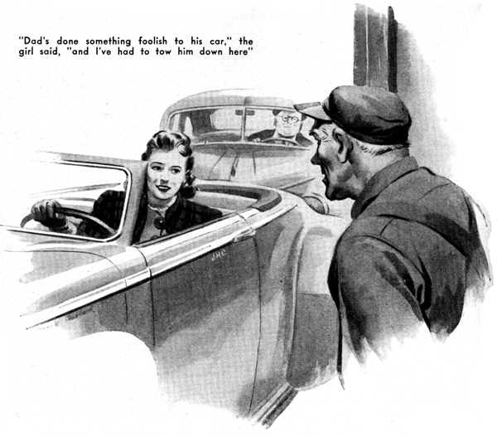
It was getting along toward five o'clock on a warm spring Saturday afternoon when Joe Clark came out of the Model Garage office into the shop and began picking time-and-material slips out of the old cigar box on the end of the workbench into which his partner Gus Wilson always drops them after he has filled them in.
"Pretty near quitting time," Joe remarked as he glanced over the smudged forms.
"Good day, hey? where's Bill?"
"I let him off an hour early," Gus said.
"He's going upstate to visit his folks over the week-end, and he's got a long drive in front of him."
A horn sounded outside, and Joe stuffed the slips into his pocket. "There's someone who want gas."
Gus glanced toward the open shop door.
"No they don't," he said. "They're coming in. It's the Callenders, and they're in trouble again. Wonder what it is this time."
A snappy roadster was driven into the shop, towing a shiny and expensive sedan steered by a portly and plutocratic-looking middle-aged gentleman whose red face and swanky golf clothes were generously smeared with grease and grime.
From the roadster leaned an easy-to-contemplate young woman whose dark eyes showed amusement. "Dad's done something foolish to his car so it won't run and I've had to tow him down here. Incidentally, Mr. Wilson, now I've got myself late for the heaviest date I've had in weeks!" she said, indicating eagerness to be off. "Now you can take care of him," she laughed. "Untie the rope, will you please? I'm going!"
Gus untied the towrope, and she maneuvered the roadster expertly out of the shop. Callender waited silently until his daughter had departed. Then he climbed out of his sedan, looked at Gus and Joe with a help-me-I'm-lost sort of expression on his florid round face, and shook his head slowly. "I'm licked!" he said briefly.
Joe tried to look politely concerned and mildly disapproving at the same time. Callender is a well-to-do-man who moved to town recently with his three-car family, and who has become an excellent customer of the Model Garage in spite of what Joe Clark considers his reprehensible habit of doing a lot of little car jobs for himself. But that habit doesn't bother Gus Wilson - he soon found that Callender isn't nearly so successful a mechanic as he is a broker, and that most of the little jobs he tackles turn up, often in aggravated form, in the shop to be done over again. "What's the trouble?" he asked, succeeding in smothering a grin.
Callender looked freshly aggrieved. "I can't understand it," he said fretfully. "It's really beyond me. For the past few days this car has been making a most peculiar sort of noise, and this morning it refused to start.
I decided that, as I wasn't going down to the city today, I'd find out what was the matter with it. My boy Kenneth - he got high marks for a course in automotive mechanics he completed at school - told me it might be a leaking head gasket. After making various tests, I removed the head of the motor. I found that the piece of copper between the upper and lower parts of the motor - the gasket - was broken in a couple of places. I drove down to the city in my daughter's car and brought back a new gasket.
"I had used meticulous care in taking the motor apart - I had marked each part, and even put labels on some of them, to make certain that I'd get them back in exactly the same positions that they had been in.
I reassembled the motor with the same care.
And now" - Callender seemed on the verge of tears - " and now the darn car won't start!"
Gus looked more serious than he usually looks when he tackles even a tough trouble-shooting job - as he said afterward, he was afraid that this time Callender had really gummed up the works.
He got into the car and stepped on the starter. The only response was a muffled cough from one of the eight cylinders. He got out, raised the hood, took out one of the spark plugs, and examined it carefully.
Then he made a quick job of stripping off the engine head. All the plugs were good and wet, and each cylinder contained considerable water.
He gave Callender a queer sort of look.
"What gets me," he said, "is where the devil all this water came from!"
"Why," Callender said, "I put it there."
"You what?" Gus demanded.
"I put it there," Callender repeated. "I noticed that there was water in the cylinders when I took the head off the motor, as to be sure that everything was exactly as it had been, I poured a little water into each cylinder before I put the head back on. Nothing wrong about that, was there?"
Joe Clark said that he heard the office phone ringing, and left hurriedly.
Gus's face didn't change. "Being careful backfires on a fellow sometimes," he said diplomatically, and went on to explain how the original gasket had caused the trouble by breaking through water to leak into the cylinders. While he talked he worked - swabbed the water that Callender had so carefully poured into the cylinders out of them, dried the spark plugs thoroughly, and then replaced the engine head. "Try her now," he said when he had finished.
Callender, his face red, stepped on the starter, and the engine took off with a heart-warming zzing. "You must think I'm an awful fool," he said.
"No, I don't think that," Gus told him.
"It's just that repairing cars isn't your job, any more than buying and selling stocks is mine. I'll let you in on a secret. Mr. Callender. When I started fooling with the market back in the easy-money days I made a bigger mistake than you made when you poured water into those cylinders - and one that cost me a lot more!"
Callender grinned. "I get your point," he said. "After this, any work that has to be done on our cars will come right in here to you."
After Callender had driven out of the shop, Gus glanced at the clock, saw that it was after six, and started to wash up. While he was at it, Joe Clark stuck his head in at the office door. "Say Gus," he said, "a fellow just phoned that his truck is stalled a few blocks down the road, and he wants to know if we'll tow him in and fix him up. Says he's got to get to New Haven tonight or bust. I know it's past quitting time, and that Bill is away, but this driver claims that if he doesn't make his delivery it'll mean holding up a national-defense job, so I thought."
"You thought right," Gus interrupted. "I'll go get him of course."
He found the stalled truck - it was a recent model of a popular make - laid out at the side of the road. Its driver withdrew his head from under the raised hood when Gus stopped the wrecker beside him.
"The darned thing just plain quit on me," he growled. "Gasped a couple of times and then quit cold. It did the same thing this morning, but then it ran all right after a garage fellow had cleaned out the fuel pump. But this time..."
"Hop in," Gus told him. "Over in my shop we'll have something to work with."
After towing the truck into the shop, Gus climbed in and stepped on the starter. The engine took hold on the first whirl. "It'll start all right," the driver said discouragingly, "but it won't keep going."
Gus speeded up the engine a little. For perhaps a minute and a half it ran smoothly. Then it gasped. Then it stopped.
Gus tried again. This time when the engine began to die off, he pulled out the choke and opened the throttle a little. But again the engine stopped. "Acts to me as if it wasn't getting enough gas," he said.
"How's your tank?"
"At least three-quarters full," the driver told him.
Gus grunted and lifted the hood. He removed the gas line between the fuel pump and the carburetor. "Step on her," he said. The starter turned the engine over fast.
"Switch her off," he instructed after he had satisfied himself that the pump was working efficiently and delivering gas under plenty of pressure.
He checked the carburetor carefully - float level, the high-speed and idling jets, and the choke valve. Everything was in perfect order. He replaced all fittings.
"Start her again," he said. Again the engine took off promptly and ran smoothly - and again after running for over a minute it stopped.
"Must be the distributor," Gus said, more to himself than to the truck driver. He checked the distributor. Its points were clean and correctly spaced. Its bakelite head had clean contacts and showed no cracks.
Gus hummed another tuneless tune. Then he took out the spark plugs and checked each one for its gap and for cracks in its insulation. The gaps didn't need any adjustment, and he couldn't find any cracks.
He replaced the coil and condenser, and then checked the timing. It was perfect!
Gus loaded and lighted his pipe. He puffed clouds of gray smoke as he did a job of heavy thinking. Then he shook his head. "It just ain't so!" he decided.
He did another job of thinking, and then got out and connected a neon-pencil tester and asked the driver to start the engine.
He held the pencil on the Number One plug and watched the spark. For a while it came through heavy and even. Then it cut out suddenly. The engine lost its momentum and stopped.
Gus cussed. Then he reopened the distributor, and went over its head very carefully for a dirty contact or a crack that he might have missed on the first checking.
He couldn't find anything. Next he took off the rotor, and just as carefully checked it for a loose or dirty contact between the contact spring and the brass brush. But the rotor seemed to be in as perfect condition as the distributor head. He cussed some more, put the rotor down on the still-warm manifold, and went on checking.
Finding nothing wrong anywhere, he began to replace the various parts. When he picked up the rotor he noticed that it was warm. Looking at it closely, he saw that a tiny hairlike crack had appeared across about three quarters of the width of the contact spring.
Gus held the rotor away from the engine, and as it cooled watched the crack disappear. He put the rotor back on the manifold, left it there for a minute, picked it up again, and saw that the crack showed.
"You'll be able to make your delivery tonight, all right, so the country's saved," he told the driver. "Your engine will run as good as new as soon as I put on a new rotor - and that won't take a minute."
"That's swell!" the driver said. He picked up the rotor and stared at it. "But I don't see anything the matter with this-here gadget."
"That's what fooled me," Gus said.
"There's a crack in the spring, but it closes up as soon as the metal cools. That's why your engine runs fine for a minute or so before it stops. When the current flows through the spring it gradually heats it enough to make the crack widen out and leave so little unbroken metal that it can't carry enough current to jump the gaps at the spark plugs. Get it?"
"No, I don't," the truckman admitted frankly. "And I'm blamed if I can see how a crack so little that most of the time you can't see it can lay out a whole truck."
Gus laughed as he started to put on the new rotor. "That's the way it is in this business," he said. "A lot of the big troubles come from mighty small causes!"

END

