October 1940

GUS BEATS THE HEAT
by Martin Bunn
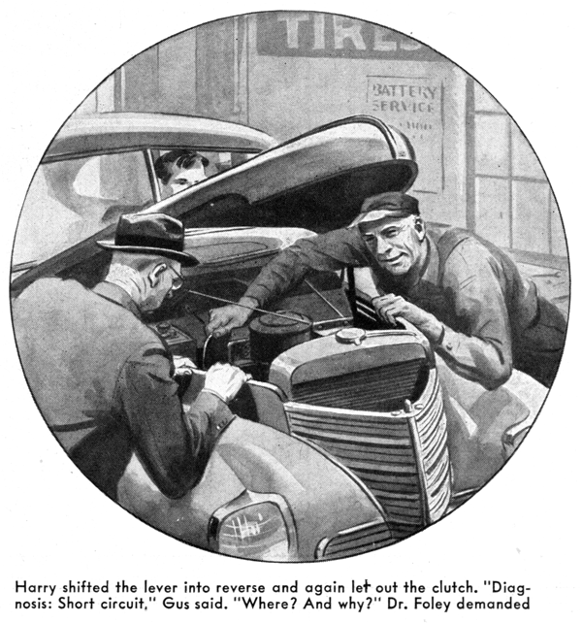
The afternoon was sunny and hot, and for once there weren't any jobs standing in the shop waiting to be worked on. So Gus Wilson, sitting in the shade of the little porch outside the office, was taking it easy and watching the cars go by.
The suburban-town Model Garage, which Gus and his partner Joe Clark have built into a satisfactorily prosperous business, stands on a main road at the foot of a slope. Gus had just filled and lighted his second after-lunch pipe when he heard an engine sputter and quit, and saw a well-shined-up sedan stop at the beginning of the upgrade.
A fat man wriggled out from under the steering wheel, and an equally fat and very flustered-looking woman moved over into the driver's seat. The man walked wearily around to the rear end of the car, took the cap off the gas tank, climbed up on the bumper, shouted something to the woman, and then, blew gustily into the tank. The car began to move again, slowly and with a succession of back fires which sounded like a burst from a machine gun. The man on the bumper continued to blow into the tank.
Suddenly the woman who was driving made a U turn. As soon as its nose was pointed downhill, the sedan's engine took hold and ran smoothly. The car turned in at the driveway and stopped at the gas pump. The man got heavily down from his perch on the bumper and demanded to know what was the big idea.
"I've had enough of this!" the stout woman told him dangerously. "I'm tellin' you, George - get it fixed!"
The man puffed out his cheeks - they were purple from his blowing - and glared at her. "I suppose you think I like it!" he said bitterly. Then he turned to Gus. "Name's George Hawkins - this is Mrs. Hawkins. Live up in Rhode Island. We've had this car for four years, and until day before yesterday we never had any trouble to amount to anything with it. Then it went bad on Mrs. Hawkins - ran all right on the level, but acted like the gas line was clogged every time she tried to go up a hill. We were starting on our vacation trip yesterday morning, so that night I took the bus to a garage and had it gone over. They checked the carburetor and fuel pump, and blew out the gas line, and told me I wouldn't have anything to worry about. Ain't that right, Estelle?"
Estelle snorted. Gus couldn't make out whether she was registering agreement or disgust. Her husband swallowed nervously and went on with his tale of woe:
"We started out yesterday morning, and for fifty miles or so things went all right. The car didn't have as much pep as usual, but we didn't have any real trouble. Then we got into the Connecticut hills, and - oh, boy!" Every time we tried to go up a grade, the car acted like it had a bad case of vapor lock. If the hill was at all steep, the motor would quit dead. After a while I got the idea that if I blew into the gas tank it would force a little gas into the carburetor. That worked well enough to keep the bus going, but before long I was darned sorry I'd ever thought of it! Every time we hit a hill, I'd have to climb out on the back bumper and blow my lungs out!
"We called it a day early in the afternoon, and I took the car to a small town garage. Sure, the feller there said it was vapor lock, and he knew how to fix it. He put in a new gas line from the fuel pump to the carburetor, keeping it well away from the manifold. He charged me plenty for the job, but he told me I wouldn't have any more trouble. He's a liar! It's been just as bad all day today, and I'm sick and tired of sitting out there on the bumper blowing my heart out and listening to a lot of smart guys make wisecracks!"
"And I'm sick and tired of this whole fool trip, and of everything about it," his wife put in grimly. "Fix this car up so we can get home, Mister, and I swear I'll never set foot in it again!"
"I don't blame either of you for being disgusted," Gus told them, managing to keep his face straight. "There's nothing that'll spoil a vacation trip quicker than a balky car. But if you'll drive into the shop I think I can fix up your trouble for you."
As Mrs. Hawkins drove into the shop, her husband followed Gus. "Make it good, Mister," he begged. "Estelle,s plenty sore, and if you fall down she'll sure give me hell!"
"You'll be a lot more comfortable waiting in the office, Mrs. Hawkins," Gus told the peevish lady as he held the door open for her. When she had vanished in sultry silence he got into the car and stepped on the starter. The engine took off, but its sound told Gus that it wasn't getting enough gas.
Leaving it running at moderate speed, Gus got out, raised the hood, and examined the fuel pump and carburetor. "The fuel pump is pumping scarcely any gas," he remarked. "The main gas line has been checked twice, so it's pretty certain to be O.K." He leaned over and eyed the rubber hose connecting the gas line and the pump: then took it off. "This might be the joker," he said. Attaching an air line to the hose, and holding a swarthy thumb over the other end he lowered it into a pan of water. Dozens of little bubbles formed on the hose and came to the surface. "That's your trouble maker," he decided.
He examined the hose closely, then handed it to Hawkins. "There are several small holes in it," he told him. "See what's been happening? Gas hasn't been leaking out of the hose. If it had been, the mechanics who have worked on your job would have located the trouble. Instead of that, air has been sucked in through those holes. As you drove uphill, the suction was stronger than it was on the level, and so much air got into the mixture that it killed your engine. When you blew into the tank - that's a new one on me - it forced more gas into the fuel line, and that kept your engine running. Easy to fix; just a length of new hose."
Five minutes later Hawkins went into the office, and then came out with his wife. She listened grimly to Gus's explanation of the engine. Then she got heavily into the car.
"I hope you have a pleasant trip home, Mrs. Hawkins," Gus ventured with a grin.
For the first time she smiled, "I guess as long as we've had all this trouble coming down here," she said, "we might as well visit my sister in the city" she looked at her husband, and her face grew grim again.
"Get in, George!" she snapped. "Don't stand there wasting the rest of the day!"
Gus watched them drive away, thanking his stars - not for the first time - that he had remained a bachelor. Then, just as he was heading for the cool office porch, Dr. Foley drove up to the shop door. "Hello, Gus," he greeted. "Busy?"
"No Doc," Gus said. "just dog lazy."
"It's the weather," the doctor said. "Maybe that's what's the matter with my car, too. I can't think of anything else. It runs fine going ahead, but the motor dies every time I put it in reverse. Diagnose that case, will you, Gus?"
"Not until I've examined the patient, Doc," Gus said, grinning. "It wouldn't be professional - it would make it seem too easy. You know that. Drive her in, please."
Dr. Foley drove into the shop. "Jack up the rear end, will you?" Gus asked Harry, the grease monkey. "Probably something has gone wrong with its appendix, or maybe its tonsils," he told the doctor.
But a routine check beneath the car failed to disclose anything wrong.
"Huh!" Gus grunted. "Well, I'll give her a real test."
He was back inside a quarter hour. "Just as you said, Doc," he remarked as he got out. "Runs swell going forward, and goes dead every time you go into reverse. Guess I'll have to do a job of trouble-shooting. Get the rear end jacked up again, Harry."
Harry jacked up the rear wheels. Gus raised the hood and relighted his pipe. "Get in," he told Harry, "and step on the starter." The engine started promptly and ran sweetly. "Now put her in reverse," he directed.
Harry did as he was told and let out the clutch. Gus's quick eye saw a spark at the rear of the engine just before it stopped. He peered in, then put his hand in and moved something. "Start her again," he said. "Now put her in reverse."
Harry shifted the lever into the reverse position, and again let out the clutch. The engine continued to run smoothly.
"Diagnosis: Short circuit," Gus said.
"Short circuit? Where? And why?" Dr. Foley demanded.
"Here's the low-down on your trouble," Gus explained. "Your engine is mounted on rubber, and it moves on its mountings. When the car is moving forward the engine settles down on the mountings. But when you go into reverse, the forward end of the engine seems to be raised a little by the torque, and its rear end settles back a little. Now, the primary wire to the distributor passes through a narrow space between the dash and the oil-filter pipe. When I saw a spark there when Harry reversed, I knew what had happened - that the movement of the engine on its mountings had chafed through the insulation of the distributor wire, just behind the filter pipe. When the car was moving forward, and the engine settle down on its mountings, nothing happened. But every time you went into reverse, the changing position of the engine squeezed that bare spot on the distributor wire between the filter pipe and the dash. That caused a short circuit which killed your engine. Fix it up, Harry."
Dr. Foley drove away, and Gus went back to the office porch. Joe Clark looked up from a ledger. "Nothing in the shop?" "Nothing much," Gus told him. "Just a couple of those little things that are hard to find and easy to fix."
"Nothing in them," Joe said gloomily.
Gus laughed. "Sure there is," he said. "Not much profit, but they're swell jobs for a hot day - they keep the old bean working, and don't make you sweat too much!"
END

