June 1940

GUS SOLVES A DOUBLE PUZZLE
by Martin Bunn
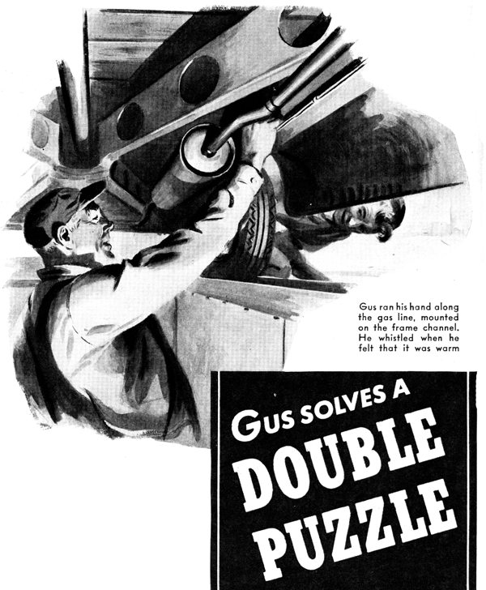
Gus Wilson looked up from the disassembled fuel pump on which he was working when a black business coupe was driven in through the open doors of the shop of the Model Garage. He grinned and began a cheerful greeting when Dave Sledd opened the car's door, but Sledd didn't give him a chance to do more than get started - he was talking fifteen to the dozen before his feet hit the shop floor.
"I just can't figure it out, Gus," he said. "The engine runs swell, and the whole darned bus seems all right. But I can't get her up over a couple of miles over forty an hour, even when I jam the pedal right down to the floor boards. I've watched the speedometer hand again and again: forty-two or forty-three is the best she'll do. She's been that way for the last week. I've been intending to bring her in to you, but I've been busy as the devil, and it really didn't make much difference so long as I was just running around town. But the first thing the boss told me when he got in the office this morning was that I've got to go away up-state today to smooth down a new customer who's having a little trouble with one of our machines - and that I'd better step on it so I'd have a chance to get him happy before his factory's closing time. I didn't have the nerve to tell the old man that the car isn't running right. He would have crawled my frame plenty for not having had it attended to. Look her over and fix her up in a hurry, will you, Gus? Give me a call at the plant when you get finished. I'll be all ready to start."
The energetic Sledd had started for the door before he had finished talking. "Hey!" Gus yelled after him. "I'm working on another rush job, and I can't stop now to go hunting bugs in that bus of yours. You'll have to wait until..."
But Sledd was through the door. He didn't answer and kept right on going. Gus grinned broadly. "That guy Dave's like a flea," he confided to Harry, the grease monkey. "He hops around so fast you never can get your finger on him,. Well, I suppose I'll have to take a look at his car, Johnson and Frederick being our biggest customer. Guess you can put this pump together, can't you?"
Harry assured him that he could put the pump together, and Gus started to check Sledd's car. The ignition system tested out all right. The carburetor was O.K. So was the fuel line. The clutch wasn't slipping. The brakes weren't dragging.
Gus tilted his black mechanic's cap over his left eyebrow and scratched reflectively back of his right ear. "What the heck!" he said finally.
"Stumped, hey?" Joe Clark, his partner in the business of the prospering Model Garage, had come into the shop from the office and was standing behind him.
"Yep, Stumped!" Gus admitted without shame. "Engine runs smooth, everything else seems all right, but the job won't do over forty-odd. At least Dave Sledd says it won't. Well, I guess there's nothing for it but for me to take it out on the road and see for myself."
He reached for his coat, but Joe stopped him. "Wait a minute," he said. "Mr. Hubbard just called up and wanted to know if you will have his car ready by eleven - he will need it then. It's after ten now."
"Darn!" Gus growled. "Hubbard's car has me stumped, too. Sledd needs his right away, and..."
"Tell you what," Joe interrupted. "You and Harry go ahead on the Hubbard job, and I'll take Sledd's bus out on the road. Maybe I'm no part of a mechanic, but I am pretty sure that I can read a speedometer as well as you can."
After Joe had driven out, Gus went back to work on the fuel pump. He and Harry had reassembled it and were replacing it on the Hubbard car when Joe came back. "Sledd's dead right," he reported. "His car runs fine, but forty-three was the very best I could get out of it... There's the phone,"
He hurried into the office, and Gus stared at Sledd's car and then at the Hubbard sedan. "I don't mind a double puzzle," he remarked, "but I'd rather work out one half at a time. Now, Harry, you..."
A motor cycle sputtered to a stop outside, and Trooper Jerry Corcoran, of the State Police, came jauntily into the shop - bread-brimmed hat tilted rakishly, blue-gray uniform immaculate, belt and boots polished to mirror-like brightness. "Hi!" he greeted. "Anything wrong around here?"
"Why," the trooper explained, "a few minutes ago I saw Joe Clark coming up the road in Dave Sledd's coupe. He was hitting it up at sixty-five. I've never seen him drive over thirty-five before, so I thought that maybe there was something the matter up here at the garage."
Gus stared at him, "Sixty-five?" he said. "You sure about that?"
"Sure I'm sure!" Jerry maintained stoutly. "I stayed behind him for half a mile, and kept one eye on my clock. I was going to whistle him down and give him a ticket, before I saw who it was."
Gus started to laugh. "I am dumb!" he said. "Hey, Joe! Here's Jerry Corcoran - and he has a speeding ticket for you!"
Joe Clark's outraged face appeared at the office door. "Speeding ticket!" he snapped. "You're crazy, Jerry! The limit's fifty on that road. I was watching my speedometer, and I was doing forty-three!"
"Yeah? Well," said Jerry, "I was watching my speedometer, and you were doing sixty-five - and if I wanted to I could make that stick as tight as a drum in court!"
"I was kidding about the ticket, Joe," Gus said. "But Jerry's right. You were doing sixty-five. Give Dave Sledd a call and tell him there's nothing the matter with his car - except that his speedometer is twenty-two miles slow! Tell him to bring it is when he gets back from his trip, so we can send it down to the service people and have it fixed."
"There's half of our doubts puzzle solved," Gus commented to Harry after Sledd had called for his car and driven it out. "Now we've got to solve the other half." He frowned at the Hubbard sedan. "I've blown out the fuel line, taken the fuel pump apart and cleaned it, and cleaned and adjusted the carburetor. I've checked the fuel line near the exhaust and at the gas tank, and there's no vapor look. The engine runs fine at idling speed. Now I'll take it out and see if it runs fine on the road. It should!"
"What's the matter with this bus, anyhow?" Harry wanted to know. "I wasn't here when Mr. Hubbard brought it to."
"The matter with it," Gus said, "is that it will run a little way, and then stop dead. After a few minutes you an start it again. Then it does exactly the same thing. It drove Hubbard nuts coming up from the city yesterday. I took it out, and it acted just the way he said it did."
He drove out. Three run-of-the-mill repair jobs came in during the half hour he was gone. When he got back he found Harry up to his eyes in work, and the shop jammed with cars. To get the Hubbard job out of the way while he did some shifting around Gus drove it over the greasing pit, leaving the engine running when he got out. "How's she doing?" Harry asked.
"Bad as ever!" Gus growled. He got down into the pit and felt the connection of the gas pipe at the tank. It was tight. Aimlessly, he ran his hand along the gas line, which was in the channel of the frame. He whistled when he found the line distinctly warm near the rear of the muffler. Close inspection revealed a small three-cornered hole in the muffler where its rear plate connected with its body. The car, he guessed, had been driven on a deeply rutted road, with the result that the muffler had come in contact with the road and had been bent sharply upward.
"Harry!" he called. "Get in the car and speed up the engine!"
Harry speeded up the engine. Gus felt it blast of hot exhaust shoot out of the muffler onto the gas line.
"Shut her off," he said. "And bring me a piece of asbestos and some wire."
He wrapped the asbestos around the muffler so that it covered the hole, and secured it with the wire. Then he climbed out of the pit. "Run her a couple of miles," he told Harry, "and see how she acts."
Harry was back in ten minutes. "Runs swell," he reported. "No trouble at all."
"That's part two of out double puzzle solved," Gus said. "Tell Joe to call Hubbard up and tell him he can have his car."
"Sure," Harry said, "But say, Gus, what was the matter with the bus?"
"Vapor lock," Gus told him. "But not where I had looked for it. When the engine was idling, the exhaust gas coming out of that hole in the muffler wasn't hot enough to do any harm. But when the engine was speeded up, it came out in a blast that caused the gasoline in the fuel line to vaporize - and, of course, the engine stopped. After the line had called off a little, you could start the engine. But when you speeded it up you had the same thing all over. That asbestos will do the trick for a few days, but we'll have to order a new muffler for Hubbard - we haven't one in stock. Tell Joe, will you?"
"Sure. Say Gus," said the young mechanic with a puzzled look on his grease-smeared face. "How come Sledd and Joe couldn't tell from the 'feel' of that car that it was going faster than forty? I could..."
"Look here, young fellow," interrupted Gus. "Think you could go out and sell like Dave, or keep books the way Joe does?"
"No," replied Harry, thoughtfully.
"You sure couldn't! Now go tell Joe about the muffler and get back to work and show me you can do that. Step on it!"
Harry stepped on it.
END

