July 1940

GUS BRINGS IN A GUSHER
by Martin Bunn
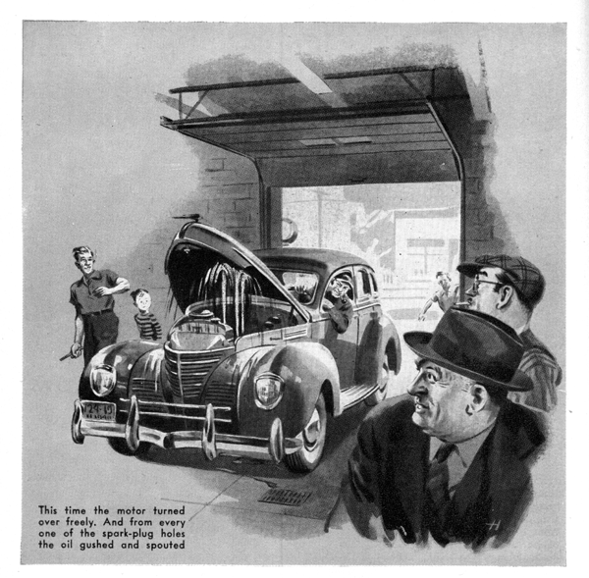
Gus Wilson, back from the weekly Kiwanis luncheon down at the Park House, saw an ancient but well-kept sedan in the shop which hadn't been there when he had left an hour and a half earlier. He knows all the Model Garage regulars' cars even better than he knows the regulars themselves, and at first glance he recognized the sedan. "What's the matter with Jack Kelly's bus now?" he asked Harry the grease monkey, who was staring at the car with a totally defeated look on his face.
"He says that he can start in second without any trouble," Harry detailed, "but that every time he tries to start in low, or goes into low after he has started, the engine stalls. It does, too. I tried it out. He says that he thinks the battery has something to do with it - that it's only a few months old, but that twice last week he had to keep his charger on it all night. But I checked the battery, and it's O.K. The job's got me stumped!" He shook his head ruefully.
While Harry had been talking Gus had been loading up his pipe. Now he lighted it. "For the last year I've been telling Jack that he'd save himself some money by buying a new car instead of trying to get the last thousand miles out of this poor old junker," he remarked. "Well, I'll get my overalls on. While I'm doing it you take those floor boards up. We'll have a look."
When he came back a few minutes later, Harry had the floor boards up. Gus puffed reflectively at his pipe as he looked down at the exposed battery and transmission. "Stalls whenever he shifts into low, but runs all right in second and high," he thought out loud. "So it can't be the battery... Jack up the rear end, Harry."
Harry did as he was told. "Now get in, and start her up in second," Gus directed. The engine started easily and ran smoothly. "All right," Gus said after a few seconds. "Now shift into low and see what happens."
Harry shifted into low - and the engine stopped dead. Gus laughed. "Switch her off, and come here will you?" he said. "Notice the layout, Harry - battery on the right side, starting motor on the left side, and the cable between the battery and the starting motor lying on the clutch housing right in front of the transmission. On old models like this one, the rods which carry the shifting forks slide in and out of either end of the transmission." He got into the driver's seat. "Now I'll show you something queer - one of those little bugs that make mechanics who won't use their heads claw most of their hair out trying to figure what the heck is the matter. I'm going to shift into low - watch that right-hand rod when I do it."
Harry saw the rod shoot forward until its end came into contact with the cable.
"Now take a close look at the cable," Gus said "See how the end of the rod has worn right through the insulation? Every time you shift into low, the rod comes into contact with the bare cable wires and causes a dead short. That stops the engine, of course, and those shorts are what have been running the battery down. Wrap that worn place on the cable with a piece of short rubber and friction tape. Then cut a sheet-metal clamp, slip the cable under it, and fasten the clamp under one of those bolts that hold down the clutch inspection cover. That'll keep the cable out of the way of the rod. When you've finished, give Kelly a ring and tell him that his car is ready for him, and that he won't have a bit more trouble until something else on it wears out!"
Joe Clark, Gus's partner who runs the business end of the Model Garage, stuck his bespectacled face in at the door which leads from the shop to the office. "There's a call for the wrecker!" he said cheerfully. "It's from a man named Woodward who lives next door to Doc Marvin - new people in town. He can't get his car started, and he wants us to tow it in and see whether we can find out just what's the matter with it."
"Go and get it!" Gus told Harry.
Half an hour later, Harry in the wrecker, carefully maneuvered a large car of expensive make into the shop. A stout, middle-aged citizen who looked both prosperous and perturbed got out of it. "I'm Mr. Woodward," he announced. "And you're Mr. Wilson, I take it. I've heard about you from Dr. Marvin. Six months or so ago I bought the house next to his and moved into it, but a few days later I was called out to the Coast on important business matters, and I just got back yesterday. I'm having trouble with my car, and the doctor assured me that you could help me."
"We'll be glad to try," Gus told him. "Just what sort of trouble are you having, Mr. Woodward?"
"I'll begin at the beginning," the new customer said. "When I learned that I would have to make a lengthy trip to the Coast. I knew that my car would not be used for several months. Mrs. Woodward has her own coupe and she always has refused to drive this large car. So I decided to storage it - I believe that is the correct term - in my own garage. I'm a man who likes to do things for himself, Mr. Wilson, and I decided to lay up my car myself. After asking advice from several people, I jacked all four wheels off the floor, removed the storage battery, drained both the radiator and the gasoline tank, removed the spark plugs and put oil in the cylinders to prevent rusting, replaced the plugs, and carefully covered the car with several sheets to protect it from dust.
"This morning I decided that I would put the car back into service. Everything was exactly as I had left it. I am certain that no one had as much as lifted one of the sheets. After removing the jacks I replaced the battery - newly charged - and filled the radiator and the gasoline tank. But when I stepped on the starter absolutely nothing happened - there was neither sound nor motion, Mr. Wilson! I tried again and again, but I couldn't get the motor to turn over. Finally, in desperation, I was about to call up the garage in the city which used to take care of my cars, when Dr. Marvin happened to hear of my difficulty and came over to recommend you. Now, what in the world do you suppose can be wrong?"
"I don't see how it can be anything very serious," Gus reassured him. "But it may take me some little time to locate the trouble. Harry can drive you home, and when..."
"No, no - I'm interested. I'll wait!" Mr. Woodward said, and settled himself comfortably on a reasonably clean spot at the end of the workbench.
Gus tested the battery, and found that it had a satisfactory kick. He checked the wiring. It was in perfect condition. He could find nothing wrong with the carburetor. But when he stepped on the starter, the same thing happened as had happened when Woodward had stepped on it - exactly nothing at all.
"See - I told you!" the new customer said, almost happily.
Gus took time out to refill his pipe and to do a little hard thinking. "Are you dead certain that you lubricated every cylinder?" he asked after he had fired up. "If you missed one, it is just possible that its piston has rusted fast to the cylinder wall."
"I didn't miss any of them," Woodward maintained. "I am absolutely certain that I put oil in each and every cylinder. I was especially careful about that."
"Then it can't be rust that's causing the grief," Gus said. "Harry, put blocks in front and back of a rear wheel and jack up the other, will you? Then put the car in high gear. Leave the ignition off."
Harry did as he was told. Then Gus grasped the raised wheel and tried to turn the engine over by hand. He couldn't move it. There was a queer expression on his face when he straightened up. He looked at Woodward, started to say something, and then changed his mind. He turned to Harry instead. "Take her off the jack, now, and remove the spark plugs, please," he told him. "All of them."
When Harry had again carried out his boss's instructions, Gus got into the car. "Stand clear, everybody," he said, stepping on the starter. This time the starting motor turned over freely, and so did the engine. And from every one of the eight spark-plug holes gushed and spouted oil!
"That's the answer," Gus said as he got out of the car. "Oil lock. No harm done, Mr. Woodward. I'll have your car cleaned up so that you can drive it out of here within a half hour. But tell me - just how much oil did you put to those cylinders?"
"Why I filed each cylinder with oil," Woodward said. "Wasn't that right?"
"This," Harry remarked as he and Gus were washing up at quitting time that afternoon, "has been one of those screwy days. First that cockeyed job of Jack Kelly's and then that dumb-cluck stunt of this new Mr. Woodward's. Say, I almost busted keeping from laughing when all that oil came spouting out of his engine."
"I would have busted you if you had laughed," Gus assured him.
"Sure - I know that," Harry agreed. "But it was funny, and you darned near laughed yourself. How did you catch on to what it was, Gus?"
"By the feel when I tried to turn that engine," Gus told him. "I'd got the same feel when I tried to move an engine whose cylinders were full of water."
"Gee, you can find all the answers, can't you?" Harry said admiringly.
"That," Gus said, "is because I usually know just where to look for them!"
END

