September 1939

GUS WINS ON DOUBLE TROUBLE
by Martin Bunn
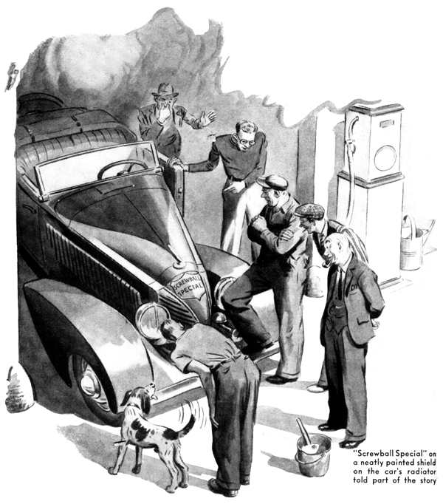
Gus Wilson is an energetic sort of fellow who gets through a lot of work in the course of a day, but he also is a fellow who believes in starting slowly - especially in starting the day's work slowly. Tackling a really hard job first thing in the morning, he is fond of contending, is as foolish as driving a car at fifty miles an hour before you get its engine warmed up.
In accordance with this theory of his of easy starting, he was standing at his bench a few minutes after eight o'clock on a fine summer morning, very deliberately laying out the tools that he thought he was going to need for a routine repair job, and talking through the open office door to Joe Clark.
"It's a queer thing," he was saying, "that out of the ordinary, you'll see at least one more thing pretty much like it on the same day. For example, you don't often see a fellow with a black eye around this highly respectable burg. Well, I saw one on my way down here yesterday morning, and I saw two other peepers down town last evening. It's the same way in this business."
"Meaning--?" asked his partner in the conduct of the affairs of the thriving little Model Garage.
"Meaning," Gus went on "that if in the morning you happen to run into a job that's a little out of the ordinary, you'll get another one very much like it before the day's out. I've seen it happen again and again.
Tell you what I'll do, Joe. I'll bet you even money that whatever job comes in here first this morning, we'll get another one of the same sort before closing time."
Experience has taught Joe Clark to be decidedly cautious about letting with his keen-minded partner. But he had been looking out of the office window as Gus talked, and now he grinned craftily. "I'll take you up on that, Gus," he said. "For a buck!"
"Huh?" Gus grunted, a little surprised. "Oh, all right."
Joe laughed outright. "Here's your first job," he said.
Gus looked up and saw a roadster that had just been pushed up to the shop doors by a battered old sedan. And what a roadster! Its breed was as thoroughly scrambled as that of the cheerful-looking mongrel pooch sitting sedately on its seat. A neatly painted shield on its radiator told part of the story: "Screwball Special." It was put together from parts salvaged from various junk yards, and Gus Wilson was one of the only two men in town who knew what automobile blood lines were represented in it - Chevrolet and Packard, Ford and Buick, Chrysler and Dodge, DeSoto and Stutz, and a dash of Auburn. The other man who knew the Screwball Special's ancestry was its builder and owner, Tim Sheridan, a young man who, in Gus's expert opinion had more than a touch of mechanical genius in his mental make-up.
As Gus ambled up to the ark, the dog jumped over the roadster's door and ran to him, its tail wagging twenty to the dozen. "Hello there, Dodger," Gus said, patting its shaggy head. From the roadster there also emerged a tall, lean young man with big round spectacles and touseled yellow hair. Gus grinned at him.
"Hello, Tim," he greeted. "That bunch of assorted grief of yours laid down and died at last?"
Tim nodded sadly. "Looks like she has, Gus," he conceded. "The old gal's got me stumped. Thought I'd haul her around to you. You're the only fellow but me who understands her. And now I don't understand her!" "Well, then," Gus told him heartlessly, "you'd better take her back to one of those junk piles you got her off, and let her rest in peace. She deserves it!"
Tim shook his head. "Don't you think it," he said. "There's a lot of thousands of miles of go in old Screwball yet - if I can get her started."
"What do you mean, 'if' you can get her started?" Gus wanted to know.
"Well," said Tim, "here's the whole sad story, Old Screwball's been running grand lately, except for one thing- - little trouble with the starter. So a couple of days ago when I didn't have anything much to do, I pulled the starter off and took it apart. There wasn't anything wrong with it except that some of the parts were all worn out. So I went down to Sol Jacobson's junk yard, and began poking through his wrecks looking for a starter. I couldn't find one just like the one I had on Screwball, but I did come across one that was in swell condition, and that I thought I could use. And Sol let me have it cheap.
"That afternoon I got to work on the starter. I used most of my old parts, but I replaced the Bendix drive, and a few other parts, with the new ones. By evening I had everything set - or thought I had. But when I stepped on her, the starter whirled but nothing else happened. Nothing at all. So, I pulled the darn thing apart again, and saw what a sap I'd been. The old Bendix drive had been a left-hand one, and the new drive was right-handed. Naturally, because of the direction of the rotation of the armature, the drive gear couldn't engage.
"Well, I cussed myself for a while, and then went to bed thinking that next morning I'd go out looking for a new left-hand drive. But before I got to sleep I had a bright idea. First thing in the morning I tried it out-just reversed the starting motor, which made the drive engage the flywheel!"
"Huh?" Gus grunted.
Tim Sheridan grinned sheepishly. "Sure - I was dumb not to have thought of it before," he admitted. "But I didn't."
"Well, I stepped on the starter. It spun the engine over all right - but that's all that happened. I kept stepping on it until I had run the batter pretty well down. Just about that time I smelled gas burning, and discovered that the carburetor was afire.
"Well, I put the fire out, and went to work on old Screwball again. I checked the ignition, and the valves, and the carburetor, and the coil, and the condenser, and even the intake manifold, I worked on it all day yesterday, but every time I stepped on her I got the same result - a sort of popping back through the carburetor that set it afire. So, you knowing old Screwball's constitution as well as I do, I hauled her over for you to have a look at her. She's got me stumped, I'll tell you!"
Gus laughed. "Get that starter off - that's all I want to look at," he said.
"But the starter's all right - it works fine now!" Tim protested.
"Sure - it works fine," Gus said. "Hey, Tim! What's gone wrong with your bean? Don't you see what you've done? By changing that drive and reversing the starter you've put together a starter that turns your engine over the wrong way. No, I don't want to see it work - I know!"
Tim shrugged his shoulders. "You usually do," he admitted as he went to work getting the starter off. A quick check showed that Gus was right. Then he pawed through this big box of old parts which he keeps in the back of the shop, and came up with a Bendix drive and a brush assembly which would fit Tim's starter. "There you are," he said. "Haul that conglomeration of old junk of yours out of here, and fix it up so that it can go on being a road hazard to respectable automobiles!"
"Thanks, Gus," Tim said. "You're a good guy. Say - don't go talking this around, will you? I don't want to be called Wrong Way Sheridan for the rest of my life!"
"Not a word," Gus assured him. "I wouldn't want to see you going around with your face as red as it ought to be! Tim whistled Dodger out of a comfortable nap under the workbench, hitched his car to his friend's battered sedan, and rolled slowly away in his Screwball Special. Joe Clark put his head in from the office door, an enraging smile on his face. "Guess that'll hold you Gus!" he gloated. "Swell chance of another job coming in today with something on it running the wrong way. That buck's as good as mine right now!"
"Maybe - maybe," Gus said.
Jobs kept on coming in ad going out all day. Ordinary, run-of-the-mill jobs - batteries to be charged, light that wouldn't burn, spark plugs that were fouled , brakes that needed adjusting. Joe Clark kept an eagle eye on them all, and by mid-afternoon Gus was beginning to find his partner's triumphant grin intolerable. He had to admit - to himself but not yet to Joe! - that in all probability he had lost a perfectly good dollar.
Along about four o'clock a truck stopped in front of the garage, and a half minute later its driver's large form filled the shop doorway. He measured a good twenty-two inches across the chest and fifteen inches through it, his nose had been broken and no one had done anything about it, and he fairly reeked of two-fisted masculinity. After one glance at this hard-looking new customer Gus growled. "Howya, Mac! What's your grief?"
"My engine overheated - very badly overheated." The big driver said mildly. "I'd really appreciate it if you would get it fixed for me as quickly as you can. I'm terribly late, and my boss is going to raise Cain with me."
"Huh?" Gus gasped. "Oh, all right - I'll be as quick as I can. Got any idea what's the trouble?"
"No, I'm afraid that I haven't ," the truck driver admitted. "Maybe I should have studied automobile mechanics instead of architecture - be of more use to me just now."
Gus laughed, "So that's how it is," he said. "Sort of tough - the way a lot of you boys just out of college can't get a chance to do the work you were trained for."
"I'm luckier than most," the driver said. "I'm going to have a job playing pro' football this fall. I'll make enough out of it to pay some surgeon for taking a piece of bone out of my shin and putting it in this bad nose, anyhow. But about my truck - "
"Drive it in," Gus told him, "and I'll have a look at it."
He checked the circulation of the water through the cooling system, the tension of the fan belt, and the valve and ignition timing, and found everything as it should be. Then he called Harry, the Model Garage's grease monkey.
"Flush out the radiator and the cylinder block," he instructed him, "and check carefully for a collapsed water hose. Then fill the radiator, and let her run for twenty minutes." He turned to the driver. "Maybe you'd better 'phone your boss," he suggested. "I'm afraid this job is going to take us the better part of an hour." "No, I won't 'phone, thank you," the big fellow decided. "The boss gets actually violent over the wire when you have to tell him something that he doesn't like. I'll walk down the road to that diner I noticed, and have a bite to eat."
Gus went on with another job, and a half hour later Harry came over to him to report that he had carried out all his orders, and that after the truck's engine had been running for ten minutes it was doing a right nice job of overheating at 212 degrees!
Gus went over to investigate and just then the driver came back. "Lift up the hood," Gus told Harry. He examined the fan belt again. Then he straightened up, lighted his pipe, and did some perplexed thinking. As he leaned down to feel the pressure in the upper hose he exhaled a little cloud of smoke. He stood staring for a long moment, and then blew another smoke cloud under the hood.
Instead of puffing back into his face, the smoke was drawn out through the radiator!
Gus turned to the driver. "Why the dickens didn't you tell me you've been having trouble with your fan?" he demanded. "You have, haven't you?"
"Why, yes," the big fellow admitted. "Early this afternoon one of the blades broke and made a lot of noise, and I stopped at a little garage out in the country to have it fixed. They did a lot of fussing around, I thought, but after a half hour or so they put on a new blade, and the fan worked all right. Come to think of it, though, it wasn't long after that when I first noticed the engine heating up."
"No wonder it heated up!" Gus said. "I can tell you just what happened. Those fellows in that little hick garage didn't have a fan assembly for this particular make of truck. But they weren't going to lose a sale, so they took an old assembly from a truck of another make, and bolted it on.
"Probably they thought that it would work all right - the chances are that they didn't know enough to realize that the fan they installed on your job was designed for opposite rotation from your old fan. Instead of drawing cool outside air through your radiator and cooling the water, it blew air heated by the engine through your radiator the wrong way and heated the water. I didn't spot what was wrong until I saw the smoke from my pipe going out through the radiator instead of blowing right back into my face. Now I'll have Harry put on the right fan assembly, and you can be on your way."
It was just five o'clock when the big and mild truck driver climbed into his seat, waved a large hand, and rumbled away.
Joe came into the shop, grinning widely. "It's official closing time. Pay up, Gus!" he demanded. "I put one over on you that time. When I saw Tim Sheridan hauling that Screwball Special of his into the shop this morning I knew darned well that you were going to start the day with a job that wouldn't be duplicated on any regular automobile. So if you'll just oblige me by handing over that - "
Joe had picked up the time-and-material slip on the day's last job, which Gus had just finished filling out, and had been glancing over it as he talked. Suddenly he let out an outraged howl.
"What the devil's this?" he demanded. "What do you mean - repairing fan running wrong way?"
"I mean that you have lost a dollar," Gus said. "Yes, that's what that job was - fixing a fan that was running the wrong way. You needn't take my word for it. Ask Harry."
"That's what it was doing," Harry corroborated. "Gus spotted the trouble when -"
"Oh, I don't care a darn when he spotted it!" Joe said disgustedly, forking over a dollar bill. "Some day, Gus," he threatened, "I'm going to get you - good and hard!"
"Maybe - maybe," Gus said soothingly. "That'll be the same day that automobiles stop doing screwy things.
END

