November 1939

GUS SOLVES A STINGER
by Martin Bunn
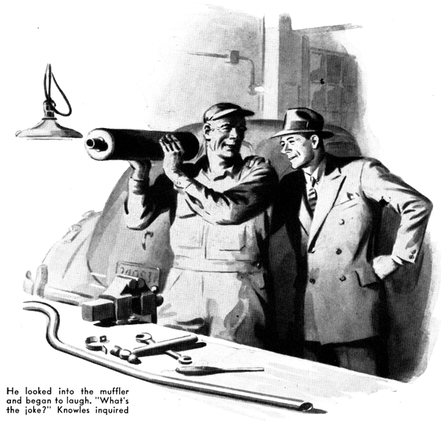
George Knowles is one of those lucky fellows who don't have to let the chore of earning a living, interfere with their having a good long vacation every year. He takes off six weeks each summer, and he always spends them in the same way - fishing up in the State of Maine.
So when George, much sunburned and looking better than a million dollars, drove his big car into the shop of the Model Garage late one afternoon, Gus Wilson grinned widely, tamped the glowing long cut down in the bowl of his old pipe, and set himself to hear all about the big ones that George had caught and the bigger ones that he had let get away.
But when George climbed out of his car and shook hands he looked preoccupied, and very apparently his mind wasn't swelling on his piscatorial triumphs. "Hello, Gus," he said. "Mighty glad to see you! Everything all right with you …Good!… Yes, I had a grand time - tell you all about it sometime soon. But right now I've got this darned car on my mind. It's the most expensive car I've bought for years - that's why I let it stand in my garage and took Jack's old open car up to Maine with me. There's only six thousand miles on the clock of this bus, Gus, but she isn't running right. Not at all right!"
"That's queer," Gus said. "I remember that she was in perfect condition just before you went away… Any chance that some one was joy riding in her while you were gone, is there? Stranger things have happened."
"No chance at all!" George maintained. "Everything in the garage was exactly as I had left it - wheels jacked up to save the rubber, and so on."
"What seems to be the matter?" Gus wanted to know.
"I can't put my finger on it," George said. "Everything seems to be working perfectly, but the car hasn't got any pep. Every time I drive it I think it's going to bog down on me. It never does - but that's the feeling it gives me. Take a run down the road in her, Gus. You'll see what I mean before you've gone a mile."
"Sure thing," Gus agreed. He slipped a cover over the driver's seat and got in. George Knowles walked around and got in beside him.
Gus stepped on the starter. The engine took off promptly and purred smoothly. He backed out of the shop, and started to drive slowly down the road. "Runs smooth as cream," he told Knowles.
"Yes," George agreed, "she runs smoothly enough. But step on her, and you'll see what I mean."
Gus pressed his foot down on the accelerator pedal. The car picked up speed, but it had a queer feel to it. "Yes," he said, "you're dead right, George. Something's wrong somewhere. The engine is running perfectly, but the car hasn't got any surge. She runs just the way I feel after I've eaten a big lunch on a hot day. I'll take her back to the shop and give her the once-over."
"Right," George agreed. "Let me out at my house, will you? You can give me a ring when you get her fixed up, or when you find out what's the matter with her, if it's anything serious."
Back in the shop, Gus refilled his pipe and then did some steady thinking. If Knowles's car had been an odd one, or even a car on which he never had one any work, its lack of surge and pep would have suggested several possible troubles to him. But the car was next door to new, and Gus had done enough little jobs on it to be sure that it had been in perfect condition just before George had laid it up while he took his six-week vacation.
After thinking things over for a few minutes Gus decided that the carburetor choke valve might be sticking, but on examining it he found that it was working perfectly. So was the float. A careful check of the timing disclosed nothing wrong. Fuel trouble was out: except when he was off on long trips George Knowles always bought his gasoline at the Model Garage and Gus takes good care that there is nothing wrong with the gas that he sells.
He was scratching his head over the puzzle when Joe Clark called to him from the office that he was going home. Glancing at the clock, Gus saw that it was a half hour after closing time, and realized that he was hungry. So he locked up the shop, got into his car, and drove downtown to get his dinner.
One reason why Gus Wilson is a top-flight automobile mechanic is that he's never able to stop thinking about a puzzling job until he has evolved a way of licking it. So all the time he was eating he was thinking about Knowles' car. "Never heard an engine that ran more nice and quiet," he said to himself. "Hey! Maybe that's it! That engine of George's runs too quiet! By gun! I'll have to take a look!"
He hurried through his dessert, drove back to the garage, let himself in and switched on the shop lights. While he was taking off his coat he heard a car stop outside and then drive off, and a moment later George Knowles came in.
"Just happened to be passing with a friend," he explained, "and saw your lights go on. Well, have you found out what's the matter with that bus of mine?"
"No, I haven't," Gus told him. "But while I as eating my dinner I had an idea. If you want to wait a few minutes, I'll tell you whether or not it was a bright one."
"Sure - go ahead," Knowles said.
Gus started the engine and let it idle. The he walked around to the back of the car and put his hand over the end of the tail pipe of the muffler.
"Yep - it was a bright idea!" he said. "I thought that engine was running too quietly. I can scarcely feel the exhaust coming out. That locates the trouble, George. It's either in the exhaust pipe or, more likely, in the muffler. It won't be long now!"
He took off the muffler and exhaust pipe. He pushed a flexible cable through the pipe with ease, proving that there was no obstruction in it. Then with the aid of a bright light, he looked into the outlet port of the muffler, and a minute later he started to laugh.
"Hey, what's the joke?" Knowles wanted to know.
"The joke's on you - on us," Gus said, pointing to what looked like a ball of mud just inside the rear end of the muffler.
"What the devil is that?" Knowles demanded.
Gus laughed some more. "That's a wasps' nest," he said. "While you were gallivantin' around up there in Maine some nice industrious insects set up housekeeping in your muffler. And they built their happy home so big that the exhaust couldn't blow it through the tail pipe. Naturally, the obstruction in the muffler caused back pressure, and enough loss of power to give your engine that dead feeling when you stepped on the accelerator pedal. You're not stung, George - but you might have got stung real bad if the old carbon monoxide hadn't done in those wasps!"
He cleaned out the muffler with a stick, and replaced it and the exhaust pipe. Then he got into the car and raced the engine. "Perfect!" was his verdict. "Pep to spare!"
Lights burning after hours in the shop of the Model Garage always are an irresistible magnet for Gus Wilson's customers, many of whom are his near neighbors and all of whom are his warm friends.
Before George Knowles had time to drive out, genial Dr. Marvin, on his way home from the last call on his evening round, came in and settled himself comfortably in the only chair. Then young Jack Simpson appeared, said "Thought I'd find you here!" to his father-in-law, and perched himself on Gus's workbench. State Trooper Jerry Corcoran rode up on his motor cycle in what sounded like a blast of machine-gun fire, and joined the gathering. And then lean Tim Sheridan, Gus's most ardent disciple, parked his "Screwball Special" out front and came in with his blond hair on end and his dog Dodger at his heels, to smoke home-made cigarettes and to imbibe automobile wisdom at the feet of his master.
In a few minutes the shop was full of tobacco smoke and conversation. George Knowles told all about his fishing trip. Then Gus told about the wasps' nest in the muffler of George's car.
"Mufflers," Jerry Corcoran said. "That reminds me of how I stuck my neck out last Sunday, and darned near broke the first rule they taught me when I went on the cops."
"What rule is that?" Dr. Marvin asked. "Never to start anything that you can't finish, Doctor," Jerry said grinning. "And that's just what I almost did!
"I guess you all know that little church about five miles out on the dirt road. A lot of people who live back in the country attend it, and some of them aren't such very good drivers. They park their cars in a field beside the church, and when they start home after the morning service they're likely as not to get in trouble and tangle up the traffic. That dirt road is narrow, with a high crown, and shallow drainage ditches on each side of it, and low clay banks on the outer edges of the ditches. So I make a point of being out there at noon on Sundays, to keep things moving.
"Last Sunday I was a few minutes late - I had to chase a fellow who was doing seventy-three on the highway, and write him out a ticket. When I came in sight of the church I saw that there were a half dozen or so cars tied up on either side of it. And when I got past the cars on my side I saw what was tying them up - an old sedan which was stalled right across the road, with its rear wheels in the ditch.
"I rode up to it, and got off my motor cycle, all set to bawl out the driver for trying to turn around in a place like that. But, when I got an eyeful of the driver, I saw that she was a darned pretty girl, and that she was all hot and bothered about the trouble she was causing. So instead of bawling her out I asked her what was the matter and if I could help her. She said that when she had turned into the road in front of the church she had started home, and then remembered that she had to go to her aunt's house, in the other direction; that she had tried to turn around and had stalled her engine, and that she couldn't get it started again.
"'Hop out, Miss,' I told her, 'and let me have a try at it.'
"She got out and I got in. when I stepped on the starter the engine took off, but it ran in a weak, sputtering sort of way, and every time I put the car in gear and speeded up the engine to try to pull the rear wheels out of the ditch, it went dead on me. After I had tried four or five times the car was full of black smoke that had me coughing and made my eyes water, and some of the young fellows who were standing around were beginning to grin and wisecrack.
"I hated like the dickens to admit that I couldn't get that car started, but I was just about to give it up and ask some of the crowd to help me push it out of the road when that black smoke gave me an idea. When I got out and took a look at the rear end I was sure that I was right. The exhaust pipe was low-hung and it stuck out several inches beyond the back of the car, and it was right up against the outer bank of the ditch.
"I got some fellows to push the car until the rear wheels ere part way out of the ditch, and blocked them with a couple of rocks. Then I took a look at the exhaust pipe, and knew that I had guessed right. When the rear wheels had rolled down into the ditch the end of the pipe had bitten into the bank and cut itself a nice, close-fitting plug of sticky clay. I suppose the gaskets were loose enough to allow enough of the exhaust to escape for the engine to idle weakly, but as soon as you gave her the gas the back pressure built up and killed it. As soon as I had cleaned out the exhaust pipe, it ran all right."
"Nice going, Jerry," put in Gus, approvingly. "You should have been a mechanic…"
"That reminds me -" interrupted Jack Simpson. But Gus Wilson was pointing an accusing forefinger at the shop clock.
"That clock reminds me," he said, "that it's a quarter past twelve! I don't want to seem inhospitable, gentlemen, but these lights are going out in exactly two minutes. And fifteen minutes after they go out I'm going to be home and in bed!"
"That's another of your bright ideas," George Knowles said, getting up and stretching.
"I'm chock-full of them!" Gus admitted.
END

