September 1938

GUS TUNES A CAR BY EAR
by Martin Bunn
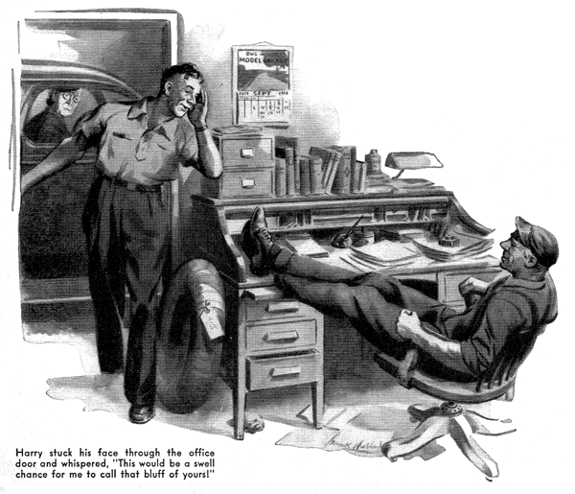
"There's something in the Bible about it-or maybe it's in Shakespeare," Gus Wilson told Harry, the young mechanic. "It goes something like this; 'Ears have they, but they hear not.' You're a funny guy, Harry. You'll listen in on one of those radio moaners for three minutes, and all the rest of the day you'll drive me nuts singing the tune. But you'll listen to an automobile engine sputtering and missing and knocking, and then by golly, you have to take it half apart to find out what's ailing it. Learn to use your ears, son-they're standard equipment on your model, and you need them in this business!"
Harry grinned at his employer, "Take it easy, boss," he said. "I'm just a young feller trying to get along in a tough world! Now, you-I suppose you could sit in there in the office, with your feet up on Joe Clark's desk, and if some one drove into the shop in a job with its motor missing, you could just tune in on it with your ears and spot the trouble without even taking your feet down and tossing a look at it!"
"Maybe I could," Gus admitted placidly. "Want to bet me two bits I can't?"
"No, I'm not ever going to bet you on anything ever again," said Harry hastily, aware from bitter experience that wagering with his boss resulted in holes in his weekly pay. "But I still don't think that you can do it-except maybe by a lucky shot in the dark once in a couple of hundred times."
"Well, we'll see," Gus said. "I've got to keep things up to date in the office for Joe while he's away - although all the thanks he'll give me is to say that I've balled up his accounts. I'll be in there for an hour or so and if some one brings in a car with its engine missing maybe I'll be able to show you why the good Lord gave automobile mechanics ears."
While he wrote out time-and-material slips in his big, sprawling hand, Gus kept his ears open to what was going on in the shop. First, Mrs. Miller drove up to the door to leave a tire to be repaired. When Harry sent her on her way laughing, after wasting only five minutes listening to her chatter, Gus grinned his satisfaction and decided that his assistant was coming along nice in the art of diplomacy.
A half hour later, careful George Knowles drove up, and Gus heard him tell Harry that there must be something wrong with his car's clutch. It was making a lot of noise. Perhaps the bearing had run dry. Harry climbed in, disengaged the clutch, and raced the motor. The noise persisted. "That proves that it isn't the clutch," Gus heard him say.
"Keep your engine running, please, while I take a look." Silence for a few moments, then Harry's voice again, now with a note of triumph in it. It's slipping, and the metal hood deflects the noise and makes it sound as though it's coming from the clutch. I'll tighten the belt for you. No, you won't have any more trouble with it." Then Knowles drove away. Yes, Harry was learning fast!
Gus was just finishing his bookkeeping job when another car was driven into the shop. Over the smooth purr of its idling engine he heard a woman's voice, and Harry's louder replies. Then the engine was speeded up, and it began to pop. Gus's experienced ear caught a sort of regular irregularity in its rhythm. "Couple of cylinders firing when they shouldn't be," he thought. Then the engine was allowed to idle again, and it resumed its smooth purr.
Harry stuck his face through the office door, grinning. "It's the woman who just moved into that big new house down the road - Mrs. Oliphant, she says her name is," he told Gus in a whisper.
"She's got a honey of a car, with less than ten thousand on the speedometer, and she says that her engine starts missing every time she gets up above twenty miles. This would be a swell chance for me to call that bluff of yours about being able to tell what's wrong with a motor by just listening to it-only I haven't the heart to show you up in front of a new customer. You'd better come out and take a look at it."
'Gus leaned back in his chair, hoisted his feet to the desk top, and grinned back at Harry. "I don't need to take a look at it," he said. "You take the distributor head off. You'll find a Y-shaped crack in it. Drill a hole right where the Y branches. Make the hole twice as big as the width of the crack. I'll be out in a few minutes."
"All right," Harry said. "But it sounds screwy to me."
Gus sat listening until he judged that Harry had the distributor head off. Then he went into the shop.
Harry was examining the distributor head, and his jaw was hanging. "It's got a Y-shaped crack in it, all right!" he muttered.
"Drill a hole in it, the way to told you," Gus said. While Harry was doing it, he turned to Mrs. Oliphant. "That hole will fix it so that your car won't give you any trouble for a few days," he assured her.
"But it's only a temporary repair. If you'd like me to, I'll order a new distributor head, and install it any time it's convenient for you to bring your car in."
"Yes - do that, please," Mrs. Oliphant directed. "Really, I'm tremendously impressed! You know, I heard what the young man whispered to you when I first drove in, and I thought it was a silly joke of some kind. Imagine running a repair shop by remote control!"
After she had driven off, Harry looked at Gus. "All right, Sherlock Holmes," he said. "Let's have it!"
Gus grinned at him. "Just educated ears-and experience," he explained.
"You'll get both in time. When an engine runs smoothly while it's idling, and then starts to raise a ruckus when you speed it up, nine times out of ten the trouble is in the distributor or the coil. And when your ears tell you that the cylinders aren't all firing at the right time, it's an odds-on bet that the trouble is caused by a Y-shaped crack in the distributor head. You see what happens, don't you? The spark follows the crack. A hole, just where the Y branches, stops the spark from jumping and stopping the spark from jumping stops the trouble. Get it?"
"Yes, I get it," Harry said. "But suppose the trouble isn't caused by a crack in the distributor head. Suppose the engine is just missing fire occasionally. Where do you go from there, Gus?"
"Well, it might be caused by the coil," Gus told him. "That's easy enough to check on. All you have to do is to pull the wire out of the distributor head, while the engine is running, and hold its end fairly close to the place where you pulled it out. If the coil is O.K., you'll get a nice blue spark. If the coil is weak, you'll get a yellow spark. Don't waste any time on a weak coil. Put in a new one."
"Another cause of a missing engine that you run into now and then is a condenser that can't stand the voltage. You can spot that by the contacts-they'll be gray if the condenser is all right, but blue if it is weak. Sometimes even a brand-new condenser is weak. The remedy is the same as for a weak coil-throw it away and put in a new one."
"Once in a while, hard scale on new distributor points is the cause of an engine missing. The scale is a sort of glaze that is so darned hard that you can't cut it, and that the juice can't get through it. There's nothing that I know of that you can do about it, except put in new points."
"Sometimes an engine will run all right at low speed, but heat up badly at higher speeds, as if it were running on retarded spark. Occasionally the cause of that will be a kink or some dirt in that copper vacuum tube, that on many cars runs from the carburetor to the distributor."
"You know what the governor is, don't you-that little do-funny with two weights and two small springs, inside the distributor? When you are running at low speed, the governor is in its normal position, which is closed; as you speed up your engine it should expand, and set the spark timing ahead. The governor is often vacuum-regulated, so if there is a kink or any other kind of stoppage in that copper tube between the carburetor and the distributor, the governor won't be adjusted to the speed and load, and the timing may be late. Then the engine will heat up badly."
"How about the spark plugs?" Harry asked. "Doesn't using the wrong ones make an engine pop when you step on it?"
"Using the wrong spark plugs causes plenty of grief," Gus agreed. "That's especially true with these new high-compression engines-you've got to use the plug recommended by the manufacturer to get the best performance. With the older engines the right plug wasn't quite so important."
"Thanks," said Harry. "I'll try to remember all that dope. But, say, Gus, come clean! When you figured out what was wrong with Mrs. Oliphant's car, how much was it what your ears told you-and how much just plain guessing?"
"My ears told me plenty! That's what they're for!" Gus said. "But there's no harm in guessing-so long as you know how to guess right!"
END

