November 1938

QUEER TROUBLES WITH OIL
by Martin Bunn
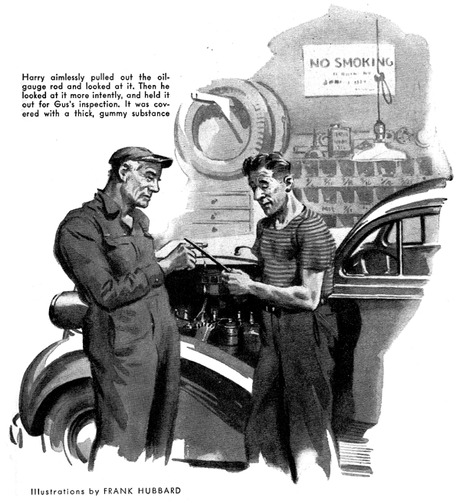
"Oh, well - let it slide," Jack Simpson said carelessly to Harry, the Model Garage's earnest young mechanic. "Probably it doesn't amount to anything - but if it does it'll get worse, and then we won't have any trouble locating it."
Gus Wilson had come in quietly from an errand downtown was hanging up his coat. "That's one way of owning a car, Jack," he remarked, "and, to tell the truth, it's a pretty popular way. But it's often a darned expensive one. What's your trouble?"
"Oh hello, Gus. I didn't see you come in," Simpson said. "While we were on our vacation last week we had a little difficulty - left rear wheel brake dragged a bit. I had the people in the garage of the hotel where we were staying look at it. They said that something had gone wrong with the brake cylinder in the wheel, and charged me three bucks for adjusting it. Now Peggy says that all the brakes drag a little - I haven't noticed it myself - and she thought I'd better come in and let you take a look at them. But there doesn't seem to be anything really wrong, so I guess it isn't worth bothering about."
"What did they do to that wheel cylinder?" Gus wanted to know.
"I dunno," Simpson admitted, grinning. "I was playing golf while they were working on it, and afterward I never thought to ask them."
"Peggy's a smart, girl," Gus assured him. "But she wasn't so smart when she married a guy who lets his car cost him more than it should just because he's too careless to check up on the little things. You'd better leave your car here for a couple of hours, Jack, and let me give those brakes a good looking over."
"All right," Simpson agreed. He had barely left the garage when Joe Clark stuck his head in at the office door. "Hurry call for the wrecker!" he announced, "from Old Man Parsons. Says he couldn't get his car started this morning. Wants you to tow it over here and fix it up - and he's got to have it back in an hour Better step on it!"
Half an hour later, Harry drove up to the shop door, towing the Parsons car. A peppery Old gentleman was with him, and Gus could see that Harry hadn't been having a happy ride.
"It's preposterous!" snapped Parsons, jumping down as soon as the car stopped.
"Mr. Wilson, my car was overhauled here less than two weeks ago. When I paid my bill, Mr. Clark assured me that everything was in excellent condition. But this morning my car refused to start! I tried. My next door neighbor tried. Then his hired man attempted to turn the motor over with a crank But it was no use. I had to walk to my office - and I was ten minutes late! I insist that you - "
"Sure thing, Mr. Parsons," Gus said soothingly. "I'll fix things up. Roll her in, Harry."
Gus tested the battery. It was strong, but not nearly strong enough to kick that halky engine into action He tried everything he knew, but he couldn't get the engine to turn over. Harry, watching him, saw that for once he was thoroughly stumped.
While Gus was scratching his ear, Harry aimlessly pulled out the oil-gauge rod and looked at it. Then he looked at it more intently, and held it out for Gus's inspection. It was covered with a gummy substance as thick as transmission grease.
"What sort of oil have you been using lately, Mr. Parsons?" Gus asked.
"Oil? The oil that you put in my car!" the customer replied tartly. "I've been driving very little, and have had no occasion to add any."
Gus poked an exploring forefinger into the messy stuff on the gauge rod, then touched the smeared finger to the tip of his tongue, and frowned. "Drain the oil, Harry," he directed. It oozed out very slowly and was thick and gummy. An examination of the engine showed that pistons and bearings were sticky with it.
"You'll have to leave your car with us for a day," Gus told the car owner. "We'll have to take the engine apart, and clean it thoroughly. Some one played a little joke on you - a mean one, too. They put sugar in your oil, probably while you had your car out last night. I can taste it - and I saw that trick pulled once before. Your drive home was just long enough for the sugar to dissolve in the oil and turn it into a gummy grease that set hard while the car was standing overnight, and stuck the pistons to the cylinder walls so tight that the engine can't turn over. There won't be any permanent damage, but it's going to be pretty close to a day's job getting the mess cleaned up."
"Hooligans!" reared the customer. "I'm going to the police and see to it that they - "
He went out fuming. Gus and Harry looked at one another, and couldn't help grinning. Then Gus shook his head. "It's nothing to laugh at, at that," he said. "It was a dirty trick - the sort of bum joke that causes a lot of trouble and expense. I suppose that some of the kids around town have it in for the old grouch, and maybe he had it coming to him - but I do hate to see an engine abused! Well we'll get at the clean-up job tomorrow. Now let's get Jack Simpson's brakes checked. I'll drive his car around the block a couple of times, and see how they act.."
When Gus drove back into the shop, ten minutes later, he beckoned Harry over to the car. "Hop in here and step on the brake," he said as he got out. "Then tell me how it feels to your dainty little size fourteens."
Harry got in and pressed his foot down on the brake pedal. "Feels as if it was working on a wet sponge!" he reported.
Gus nodded. "That likely means one of two things," he said. "Either that the brake shoes are out of adjustment, or that air has somehow got into the hydraulic system. But there's something else. All four brakes on this car drag a little - just as Peggy told Jack they did."
"It usually is a sign that you've got a quite a job on your hands," Gus told him. "You're clear on how hydraulic brakes work, aren't you? When you press your foot down on the brake pedal, the pedal's connection forces the piston of the hydraulic system's master cylinder inward. That exerts pressure on the brake fluid in the master cylinder, and forces some of it through the copper pipes that connect the master cylinder with each of the four wheel cylinders. Then the fluid exerts equal pressure on the pistons of each of those four cylinders."
"Sure," Harry nodded. "But what makes Simpson's brakes drag?"
"Well," Gus went on, "the pressure exerted by the brake fluid on the wheel-cylinder pistons forces them outward against the brake drums, creating friction that causes the brakes be drag a little
"When you take your foot off the brake pedal, the pressure from the master cylinder is removed from the wheel-cylinder pistons. Then the return springs on the brake shoes force the pistons inward, and the pistons force the brake fluid back into the master cylinder."
"On this car the brakes drag - they don't return promptly to the 'off' position when the pressure of your foot on the brake pedal is removed. If only one brake dragged, the most likely cause would be a return spring that wasn't working property. Maybe all that would be necessary would be to clean it off well; but more likely it would have lost its contracting power, in which case you'd have to put in a new spring.
"But when all four brakes fail to return promptly to the 'off' position it's a sure sign that the trouble is in the entire hydraulic system. And it's almost certain that it is caused by engine oil or kerosene - any mineral oil - having somehow got into the brake fluid. Even a very little of it will cause the fiber cups in the master and wheel cylinders to swell out of shape, so that the cylinders will not work property. When that happens the brake fluid is prevented from returning promptly to the master cylinder, and its pressure keeps the brake bands in contact with the brake drums, and causes drag.
"Remember what Jack said about having some trouble with one of his wheel cylinders, and having it taken care of at the garage attached to a country hotel? That's the tip-off. In fixing the cylinder the garage men probably washed its parts in kerosene, and the kerosene has worked all through the hydraulic system. See here - "
Taking the cylinder apart, he showed Harry how the fiber cups were swollen and distorted.
"Now let's get busy!" he said. With Harry's help he removed all the cylinders. After washing the parts thoroughly with brake fluid, Gus replaced the cups with new ones, and reassembled and replaced the cylinders. Then he did the same thing with the master cylinder. After reconnecting the pipes with the cylinders they filled the tank with fresh brake fluid that they pumped slowly through the system to flush it out and to bleed the air out of it. Then Gus replaced the bleeder screws, permitting no air to get into the brake lines, and gave the brake shoes a careful adjustment.
"I'll try her out," he said. After driving around the block once he came in whistling.
"That did it," he said. "That spongy feeling of the brake pedal is gone, too - they must have got air as well as oil in the system when they fixed that cylinder."
"I'll admit that you're pretty good-good as a brake-testing machine," Harry told his boss. "Say, Gus - what else can you find out about brakes by just stepping on the brake pedal?"
"Quite a lit," Gus assured him. "If the pedal goes all the way down to the floor boards under moderate pressure, it's usually an indication that the brake linings are badly worn - or, less frequently, that the brake shoes aren't adjusted property, or that there is either a leak in the hydraulic system , or there's air in it.
"If brakes squeak when you apply them, it's usually a sign that the brake linings are dirty - that dust has clogged the pores of the asbestos friction lining and caused it to glaze over. You can kill the squeak by cleaning the linings with a stiff wire brush dipped in gasoline, and put on a new washer to stop the leak.
"Sometimes a car will pull to one side when you step on its brakes. A possible cause of that could be that the lining on one wheel is of a different brand from the linings on the other wheels. Different makes of linings have different breaking efficiencies, and one lining of low efficiency will make your car slue to one side. Well, it's quitting time... Just learn to use the old bean, Harry, and you'll do all right with brakes or anything else in this business."
While he had been talking, Gus had been making out a time and material slip for the Simpson job. He held it out for Harry to see.
"Ran up pretty high for a little job that Jack thought wasn't worth bothering with, but if he'd followed that idea of his of letting it get worse before he did anything about it, it would have cost him a lot more in the end."
END

