March 1938

Gus says:

STOP YOUR STARTING TROUBLES

by Martin Bunn
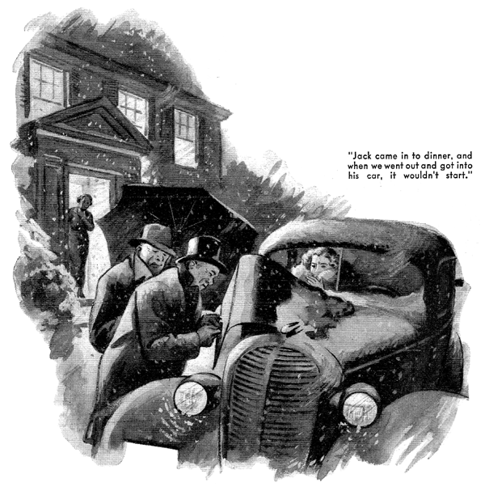
The neat little office of the Model the Garage seemed especially bright and snug to Gus Wilson that evening. Outside, Old Man Winter was indulging himself in what probably would prove to be his last serious tantrum of the season. Gusts of snow, driven by a howling wind, swirled against the big front window.
Tilting his chair back against the warm radiator, Gus tamped down the glowing tobacco in the bowl of his pipe and grinned across at his partner, Joe Clark, who as usual had his head buried in a lodger. "In just about five minutes," he said, "that durned telephone is going to ring, and somebody's going to say that he's in trouble four miles down the road, and will we send the wrecker out and tow him in? And it's no night for a pleasure trip!"
"Well," answered Joe, "that's what we invested in a wrecker for, isn't it?" His horn-rimmed glasses glittered as he looked up from the ledger. "Say, Gus - here's a queer thing. You know that Henry Miller and George Knowles have cars of the same model and that they bought them at just about the same time. And they average about the same mileage - around 500 miles a month. Well, in the last year Miller has paid us more than twice - pretty near three times - as much for repair work as Knowles has. What's the answer?"
"The answer is that Knowles isn't married to Mrs. Miller," said Gus promptly.
"Huh?" asked Joe.
"Sure, that's the answer," insisted Gus. "Mrs. Miller drives quite a lot while Henry's busy down at his store and she's not what I'd call a competent driver. She's one of those dames who slam a car around, and slamming a car around always gets into the repair bills sooner or later - generally sooner."
"Oh, women drivers aren't so bad, any more," said Joe.
"I didn't say that women are bad drivers - I just said that Mrs. Miller is a bad driver," said Gus placidly. "Some women know how to handle a car as well as most men. There's Peggy Knowles - she drives as much as Mrs. Miller does, and her driving doesn't cost her father anything but just for the gas and oil. But Peggy's been around this garage a lot - remember how she started coming over here for air for her bike tires when she was just a little kid?- and being a smart girl, she's learned quite a lot about cars. By the way, that sounds like that Knowles horn now!"
Gus walked over to the window and looked out. "Yep, it's the Knowles car, all right," he said. "And it's pushing in a cripple." He pulled on his short overcoat, closed the office door carefully behind him, and slid open one of the garage doors. Snow drifted in onto the concrete floor as the Knowles car nudged the "cripple" gently into the garage. Then a young man wearing evening clothes and a frown got out of the first car, and a girl stuck her head out of the window of the other car.
"This is Jack Simpson, Mr. Wilson." She said, with a wave of her hand toward the frowning young man. "We're going to a dance at the country club. Jack came in to dinner, and when we went and got into his car, it wouldn't start. Dad's got to have our bus to take mother to her club meeting. Try to get Jack's car started for him, won't you please Gus? I'll be waiting over at the house, Jack - make it snappy, or we'll miss half the fun. Good night, Gus!" Her car backed smoothly out into the storm.
Gus pushed the garage door closed, and looked at the frowning young man.
"Got any ideas what's wrong?" he asked.
"Of course!" snapped Simpson. "My battery has run down somehow. Got a rental you can stick in?"
"Yep, we've got rentals," grunted Gus. He got into the car and pulled the light switch. The lights came on, but rather dimly. Then he stepped on the starter. Nothing happened.
"It's the battery, I tell you!" snapped Simpson. "It's been getting weaker and weaker for the past week. Put in a rental, will you, so that I can get going!"
Gus looked at him steadily for a couple of seconds. Then he shrugged his big shoulders.
I'd hate to have Peggy Knowles miss her dance," was all he said. He walked away, came back with a rental battery.
I'll have your battery ready for you any time after four tomorrow afternoon."
"Thanks!" said Simpson. He jumped into his car, and jerked the light switch. The lights flashed on. "That's better!" he said. Then he kicked the starter. And again nothing happened.
Gus grinned at him. "I've been in this business long enough to learn that before you start fixing anything it's a good idea to find out what's wrong," he remarked. "Hop out and I'll try to find out what's the matter with this job of yours - and to start her rolling before Peggy gets on the phone and begins burning up both of us!"
He lifted the hood, snapped a length of cable onto one of the battery terminals, and touched the other end of the cable to a terminal of the starting motor - it turned over with a shirring rumble.
"Thought so!" Gus grunted. Your battery was pretty well down, all right, but not so bad that it wouldn't have given you juice enough to start. It's your starting switch that has gone bad."
He swung a wire-guarded electric lamp under the hood, peered inside, and wrinkled his nose in disapproval. "Sure, there's your trouble - dirty contacts on the starting switch. And are they dirty!" He cleaned them quickly, closed the hood, replaced the battery compartment cover, hopped in, turned the ignition switch, and stepped on the starter. In an instant the engine was running sweetly.
"There you are, mister!" he said.
"Get in and go on to your dance. You don't even have to tell Peggy that it wasn't my thick-headedness that held you up so long!"
Gus had just taken Jack Simpson's battery off the charging line, the next afternoon, when Peggy Knowles came in.
"Have a nice time at the dance last night?" he asked, grinning at her.
"Wonderful!"
"Your boy friend got his car started all right coming home?"
"Of course," she said. "And he told me that he had been sort of snooty to you, and that you'd told him where to head in. He's coming around to get his battery pretty soon, and to try to make up with you, I'm afraid he doesn't know much about cars, Gus - except just driving them. I wish you'd tell him a few things when he comes in - about batteries, and starters, and so on. I just hate it when a car won't start!"
"So did Mr. Simpson," grinned Gus," But I'm afraid that he won't be interested in the details of keeping his connections tight, putting water in his battery, and such."
"Maybe he isn't interested in them - but I am!" said Peggy. "You see, Gus, we're going to get married - and we'll have plenty of things to do with our money besides handing it over to you and Joe to pay unnecessary repair bills!"
"That does make things different," agreed Gus. "All right, Peggy - I'll tell him anything he wants to know."
Jack Simpson drove into the garage about a half hour later, and came into the shop smiling broadly.
"I'm sorry about last night, Mr. Wilson," he said.
"I didn't know that you and Peggy were such old friends. And I was sort of upset about my darn old bus not starting. No hard feelings?"
"Not a one," said Gus heartily, "Well, here's your battery - all recharged and all ready to run down again if you don't take better care of your electrical system. If you want to leave your car here for an hour, I think that I can save you some money and a lot of future trouble by checking your wiring.
"Fine!" agreed Simpson, "Let me stay here while you're doing it - and tell me something about how to stop starting trouble."
"The best time to stop it," said Gus, carrying the battery over to the car, "is before it starts - same as most other car troubles.
"So far as the battery itself is concerned, you don't have to worry much about it. Just remember to have it checked once a month - maybe once in three weeks would be better in really hot weather. If the hydrometer reading is above 1.225 and the same for all cells, al you need to do is have distilled water added to take the place of what has been lost by evaporation.
If the hydrometer reading is below 1.225 and the same for all cells, your battery needs recharging. But if the readings for the different cells vary considerably, have your battery taken out of the car and given a more thorough test. The chances are that it is worn out and you need a new one.
"No matter how good a storage battery is, or how fully charged it is," Gus went on, as he put the cables in place, "you can't take more current out of it than your generator stores in it while your car is running. Every time you test your horn, or light a cigarette with your electric lighter, or play your radio, or use any of the other electrical gadgets you have on your car, you take some current out of the battery. If you drain it too much, you won't have enough juice left to get action when you step on your starter. Remember that cranking your engine requires anywhere from 100 to 400 amperes for a few seconds - something like forty times as much current as you use to operate all your lights.
"If you've got the right battery for your car - and for your collection of electrical gadgets - you may still get in trouble through your current leaking away. I see that you've got an electrical clock, and that although it's connected it isn't running. You'd better either get it going or let me disconnect it. An electric clock that's running doesn't use enough current to bother about, but one that is connected but not running may drain as much as three amperes hours a day out of your battery."
"Gosh, I'm glad you told me," said Simpson. "Suppose you disconnect it until I have a chance to get it fixed."
"Then there are short circuits," Gus continued. "They'll kill any battery and do it quick. They're easy to check for. First, check your stoplight and make certain that it's not stuck. Next, check your fuses and see that they haven't been burned out. Now switch all your electrical equipment off. Make sure that the ground strap - that's this braided wire cable that connects one of the terminal posts of the battery to the frame of the car - is connected. Now tap the other terminal clamp against its battery post. See it spark? Just as I thought - you've got a short circuit somewhere. Let's see now - here is is! Insulation worn off this cable. Might have set your car afire!"
"So that's the reason why my battery ran down!" Simpson exclaimed.
"It's a mighty good thing you made this check-over!"
"Next," said Gus, "I'll just clean and tighten these connections, so that the current can flow through them freely.
That finishes the check on your wiring. You should have that done every 10,000 miles that you drive.
"Now, suppose you know that your battery is fully charged, and that your wiring is all right, but still your starter won't work.
Remember how I found that dirty contact in your starting switch last night? Always look for that.
"If your starting switch is all right, maybe the trouble is with the brushes of the starting motor. Cleaning the brushes and the commutator probably will do the trick.
"Sometimes the starting motor spins when you step on the starter, but still your engine doesn't start. Better take the starting motor out of the car, and give it a good looking over. Maybe the piston gear is too tight - or maybe its spring is broken, or its teeth broken or clogged with dirty grease. But you needn't worry about any of those troubles - not just now, anyway!
"Now I'll just take a look at your spark plugs - if they're fouled or out of adjustment they make starting harder than it should be. Better have them checked every 10,000 miles. No - they're O.K."
Gus straightened up and wiped his hands on a piece of waste. Then he picked up the battery he had just removed from Simpson's car, and started across the garage toward the bench supporting the charger. "Well, you won't have any starting troubles for quite a while now, Mr. Simpson," he said.
"Oh, make it 'Jack,' won't you?" said Simpson. I've an idea that I'll be coming in to see you pretty often!"
"Always welcome, Jack," said Gus. "We'll take your money when we have to - but I like to help a young fellow keep his car running without it being too tough on his pocketbook. Especially when that young fellow is going to marry a fine girl like Peggy Knowles!"
END

