July 1938

REAR ENDS AREN'T FOOLPROOF
by Martin Bunn
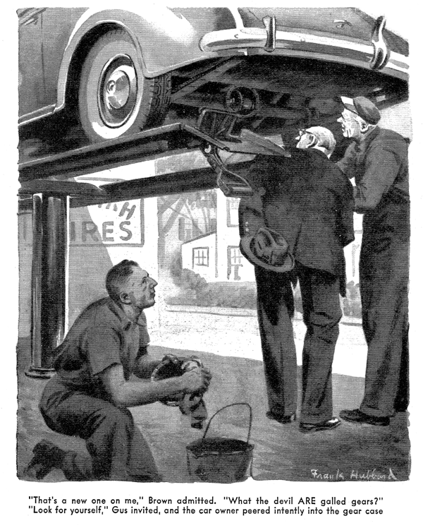
It was summer Wednesday afternoon. All the regular customers of the Model Garage who had met with motoring misfortunes on their week-end jaunts had already been in to tell Gus Wilson their tales of woe and to have their troubles taken care of, and those who were planning to start on trips Saturday noon hadn't yet got around to driving their cars in for check-ups and lubrication. There really wasn't anything much to do, and Gus - who always has purposeful energy to spare when there is need of it - was leaning against the wall outside the office and enjoying a whole-soled loaf as he waited for some one to drive up to the pump and ask for five gallons of gas. From inside the office came an uneven click - click-click - click as his partner, Joe Clark, pecked out an accessories order on his ancient typewriter. Through the wide-open doors of the shop floated intermittently, the pleasant ringing of a machinist's hammer on steel, and the considerably less musical sound of Harry singing the latest popular song.
The honk of a horn made Gus look up. A car was turning into the drive-way. And it was Mrs. Miller's car, Gus ducked hastily into the office. "Hey, Harry!" he called to the mechanic.
"Take care of this customer, will you? I'm busy!"
Joe Clark looked up. "What's the matter? He demanded.
"Quiet!" Gus cautioned him. "It's Mrs. Miller, and it's a lot too hot to listen to her talk for an hour or two!"
"Nor for me," said Joe. "I wish we had a few more like her on the books. Say, that woman can do more things to a car in driving down to the chain store than most people can in driving from here to Canada and back!"
Joe went out front. For a moment Gus heard his voice and Harry's; then Mrs. Miller's going on and on to a shrill and exclamatory monologue. After a few minutes, Harry put his grinning face in at the door, "Say, Gus, here's a funny one," he said. "You better have a look at it."
"Funny ones" are Gus Wilson's long suit. He went out with Harry without an objection.
Mrs. Miller was telling her troubles to Joe Clark for the third time. Mrs. Miller's idea of describing automobiling grief is to work in all the technical terms that she is able to remember out of the many repair-shop conversations that have been occasioned by her numerous harrowing experiences - although she hasn't the haziest idea of what most of them mean. "It was terrible," she was saying. "In all my life I've never heard such an awful grinding noise in a car. I don't know what Mr. Miller will say, I'm sure. Every time I got up to thirty-five, I thought that the motor was coming apart - absolutely coming apart! Maybe it's the transmission - or the distributor. Yes, I'm sure it must be the distributor. Harry, please look at the distributor. Now where has that Harry gone to?"
"I'm right here, ma'am," said Harry. "And here's the boss. He'll soon fix you up."
Mrs. Miller turned her stream of conversation on Gus, and drenched him with it. She had driven to a near-by town to call on a friend. On the way, she had remembered that her husband had cautioned her not to forget to stop at the Model Garage and have the oil changed. To save time, she had had the change made at a service station while she visited with her friend. The car had run all right when she had started for home. But as soon as she had got out of traffic and speeded up, the grinding noise had started. And the faster she went, the worse it had become. When she had slowed down to below twenty miles it had stopped. "It must be the distributor," she concluded. "Don't you think it is the distributor, Mr. Wilson?"
Wooden-faced except for a furtive wink at Joe Clark, Gus admitted that it might be the distributor - or even the differential. "It isn't anything that can't be fixed," he reassured her hastily. "Hop in, Harry, and turn her over." Harry hopped in and turned the motor over. The engine ran quietly. Then Harry pressed his foot down on the accelerator - and at once a high-pitched grinding sound filled the shop.
Gus motioned to Harry to stop the engine.
"Sounds like a burned-out bearing," said Joe Clark.
"It does sound something like that - but I've never heard a noise exactly like that one before, Gus said, looking a little puzzled. "Speed her up again, Harry." He opened the hood and stood listening with his head cocked to one side. Suddenly he reached in, and jerked something from under the hood. The grinding noise stopped - and didn't start again.
Gus turned to Mrs. Miller, "Well, it wasn't the differential," he assured her. "or anything else serious." He held out his big hand and showed her a disk of heavy cardboard. "When they changed your oil, he told her, "they tied this card on to the radiator brace near where it is fastened to the dash - the way they always do to remind you when you should have your oil changed again. See how the card is twisted - into something like the shape of a propeller blade? Well, when you were driving slowly nothing happened. But when you speeded up, the stream of air from the fan became strong enough to start the card revolving, and as it whizzed around the edges rasped against the dash, making the noise that made you think that your engine was coming apart. Not a bit of harm done."
Mrs. Miller drove off gushing thanks. Gus looked after her, smiling. "She's not a bad sort of woman," he said, "even if she is the world's silliest talker and worst driver. Funny thing about noises in a car," he went on reminiscently. "I remember once when I was - "
From outside the open doors came a high pitched grinding shriek that set the three men's teeth on edge. "Here's someone who is in real trouble, and no fooling!" Gus said as they started out.
A big and plutocratic-looking roadster had stopped in the driveway, and a big and equally plutocratic-looking gray haired gentle-man was getting out of it.
He gave the three of them a quick glance, and then addressed Gus. "You're Gus Wilson, of course," he said. "My name is Brown - Z. Jonas Brown; lawyer in the city - maybe you've heard of me. Well, down at the hotel they told me that you re a man who knows his business inside out. Did you hear that confounded noise when I drove up?"
"I heard it," Gus said.
"I've been listening to it for sixty miles," Z. Jonas Brown said grimly. "And I've had enough of it! I haven't been doing any driving for the past several years - too busy; wouldn't be driving now except that my chauffeur got sick in Albany. But I used to know something about cars. I'd say that noise means trouble in the rear end - only they tell me that rear ends don't break down any more. What do you say?"
"Judging by what my ears tell me," Gus said, "my guess would be the same as yours. But a long time ago I learned not to believe what my ears tell me until I've checked up with my eyes. Want me to take a look?"
The big man nodded. "Put her on the lift and raise her up, and get the rear-end cover off," Gus told Harry. After they had emptied the rear-end of grease, and flushed it thoroughly, Gus made a careful examination of the gears. When he finished, he looked at Brown, and slowly shook his head from side to side.
"Wait, what is it?" demanded the lawyer. "Gear tooth broken?"
"No, nothing is broken," Gus said. "But your gears are badly galled."
"That's new one on me," Brown admitted. "What the devil are galled gears?"
"Look for yourself," Gus invited. The car owner put on a pair of rubber-tired spectacles and peered intently into the gear case. "Notice how highly polished those gears are?" Gus said. "And see how the polish has been worn off them in places? Well, that's what galled gears are."
"But why," asked Brown, "are they galled? What's the cause?"
"The wrong grease directly," Gus told him. "indirectly, your chauffeur's trustful nature - or maybe his carelessness. He had this car lubricated at some service station, and he didn't check up to make certain that they used the grease recommended by the manufacturer - grease of the proper viscosity. There aren't any two greases in the world that will mix properly in a car's rear end."
"Humph!" grunted the lawyer, and Gus had an idea that the chauffeur was going to be in for a torrid ten minutes.
"All right, Mr. Wilson. Get the trouble fixed up, so that I can be on my way within an hour. I've got work to do tonight.
"Galled gears." Gus said, "are one of the things that can't be fixed up. I can adjust them so that they won't be quite so noisy, but not so that they won't bother you. New gears are what you need, Mr. Brown - nothing else will do any real good. They'll cost you something over fifty dollars, but they'll save you a lot of wear and tear on your nerves."
"Put them in!" snapped Brown impatiently.
Gus shook his head regretfully. "I'd like to do the job for you, but I'd have to get the gears from the city, and you couldn't have your car until some time tomorrow afternoon. I'll adjust - "
"You'll adjust nothing!" growled Brown. "You found the trouble, so you fix it! Get the gears and put them in, and I'll send my chauffeur for the car as soon as he gets over his cold and comes back to work. And don't forget to tell him a few things about watching his lubrication. Run me down to the railroad station, will you?"
After he had ridden off with Joe Clark, Gus looked at the gleaming roadster , and shook his head almost sadly. "It's money in our pocket, of course," he said to his assistant, "but I hate to see a swell job like that one given that sort of treatment!"
"It ain't right," Harry agreed, "But what was it that the old bird said about rear ends never breaking down any more?"
"It came close to being the truth," Gus said. "How many rear-end jobs have you worked on since you've been here?"
Harry thought back. "Not so many," he admitted. "There was George Nelson's coupe, and the Bronsons' bus - that's all that I remember."
"Nelson's coupe is a '31 model, and the Bronsons' car a '33." Gus said. "That's the answer, Harry - any model before 1931 was liable to have rear-end trouble, but you don't run into it much in the later models. And when you do run into it, it's nearly always the result of the owner using improper lubrication.
"When a car comes in making a sort of growling noise, it's a pretty sure sign that it has a tooth broken out of one of the gears - usually caused by the breaking of a spacer that separates the balls in a bearing. When there's a sort of click every time the wheels turn, it's usually a broken tooth in one of the spider gears that allow play in the wheels in turning. Sometimes you'll get a whistle at high speeds, and no noise at all at low speed - that's usually an inefficient adjustment lock that needs to be either tightened or loosened to obtain the proper adjustment.
"But remember, no matter what sort of rear-end trouble results, the cause nearly always is improper lubrication. That's especially true of the cars of recent models. Car owners would save themselves a lot of grief if they'd always have their lubricating done where they know it will be done right. I want them to know that it will be done right at the Model Garage - that's why I'm so fussy about finding out just what lubricant the manufacturer recommends for every car that comes in here. Almost any car on the road these days needs at least three different kinds of lubricants. Some service stations haven't got them all - and a few service stations that haven't got them all use something else. And using the wrong lubricant means certain trouble - even in these days when rear ends don't break down any more!"
END

