February 1938

HOW TO USE SKID CHAINS
by Martin Bunn
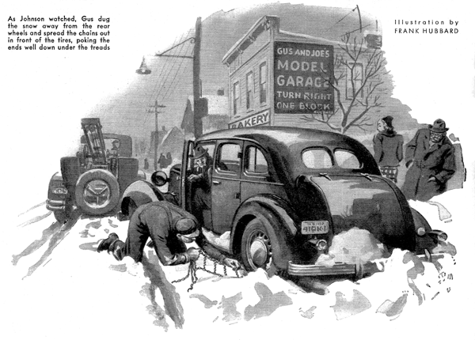
Gus Wilson placed the telephone receiver back on its hook.
"I had a hunch we'd get a call like this from Johnson before the winter was over," he grumbled to Joe Clark, his partner in the Model Garage. "He's stuck in a snow drift a block or so out on Livingston Street."
"You'd better come along and lend me a hand."
A few minutes later, Gus brought the service car to a stop beside a large sedan that was almost hub-deep in the soft snow that edged the road. Judging from the ruts in the snow, the owner had made several attempts to free his car before calling the Model Garage.
"Got your chains handy, Mr. Johnson?" asked Gus, as he inspected the position of the stuck car.
"Never use them!" snapped Johnson. "The chains haven't been made yet that are any good. All they do is bounce you along the road and help you to skid."
Gus said nothing. Long experience with obstinate car owners had shown him that it was useless to argue. Instead, he unstrapped the short shovel that hung on the side of the service car, and rummaged around in his trunk-size tool kit for a pair of old chains that would be large enough to fit Johnson's tires.
As Johnson watched, Gus dug the snow away from the rear wheels and spread the chains out in front of the tires, poking the ends well down under the treads.
"Watch it now, Joe," he warned, as he climbed into the driver's seat, started the motor, and let in the clutch gently. For a moment the wheels spun, but as they gained traction on the cross links of the chains, the car moved ahead slowly to the harder snow to the middle of the road.
"If you'd use these," said Gus as he picked the chains up out of the snow, "you'd spare yourself a heap of trouble. Just what is your pet peeve against chains anyway?"
"Plenty," grumbled Johnson. "They're pesky things to put on, they're noisier than the devil, they make your car skid sideways, and before you know it they're worn out and pounding dents in your fenders. And besides, they - "
"Whoa!" interrupted Gus with a chuckle. "Let's take one thing at a time, I'll admit chains aren't the easiest things in the world to put on, but if you use a little common sense you can do the job without even rolling up your sleeves. Watch."
Gus spread the two chains out neatly behind the rear wheels with their snap ends nearest the tires. Then he pushed the end of one of the side chains through the spoke hole at the bottom of one of the wheels and snapped it onto the side chain on the other side of the tire. This served to fasten the end of the chain to the tire. When he had repeated the operation with the other rear wheel, he climbed back into the driver's seat.
"Now, all we've got to do is put the car in reverse, back up slowly, and presto - both chains will be around the tires."
As the car moved backwards, the rear wheels rolled over the cross links and the ends looped through the spokes held the front of the chains snugly against the treads. After one complete turn, the chains were entirely around the tires and all that was needed to finish the job was to fasten the ends together.
"There, that wasn't so bad, was it?" asked Gus drying his hands on his overalls.
"You win, Gus," agreed Johnson, grinning. "But you will have to admit that chains can get you into some pretty bad side skids if you don't watch yourself."
"Chains do act queer at times," admitted Gus. "The main trouble is, people think that, just because they have chains on, they can turn cowboy and the car won't slide. Naturally, you can't jam on the brakes too suddenly or go around corners too fast. If one wheel happens to lock at a point where there isn't any cross link, the tires are bound to slip. Chains are no free permit for reckless driving in any case, but you're a darned sight safer with them than without them. And there's plenty of going, like the soft snow that you got stuck in, where you just can't navigate without them.
"And, as far as the racket goes," continued Gus as he strapped his shovel back on the rack on the side of the service car, "you can get rid of most of it by fitting your chains with spring spreaders. They'll cut down the noise and make your chains last longer."
"There's one thing to remember, though. If you do use spreaders, take them off when you get stuck in deep snow. The extra slack in the cross links will let them take a better bite. If chains are too tight and fit the tires too snugly, they won't grip at all."
"What would you have done if you hadn't had any chains to fit my car?" asked Johnson.
"I'd have hooked on the tow car and pulled you out," grinned Gus. "That's the easiest way, I only used the chains to show you they're good things to have along. There are all sorts of tricks you can use to get a car out of deep snow. The main thing is to remember that the rear wheels can turn independently, so there's no sense doing something to one wheel if the other is going to spin.
"A couple of old potato sacks are handy things to carry around with you," Gus went on. "You can stuff them down under the tires when your wheels spin. They're a help even when you're using chains, and when they're not doing active duty they're mighty fine anti-rattlers for packing the tools in your tool compartment."
"But no matter what you use," continued Gus, as he stooped down and started unfastening the chains on Johnson's car, "let a little of the air out of your rear tires. If they're a trifle soft, they'll offer more traction surface and won't bounce and spin so much."
"Say, what in blazes are you up to, there?" bellowed Johnson when he realized that Gus was removing the chains.
"Thought I'd better get these mud hooks off your car before they put you into a bad skid," replied the veteran mechanic with a chuckle.
"O. K., Gus. You win. But don't rub it in," grinned the car owner. "Just leave those chains right on there and stick the pair on my bill. I guess the clatter of chains and a few barked knuckles are better than a cracked skull and a ride in an ambulance."
END

