April 1938

GUS JUDGES A CONTEST
by Martin Bunn
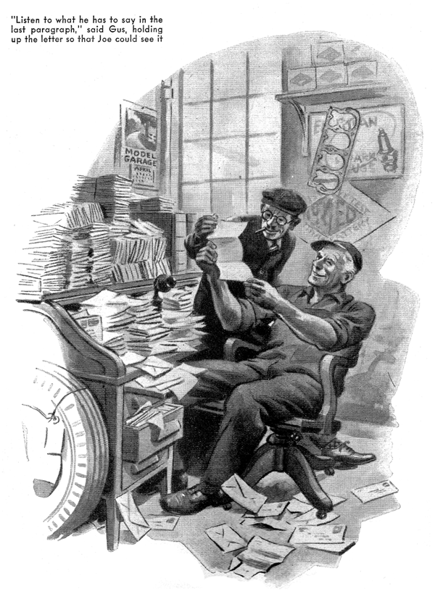
As Joe Clark walked into the small office that adjoined the Model Garage repair shop, early one Monday morning, he spied Gus Wilson, his partner, working at the desk. Almost hidden by piles of papers and letters, the gray - haired mechanic was busily adding up a long column of figures.
"Now let's see," Gus was muttering to himself. "Twelve and eighteen make thirty, plus six is thirty six, plus fourteen is fifty."
"What in blazes are you doing, figuring out your income tax?" interrupted Joe.
"Might as well be," replied Gus looking up from his work. "I'm trying to figure out what part of an automobile causes the most trouble."
"What brought that up?" asked Joe, scratching his head.
Gus jerked his thumb in the direction of the piles of papers that cluttered the desk. "Answers to that contest Martin Bunn ran in POPULAR SCIENCE MONTHLY back in January. Folks from all over the world have written in telling me about their mysterious car troubles and how they fixed them. I've been reading them over and trying to figure out what variety of trouble pops up most often."
"Running out of gas, probably," put in Joe.
"Nope, guess again. It's the distributor, with the ignition wiring running a second, then comes the carburetor, with dirt in the gas tank and battery trouble trailing close behind."
"What causes the least trouble?" asked Joe.
"Wasps," replied Gus with a grin.
"Wasps?" repeated Joe. "How the devil can wasps cause car troubles?"
Gus dug down to the bottom of one of the large piles of letters. "This letter comes from a fellow way out in the middle west," he said, settling back in his chair as Joe perched himself on the edge of the desk. "He'd always had a yen to do his own repair jobs and one summer a few years back he figured he'd give the motor in his bus a thorough going-over.
"It took him a couple of weeks to do the job, and when he did finish, the blamed car ran worse than it did before. Had funny symptoms, percolated fine at idling speeds, but nothing he could do would coax it over twenty miles an hour.
"Thinking he'd probably pulled a boner somewhere, he took the car to a garage. The mechanic there couldn't fix it, so he took it to another, and finally to a third. They tested the carburetor, the timing, the ignition -- everything checked, but no one could wheedle any speed out of the blamed bus."
"What was the trouble?" asked Joe impatiently.
"You'd never guess," replied Gus, holding the letter up for Joe to see.
"The trouble went on for several days,' he writes, 'so finally my brother-in-law and I decided to strip the motor and examine each part carefully. After we had removed the ignition system and the carburetor, we went to work on the intake manifold. As I leaned down to check the intake holes in the side of the motor, I squinted into the first intake port and what do you suppose I saw? A large mud-dauber's nest was completely plugging the hole. Evidently, when I had the motor down for the overhaul, the darned wasp decided it was a swell site and went to work building its nest. Naturally, it cut down the intake and choked the motor.'"
"Well, I'll be darned," grinned Joe.
"Next thing you know, we'll be hearing that a car won't run because trees are growing out of the exhaust."
"And that's not so far-fetched, either," put in Gus. "I got a letter from another fellow whose car wouldn't run, and he found twenty-five acorns in his intake manifold. He hadn't been using his car for a few weeks, and some cagey mouse must have laid up a store there.
"Then there's a fellow down south who blamed a cat for his most mysterious car trouble. He was riding along one night when he heard a racket that sounded mighty like the yowl of a cat.
He stopped the car and raised the hood.
There was no sign of a cat, but a tiny puff of stream came from the front of the motor. It turned out that the water-pump bearing had run dry and was so blamed hot that it boiled the few drops of water that leaked out now and then.
The steam would get trapped between the packing and the packing nut, and when enough pressure would build p she'd hiss out with a terrific yowl."
"How many letters did you get?" asked Joe.
"Haven't counted them yet," said Gus, lighting his pipe, "But there are answers from all sorts of people: doctors lawyers, housewives, school principals,--"
"Get any from rival garage mechanics?" interrupted Joe.
"Yeah," nodded Gus. "And by the way, speaking of garage people, what's the idea of you sending in an answer?"
"Me?" sputtered Joe.
"Yes, you," grinned Gus, with a twinkle in his eye. "Take a look at this."
Joe Clark leaned down to read the letter Gus held in his hands. At the top of the page, neatly penned in unfamiliar handwriting was a name and address:
Joe Clark,
(Joseph M. Clark),
Staten Island, N.Y.
"Looks as though you've got a namesake who reads POPULAR SCIENCE MONTHLY," said Gus, with a chuckle, as he tossed the letter back on the heap.
END

