September 1937

GUS GIVES
A GOOD STEER ON STEERING
by Martin Bunn
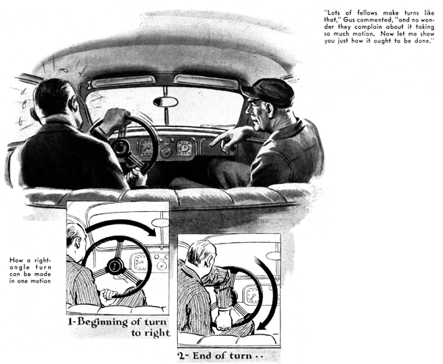
Gus Wilson, part owner and chief mechanic of the Model Garage, was in the cellar with his partner, Joe Clark, discussing some proposed changes in the racks for storing new tires
"Seems to me, Joe -" Gus was saying, when a familiar creaking in the beams over his head interrupted him. The rumble told Gus that a customer's car had just rolled into the main floor. He headed for the stairs, but before he reached them there came a final, protesting creak from the beams as the brakes on the incoming car were jammed on with vicious force, and a voice like the bellow of a bull shouted an ear-splitting, "Hey, Gus!"
"Hello, Tim," Gus grunted to the huge, heavy-set man who was climbing out of his brand new sedan. "What's eating you today? Have you pushed one of the pedals through the floor boards, torn the emergency brake lever out by the roots, or maybe accidentally ripped a hunk out of the steering wheel?
"G'wan, Gus, stoop kidding." Tim Grogan replied with a chuckle that shook his barrel-like chest. "I just stopped in to see if you could do anything about this steering gear."
"What seems to be the matter with it?" Gus asked, as he reached through the window and gave the steering wheel an experimental twist.
"Nothing's busted," Grogan explained. "What I'm kicking about is all the motion you have to go through just to turn around a corner and, worse yet, when you have to park the car. Why. When I swing a corner I have to turn that darned steering wheel like I was winding up a music box. It's a nuisance. What's the sense of making a steering wheel that you have to turn so far to make the front wheels do what you want them to? My last car was bad enough, but this is much worse. Why can't they make them like they did in the old days, when all you had to do to go around a right-single corner was to give the wheel about a quarter turn or so?"
"Well," explained Gus, "one of the reasons why they make steering wheels like they do now is so women can turn them easy - and you know a lot of women drive, these days. The more you gear down the steering wheel, the more you must turn it to get the front wheels to any given angle - and the easier it moves, too."
"Humph!" Grogan snorted disgustedly. "Just a lot of sissy automobiles. That's what they're turning out, these days. Made for women, and for men with jelly in their arms instead of muscles!"
Gus grinned. "Two bad we can't all be regular humans like you! Seriously, though, there are other reasons for the low gearing of steering wheels. I'll bet even you wouldn't like to handle a modern car if it had the quick-action effect you talk about. You've got to remember two things. First, it really takes a lot more power to turn the front wheels of a modern car than it used to because of the big tires all cars use nowadays. I grant you that steering in ordinary driving would call for only a little more pull on the wheel if you had and old time steering-gear ratio, but I'll bet that with all the muscle you've got, you wouldn't find it any too easy to park such a car in a small space - especially if the tires happened to be a trifle soft. And a man with just ordinary muscles would feel like he'd been through a wrestling match by the time he got front and rear wheels against the curb.
"Then there's another point to be considered," Gus went on, "and that is the speed cars travel now. In the days when they used quick-acting steering gears, thirty-miles an hour was that and forty or fifty was going like the devil. At high speed, a quick-acting steering gear calls for a lot of skill, specially if the road isn't any too smooth. A dub is quite likely to wobble all over the place with such a combination.
"Aside from that," Gus continued, warming up to his subject, "think what would happen to the average man if he had a quick acting steering gear and he got a blow-out on the front wheel while he was going fast. Even with the low-rates steering, the drag of the flat tire may pull him off the road, and with a quick-acting steering gear he'd be dead certain to end in the ditch."
"Yeah, I can see how that would work out," Grogan grudgingly admitted, "but it seems a shame that I have to go through so much arm motion just because other fellow aren't strong enough to hold the wheel. Here's an idea! Why doesn't some manufacturer make a 'two-speed' steering gear so you could set it for quick-acting ratio for ordinary running around, and shift to the slow, powerful gearing when you had to park or tear off a bit of speed."
Gus laughed, "And what would happen to the bird who forgot he was not for quick-setting steering when he gave the wheel a yank to swing out and pass a car? He'd likely swing over so far he'd bash the car coming the other way. No, I don't think much of that idea, although you're not the only one who's thought of it.
"Maybe the trouble with you," Gus suggested, "is that you don't know how to handle a steering wheel."
"You've got a nerve to say that," Grogan protested, "knowing al the years I've been driving a car."
"Maybe I'm wrong," Gus smiled. "How about taking a little drive so you can prove it?"
"I'll show you, all right," snapped Grogan. "Climb in!"
They started down the road with Grogan's huge hands gripping the wheel in a conventional position, one on each side about half way up to the top of the rim.
"Suppose you take the next right turn," Gus directed.
As they reached the turn, Grogan swung the wheel a quarter turn to the right, bringing his left hand to the top of the wheel and his right to the bottom. As he reached this position he let go with his right hand and, grabbing the wheel at the top, pulled it around to the right for another half turn. Then his left hand grasped the wheel at the left side and continued the motion until his hand was at the top. This gave him one complete turn of the steering wheel, which moved the front wheels far enough to make a sharp right-angle turn.
As they passed the middle of the quarter circle, Grogan went through the same motions in reverse, so that he made six distinct changes with his hands in order to make the turn.
"Lots of fellow do it about like that," Gus commented, "and no wonder they complain about it taking so much motion. Now let me show you how it ought to be done."
They changed places and continued down the road.
"Now in the first place," Gus explained as they approached another right-angle corner, "before you get to the place where you are going to turn, place your left hand on the bottom of the wheel if you are going to turn right, or your right hand if you are to turn left. Grasp the wheel like this, with the hand under the rim instead of over it. As you reach the turn swing the wheel around. When your hand reaches the top and starts down the other side , lean your body forward and twist it slightly toward the direction in which you are turning like this. Doing that makes it possible to swing the wheel till the hand is clear down to the bottom giving you one complete turn of the steering wheel with one continuous motion. As you pass the peak of the curve, simply reverse the movement of the hand, so that you end up going straight ahead again with only two motions, and no head shifting at all - except, of course the one you make before you reach the turn."
"It's funny that way of doing it never occurred to me," Grogan admitted. "I can see that it's all in leaning forward and twisting your body a bit, because, if you didn't do that, you couldn't swing the wheel far enough with one hand. Let me try it."
The changed places again and Grogan steered around several corners by Gus's method.
"It's a perfect clock going several sharp corners that way," Grogan observed enthusiastically, as his huge hand swung the wheel around to the straight again and they headed back to the garage.
"Did you notice how the wheel swings back to the straight-ahead position by itself!" Gus asked. "All modern cars are made that way. It is called the corner action and is caused by the angle and position of the king-pin with relation to the axle itself. Some fellows take advantage of that action. They let go of the wheel completely, let it spin most of the way back, and grab it again."
"I've tried it myself," Grogan replied.
"It's kind of uncertain, though, and once I nearly walloped a delivery wagon because the wheel didn't turn as fast as usual."
"That's just the point I was going to mention," Gus went on. "The easier action is mighty good thing. The fact that the wheels have a natural tendency to swing to the straight-ahead position makes driving a lot easier. But you shouldn't ever depend on it in close quarters, because the quickness with which the wheels swing back depends on several things, one being how level the road is, figured across.
"There's only one safe way to drive a car. That is, never to let go of the wheel completely while the car is in motion.
"Up to say twenty-five or thirty miles an hour, at least one hand should grip the wheel firmly, and when you're going faster than that, keep both hands on the wheel. If the thumb and forefinger of one of your hands are hooked around a spoke of the wheel, that gives a firm-hold without having to grip with much pressure."
Grogan laughed. "Lots of young fellows I know go in for one-hand steering when the right girl is in the car beside them!"
"And take a chance of handing the girl a plaster cast instead of an engagement ring!" Gus growled as he climbed out in front of the Model Garage.
END

