October 1937

GUS SAYS...QUIT STALLING!
by Martin Bunn
The Veteran Mechanic
Tells What To Do When Your Motor Goes Dead
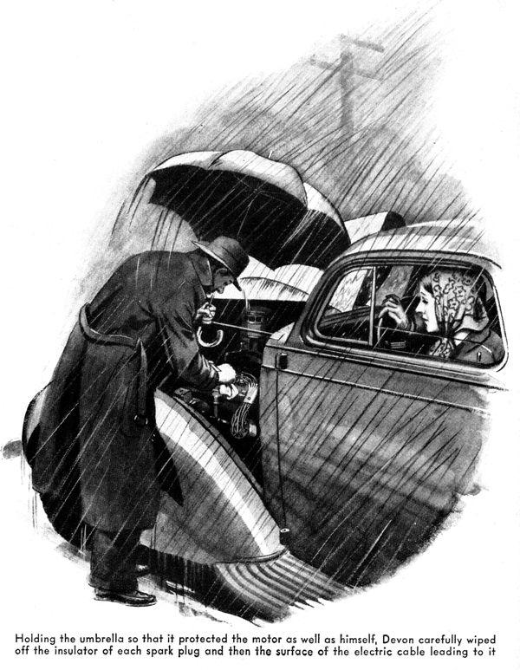
"Might as well be trying to drive a submarine!" Jim Devon growled disgustedly, as he leaned forward in an attempt to see more clearly through the sheets of water streaming down his windshield. "Just our luck to run into a storm!"
"You're pretty hard to please, Jim," his wife observed. After all the fine weather we've had on this trip you growl because we happen to run into a little rain in the last few miles! I'd say we've had extra-good luck with the weather."
"Sure we have, dear," Jim smiled. "Don't mind me. You know I always did hate driving in the - what the dickens has happened now?"
They had stopped for a traffic light and, as Devon was talking the motor suddenly stalled. He stepped on the starter again and again, but the motor refused to start.
"That's funny," Devon muttered, "never did that before. I guess one of the spark plugs has gotten a soaking. Gimme the umbrella while I wipe them off."
Holding the umbrella so that it protected the motor as well as himself. Devon carefully wiped the insulator of each spark plug and the surface of the cable leading to it. When he climbed back into the car and stepped on the starter pedal again the motor started at once.
Guess I know my onions!" he bragged, as they started down the road.
"Now, as I was saying - " He did not finish the remark, for the motor interrupted it by going dead again.
"Now what in thunder is the matter?" Devon exclaimed. "Can't be the spark plugs this time, because it's almost stopped raining. Maybe there's a loose wire somewhere."
He got out a screwdriver and pliers and tested all the wire connections he could get at conveniently, but found nothing loose.
"Humph!" he grunted. "Must be a burned-out coil or something. Well, guess I'd better phone the Model Garage and have Gus tow us the rest of the way home - it's only three miles or so."
"First try it again. Maybe it'll work now," his wife suggested.
Devon followed her advice and the motor started at once. However, it skipped explosions and showed signs of stalling again at slow speed so that he had to keep his foot on the throttle all the time in traffic.
"Take me home first, so I can get dinner started," his wife suggested, as they came in sight of the Model Garage, "and then you can run back and have it fixed while the meat is cooking."
"O.K. by me, if it'll run that far," Devon growled.
Ten minutes later, he pulled up in front of the Model Garage with the motor racing. As Gus Wilson, mechanic and half owner of the establishment, came over to him, he took his foot off the throttle pedal and the motor stalled almost at once.
"That makes the third time it's gone to sleep like that in the last half hour, Gus. See if you can find what's the matter."
As Gus lifted the hood, the odor of raw gasoline filled the air. The outside of the carburetor was dripping with the fluid.
"Shouldn't be hard to find that trouble," Gus muttered. "The motor is being drowned in gasoline. Either the carburetor float has sprung a leak there's dirt under the float needle valve or it's a combination of a tiny bit of dirt under the float needle plus too high fuel-pump pressure."
"And I thought it was rain on the spark plugs!" Devon growled, crestfallen.
"No ordinary rain ever stopped a motor once it was warmed up well, Gus maintained, "unless the distributor cap leaked water or was cracked or something like that. Of course, in the kind of a rainstorm we've just had enough water may be blown through the radiator or sideways through the hood louvers to make one or two of the spark plugs skip a few explosions, but the heat of the engine at normal running temperature will evaporate any water that hits them in no time at all.
"No," continued Gus, as he got his tool kit and started to remove the carburetor, "about the only time rain puts the ignition out of kilter is when you leave the car in the rain for hours till it is stone-cold and a film of moisture settles all over the plug insulation and the high-tension wiring as well.
Sometimes the motor won't start under such conditions, and even if it does the wettest plugs are likely to miss a lot till the motor warms up enough to dry off the moisture."
"Anything the matter with that float?" Devon asked, as Gus removed it from the carburetor and shook it gently.
"Tight as a drum," Gus replied. "If any gas had leaked into it, you could hear it slopping around when you shake it. There doesn't seem to be much dirt in the carburetor either, so I guess we'd better have a look at that fuel pump."
Gus disconnected the gas pipe between the fuel pump and the carburetor, and connected the former with the gauge on the testing stand. Then he started the motor, which could be run for a brief time on the gasoline remaining in the carburetor float chamber. The gauge showed that the pressure developed by the pump was considerably higher than it was supposed to be.
"Now, here is what happens," Gus explained. "So long as no dirt gets under this needle valve that is operated by the rising and failing of the float everything is fine, because the extra pressure is not nearly enough to force the needle open against the closing pressure produced by the float. But the minute the tiniest speck of dirt lodges under the needle, the gas keeps on flowing after the gasoline level in the float chamber has reached its proper height.
"Of course, the speed of this excess flow," Gus went on, "depends on how big the speck of dirt is, as well as on the pressure of gasoline. And you've got to remember that the motor, even when it's idling, uses gas steadily. If the fuel-pump pressure is normal, a tiny piece of dirt under the needle will not cause gas to flow faster than it is burned by the engine, so no harm is done."
"Now I get it," Devon interrupted.
"If the pump pressure is high, a lot more gas is forced through, the carburetor is flooded and the motor stops from having too rich a mixture. So when I let the motor stand while I cleaned the plugs the first time it started, and while I tried to find a loose wire the second time the excess gas cleared away and the motor started. And I was blaming the ignition all the time!"
Gus smiled. "Anybody could make that mistake. The funny part of it is that you probably could have started the motor right away either time just by opening the dash control of the throttle and holding it that way for a few seconds before you stepped on the starter instead of giving the throttle pedal a quick jab like most people do at the instant when they step on the starter.
"When you jab the pedal," Gus explained, "this plunger shoots raw gas into the manifold - because there's too much gas already."
"So what I should remember," Devon summed up, "is that the next time the motor stops like that, I should get it started with the dash-control throttle and of course, not use the choke. Is that right?"
"Correct - if the dirt that's causing the trouble happens to be under the float needle valve," Gus pointed out. "But if the motor stops when it's idling because dirt has partly clogged the carburetor jets, then you're up against exactly the opposite situation. In that case, the motor dies from gas starvation, so pulling out the choke to get a thicker mixture in the cylinders will get you started. And, after the motor is idling pretty fast, you often can suck the dirt out of the clogged jet by yanking the choke all the way out for a half second or so while you step on the throttle. That trick also will cure 'stuttering' caused by water in the carburetor."
"That makes sense," Devon agreed, "but how do you know which trouble you're up against? Suppose she just stalls. How are you going to tell whether it's dirt under the float needle or dirt in the idler jet?"
"Since it usually happens in traffic," Gus replied, "and the first thing you notice is that the motor isn't running any more the best thing to do is to treat the motor as if it were flooded - and if it doesn't start after a couple of attempts, then give it the works with the choke. Always try the remedies in that order, because if you go at it the other way around, you'll flood the motor worse than ever - if flooding happens to be the trouble."
"Of course," Gus added, "if the trouble is caused by a leaky float that lets the level of gasoline in the float chamber get too high, the way to get the motor going when it stalls from flooding is the same as for dirt under the float needle. But unless you have the float fixed at the first opportunity, it'll only be a question of time before enough gas gets inside the float to sink it, and then your goose will be cooked. The motor will choke up every time you start it, and you won't be able to keep the engine running at all except at racing speed."
"Seems to me," Devon recalled, "I had a leaky float on a car I owned several years ago, and while the motor ran pretty badly, stalled often, and used a whale of a lot of gasoline. I could still use it, and it certainly didn't stall every time I started the motor. Why shouldn't a modern car do at least as well?"
"Your old car," Gus explained, as he finished the job on the carburetor and fuel pump, "undoubtedly had a vacuum-tank fuel feed that probably was set pretty close to the level of the carburetor. Besides that, I doubt if the float could have been so filled with gasoline that it wouldn't float at all. Anyway, it wouldn't have worked that well with a modern pump-feed system, if the pressure was higher than normal."
"Couldn't the old vacuum tank produce extra pressure too?" Devon asked.
"That was one of the faults it didn't have," Gus chuckled, "although it had plenty of others.
"With a vacuum tank, you know, there was no pressure-feed system like you have with a fuel pump. The gas just flowed down from the tank to the carburetor by its own weight.
"It's easy to see that when you get your pressure by letting gasoline flow down by gravity from one tank to another, the only way you could get higher pressure without moving the vacuum tank would be by changing the law of gravity - and even Einstein hasn't been able to do that!"
END

