December 1937

DRIVING A CAR BY EAR
by Martin Bunn
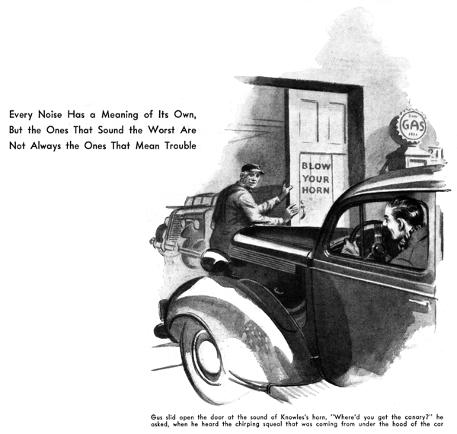
For the tenth time, John Knowles glanced apprehensively at his oil gauge and nervously tapped its glass cover to reassure himself that the needle hadn't stuck. Then, to make doubly sure, he threw out the clutch and took his foot off the accelerator so that the motor slowed to idling speed. The oil-gauge needle immediately dropped to a few pounds instead of its normal position near the thirty-pound mark. When he speeded up the motor and let in the clutch again, the needle swung up to its former position.
"That settles the oil-pressure question, all right," he muttered to himself. "So whatever that confounded squealing is, it certainly isn't coming from a dry bearing in the motor. With all that oil pressure, I don't see how any bearing could run dry."
The noise continued, however, and was very pronounced when he had to go slowly in traffic.
"I just hope I can get to Gus's place before there's any damage done," Knowles grunted, as he rounded a curve and the sign of the Model Garage came into sight.
Gus Wilson, mechanic and half owner of the establishment, slid open the door at the sound of Knowles's horn.
"Where'd you get the canary?" he asked with a grin, when he heard the chirping squeal that was coming from under the hood of the car.
"Is it something serious?" Knowles asked nervously, after he had stopped in the shop.
"Serious!" Gus grunted, walking over to the car and lifting the hood.
"There's no noise a car can develop that sounds worse and means less than that commutator squeal. That's what you've got. Ordinarily, the brushes of the generator slide on the surface of the commutator without making any noise. But once in a while, when conditions happen to be just right for it, the commutator takes on a glaze that causes the brushes to vibrate like violin strings when you scrape a bow over them.
"If you just forget about it," Gus continued as he lifted the hood and applied a screw driver to the dust band over the commutator, "the chances are about a thousand to one that the noise will go away in a day or two, and you may never hear it again as long as you own the car. Or it may come back from time to time. If you want to get rid of the squealing, all you have to do is to clean the commutator like this."
He took a small flat-ended stick, pulled a piece of stout cloth over the end of it, and pressed it against the spinning commutator. The noise stopped at once.
"Always use a piece of wood, never the end of a screw driver," Gus cautioned, "and a stout piece of cloth that won't tear into shreds and get caught under the brushes. If it still squeals a bit after a cleaning like this, put just the tiniest trace of petroleum jelly on the cloth and try it again. That'll cure the most stubborn case of commutator squeal you'll ever run across."
"That's a relief, Gus," said Knowles. "Put it on my bill."
"That'll be a big item," Gus laughed.
"Killing one canary - ten cents.' Forget it!"
"All right, then, fill up the gas tank and check the oil," Knowles smiled.
"I suppose you think I'm an awful nuisance, Gus," he went on, after he had backed the car out to the pump, "but I can't help worrying when I hear any funny noise."
"It's a lot easier on your pocketbook to be that way," Gus grunted, as he unhooked the gas hose and started the pump motor, "Gus grunted, as he unhooked the gas hose and started the pump motor, "than it is to be one of those birds who never suspect there's anything wrong 'til the wheel drops off or the motor quits cold.
"The big thing," he continued, "is to get to know which noises mean things that don't amount to much - like that commutator squeal, for instance - and the noises that spell trouble coming. Take brakes that howl just as you come to a stop. There's a noise that doesn't necessarily mean that the brakes are going had. Sometimes after a couple of thousand miles, the brakes on a new car will develop a squeal that will last for a few days and then go away for good. Or they may only howl In very dry weather, or when you get them soaking wet. The important thing is whether the noise keeps up, or whether it comes only once in a while and then disappears. The same thing applies to chattering brakes, because a chatter and a howl are a about the same thing. Both are vibrations caused by some particular condition of the brake lining and the brake drum - usually a glazed surface on the brake lining. A long run down a mountain with the brakes partly on may put a temporary glaze on the surface, but it will disappear after a few quick stops. Of course, if the car has seen many thousands of miles of hard service, and the brakes suddenly begin to chatter or squeal continually, they ought to be checked right away."
"Are there many other noises I'm likely to hear that don't mean real trouble?"
"Sure plenty of 'em," Gus replied, as he put the end of the hose back on its hook. "Sometimes, on a cold morning, while you're letting the motor warm up a bit, you may hear a sputtering, gurgling noise from under the car. Don't let it worry you. It'll be water, condensed from the exhaust fumes in the muffler, being forced out the vent hole. If you se a small puddle of water on the floor after you drive the car out, that's probably where it came from. Then, if you hear a 'slap, slap, slap,' noise when you drive onto a smooth concrete road from a dirt road or from your own bluestone-covered driveway, it probably isn't a piece of the tire tread coming loose, but a small stone wedged into the tread. If the noise doesn't stop within a quarter mile or so, it isn't a bad idea to get out and investigate. There's always a chance that it's a nail or a piece of scrap metal.
"There's another noise that sounds like trouble but doesn't mean much," Gus continued as he directed a golden stream of oil into the filler hole. "That, is a sort of a ticking rattle that comes from one of the wheels just as the car stops. It's a lot like the sound we used to get from a loose demountable rim in the days when cars had such things. But, while a loose rim in the old days might mean a tire coming off on the road, the noise you hear nowadays means only that the large snap-on cap over the hub of the wheel is a bit loose. If it fell off, you'd have to buy another one, but the operation of the car wouldn't be affected."
"How about some of the noises that are real danger signals?" Knowles asked, while the mechanic was rechecking the oil level.
"There's one that a lot of people don't listen for," Gus replied, "and that is the rather sharp click accompanied by a slight jar, that comes when you have backed and you let in the clutch to go forward again. If you hear that sort of a noise, you'd better check up on the tightness of the back wheels on the hubs. If a wheel is loose and is sawing back and forth against the key, the key may be sheared off and the wheel will be free n the shaft - which means a tow-in job. Or else the end of the shaft may snap off, and then you will be in trouble."
"Sometimes I hear a slight click if I don't have the motor going at the right speed when I let in the clutch after shifting gears," Knowles remarked. "Is that the same thing?"
"The click you hear then is mostly the taking up of the play - or, in other words, the backlash in the whole drive from motor to rear wheels," Gus explained. "You can get that sound in most cars, no matter how tightly the wheels fit."
"How about motor noises? Is it easy to learn to tell which noises mean that real trouble is coming?"
"How are you going to do that," Gus countered, "when most of the things that mean trouble coming to the motor don't give any warning noises? The noise comes after the damage is done. Take the oil supply, for example. If it fails and you don't happen to notice the lack of pressure on the gauge, or the increase in motor heat on the dash thermometer, then the first thing you know about it is when a heck of a lot of clattering and clanking tells you that a hearing is shot, or when the motor stops because the pistons stick. All that your ears can do is to tell you when something has gone wrong - not when it is about to go wrong."
"Now I think of it, I can see that it would have to be that way," Knowles admitted, "because the engine parts move at such high sped and fit so closely. As long as they fit, they can't make any funny noises - and when anything happens to make 'em loose, the damage is already done. Are there any other important things to listen for, outside of the motor?"
"Well," said Gus, wiping his hands on a wad of waste, "if you hear a grating and grinding noise from a front wheel and you feel a slight drag on the steering wheel on that side, slow down at once and head for a repair station, because you've probably broken a front-wheel bearing."
Knowles climbed into his car and started the engine.
"Thanks a lot, Gus," he said. "I suppose this listening for noises is a necessary evil of motoring, eh?"
"It isn't for one of my customers, anyhow," grunted Gus.
"How's that?" Knowles asked. "Is he one of those 'I should worry' drivers?"
"He's just as fussy as you are - but he's stone deaf!"
END

