August 1937

MORE POWER TO YOUR CAR
by Martin Bunn
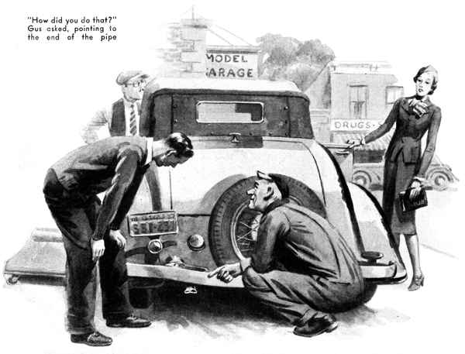
"This bus has almost as much power left in it as a flea - and a sickly flea at that," grumbled young William Barton disgustedly, as he shifted back into high gear at the top of the hill.
"Billy, you're the limit," snapped his good-looking bride. "With all this perfectly beautiful scenery to look at, all you can think about is that miserable engine. I wish we had come by train!"
"So do I - or I will pretty soon, if this motor doesn't begin acting better," Bill growled. "But don't let's quarrel about it, honey," he added with a smile.
"You admire the scenery and leave me to worry about the motor. Just be thankful you don't have to take an eyeful of cinders with the scenery!"
"Do you really think it is getting any worse?" she asked. "Because, if it is, maybe that funny hissing noise I hear has something to do with it."
"What funny hissing noise? Do you hear it now?" Barton demanded, cocking his head first to one side and then to the other.
"No - only when you push on the accelerator," she replied. "Step on it quickly now, and listen."
They happened to be passing a high bank at the side of the road as Barton jammed the throttle pedal to the floor, and a strong hissing noise was very noticeable.
"Gosh!" he exclaimed. "I'll bet I know what the trouble is. Probably the muffler is all clogged up. We ought to stop and have that fixed. It's just wasting gas, as well as taking all the power out of the motor."
A few minutes later, they sighted the Model Garage, and Gus Wilson, half owner and mechanic, greeted them as they pulled in.
"I'll just run over there and send out a flock of post cards while you have it fixed," said the bride, as she caught sight of a drug store down the street.
"Don't forget to tell them how fine the car is running," laughed Barton, turning again to Gus.
"Muffler seems all clogged up so she has no power," he explained.
The veteran mechanic stretched himself out on a creeper and slid under, "Step on the accelerator now," he ordered. In a second or two he slid out again and went around to the back of the car. "How did you do that?" Gus asked, pointing to the end of the pipe.
Barton got out and came around to the back of the car. He saw that the end of the exhaust pipe evidently had hit a rock or some other object projected from the mud, so that the opening had been crushed to a tiny semicircular crack.
"The outside shell of your muffler is rusted through in one place," Gus informed him, "so when the pipe got bashed closed like that, the back pressure made the gas hiss through the hole in the shell. I'll fix you up in a jiffy."
With a screwdriver, he pried open the closed end of the pipe enough to start the rounded and of a ball-peen hammer in the opening. Then, with another hammer, he drove the ball into the pipe, expanding it and making it nearly as round and full as when it was new.
"Simple enough, when you know how to do it," laughed Barton. "That ought to bring the power back a bit, but shouldn't something he done about that hole in the muffler?"
"Why bother?" Gus questioned. "The gas hissed through the hole only because it couldn't get out the regular way. You'll find it doesn't hiss now that the tail pipe is open. I could strap a piece of sheet asbestos over the hole with a band of sheet iron, but that would only speed up the rusting of the rest of the shell, and it wouldn't be long before it rusted through at some other spot.
"You don't hear much noise right now because of the hole, and I've seen mufflers go along for a year or two with a hole in them like that in them like that without getting much worse. When it finally breaks open, so you can hear the snap of the exhaust, then you can put on a new muffler. They don't cost much," Gus concluded.
"Well, I suppose you can't expect much power from a secondhand car, anyhow," Barton remarked. "Soon as I can get enough money together, I'll have to get a new one, and then I'll have some real power!"
"Fine idea to get a new car, mister," Gus commented, "but don't get the notion that because a car is secondhand it has to be weak on power. The trouble with most people who buy secondhand cars is that they just take them as they are without ever giving a thought to what could be done to put them back in good shape as far as power and smooth running are concerned."
"How do you mean, put in shape?" Barton asked. "Isn't loss of power and speed caused by general wear on the motor? How can you fix that without practically putting in a new motor?"
"Why do that?" Gus countered, "Just stop and think what makes a gasoline motor go. The piston goes down and drawn in a charge of air and gasoline vapor. Then it comes up and compresses it. Then the spark fires the charge, and the piston is driven down. The crankshaft and the drive shaft and gears transfer this power to the rear wheels.
"Now, where would you lose power? If the piston rings leaked badly, the piston wouldn't draw in a full charge, and a lot of the motors would leak past the rings the other way when the piston comes up on the compression stroke. The only other place where you could lose any power would be through a leaky exhaust valve that let some exhaust gas be drawn back into the cylinder with the charge, or if some of the charge escaped through a leaky intake valve back into the carburetor manifold. So, when you come right down to cases, loss of power in the motor block itself is mostly a question of leaky valves or rings.
"How about the cams that operate the valves? Can't they be worn, too?" Barton asked.
"In a very old car, you may find the case worn enough to affect the power," Gus explained, "but otherwise so long as the timing chain or gears hold together, there won't be more than a trifling loss from that source."
"Sounds encouraging, at any rate," Barton agreed. "But I've heard that just putting in new rings won't do much good unless you have the cylinders ground and that costs plenty, doesn't it?"
"It all depends on how much wear there is. Now this cylinder block here," Gus explained as he had Barton over to a corner of the garage and pointed to a motor that had been pretty well taken apart, "was run after the oil gave out, until the pistons actually stuck. See those deep scores down the sides of the cylinder walls? There's not much you can do with a cylinder block like that, short of grinding a new oversize bore and fitting special pistons and rings. But if the wear is just the ordinary kind that comes from regular use, the cylinders can be honed - which is a lot less expensive than grinding. Or, if the wear is not so much, you can fit some of those spring pressure piston rings that make a gas tight fit even in a cylinder that is worn quite a bit out of round."
"So it comes down to a valve-and-ring, job, then," Barton observed. "That doesn't sound so bad, but how about oil pumping? There's no use getting back the power if you still have to buy oil every time you get gas."
"Fixing the rings cures oil-pumping too," Gus maintained. "As a matter of fact the better-grade second-hand cars that are offered for sale have mostly belonged to only one or two people. The second owner, if there was one, probably ran the car till it began to pump oil and other little troubles started to crop up. If you get a car in no worse condition than that, sometimes a new set of regular rings will do the trick - and, if not, the spring pressure ones are almost sure to make the motor practically as good as new."
"But how about the carburetor and the ignition system? Don't they wear out too?" Barton interrupted.
"There's not much to cause trouble about this," Gus laughed as he picked up the carburetor from the dismantled motor. "Let's see, the float might be leaky, if it is, it doesn't cost much to fix or replace, and then it's as good as new. The same goes for the first needle valve. The spray jets might be partly clogged, but they're easily cleaned. Almost the only other thing might be excessive wear on the butterfly shaft. That can be fixed with a ruffled sheet metal brushing around the shaft.
"As far as the ignition system goes," Gus continued, "if it gives a good spark, you get full power. If not, you have to replace whatever has broken down. The breaker contact points and the points of the spark plugs are about the only parts that show wear in relation to the mileage."
"Anything else to consider from the power-less angle?" Barton asked.
"Not much that amounts to anything," Gus replied. "If your piston rings are good, and the ignition system and the carburetor are in shape, you haven't anything to worry about. You'll get good power and gas-and-oil economy. Of course, under inflated tires, wheels knocked out of line, or dragging brakes can pick up power, but it's easy to check these points. On an older car, too, you might have a worn universal joint."
"You encourage me a lot," Barton grinned. "But one thing I'd like to know is how to figure out whether it is worth while to fix up a used car or to trade it in for one in better condition?"
"That's not hard to answer," Gus replied. "Get a reliable service station to give you a lump estimate on all the repairs you'll need, and then shop around and find out how much it will cost you to trade for a better used car.
"And," Gus added with a smile, as Mrs. Barton returned and the young couple prepared to depart, "remember that a bird in the hand is worth two in the bush. Most likely, the car you buy will need some work done on it, too!"
END

