September 1936

COMMON SENSE

MAKES GOOD DRIVERS
by Martin Bunn
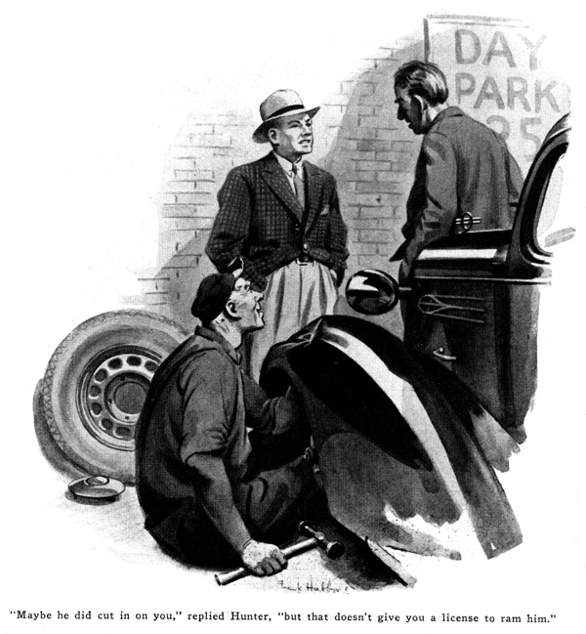
Barry Pendleton turned his car in at the Model Garage, slammed on the brakes with a savage jerk, climbed out, and glared angrily at the badly crumpled front fender of his new coupe.
"Smacked somebody, eh?" asked Gus Wilson, mechanic of the establishment, as he bent over and ran his huge, gnarled hand lightly over the indentations.
"I did not!" Pendleton denied heatedly. "The darned idiot cut in on me. That's the fourth time this year somebody's slammed into my car, and I'm getting sick of it. Next time, I'm going to hand whoever does it a swift sock in the jaw - and I don't mean maybe!"
"But supposing you were to blame - like this time?" chuckled a man whose car had pulled in and stopped behind Pendleton so quietly that he hadn't heard it. "It'd kind of make the fellow extra mad to punch him after running into him, wouldn't it?"
"Say! Where do you get that stuff?"
Pendleton snapped at the newcomer. "Didn't I say he cut in on me?"
"Maybe he did," replied old Thaddeus Hunter, as he leaned his six feet of skinny height against his sedan, "but that doesn't give you a license to ram him. That dent never came from a side-swipe - did it, Gus?"
"Couldn't have," growled Gus, between thumps with a fender hammer as he gradually raised the dent. "See where the bottom of the dent is. Nothing coming from the side could have got there without bending in the side first."
"Well, maybe he didn't actually hit me," Pendleton reluctantly admitted.
"But he pulled in so quick that I couldn't help but hit him."
"That doesn't sound right, either," the older man argued. "When a fellow passes you, he's going faster than you are. But you must have been going faster than he was, else you couldn't have hit him. How do you figure that out?"
'He wasn't trying to pass," Pendleton explained. "The dumb-bell was driving right out in the middle of the road, so I thought I'd shoot by on the inside. Just as I got nearly up to him, he swung over toward the edge of the road, for no reason at all. Naturally, I hit him. How could I help it?"
Hunter chuckled. "Young man, if all the motorists who've got into trouble from trying to pass on the wrong side were laid end to end they'd reach from here up to the north pole and down the other side 'most to China, I reckon."
"All right, go ahead and kid me if you get any fun out it," growled Pendleton, "but just wait till I catch you after a smash and I'll hand it all back to you."
"Guess you'll have to wait quite a while for that come-back," Gus grinned, as he squinted along the line of the dent to note his progress.
"Hunter hasn't had a real accident in the thirty years he's been driving a car, and he hasn't even so much as dented a fender in a dog's age."
"Thirty years!" Pendleton exclaimed.
"You were driving a car over five years before I was born. Then you don't drive many miles a year, or else you'd have accidents the same as other people."
"Other people don't all have accidents," Hunter corrected. "Thousands of 'em can show just as good a record as mine. Trouble is," he continued, poking at the end of his stogy to keep it from burning up, "the people that have accidents have forgotten what automobiles are for."
They can't seem to remember that getting there safely is the first object. And that's just a matter of applying common sense to your driving."
"I've got just as much common sense as anybody," Pendleton growled.
"Sure you have," agreed Hunter. "Only, are you sure you use it? A while back, you said the fellow you bashed into was a dumb-bell because he drove way out in the middle of the road. Maybe he was, but if a fellow is so dumb he doesn't know enough to stay over on his own side of the road then your common sense ought to tell you he's likely to do almost any other dumb trick on the calendar."
"But common sense isn't everything there is to driving, by a long shot," Pendleton interrupted. "How about skill, and good eyesight, and muscular coordination, and knowing just how fast you can go around curves without skidding, and that sort of thing? Aren't they just as important as common sense?"
"Not by an oversize jugful!" Hunter replied, emphatically. "Say, Gus, how long will it take you to finish that fender?"
"An hour, at least," Gus replied, as he adjusted a rubber backed grinding disk on the end of his flexible shaft. "It's got to have a couple of coats of lacquer sprayed on after I get it flattened out smooth."
"Then, young fellow," Hunter suggested, "suppose you drive with me over to the lumber mill in Pineville and back while Gus finishes your bus. Maybe I can show you why no amount of plain skill can make up for lack of common sense and good judgment."
Pendleton was willing. As he climbed in beside Hunter, the latter craned his thin neck first one way and then the other to get a clear view of the road both ways before he let in the clutch.
"No skill required there," the older man observed, as they backed out, turned, and started down the road.
"Just common sense tells you to make sure there's nothing in the way when you back out or even start up from the curb."
"I always glance in the rear-vision mirror before I start up," Pendleton said, "so you haven't got anything on me there, anyhow."
"So do most people," Hunter agreed. "But how many of 'em wait long enough to be sure there's no car passing right close, in the blind spot of the mirror? An inside rear-vision mirror only shows you the road some distance back through the rear window of your car. If a car is quite far out in the road, it passes out of view in the rear-vision mirror quite a bit before it actually comes by you. Lots of fenders get smashed because drivers forget that. Unless you poke your head out of the window and look back, you can't be sure - unless you wait for several seconds after you see that the road is clear in the mirror, so that if any car is in the blind spot it will have a chance to pass before you swing out.
"Now, here's the other side of it," Hunter went on, slowing up, as they swung around a corner into a street that was lined with parked cars on both sides. "Common sense should tell you that there may be a dumb-bell among the owners of these parked cars - and especially in a place like this, where all the cars are parked with their noses to the curb. Any one of them is likely to back out right into you. Of course, if there isn't any traffic coming the other way, you don't have to be quite so careful. Then, if you keep an eye on the row of parked cars, you can swing over if one starts to back out.
"Now," he continued, as they turned into the state road and rapidly overhauled a couple of heavily laden trucks, "I've found that I'm not so good on judging the relative speeds of oncoming cars so I won't attempt to pass those trucks until there is no possible chance that a car coming the other way will get me in a jam. I certainly wouldn't attempt it, under any circumstances, while we're going around this curve.
"Incidentally," Hunter continued, after they had come to a straight stretch and passed the trucks, "lots of drivers get the idea that they can judge the speed of an oncoming car to a hair when they really can't do it any better than I can. If you think you're hot stuff at that game, just get somebody to hold the watch on you while you estimate how long it will be before any give car passes you, how long it will take you to reach some point quite a distance down the road from where you are, and how long it will take you to swing out and pass a car and swing back onto your own side of the road again. You'll probably be astonished how far off your estimates will be.
"If you have a stop watch, you can time it yourself. If you have any natural aptitude for judging speed and distance, timing that way will help bring it out, and if you haven't, it will show you up to yourself without running any risks of a head-on collision."
"I get you," said Pendleton. "If you can estimate just how long it will be before the car coming the other way will reach you, and how long it will take you to pass the car ahead, and do it accurately, then the difference in time is your margin of safety. That's a swell idea. I'll try timing myself."
"Now, here's another problem where common sense wins out most times," Hunter said, as they pulled up behind a car that was rolling squarely down the center of the road.
"In a case like this, sound your horn once. If the driver pays no attention sound it again in a few seconds. Remember that he is intent on his driving, and may not hear you at first. If he doesn't pull over after the third attempt, crawl up close behind and stick right there. The kind of a driver who sticks to the center of the road usually is a bit nervous about a car following too closely, and he'll either pull over and let you go by, or speed up as if it isn't necessary. Of course you've got to keep your eye peeled for what's in front of the other car when you're close up like that, so you'll spot any danger as soon as he does and put your brakes on in time with him. And, naturally, you'll drop back a bit if for any reason you can't see what's ahead of him. Furthermore, it stands to reason that keeping too close to the car ahead is mighty risky if your brakes aren't in top-notch shape - but, then you shouldn't be on the road anyhow if they aren't!
"At night, it isn't safe to get so close, but you can turn on your distance headlight beams and that will generally get results."
"Not if he has his rear curtain pulled down," Pendleton observed.
Hunter laughed, "That makes him a double dumb-bell, so you'll have to be extra careful.
A lot of drivers pull down the rear curtain to cut out the glare of headlights in their rear-vision mirrors, but it doesn't strike me as the safest thing to do. It's always better to know what's going on behind your own car.
"I'm not saying that skill in driving isn't worth having," Hunter explained. "Knowing exactly where your wheels are is a help sometimes. Watch what happens to that empty cigarette package down the road."
Pendleton spotted the package, and looked back after the car had passed. The paper was completely flattened.
"Any skillful driver should be able to make either front wheel pass over any given spot, but many drivers can't come within six inches of a target with either wheel.
"Here's another point," Hunter went on, as they rounded a curve and came in sight of a crossing just as the light turned red. "Common sense will tell you it's wise to take your foot off the throttle and coast to a stop in a case like this. It saves the brakes. Further more, when you do have to jam on the brakes, always try to do it in such a way that you have several yards to spare. After your car has practically stopped, let up on the brake enough so she'll slide forward in that extra safety space. If the fellow behind you hasn't good brakes, he may not be able to stop as quick as you can, but by doing things this way you'll make him jam his brakes on in time so that he'll either stop before he hits you, or he'll bump you while your car is still moving and the shock won't be as great."
"I can see how that would work out," Pendleton said. "If you were, say, fifty feet or so in front of him when you slammed on the brakes, and his brakes weren't as good as yours, he'd come right up on you, but just before he'd slam you, you'd ease ahead and let him stop on the extra few yards. That's a good trick, too."
They returned to the Model Garage just as Gus was giving the final polish to the lacquered spot.
"I won't stop now, Gus," Hunter said.
"The rattle I wanted you to find seems to have disappeared. When it comes back, I'll drop in again."
"That old geezer is some slick driver, all right," Pendleton admitted as he climbed into his own car, "and he's no slow poke, either.
We were hitting fifty on the state road."
"But he isn't as good as you are, eh?" Gus asked, with a twinkle in his eye.
"He's better," growled Pendleton. "But he won't be for long. I can mix common sense with my driving just as well as he can!"
END

